APPLICATION FOR PERMISSION TO IMPORT AND/OR EXPORT
ASBESTOS OR GOODS CONTAINING ASBESTOS

Instructions

- Section 1 – all applicants must complete this section
- The applicant name is to be the same name that will appear on the customs import or export entry
(as the goods owner) at the border, to be listed as the permit holder. Differing details will invalidate the permit at the border.
- The applicant’s physical address will be listed on the permit, to where the intended importation will be delivered, or intended exportation will originate from.
- Section 2 – all applicants applying to import asbestos must complete this section and at least 1 of the following subsections:
- Section 2a – import asbestos for research and /or analysis (including UK HSE AIMS schemes)
- Section 2b – import asbestos for display
- For gallery exhibits, confirmation of asbestos content is required prior to completing application.
- Section 2c – import asbestos for the purpose of disposal
- Section 3 – all applicants applying to export asbestos must complete this section
- General guidance
Please complete the application electronically.
Organisations based outside Australia must provide the Australian name and address details of the actual importer (consignee), even if using a local subsidiary that trades under a different name.
If intending to use a third party to receive the goods (importation consignee): Provide organisation name and address details. Permit will be listed to applicant c/- third party. This must be identical to the goods consignee details on the customs import entry.
Sections may be extended into the next page if required. Your information is not restricted to a single page.
Important: To avoid delays in processing your application, please provide as much detail as possible when answering the questions.

Section 1
Organisation details
All applicants must complete this section

Question | Applicant response
Previous permission number (if applicable):
Applicant name:
ABN:
Foreign organisation registered number:
Contact officer name:
Phone number:
Email address:
Physical address for intended importation/exportation:
Postal address (not for intended importation):
Website:
Type of organisation or business: | Choose an item.
Application for permission to: | Import asbestos: ☐ Export asbestos: ☐
Is this request for a single use or multiple use permit?  If a single use permit, what is the intended end date for the importation? | Single use: ☐ Multiple use: ☐  00 month year
Is your request urgent? | Yes: ☐ No: ☐  If yes, you must provide a reason and requested end date here:
Is your organisation a laboratory?  If yes, do you give permission to list your organisation’s details on ASSEA’s website?  A list of laboratory permit holders is published to assist importers and exporters intending to move asbestos risk-goods across the border. This only applies for permits greater than 6 months that are not for a specific project, and is not applicable to importations for the UK HSE proficiency schemes. | Yes: ☐ No: ☐  Yes: ☐ No: ☐  If yes, please complete the contact information below:  Name:  Phone:  Address:  Email:
Do you give a general assurance of compliance with all applicable laws? | Yes: ☐ No: ☐  If no, please provide a reason here:
[Back to top]
Section 2
Importation of asbestos, and goods that contain asbestos
All applicants applying to import asbestos must complete this section and at least 1 of the subsections (2a, 2b or 2c)

No. | Question | Applicant response
1 | What is the purpose of the asbestos importation? | Research and/or analysis: ☐ (complete subsection 2a)  Display: ☐ (complete subsection 2b)  Disposal: ☐ (external territory only) (complete subsection 2c)
2 | What port or city will the asbestos or goods that may contain asbestos enter Australia?
3 | Has confirmation to import been sought from a state or territory WHS authority? | Yes: ☐ No: ☐  If yes, provide the name of the authority: _____________  Include copy of response from WHS authority with application.
4 | Has permission to use asbestos been obtained from a WHS Regulator? | Yes: ☐ No: ☐ N/A: ☐  If yes, provide the name of the regulator: _____________
5 | Using the map below as a guide, list all the countries or regions where the asbestos would be imported from.
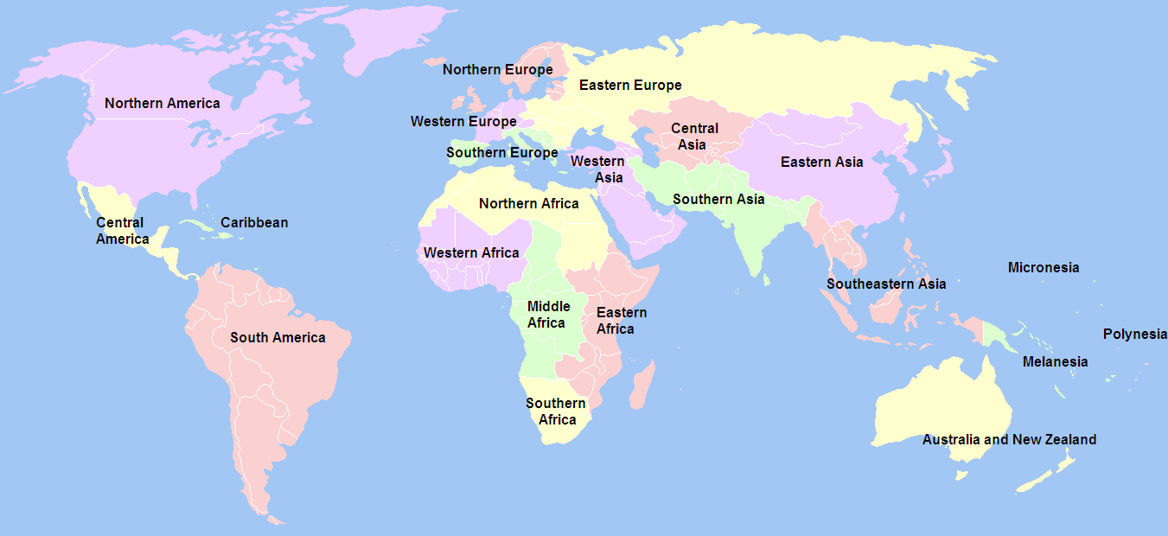
Source: UNSD standard
[Back to top]
Section 2a
Importation of asbestos, and goods that contain asbestos, for the purposes of research and/or analysis
Complete this section if you are applying for permission to import asbestos for research or analysis

No. | Question | Applicant response
1 | If the asbestos is being imported for participation in any of the UK HSE proficiency schemes, please indicate. | RICE: ☐ AIMS: ☐ AISS: ☐  N/A ☐
2 | What is the reason for the analysis and/or research?  e.g., to test representative samples from an intended importation; to test samples from overseas structures unrelated to a potential importation. | If only for the purpose of that detailed in question 1 indicate: N/A ☐
3 | If known, what form of asbestos silicate is being imported? /*If not, indicate: to be determined. | Remove those not applicable.  Raw asbestos mineral: chrysotile, actinolite, tremolite, amosite (grunerite), anthophyllite, crocidolite.  TBD: ☐
4 | Please list what type of goods the samples are taken from?  e.g., building materials, air monitoring cowls, vehicle parts, tiles, gaskets from machinery etc | New and unused goods: Yes: ☐ No: ☐
5 | What are the estimated or known dimensions of the products/samples?
6 | How many consignments will be imported within the permission period (known or estimated)?
7 | Estimate the percentage (%) of imports expected to test positive for asbestos.
8 | Is the research and/or analysis to be carried out by someone other than the importer? | Yes: ☐ No: ☐  If yes, please provide details:  Name of organisation/laboratory:  Address:  Phone:  Email:  NATA accreditation number or WHS regulator approver details:
9 | Describe the packaging and labelling arrangements for transport and storage from the border, at the laboratory and for the disposal of positive samples.
10 | Describe how the consignments will be transported from the border to the laboratory and how positive samples will be transported to a licensed disposal facility or to the border for export.
11 | Describe the handling procedures prior to and during testing and disposal of positive samples.
12 | What is the estimated total disposal of asbestos waste at the end of the permit period?  e.g., 1m³ , 10m³
13 | Will the asbestos waste be exported back to the originating country under the Customs (Prohibited Exports) Regulations 1958? | Yes: ☐ No: ☐
14 | Has an export permission been granted or applied for? | Yes: ☐ No: ☐
15 | Has the applicant previously been refused import or export permission for asbestos? | Provide date and reason given for refusal.
[Back to top]
Section 2b
Importation of asbestos, and goods that contain asbestos, for the purpose of display
Complete this section if you are applying for permission to import asbestos for display purposes

No. | Question | Applicant response
1 | How many consignments will be imported during the permit period?
2 | If known, what form of asbestos is being imported? | Raw asbestos mineral: ☐ Goods containing asbestos: ☐  Remove those not applicable.  Chrysotile, actinolite, tremolite, amosite (grunerite), anthophyllite, crocidolite.
3 | If manufactured goods are being imported, describe them and detail where the asbestos is located in the goods.
4 | What length of time will the asbestos or goods be kept in Australia?  (NB: This may be permanently or indefinitely).
5 | Has an export permission been granted or applied for? | Yes: ☐ No: ☐
6 | What is the purpose of the display?  e.g., education about asbestos safety, display of goods at an exhibition.
7 | Where will the display be located? (include the address)  Will the display be static or mobile?  Will the display be private or open to the public?  How long will the asbestos or goods that contain asbestos be displayed for?
8 | Describe how the asbestos or goods that contain asbestos will be displayed.  e.g., in an airtight cabinet, in an open exhibition.
9 | What are the labelling and signage arrangements for the display?
10 | Who will be in control of the asbestos or goods that contain asbestos while they are in Australia (if not the applicant)?
11 | What transport arrangements and procedures are in place for transportation from the border, including packaging and labelling?
12 | What handling procedures are in place once the asbestos or goods that contain asbestos are received?
13 | What are the packaging and labelling arrangements for storage?
Work Health and Safety laws in all Australian states and territories require an asbestos register and asbestos management plan when asbestos is known to exist in the workplace. These must be developed and maintained if the intended importation is introducing asbestos into a destination that is a workplace.
[Back to top]
Section 2c
Importation of asbestos for the purpose of disposal
Complete this section if you are applying for permission to import asbestos for the purpose of disposal

No. | Question | Applicant response
1 | What Australian external Territory will the asbestos waste be imported from?
2 | What is the estimated number of consignments per year?
3 | What is the estimated quantity of asbestos waste to be imported per year?  e.g., 1m³ , 10m³
4 | Describe how your asbestos management plan addresses transport arrangements, handling arrangements and labelling.  If the asbestos is being exported from Norfolk Island, Christmas Island or Cocos (Keeling) Islands—does the asbestos management plan also address the transport, handling and labelling of the asbestos in the external territory to the port for export?
5 | Provide details of the disposal facility on the mainland where the asbestos waste will be disposed of, including whether that facility has agreed to accept the waste.
6 | Provide details of how the asbestos will be transported to the mainland, as well as on the mainland.  If the asbestos is being exported from Norfolk Island, Christmas Island or Cocos (Keeling) Islands—please also advise of the transport arrangements for in the external territory.
Permission to export asbestos in line with the Customs (Prohibited Exports) Regulations 1958 is required to export waste from Norfolk Island, Christmas Island or Cocos (Keeling) Islands for disposal on the mainland. Complete section 3.
[Back to top]
Section 3
Exportation of asbestos
Complete this section if you are applying for permission to export asbestos from Australia

No. | Question | Applicant response
1 | What port/airport will the asbestos be exported from?
2 | Where will the asbestos be exported to?
3 | What is the estimated number of exports per year?
4 | If known, what form of asbestos is being exported? | Remove those not applicable.  Chrysotile, actinolite, tremolite, amosite (grunerite), anthophyllite, crocidolite.
5 | What is the reason for the exportation?
6 | Outline your asbestos management plan including handling procedures prior to export, packaging and labelling arrangements for transport.  (You may refer to import section if the application is for import and export).
[Back to top]

