APPLICATION TO RENEW PERMISSION TO IMPORT AND/OR EXPORT ASBESTOS OR GOODS CONTAINING ASBESTOS

Instructions

- Section 1 – all applicants must complete this section
- Section 2 – all applicants applying to import asbestos must complete this section and at least 1 of the following subsections
- Section 2a – import asbestos for research and /or analysis
- Section 2b – import asbestos for display
- Section 2c – import asbestos for the purpose of disposal
- Section 3 – all applicants applying to export asbestos must complete this section

Important: To avoid delays in processing your application, please provide as much detail as possible when answering the questions.

Section 1
Organisation details and past permit use
All applicants must complete this section

Question | Applicant response
Current and previous permission numbers:
Applicant name:
ABN:
Contact officer name:
Phone number:
Email address:
Physical address:
Postal address (if different to physical address):
Website:
Type of organisation or business: | Choose an item.
Application for permission to: | Import asbestos: ☐ Export asbestos: ☐
Is this request for a one-off or ongoing permit?  Is your request urgent? | One-off: ☐ Ongoing: ☐  Yes: ☐ No: ☐  If yes, you must provide a reason and timeframe here:
Is your organisation a laboratory?  If yes, do you give permission to list your organisation’s details on ASEA’s website? | Yes: ☐ No: ☐  Yes: ☐ No: ☐  If yes, please complete the contact information below:  Name:  Phone:  Address:  Email:
Do you give a general assurance of compliance with all applicable laws? | Yes: ☐ No: ☐  If no, please provide a reason here:
- What year did you last hold a permit?
- In relation to the items imported under the last permit held by your organisation:
- What percentage (%) of imports tested positive for asbestos?
- What was the volume of asbestos waste from the imported items?
How was the asbestos waste disposed of?
Have there been any health and safety issues involving the following activities during the permit period?  - the importation and testing of samples suspected of containing asbestos, or  - the exportation of asbestos | Yes: ☐ No: ☐  If yes, please describe:
Has there been any changes to your health and safety management system since your last application? | Yes: ☐ No: ☐  If yes, please provide details of changes relevant to the importation and asbestos testing:
[Back to top]

Section 2
Importation of asbestos
All applicants applying to import asbestos must complete this section and at least 1 of the subsections (2a, 2b or 2c)

No. | Question | Applicant response
1 | What is the purpose of the asbestos importation? | Research and/or analysis: ☐ (complete subsection 2a)  Display: ☐ (complete subsection 2b)  Disposal: ☐ (external territory only) (complete subsection 2c)
2 | What port or city will the asbestos or goods that may contain asbestos enter Australia?
3 | Has confirmation to import been sought from a state or territory WHS authority? | Yes: ☐ No: ☐  If yes, provide the name of the authroity: _____________
4 | Has permission to use asbestos been obtained from a WHS Regulator? | Yes: ☐ No: ☐ N/A: ☐  If yes, provide the name of the regulator: _____________
5 | Using the map below as a guide, list all the countries or regions where the asbestos would be imported from.
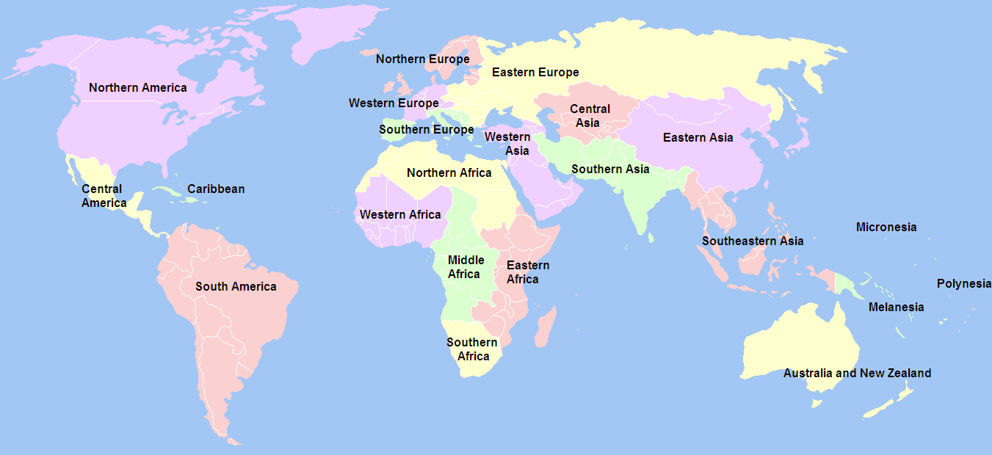
Source: UNSD standard
[Back to top]

Section 2a
Importation of asbestos for purposes of research and/or analysis
Complete this section if you are applying for permission to import asbestos for research and /or analysis
No. | Question | Applicant response
1 | What is the reason for the analysis and/or research?  e.g., to test samples prior to full shipments; to test samples from overseas structures unrelated to a potential importation.
2 | What form of asbestos is being imported?  e.g., naturally occurring mineral, chrysotile, tremolite, amosite.
3 | What type of goods are samples taken from?  e.g., building materials, air monitoring cowls, vehicles, tiles.
4 | How many consignments will be imported within the permission period (known or estimated)? and,  Estimate the percentage (%) of imports expected to test positive for asbestos.
5 | What are the estimated or known dimensions of the products/samples?
6 | What is the estimated total disposal of asbestos waste at the end of the permit period?  e.g., 1m³ , 10m³
7 | Will the asbestos waste be exported back to the originating country under the Customs (Prohibited Exports) Regulations 1958? | Yes: ☐ No: ☐
8 | Is a current export permit held by your organisation? | Yes: ☐ No: ☐  If yes, what is the permit number?  If no, do you intend to apply for an export permit?  Yes: ☐ No: ☐
9 | Is the research and/or analysis to be carried out by someone other than importer? | Yes: ☐ No: ☐  If yes, please provide details:  Name of organisation/laboratory:  Address:  Phone:  Email:  NATA accreditation number or WHS regulator approver details:
10 | Describe the handling procedures prior to and during testing and disposal of positive samples.
11 | Describe the packaging and labelling arrangements for transport and storage from the border, at the laboratory and for the disposal of positive samples.
12 | Describe how the consignments will be transported from the border to the laboratory and how positive samples will be transported to a licensed disposal facility or to the border for export.
[Back to top]

Section 2b
Importation of asbestos for the purpose of display
Complete this section if you are applying for permission to import asbestos for display purposes
No. | Question | Applicant response
1 | How many consignments will be imported during the permit period?
2 | What form of asbestos is being imported?  e.g., naturally occurring mineral, chrysotile, tremolite, amosite.
3 | Describe the type of goods being imported.
4 | What length of time will the asbestos or goods be kept in Australia?  (NB: This may be permanently or indefinitely).
5 | Has an export permission been granted or applied for? | Yes: ☐ No: ☐
6 | What is the purpose of the display?  e.g., education about asbestos safety, display of goods at an exhibition.
7 | Where will the display be located? (include the address)  Will the display be static or mobile?  Will the display be private or open to the public?  How long will the asbestos or goods that may contain asbestos be displayed for?
8 | Describe how the asbestos or goods that may contain asbestos will be displayed.  e.g., in an airtight cabinet, in an open exhibition.
9 | What are the labelling and signage arrangements for the display?
10 | Who will be in control of the asbestos or goods that contain asbestos while they are in Australia (if not the applicant)?
11 | What transport arrangements and procedures are in place for transportation from the border, including packaging and labelling?
12 | What handling procedures are in place once the asbestos or goods that contain asbestos are received?
13 | What are the packaging and labelling arrangements for storage?
[Back to top]

Section 2c
Importation for the purpose of disposal
Complete this section if you are applying for permission to import asbestos for the purpose of disposal

No. | Question | Applicant response
1 | What Australian external territory will the asbestos waste be imported from?
2 | What is the estimated number of consignments per year?
3 | What is the estimated quantity of asbestos waste to be imported per year?  e.g., 1m³ , 10m³
4 | Describe how your asbestos management plan addresses transport arrangements, handling arrangements and labelling.  If the asbestos is being exported from Norfolk Island, Christmas Island or Cocos (Keeling) Islands—does the asbestos management plan also address the transport, handling and labelling of the asbestos in the external territory to the port for export?
5 | Provide details of the disposal facility on the mainland where the asbestos waste will be disposed of, including whether that facility has agreed to accept the waste.
6 | Provide details of how the asbestos will be transported to the mainland, as well as on the mainland.  If the asbestos is being exported from Norfolk Island, Christmas Island or Cocos (Keeling) Islands—please also advise of the transport arrangements for in the external territory.
7 | Is export permission also being sought?  (Please note, permission to export asbestos under Customs (Prohibited Exports) Regulations 1958 is required to export the waste from Norfolk Island, Christmas Island or Cocos (Keeling) Islands). | Yes: ☐ No: ☐
[Back to top]

Section 3
Exportation of asbestos
Complete this section if you are applying for permission to export asbestos from Australia

No. | Question | Applicant response
1 | Where will the asbestos be exported from?
2 | Where will the asbestos be exported to?
3 | What is the estimated number of exports per year?
4 | What form of asbestos is being exported?  e.g., naturally occurring mineral, chrysotile, tremolite, amosite.
5 | What is the reason for the exportation?
6 | Outline your asbestos management plan including handling procedures prior to export, packaging and labelling arrangements for transport.  (You may refer to import section if the application is for import and export).
[Back to top]

