Asbestos in SAN DA branded gaskets
Purpose
This safety alert provides information about the presence of asbestos in imported gaskets produced from gasket sheeting manufactured under the SAN DA brand, in the People’s Republic of China (China).
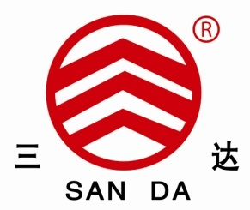
Figure 1: SAN DA brand
Background
In March 2021, the Australian Border Force (ABF) examined two gaskets in a consignment of after-market parts and components imported from China destined for use in construction plant. The two gaskets were compatible with models of Komatsu and Shantui bulldozers. The gaskets were sampled and tested and found to contain chrysotile asbestos.
Product description
Part No. 144-33-21340, for use within the Steering Case Cover and Part No. 144-40-22220, for use within the Brake Piping with brake assistor. Both are compatible with a number of Komatsu and Shantui construction plant models.
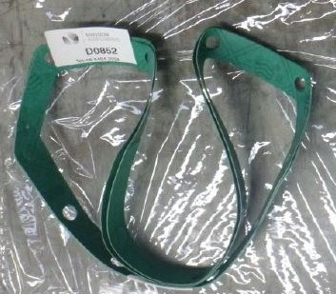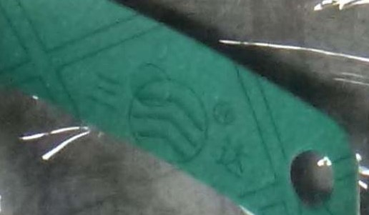
Figure 2: After-market gasket 144-33-21340 with markings.
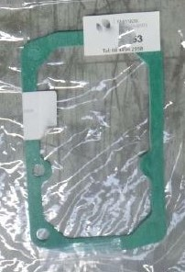
Figure 3: Aftermarket gasket 144-40-22220.

SAN DA gasket sheets are manufactured by HEBEI HENGDA SEALING MATERIALS CO LTD in China. This company manufactures and sells asbestos and non-asbestos gasket sheeting, which is used to produce specific gasket components for automotive, construction plant and machinery applications. Specific gasket designs may be cut from the sheeting by third party suppliers to Australia.
Asbestos in imported products
While asbestos has been prohibited in Australia since December 2003, in some countries it is still used in manufacturing. The importation, manufacture, supply, sale and use or reuse of asbestos and asbestos-containing products is not permitted, except under very limited circumstances. Some supplier countries may classify goods with low levels of asbestos as ‘asbestos-free’ or ‘non-asbestos’. Sourcing apparent non-asbestos products from manufacturers that also make asbestos products is a risk for importers. In Australia, any level of asbestos is prohibited for import or use.
Risk control
After-market gaskets manufactured in China and sourced from third-party suppliers based in China, Hong Kong and Taiwan are a risk for containing asbestos. Online marketers of specific gaskets for construction plant and machinery may not disclose the actual manufacturer of the gasket material that the template is cut from.
Plant and machinery operators and maintenance crews in possession of gaskets with identical markings to those depicted above are advised not to undertake any activities that may disturb the structure of the gasket. They should contact the Australian supplier for clarification of the source of the gaskets and seek the guidance of an asbestos professional.
Action Required
- Importers must ensure they do not import asbestos into Australia. They need to be aware of the varying definitions and standards applied in the country of origin and/or supply and ensure they receive adequate evidence of non-asbestos materials used by the manufacturer. A declaration of no asbestos from the overseas supplier, on its own, is not acceptable evidence.
- When a risk is identified at the border, the ABF will require assurance from the importer, in the form of documentary evidence, that the goods do not contain asbestos. A test report from a NATA accredited laboratory (or equivalent international laboratory) showing no detectable asbestos is the best form of assurance. If adequate assurance is not provided, importers will face delays and be responsible for costs incurred when the goods are held at the border for the purposes of sampling and testing. See the ABF website for further information.
If a consumer wishes to dispose of equipment they believe may contain asbestos, they should take it to a licensed facility that handles hazardous waste. Further information on the disposal of asbestos waste may be obtained from local government authorities, the relevant environmental protection authority or waste disposal authority in your state or territory.

Where do I get advice?
If unsure what to do, contact your State/Territory/Commonwealth WHS regulator:
Jurisdiction | Regulator | Contact Details | Website
Commonwealth | Comcare | 1300 366 979 | www.comcare.gov.au/
QLD | Workplace Health and Safety Qld | 1300 362 128 | www.worksafe.qld.gov.au/
QLD | QLD Gov Asbestos page | 13 74 68 | www.asbestos.qld.gov.au/
ACT | WorkSafe ACT | 02 6207 3000 | www.worksafe.act.gov.au/
ACT | ACT Gov Asbestos page | 13 22 81 | www.asbestos.act.gov.au/
NSW | Safework NSW | 13 10 50 | www.safework.nsw.gov.au/
NSW | NSW Gov Asbestos page | 13 10 50 | www.asbestos.nsw.gov.au/
NT | Worksafe NT | 1800 019 115 | www.worksafe.nt.gov.au/
NT | NT Gov Asbestos page | 1800 019 115 | www.asbestos.nt.gov.au/
SA | SafeWork SA | 1300 365 255 | www.safework.sa.gov.au/
SA | SA Gov Asbestos page | 1300 365 255 | www.asbestos.sa.gov.au/
TAS | Worksafe TAS | 1300 366 322 | www.worksafe.tas.gov.au/
VIC | Worksafe VIC | 1800 136 089 | www.worksafe.vic.gov.au/
VIC | Vic Gov Asbestos page | 1800 136 089 | www.asbestos.vic.gov.au/
WA | WorkSafe WA | 1300 307 877 | www.commerce.wa.gov.au/WorkSafe
NZ | WorkSafe NZ | +64 0800 030 040 | www.worksafe.govt.nz

This Alert has been developed by the Heads of Workplace Safety Authorities (HWSA) Imported Materials with Asbestos Working Group, whose membership comprises representatives from: Australian Border Force, Asbestos Safety and Eradication Agency, Attorney General’s Department, Australian Competition & Consumer Commission, New Zealand Customs Service, Comcare, Safe Work Australia, SafeWork NSW, SafeWork SA, NT WorkSafe, Workplace Health and Safety Queensland, WorkSafe ACT, WorkSafe Tasmania, WorkSafe Victoria and WorkSafe WA, WorkSafe NZ.

