Asbestos in Acetylene Cylinders

Purpose
This safety alert provides information about imported acetylene cylinders that have been found to contain asbestos.

Background
The asbestos identified through tests relate to the internal insulation (porous mass) in the acetylene cylinders. The cylinders were manufactured and supplied by companies based in the People’s Republic of China (China). The Australian importer was advised by the China- based supplier that the cylinders were asbestos-free. A batch was tested in China in 2018 and the laboratory certificate stated the insulation did not contain asbestos. Another batch was tested in 2020 by a National Association of Testing Authorities (NATA) laboratory In Australia and was found to contain chrysotile asbestos.

Product description
Acetylene is a colourless gas which is widely used as a fuel and a chemical building block. It is the hottest of all fuel gases and is used for a number of applications including welding, plastics and acrylic acid derivatives and portable lighting. An acetylene cylinder has a different design from most other gas cylinders. It consists of a steel shell containing a porous mass. Asbestos might be located in the porous mass, the neck and base of the cylinder, depending on where it is manufactured. The acetylene gas in the cylinder is dissolved in acetone which is absorbed by the porous mass. Like other compressed industrial gases, acetylene can be hazardous to the user and for those nearby if not handled and used correctly.
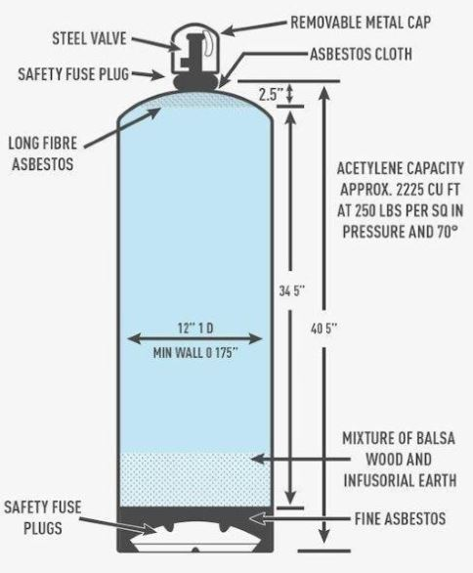
POROUS
MASS
Figure 1: Acetylene cylinder - internal components (may not be typical).
(Main graphic courtesy of OSHAcademy).
Asbestos in imported products
While asbestos has been prohibited in Australia since December 2003, in some countries it is still used in manufactured products. Certification of asbestos-free goods from some overseas manufacturers have been found not to meet Australian requirements. The importation, manufacture, supply, sale and use or reuse of asbestos and asbestos-containing products is not permitted, except under very limited circumstances.

Some supplier countries may classify goods with low levels of asbestos as ‘asbestos-free’. In Australia, any level of asbestos is prohibited for import or use.

Risk control
Available information indicates that these cylinders do not pose a measurable health risk through normal consumptive use. Consumers should not perform any maintenance, repairs or modifications on these cylinders. If you have concerns, you should contact the Australian supplier.

Action Required
- The importer must ensure they do not import asbestos into Australia. They should be aware of the varying definitions and standards applied in the country of origin and/or supply. Australian regulations apply at the border. Commercial importers of these cylinders should apply a risk management process for asbestos to their supply chain/s.

- When cylinders of risk for asbestos are identified, the Australian Border Force (ABF) will require assurance from the importer, in the form of documentary evidence, that the acetylene cylinders do not contain asbestos. A test report from a NATA accredited laboratory (or equivalent international laboratory) showing no detectable asbestos is the best form of assurance. If adequate assurance is not provided, suppliers will face delays and be responsible for costs incurred when the cylinders are held at the border for the purposes of sampling and testing. More information is on the ABF website.

- If empty acetylene cylinders containing asbestos cannot be returned to the Australian supplier for replacement, they should not be disposed of unless they are taken to a licensed facility that handles hazardous waste. Further information on the disposal of asbestos waste may be obtained from local government authorities, the relevant environmental protection authority or waste disposal authority in your state or territory. Used cylinders must not be cut open or their structural integrity compromised, unless under the direction of an asbestos professional.

Where do I get advice?
If unsure what to do, contact your State/Territory/Commonwealth WHS regulator:
Jurisdiction | Regulator | Contact Details | Website
C’wealth | Comcare | 1300 366 979 | www.comcare.gov.au/
QLD | Workplace Health and Safety Qld | 1300 362 128 | www.worksafe.qld.gov.au/
QLD | QLD Gov Asbestos page | 13 74 68 | www.asbestos.qld.gov.au/
ACT | WorkSafe ACT | 02 6207 3000 | www.worksafe.act.gov.au/
ACT | ACT Gov Asbestos page | 13 22 81 | www.asbestos.act.gov.au/
NSW | Safework NSW | 13 10 50 | www.safework.nsw.gov.au/
NSW | NSW Gov Asbestos page | 13 10 50 | www.asbestos.nsw.gov.au/
NT | Worksafe NT | 1800 019 115 | www.worksafe.nt.gov.au/
NT | NT Gov Asbestos page | 1800 019 115 | www.asbestos.nt.gov.au/
SA | SafeWork SA | 1300 365 255 | www.safework.sa.gov.au/
SA | SA Gov Asbestos page | 1300 365 255 | www.asbestos.sa.gov.au/
TAS | Worksafe TAS | 1300 366 322 | www.worksafe.tas.gov.au/
VIC | Worksafe VIC | 1800 136 089 | www.worksafe.vic.gov.au/
VIC | Vic Gov Asbestos page | 1800 136 089 | www.asbestos.vic.gov.au/
WA | WorkSafe WA | 1300 307 877 | www.commerce.wa.gov.au/WorkSafe

This Alert has been developed by the Heads of Workplace Safety Authorities (HWSA) Imported Materials with Asbestos Working Group, whose membership comprises representatives from: Australian Border Force, Asbestos Safety and Eradication Agency, Attorney General’s Department, Australian Competition & Consumer Commission, Comcare, Safe Work Australia, SafeWork NSW, SafeWork SA, NT WorkSafe, Workplace Health and Safety Queensland, WorkSafe ACT, WorkSafe Tasmania, WorkSafe Victoria and WorkSafe WA

