ACT GOVERNMENT

Strategy:
Access Canberra/Workplace Protection/WorkSafe ACT –
Last Mr Fluffy premises containing bulk loose fill asbestos in ACT remediated
Removal
Outcome:
(O4.1) Priority actions identified support removal of ACMs in poor condition
Deliverable:
(D4.1) Identify priority areas where ACMs may present a risk due to deterioration for action
Location: ACT

The issue
Since the early 1990s the presence of loose fill asbestos (Mr Fluffy) was confirmed to be in place in the roof cavity of number 1, Edgar Street, Ainslie (Figure 26).
At the time the premises was leased to a business and was deemed commercial.
During 2014 a prohibition notice was placed on the premises directly below the roof space due to high levels of asbestos fibre contamination in the business/ workplace areas. The prohibition notice remains in place to date.
The roof cavity of number 1 was the only known location in the ACT that still contained loose fill asbestos in bulk form. It was a government imperative to remove the asbestos for the safety of the community. Advice from consultants Robson Environmental confirmed that there would be a major safety concern in the event of an adverse weather event or fire in the building.

Action taken
In 2017 WorkSafe ACT engaged with the owner of number 1 Edgar Street to consider options for the safe removal of the asbestos at his expense. Testing was conducted on the roof spaces adjacent to number 1 and it was found that the fibres had migrated to the roof cavity of numbers 3 and 5 Edgar Street, with no residual find of asbestos in number 7 Edgar Street (Figure 25).
WorkSafe ACT immediately advised the owner/s of numbers 3 and 5 Edgar Street of the health and safety issue and stated that the roof spaces had to
be hygienically cleaned and a full remediation of the affected area must be completed at their own expense. Furthermore, the owners were advised that if this action was not undertaken community safety could not be assured as the buildings aged and deteriorated.
At some point in time the buildings would need to be demolished.

Results
The bulk loose fill asbestos was removed during 2017 from the roof space at number 1 Edgar Street.
During June/July 2018 the roof space of numbers 3 and 5 Edgar Street underwent a full environmental hygiene cleansing.
The entire roof space of the building, from numbers 1 to 7 Edgar Street, had full replacement of electrical wiring, plumbing and insulation.
The roof tiles were replaced to prevent the water egress into the building.
The entire building has been resealed with an Asbestos Management Plan now in place to ensure no intrusion into the wall cavities are made for future renovations.

Outcomes
The shopping precinct has returned to normal commercial business with no safety concerns to the community.

Next steps
A full review is underway by WorkSafe ACT to establish an agreed terms of management for the building/s with the owners. This will facilitate the removal of the Prohibition Notice and the area immediately beneath the roof space of number 1 Edgar Street can return
to commercial leasing by the owner.
Ongoing monitoring and assessment of annual inspections by Licensed Asbestos Assessors will be maintained by WorkSafe ACT, at intervals not exceeding 12 months.
Once satisfied with the management and control
of the building to ensure encapsulation and approved management of the premises the prohibition notice will be removed.

More Information
www.act.gov.au/accessCBR
Figure 25: Ainslie shops in Edgar Street – left to right – shop 1 – 3 – 5

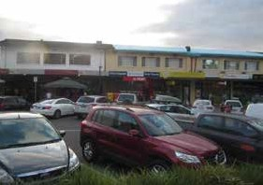

Figure 26: Photo in the roof cavity of shop number 1 Edgar Street – Ainslie Shops

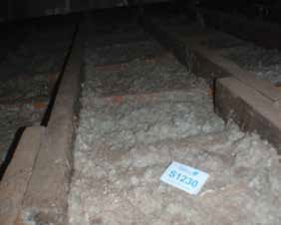

40 41

