SOUTH AUSTRALIAN GOVERNMENT

Strategy:
SafeWork SA – Safety Alert for building owners and managers on millboard lining in heating ducts
Identification
Outcome:
(O3.4) Estimated total presence of ACMs in the built environment is available.
Deliverable:
(D3.2) Review building and infrastructure data to estimate likely presence of ACMs
Location: South Australia

The issue
In late 2016, SafeWork SA was alerted to potential asbestos-containing millboard lining in heater banks in buildings throughout Adelaide by the Air-Conditioning and Mechanical Contractors Association of SA. As much of the installation work took place in the 1970s and 1980s, not all building owners were aware of it and may not have included it in their asbestos registers.
Asbestos-containing millboard has been used in
the construction industry all over the world due to its flame-resistant properties. It was extensively used in the electrical industry to line boxes or compartments that housed heat or spark-producing electrical equipment such as heating, ventilation, air conditioning and refrigeration (HVAC&R) plant.
With many older buildings across Adelaide undergoing refurbishment and retrofitting, there was a potential exposure risk to contractors undertaking these works from the millboard lining.
SafeWork SA determined that the millboard lining should be identified as containing asbestos and removed prior to demolition or refurbishment to minimise exposure risks.
SafeWork SA developed a communication plan which included the issuing of a Safety Alert to building owners.

Action taken
guidance material for workers that highlights risks and hazards with equipment, work practices or workplaces, and provides advice on the required action to prevent an incident from occurring. For this case relating to asbestos-containing millboard lining in heater banks, SafeWork SA’s Safety Alert provided advice on where the asbestos could be located, factors and risks to consider, and what action was required to ensure building owners were meeting their work health
and safety legal responsibilities.

Results
SafeWork SA was able to:
identify and contact 42 building owners to alert them to potential asbestos-containing millboard lining in heater banks
provide a general industry-wide awareness with the Safety Alert available on the SafeWork SA website
provide stakeholders with information about old air conditioning systems and the potential for asbestos millboard.

Outcomes
The development of the Safety Alert will assist
building owners and managers identify and build upon information already contained in a buildings asbestos register, improve compliance and reduce the risk
of exposure.

Next steps
Engagement with stakeholders, community and homeowners regarding potential asbestos exposure risks remain a priority for SafeWork SA. As new issues emerge, SafeWork SA will develop a communication plan to inform the public on the dangers. The process through which this Safety Alert was developed can help inform those processes.

More Information
https://www.safework.sa.gov.au/news/asbestos- and-air-conditioning-ductwork#

SafeWork SA worked with the Air Conditioning and Mechanical Contractors Association of SA to identify buildings that they knew of that had millboard lining installed in the ducts adjacent to the heater banks.
SafeWork SA then wrote to all known building owners and managers, based on this list, alerting them to the potential presence of asbestos-containing millboard lining, and their responsibility to include the millboard lining on their asbestos registers.
To capture any building owners or managers not listed, a Safety Alert was developed and placed on SafeWork SA’s website. The Safety Alert is an agency-developed

36

Figure 21: Asbestos lining within a heater bank. Figure 22: Textile flexible joint in the exhaust duct.
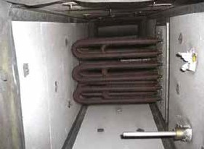
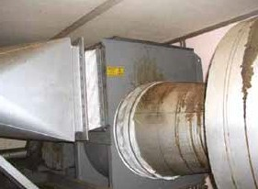

37

