NSW GOVERNMENT

Strategy:
SafeWork NSW – Improving asbestos awareness in Aboriginal communities
Awareness
Outcome:
(O1.3) Demonstrated cultural and behavioural change within the community as a result of improved understanding of both the health risks and exposure pathways of asbestos in both commercial and residential environments
Deliverable:
(D1.3) Develop practical, evidence-based asbestos safety awareness material for people likely to come into contact with ACMs in a residential setting
Location: NSW

The issue
Many Aboriginal communities in NSW contain fibro houses and buildings, and may have limited or no access to information on the health risks of asbestos or safe behaviours around asbestos containing materials. Aboriginal land is also particularly susceptible to illegal dumping of asbestos because it is often located in remote areas or undeveloped urban parcels of land.
There is also a lack of licensed asbestos removalists in regional areas where many Aboriginal communities are located.
To address this issue, an initiative of the NSW 2013– 2016 State Wide Asbestos Plan was to ‘work with communities in regional, rural and remote regions of NSW, including the Aboriginal Land Councils and communities, to promote the safe management of asbestos’.
A Heads of Asbestos Coordination Authorities (HACA) sub working group was established with representatives from the:
Asbestos Safety and Eradication Agency Environment Protection Authority
Local Government NSW Ministry of Health
NSW Aboriginal Housing Office NSW Aboriginal Land Council NSW Ombudsman’s Office.
The group undertook research and consultation with local Aboriginal Land Councils to develop an effective and culturally appropriate program aiming to:
raise awareness amongst Aboriginal communities to promote the safe management of asbestos
build capacity and capabilities to deal with asbestos within Aboriginal communities.
equip Aboriginal communities to adequately remediate asbestos issues locally where possible.

Action taken
Research
The project team consulted with Aboriginal Local Land Councils and Aboriginal Housing providers to identify key asbestos issues.
Research case studies were also undertaken at La Perouse (metropolitan Sydney), Murrin Bridge (320km southwest of Dubbo) and Lake Cargelligo (140km south of Griffith, NSW) to gain a better understanding of asbestos issues particularly in historic Aboriginal communities.
Stakeholder engagement
Stakeholder engagement was carried out by way of face- to-face meetings, forums, by telephone and by email with Aboriginal Local Land Councils and Zone Directors, with the aim of knowledge sharing and collective learning about the asbestos issues facing Aboriginal communities.
The engagement with Zone Directors of Aboriginal Local Land Councils helped to identify the level of knowledge within Aboriginal communities, and to identify known behaviours, which may cause risk or harm to health and safety.
The project team worked directly with the Aboriginal Local Land Councils and other key stakeholders to ensure the development of the communication strategy and campaign messaging was accurate and culturally appropriate.
Communication strategy
Research findings helped to direct the development of the communication strategy, which was launched during Asbestos Awareness Month in November 2016.
The communication strategy targeted the key issues through culturally appropriate messaging and methods of communication.
A suite of guidance material and campaign collateral including flyers, posters and asbestos safety checklists were produced to provide support and guidance for all members of the Aboriginal community, according to their roles and responsibilities for asbestos management.
Building capacity and capabilities in Aboriginal communities
A pilot program to build capacity and capabilities in Aboriginal communities was rolled out through
training of Local Aboriginal Land Council workers, Aboriginal Green Teams and Aboriginal staff from local government and organisations.
The aim was to provide non-friable asbestos removal and Asbestos Supervisor training to Aboriginal participants to help them find asbestos-related work experience or employment.
SafeWork NSW engaged a training provider to deliver a program of courses including:
non-friable asbestos removal training asbestos supervisor training
general construction induction training.
Working with Aboriginal Local Land Councils, suitable Aboriginal participants were sought who had experience working within their community, for
example, from Green Teams skilled in natural resource management and building maintenance workers or those who had previously completed other relevant courses, such as Certificate I in Construction.
SafeWork organised the training sessions which were delivered in Liverpool, Dubbo, Karuah, Casino and Ulladulla.
Training incentives were also offered through Local Government NSW and a workshop was held at the 2016 Local Government Aboriginal Network Conference (24–26 August 2016 in Tweed Heads) on asbestos
issues to both share knowledge as well as consult with delegates.

Results
Guidance material
A suite of culturally appropriate guidance material was developed and distributed as information kits
to approximately 250 recipients, including l Aboriginal Local Land Councils, Aboriginal Housing providers, the NSW Aboriginal Land Council, HACA and other key stakeholders. These information kits included posters, magnets, caps, tote bags and an asbestos safety checklist, plus a total of 5,000 brochures for further
distribution in to the Aboriginal community to increase knowledge and awareness about asbestos (Figure 19).

28 29

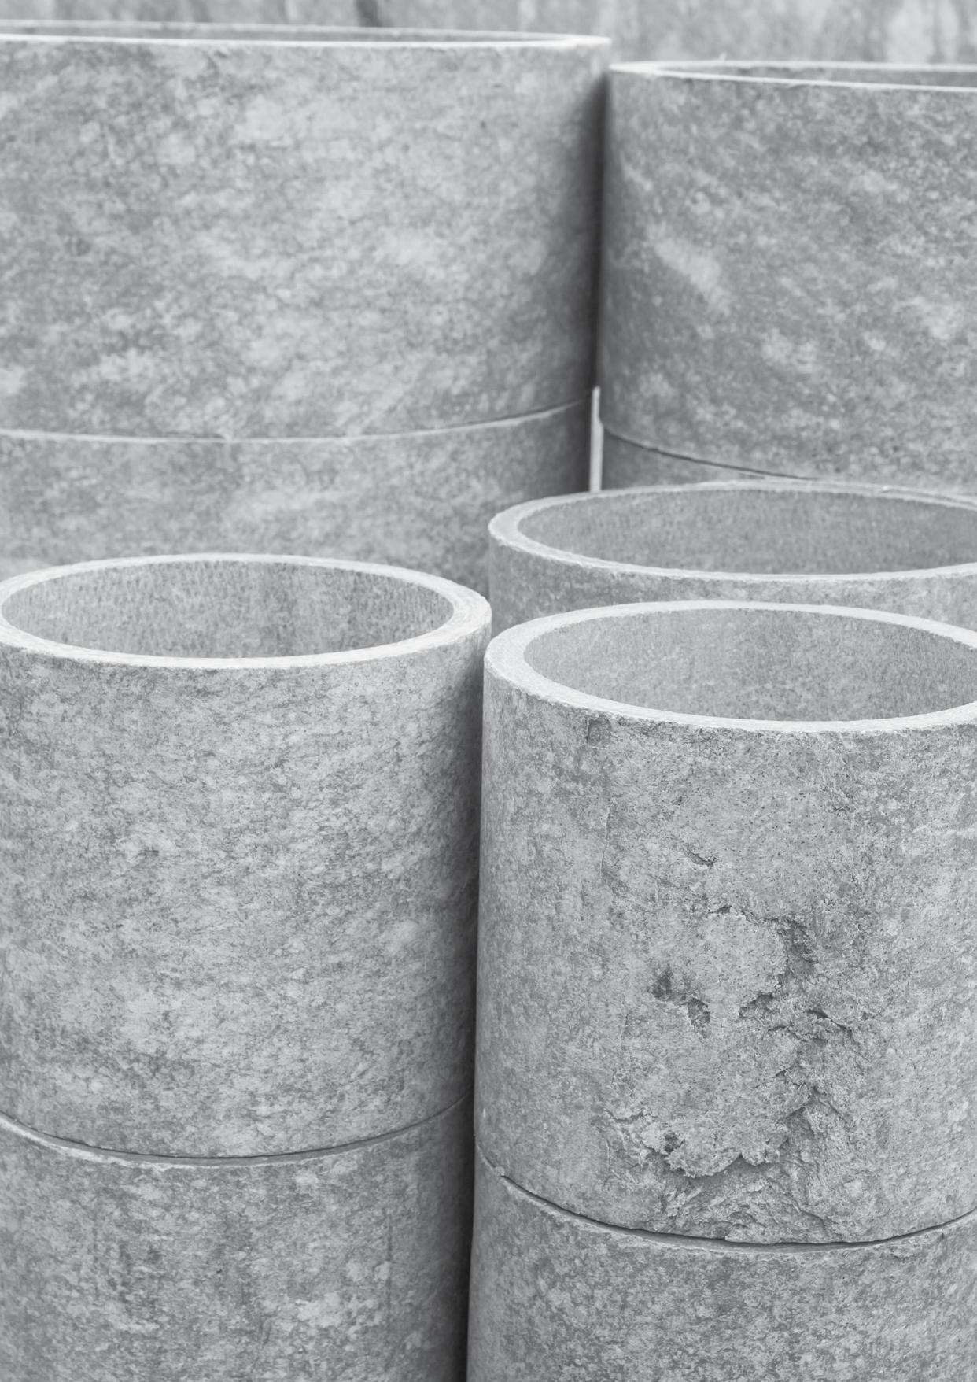
Asbestos removal training statistics
forty-five people completed the Remove Non-
Friable Asbestos Training
thirty-two people completed the Asbestos Supervision training
eighteen people from the Clontarf Foundation in Wagga Wagga were trained to improve the
employment prospects of young Aboriginal men.

Outcomes
There were several positive outcomes from the training program.
A 70 per cent Aboriginal-owned and operated civil and building construction company gained experience
in asbestos removal, working in conjunction with a licensed asbestos removalist. After the required industry experience, the company will be able to apply for
their own asbestos licence, which will enable them to expand their business.
Some of the other participants have also gained employment with licensed asbestos removalists, and a number of Land Councils are evaluating how they could integrate their workers’ new skills into their environmental programs.
Sufficient training and experience acquired through the project may lead to Local Aboriginal Councils’ eligibility to apply for and obtain a non-friable asbestos removal licence with SafeWork NSW.

30

Next steps
The Environment Protection Authority (EPA) have been granted funding through the NSW Government for asbestos management, clean-up and awareness activities including specific funding for Aboriginal Programs. A new asbestos directorate has been established within the EPA as at 1 July 2018 who will oversee key prevention and awareness campaigns.

More information
https://asbestosawareness.com.au/

Figure 19: Asbestos awareness poster for Aboriginal communities

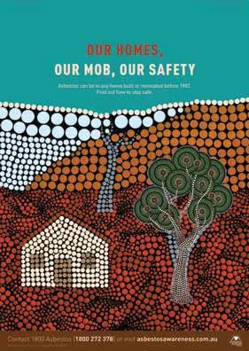

31

