AUSTRALIAN GOVERNMENT

Strategy:
Identification

Outcome:
(03.6) Effective coordinated response when ACMs in imported products are identified

Deliverable:
(D3.4) Support the 2003 ban on the importation of ACMs with improved coordinated efforts to identify and respond to the importation of ACMs

Location: National

The issue
Novelty fire wallets (Figure 17) are a product used by magic enthusiasts having the appearance of a regular leather wallet but produce a large flame when opened. The wallets contain absorbent pads that are pre-filled with lighter-fluid ignited by a flint striker upon opening. The fire wallets are known to potentially contain chrysotile asbestos in the absorbent pads as a fire retardant.
These novelty fire wallets were supplied online by
‘All Media Collectables’ via the eBay store from July 2011 to November 2013. Testing of these products detected the presence of chrysotile asbestos (white asbestos) in the flame pads of the wallet. The importation of asbestos or goods containing asbestos into Australia is prohibited under the Customs (Prohibited Imports) Regulations 1956 (Customs Prohibited Import Regulations).

Action taken
During 2013–14 the ACCC commissioned a scientific risk assessment confirming the wallets contained asbestos and requested a voluntary recall of these fire wallets.
The ACCC has issued guidelines for suppliers to initiate their own recalls once a product has been identified as presenting a safety risk. A voluntary recall is communicated through a variety of means, including: media releases, recall notices on supplier’s website and supplier’s networks, social media and contacting consumers. The ACCC works with stakeholders to encourage the supply of safe consumer products.
In the case of the voluntary recall of these fire wallets the following steps were also taken.
Consumers were advised to contact asbestos disposal facilities to inform the facility that they needed to dispose of a recalled fire wallet that contains a very small amount of asbestos. Consumers were also advised to confirm disposal fees as costs can vary widely.
Consumers were also advised to ask All Media Collectables to reimburse them with any reasonable disposal costs and to retain receipts for this purpose. All Media Collectables offered a refund/replacement under the recall of these goods.
The wallets were to be double-bagged prior to disposal and were not to be sent via mail.
Consumers could also contact the ACCC if they had any queries or concerns about disposal.
Australian Competition and Consumer Commission (ACCC) – Hazard Analysis and Management of Novelty Fire Wallets
The ACCC continues to periodically monitor the market as part of routine surveillance operations. In December 2017 and January 2018 the ACCC identified and purchased seven fire wallets from various eBay suppliers located in Australia (NSW, NT and Qld.). Each wallet was examined by a NATA accredited laboratory by Polarised Light Microscopy with Dispersion Staining (PLM/DS) using methods of AS 4964 and supplementary in-house instructions.

Results
The scientific risk assessment of the 2013–14 recalled fire wallets were found to contain asbestos. That risk assessment concluded that the health risk from the use, handling or disposal of these products presented low risk; however, the Australian Consumer Law together with environmental protection laws apply to all ACMs regardless of the levels.

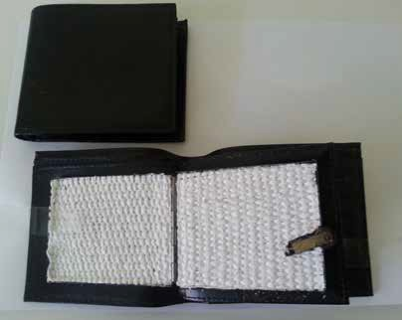
Figure 17: Fire wallet showing asbestos lined absorbent pad
The results of the wallets examined by a NATA accredited laboratory in 2017 showed that no asbestos was detected. The laboratory disposed of the samples safely.

Outcomes
Effective coordinated response when ACMs are identified in imported products, supporting the 2003 ban on the importation of all ACMs

Next steps
The ACCC applies a risk based approach to scheduling of operational market surveillance and product testing taking into account factors including inherent product risk and market behaviour, informed by most recent testing results. Testing of fire wallets is not scheduled for the 2018–19 financial year; however, the ACCC will continue to respond to intelligence reports.

More information
https://www.accc.gov.au/consumers/consumer- protection/buying-safe-products

24 25

