WESTERN AUSTRALIAN GOVERNMENT

Collection, treatment and disposal of asbestos and bituminous coated pipes

Link to the National Strategic Plan:
Strategy: Removal
Deliverable:
Pilot residential ACM identification tools and strategies with local government partners
Outcome:
Improved practice in the residential sector to identify and minimise the risk of exposure, in particular for DIY home renovators
Location:
Western Australia, statewide
The issue
Water supply pipelines installed throughout Western Australia in the 1960s and 1970s were coated in a bituminous material containing asbestos and other contaminants.
In 2016, Western Australia Water Corporation launched a project to collect, treat and dispose of significant quantities of the asbestos coal tar coated pipes and
manage impacts from the pipes that had been removed from the network and stored throughout the State.
Contractors were engaged to identify a treatment solution that safely removed the contaminant product from the mild steel cement lined (MSCL) pipes and diverted the pipe product from landfill to a centralised storage facility for processing.
A custom-made treatment facility was developed to remove personnel from the treatment process and uses high pressure water to remove and contain the
contaminant product for further processing and disposal.

Action taken
Pipe collection

More than 11 kilometres of pipe was collected from more than 60 locations state wide and stored at a dedicated facility. The collection included a comprehensive evaluation and classification program and regulator, community and stakeholder engagement.
Processing facility

A contractor was engaged to develop an innovative treatment solution resulting in:
securing a suitable site to store the pipe and establish a customised pipe handling and
stripping plant.

storage and operating licences issued by the Department of Environmental Regulation
development of an enclosed remotely operated pipe coating stripping plant utilising high-pressure water.
monitoring processes including air sampling, acoustic surveys and controlled waste sampling and analysis.
filtration of water used in processing for asbestos, Polycyclic Aromatic Hydrocarbons (PAH) and Polychlorinated Biphenyls (PCB) in the waste stream.
Licensing and regulatory considerations

The licencing process considered not only the asbestos management but also other contaminants such as PAHs and PCBs that were detected in the asbestos pipe coating.

Results
The project resulted in a custom built facility dedicated to the storage and processing of asbestos and bituminous-coated pipes, with potential application to other contaminant coated products.
It is expected the project will be completed in late 2017 with initial feedback indicating:
safe stripping of pipes was achieved without personnel involvement and with minimal environmental impact
diversion of pipe product from waste stream was achieved
management of 60 sites across the State

reduction of impacts associated with asbestos coal tar coated out of service pipes.

Outcomes
Contaminated pipe was removed and recovered from more than 60 areas of Western Australia, including removal of asbestos impacts.
The project resulted in development and licensing of a new treatment plant and contaminant product was removed and verified for reuse/ diversion from landfill.

Next steps
The processing and treatment program for identified pipes will be completed and consideration will be given to ongoing management of waste materials impacted by coating.

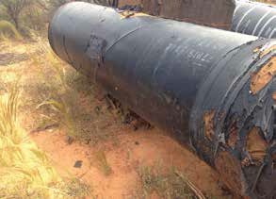
Figure 24 and 25: The redundant pipes were in varying states of degradation

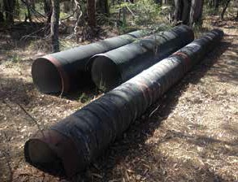

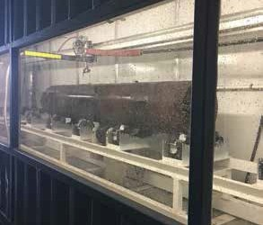
Figure 26: The treatment plant removes personnel manual labour and utilises water pressure to remove the coating from the pipes, supporting pipe reuse or recycling and diverting waste from landfill.

62 63

