WESTERN AUSTRALIAN GOVERNMENT

Asbestos Cement Roof Removal Strategy

Link to the National Strategic Plan:
Strategy: Removal
Deliverable:
Investigate the barriers to the safe removal of ACM from Government, commercial and residential properties and develop policy options to support the removal of asbestos in poor condition
Outcome:
Identification of the barriers and obstacles for timely and safe asbestos cement roof removal and disposal in the residential sector
Location:
Western Australia, statewide
The issue
Asbestos cement roofs were installed between the 1940’s and 1980’s throughout Western Australia.
They are now increasingly deteriorating and coming to the end of their useful life. As asbestos cement roofs deteriorate they release asbestos fibres into the environment. As they age they become more brittle increasing the risk of falls and the complexity of intact sheet removal. Asbestos cement roofs can cause considerable contamination as a result of fires,
non-compliant removal practices, and illegal dumping.

Until now, advice for asbestos cement products has been to maintain them if they are in good condition and remove them if they are starting to deteriorate. However, older roofs are increasingly difficult to maintain or restore to good condition and some roof maintenance, such as harsh cleaning of moss and lichen, may lead to further damage and the spread of contamination.
It is clear that many, and eventually all, asbestos cement roofs need to be removed. The Department of Health Western Australia is increasingly providing advice or direction to building owners recommending removal over maintenance of existing asbestos cement roofs.
However, there are a number of obstacles to the safe removal and replacement of asbestos cement roofs, relating mostly to cost and a poor understanding of the legislative removal and disposal processes. The aim of the asbestos roofs project is to identify the obstacles for the removal of these products in the residential environment and investigate strategies
to overcome these.

Action taken
Current and proposed activities by the Western Australia Department of Health under the asbestos cement removal strategy include:
consultation with local governments and relevant regulatory agencies about the costs and management of asbestos disposal.
a review of the total costs of removal, disposal and replacement of an existing asbestos cement roof, as compared with replacing other types of roofs
the development of a discussion paper on possible incentives, education needs and possible regulatory requirements for the removal of asbestos roofs

Outcomes/next steps
This project is currently being undertaken in Western Australia but it is expected the findings will be relevant to other jurisdictions.

More information
http://ww2.health.wa.gov.au/~/media/Files/ Corporate/general%20documents/Asbestos/PDF/ GuidanceNoteonAsbestosCementRoofs20162%201.ashx

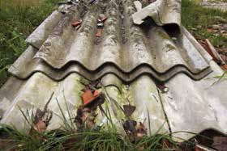
Figure 22: ACM corrugated roofing

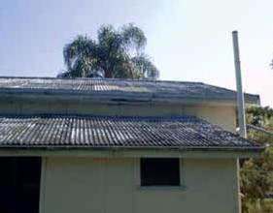
Figure 23: Narrow corrugated AC roof cladding

60 61

