SOUTH AUSTRALIAN GOVERNMENT

Asbestos removal notification data moves online

removal concerns are raised by the community, minimising unnecessary inspector attendance and unnecessary job delays for the removalist.
The portal collects valuable data, including the quantities and types of asbestos removed in workplaces and residential areas, providing the ability to monitor trends

Next steps
Currently the South Australian Government is developing and reviewing the state emergency plan and an issue was identified that no information was available on the location of asbestos in the suburbs. The data collected via SafeWork SA’s notification portal

Link to the National Strategic Plan:
Strategy: Best Practice
Deliverable:
Identify opportunities to share best
monitoring (In South Australia, air monitoring is also
required for class B asbestos removal work). This detail is also collected in the new online notification portal.
Once notification is completed via the portal, the removalist cannot amend the information provided. A dedicated asbestos removalist email address was created for correspondence with licence holders where they can
and share information with other regulatory bodies.

Two class B asbestos removalists have had their licenses cancelled recently indicating the portal is a valuable tool to monitor compliance with licence conditions and regulations.
will be used to assist identifying suburb hotspots by reviewing asbestos removal activities in the area. As more data is collected, the applications and uses of the portal will further benefit South Australia and improve disposal practices for ACMs across the state.

practice for initiatives related to the
safe management of asbestos such as licencing, education, training and home renovations where ACMs may be present
Outcome:
Evidence based best practice to minimise risks in targeted areas
Location:
South Australia, statewide

The issue
SafeWork SA undertook an initiative to streamline the collection of asbestos removal notification data and other documents that were required to be provided to the work health and safety regulator.
An online portal was developed to eliminate the administrative burden and delays for asbestos removalists as a result of processing hard copy forms, including notification forms, clearance certificates and waste transport certification.

Action taken
To launch the new online portal, SafeWork SA provided asbestos removalists with a unique user name, password and training. The online notification portal aims to make the notification process as streamlined and user-friendly as possible, and ensures all mandatory information is provided.
Asbestos removalists have the option to select an air monitoring company or a licensed asbestos assessor to comply with the regulatory requirement of air
notify of any changes to allow SafeWork SA to monitor amendments and ensure compliance. To further monitor compliance, the clearance certificate must be uploaded within five days and the waste transport certificate uploaded within 14 days of job completion. This process ensures asbestos waste is being disposed of correctly.

Results
Moving the notification process to an online solution has allowed removalists to lodge an application at any time that is convenient to them. It also removes the
costs of postage or the inconvenience of having to visit a Customer Service Centre during opening hours to lodge the paperwork.
The notifications portal allows licence conditions for asbestos removalists to be easily monitored and the data collected to be widely utilised. Proactive inspections by SafeWork SA inspectors can be targeted and inspectors can review information prior to attending an asbestos complaint. A greater understanding of where asbestos
is located in the community is being developed and the quantities and types of asbestos removed can be more accurately recorded. Information is also being gathered on past removals in local council areas to
inform future activities. The data is being shared with the Environment Protection Authority via a memorandum of understanding to assist its investigations and promote
a collaborative effort to improve asbestos disposal practices in South Australia.

Outcomes
The online notification portal has been positively received by licence holders in South Australia, with removalists advising they prefer the portal and dedicated email address to lodge notifications as it streamlines the process and minimises any delays in commencement of work. There is easy access to SafeWork SA’s Help Centre when asbestos

More information
https://www.safework.sa.gov.au/notif/home

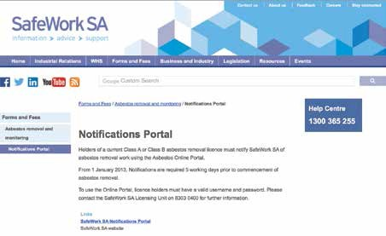
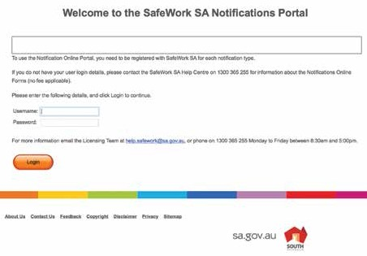https://www.safework.sa.gov.au/show_page.jsp?id=113141

64 65

