NSW GOVERNMENT

Link to the National Strategic Plan: Strategy:
“Betty”- Driving home the dangers of asbestos: A portable model house displaying where asbestos can be found in the home
Awareness
Outcome:
Increased community awareness of the risks posed by asbestos and its impact on the health of the community
Location:
NSW, statewide

The issue
One in three Australian homes contains asbestos in some form or another. With the popularity of renovator lifestyle television programs spurring a boom in DIY and home renovations, together with a lack of community
understanding of the types of ACMs that remain in homes, a strategic, practical education program aimed to address the need for practical asbestos education was required
Action taken
The Heads of Asbestos Coordination Authorities (HACA) determined that an education resource was needed -that was big, portable, practical, safe, accurate and engaging
- to advance awareness of asbestos. They aimed to achieve practical consumer learning, deliver potentially life-saving messages to communities and to drive traffic to asbestosawareness.com.au.
Extensive research and development was undertaken in the design and construction of a portable model house, ensuring it would be more than a moving billboard
and become a world-first experiential communication tool. Purpose built, “Betty” the portable model house, demonstrates the many and various product types and locations where asbestos might be found in homes to educate homeowners about ACMs in homes, provide easily digestible information on safe practices, and engage stakeholders and media to drive traffic to the website.
Betty is driven, manned and maintained by dedicated, trained volunteers Geoff and Karen Wicks. Since Betty was launched in November 2012 she has toured extensively throughout NSW to deliver her vital message to thousands of homeowners in hundreds of communities and has appeared at Sydney’s Royal Easter Show twice and been the feature of industry, trade, life-style, community and local government events in multiple regions around the state.
During Betty’s tours of duty there is extensive media activity around her appearances. To date, Betty has travelled more than 50,000 kilometres and conducted extensive community and media engagement tours throughout NSW, Victoria, Queensland, South Australia and the Northern Territory.
Results
during Betty tours, daily website visits increase up to 193%
Betty consistently drives over one-third of annual traffic to asbestosawareness.com.au
outside Asbestos Awareness Month, Betty is the primary resource driving website traffic
Betty has exhibited at 207 health and community events, toured to 177 communities and conducted media events in the majority of these locations
Betty has distributed more than 130,000 brochures and 50,000 magnets and branded tape measures
  - Betty has engaged with 144 Councils, over 7,000 renovation students and 4,000 conference delegates and appeared at 65 Bunnings stores engaging DIY renovators and trades people
As demand and booking requests increased, to address the issues of availability, the Betty virtual tour ‘Asbestos in Your Home’ was launched to deliver online global access to Betty’s message.
Outcomes
In addition to engaging members of the community in a practical learning style, Betty effectively garners media coverage reaching into Australian homes and driving increased online education in every community she visits.
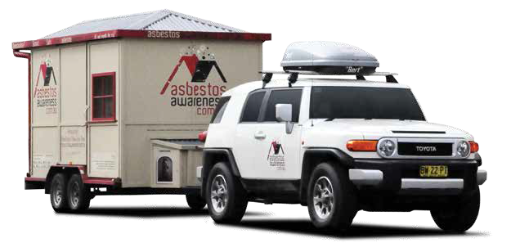
What makes Betty so effective is that she delivers serious, life-saving messages in an educational, creative,
Figure 21: Betty
non-threatening format that engages communities, stakeholders, media outlets, health, government and international asbestos awareness advocates.
Betty is a novel approach to a serious issue that has exceeded expectations in delivering practical learning experiences to hundreds-of-thousands of Australians, while leveraging stakeholders and media to increase traffic to asbestosawareness.com.au and engage broader audiences in online education.
Next steps
Betty is set to tour Western NSW and Tasmania during Asbestos Awareness Month in November 2017 and will continue her community awareness and education program throughout NSW in 2018.
More information
www.asbestosawareness.com.au
Watch Betty in action: https://vimeo.com/80178222

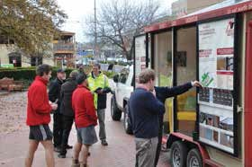
Figure 20: Betty in Orange NSW

52 53

