CASE STUDY EIGHT

PRENSA – Putting Safety First
Prensa is an Australian risk management firm with offices around the country. One of its main business streams is helping property owners and property managers identify, assess, manage and remove hazardous materials, including asbestos. Key asbestos-related services include risk assessments, hygiene and abatement services, monitoring of airborne fibres and asbestos soil assessments. It also has three NATA accredited laboratories for identifying and counting asbestos. While it is a relatively new company, most of Prensa’s senior consultants have been managing asbestos for over 20 years and are members of industry associations including the Safety Institute of Australia and the Australian Institute of Occupational Hygienists.
There are many facets of asbestos management that are not mandated by law, such as training requirements for persons considered “competent” in assessment, accreditation of laboratories for fibre counting and the independence of inspections of non-friable works (in some circumstances). But Prensa always puts safety first, aiming to reduce the risk of asbestos exposure to as low as practicable, irrespective of the minimum legislative requirements.
While this extra layer of scrutiny sometimes puts Prensa at a competitive disadvantage due to the higher costs involved, the benefits for clients are invaluable, including protecting health, protecting brand image, and minimising cost overruns on projects.

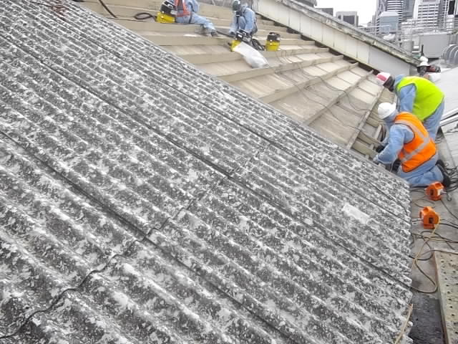

What have they done?

Training for clients
Prensa provides asbestos awareness training to clients and community groups as part of its core services. This training is sometimes offered free of charge to ensure clients and potential clients fully understand the risks and their obligations.
The more we can do to educate our clients about the importance of managing hazardous materials effectively, the better equipped they are to minimise the risk of exposure to their tenants, staff and visitors. (State Manager)
In their training, Prensa includes practical, real-life examples of situations that clients or others may come across in the workplace. The trainers use photographs as well as actual samples of different types of asbestos for clients to see what the materials look like. On some occasions, clients are invited to (safely) observe asbestos surveys so they can see firsthand what the materials look like and learn about the particular risks involved, related to, for example, the location, condition and disturbance potential of the material.
Along with training, Prensa prepares regular newsletters to notify clients of changes to legislative requirements and alert them to relevant information and training events that are occurring in the industry.
Property managers are a key client group that Prensa aims to influence. They educate property managers both on the risks involved with asbestos and also how to mitigate the risk through effective contractor management processes such as careful selection and induction, requiring permits to work and the different types of surveys required for different situations.
There are two forms of survey that can be undertaken – a management survey, involving a walk-through inspection, and a more comprehensive survey known as an intrusive survey. An intrusive survey aims to identify, as far as practicable, all asbestos containing materials (ACMs) in a building, and is recommended before any refurbishment or demolition takes place. In one case, prior to the refurbishment of a strip of shops, a property manager confirmed that an asbestos survey had been undertaken, but it was a management survey not an intrusive survey and therefore had not identified asbestos behind the walls and in the ceiling. When the builders began to cut holes in the ceiling they exposed friable asbestos. This oversight halted work for months, cost many thousands of dollars and unnecessarily put contractors at risk. This is why it is important that property managers understand when to commission different types of surveys.

Specialist skills in identification and assessment
Prensa’s laboratories are accredited by the National Association of Testing Authorities (NATA). NATA is the body that quality assures all testing, calibration, measurement and inspection activities in Australia. Legislative requirements recommend but do not mandate the use of NATA accredited laboratories for asbestos fibre counting. NATA accreditation involves a rigorous assessment against a number of standards including the requirement for routine surveillance audits and 18-monthly external audits – Prensa feels this is an important process to go through to ensure accuracy and consistency of its services.
With the exception of the ACT, state and territory legislation does not mandate specific training for people undertaking asbestos surveys, or any testing of skills. It only refers to “competent persons”. This allows for self-regulation in terms of the minimum competency requirements for persons undertaking asbestos surveys. Prensa has witnessed numerous mistakes made by poorly-trained people. Hence, it has implemented its own detailed competency assessment process that includes written exams along with demonstrations of competency on site, to ensure all their consultants have the necessary skills to conduct asbestos surveys. Prensa also undertakes representative audits of sites where consultants have already completed their surveys to confirm that the process and findings were correct.
Several years ago, we surveyed a multi-storey building in North Queensland that had previously been surveyed by a local contractor. The contractor identified a small number of asbestos containing fire doors in the building, which had been managed by the owner of the property. When a new property manager took over control of the building, we were asked to survey the property and found a large number of both friable and non-friable materials that were not identified by the original contractor, some of which were friable and in poor condition potentially exposing maintenance contractors to an asbestos risk when working in these locations. (State Manager)

Monitoring safe removal practices
Prensa provides its clients with detailed site plans that identify the locations of asbestos items for complex sites. An example of one of their site plans is provided below.
They also offer detailed documentation on ACM removal specifications. This ensures that methods used to remove the materials are consistent with the Code of Practice on How to Safely Remove Asbestos. It also allows asbestos contractors to quote for works effectively and allows clients to have a consistent basis upon which to compare quotes.
Clients need to be able to compare apples with apples. The scope of work defines the methods that should be used to remove the asbestos safely. Unless there is a scope of work that includes all technical details, contractors may choose to conduct the removal in a different manner which can lead to different pricing and sometimes cause a secondary risk to the building owner. (State Manager)
Prensa often reviews the contractor’s asbestos removal control plans on behalf of clients. This provides an extra level of scrutiny over what is being proposed by the contractor to ensure that methods of removal are consistent with the Code of Practice on How to Safely Remove Asbestos.

Challenges

Convincing stakeholders of the value of independence
For domestic premises in Queensland, the licensed asbestos removalist, rather than the person commissioning the work, is responsible for ensuring the clearance inspection is carried out. It is permissible (in some circumstances) for the competent person to be employed by the business that conducted the removal, as long as they were not personally involved in the removal process.
Prensa believes it is imperative that an independent hygienist undertakes the clearance work. Problems arise when contractors use their own staff or close business associates for clearance certificates because inspections may not be as rigorous as they should be.
Prensa advocates with its clients to separately engage an independent hygienist, particularly for conducting the clearance inspection, but also for monitoring the safety of workers onsite.

Balancing costs with safety
Asbestos removal is a competitive business and the impact of extra safety precautions on the bottom line can prevent the contractor from securing work.
Despite the asbestos contractor licensing system, statutory laws and codes of practice, Prensa has experienced a wide difference in standards of workmanship, risk control and technical competence exhibited by contractors. Prensa is careful about which asbestos removal contractors they work with or refer to clients. Prensa will take recommendations from trusted colleagues, review documentation to ensure contractors have seriously considered the issues for each individual site, trial contractors prior to long term engagement and carefully monitor their performance on site.
Prensa also has a challenge sometimes in convincing clients of the value of going above and beyond the code of practice, when required. Prensa educates clients about the options and risks in a rational, factual way so that they can make informed decisions.
It’s difficult for clients to understand what they’re getting for their money - they’re getting an empty space for $300,000! It’s about how you communicate the issues. You need to present the facts. (Managing consultant)

Getting the next steps to happen
Once Prensa submits its report, the property manager or property owner needs to take action on the recommendations. There is potential here for the system to fall down. Sometimes the report is filed away, even when there are ongoing risks identified. Prensa always follows up with phone calls to clients to talk through the findings of the report and help managers and owners work out how to act on the recommendations.
Handing over a document is usually only the first step. They need to know how to use the report and what the next steps are for managing the issues. (State Manager)

Key messages about how to make it work
Prensa is all about putting safety first when it comes to managing asbestos. They have processes that go beyond legislative requirements when necessary, and they actively advocate with clients and other stakeholders to promote understanding of risks and improve practice.
Their key messages for other occupational hygienists working with asbestos are:
- Lowering standards does not increase profits in the long term.
- Drive change through regular training and discussions with your clients
- Take the safest route and set the highest standards, always considering those who will be affected by your actions.

