CASE STUDY FOUR

Ergon Energy – Putting Safety into Practice
When it comes to managing asbestos, having great policies and procedures in place is one thing; but ensuring staff follow them consistently is a different, and far more challenging, matter.
With more than 2000 field staff who work, or are likely to work with or disturb asbestos containing materials (ACM) on a regular basis, and many others who manage buildings and plant containing ACM, making safe practices a part of the way things are done is a high priority for Ergon Energy.
In order to ensure that staff understand the risks of asbestos exposure and take safe work procedures seriously, Ergon Energy has invested considerable time and resources, and undertaken a highly collaborative approach to establishing best practice.

What have they done?

Make best practice the easiest practice
Where possible, Ergon Energy has replaced complex safety procedures with higher control measures that simplify the process. For example, Powered Air Purifying Respirators (PAPR) have replaced traditional P2 respirators for teams working with Silva link fuses on electricity poles, many of which contain friable asbestos. Unlike P2 masks, which require the person to be clean shaven to ensure a proper seal, PAPRs consist of a hood that goes over the person’s head and a pump that generates a constant positive air pressure, preventing any chance of airborne asbestos fibres being inhaled.
“It’s a simpler way to do things now. There was resistance at first with the P2, with having to shave and all that sort of stuff. Now you just grab the hood and follow your training and away you go... We haven’t had a drama since.”(Justin Pitts, Work Group Leader)

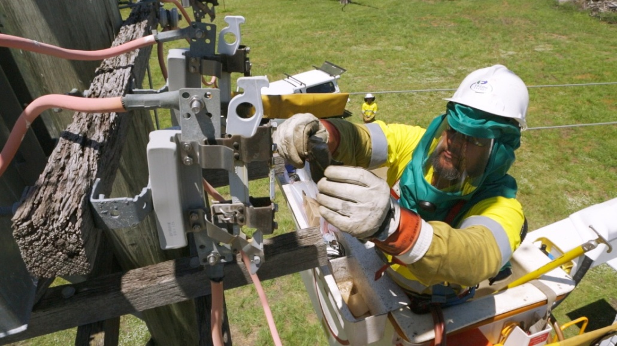

Engage field staff in developing safe practices
Having field staff and union delegates engaged in the process of developing safe work methods has become a regular part of Ergon Energy’s practice. These stakeholders are routinely involved in the development of solutions and innovations around particular asbestos issues, as well as in other activities such as the filming of training videos and trialling processes and safety equipment.
Having a sense of ownership of the processes and practices has made a big difference in the willingness of staff to adopt best practice. Even those not directly involved in the development take the processes seriously, because they know their peers have been involved in developing them. Staff involvement ensures the safe work methods end up being simpler and more effective in the field.
“If you make the process or procedure as simple as you can get it, they don’t need shortcuts, because it’s the shortest route anyway.” (Andrew Bowe, Work Group Leader)

Keep documentation as simple as possible
For each of the tasks conducted by field staff that involve disturbance of asbestos, there is a documented safe work method statement. These statements are kept to 1 or 2 pages, with dot points of the key steps.
“You’ve got to make it short and sharp. You see some companies that write 15 or 16 pages. The guys aren’t going to read it..... Talk to people in the field and make it real and relevant.” (Wayne Cullen, Asbestos Manager)
These documents are easily accessible out in the field in both hard copy and electronic formats.

Ensure that expert knowledge and advice is available
Geoff McGraw is the Lines Manager for the Tropical North Hub. He is responsible for the construction and maintenance activities on the “poles and wires” across the Far Northern region of Queensland from Innisfail to the Torres Strait Islands and west to the Northern Territory. This includes overseeing the governance arrangements across several depots in the region. So his obligations in relation to asbestos are far reaching. Ergon Energy provides Geoff with the tools and policies for implementing best practice, but also ensures the Asbestos Manager is available to support the whole process. As Geoff explains:
“I am not an expert in asbestos, but I know where or who to go to get the expertise. It’s almost a one stop shop with Wayne, where staff know that if they need advice, they can go to the Asbestos Manager. Having that as a specific role makes a big difference.... I think that it highlights the importance of the issue and where it sits within the business priorities from a safety perspective. Secondly, I believe it gives a sense of confidence and trust to not just the managers, but right down to field staff, that there is someone that they can ring and they can get specific and up to date advice on that issue. ”

Help staff to understand ‘the why’
There’s now a much greater understanding amongst staff of the consequences of asbestos exposure. Understanding ‘the why’ has helped to drive compliance with the policies Ergon Energy has put in place.
“It’s very easy to develop and implement a policy and say ‘you must do this’.... but unless the workers understand why they have to do it, it’s very difficult [to get people to follow it]. With asbestos it makes it a lot easier if the majority of the people understand the why.”(Geoff McGraw, Lines Hub Manager)
“We did a lot of education with the guys about the effects of asbestos....” explained team leader, Andrew Bowe. For example, the Cairns depot held a ‘Stop for Safety’ day, where the depot was shut down for the day (apart from emergency responses). Staff went around different ‘stations’ to learn more about topics important to them - one of which was a presentation and discussion about asbestos.
“There was a really healthy discussion that day around asbestos and it really got into everyone’s minds.” (Andrew Bowe, Work Group Leader)
Union delegate, Jason Stevens, also sees education as having been a key factor in encouraging staff to adopt best practice. This has included training for all staff, and regular team briefs where they are shown video footage of examples of situations and how people have dealt with it.
“You have to bring it to their home front. What’s important to them is where they are going to take notice. They may not know relatives or friends that have been affected by the disease, but if they know of the risk in their workplace or their community, it’s got to hit a button there somewhere.” (Jason Steven, Union Delegate)

Challenges
One of the biggest problems with asbestos awareness is that the effects aren’t visible for a long time. Those driving the adoption of best practice at Ergon Energy have found that an effective way of getting action is to ask managers and staff to think about how they would feel if they heard in the future that one of their team members or mates had an asbestos-related disease such as mesothelioma.
“We spend most of our time and our energy and innovation on the here and now.... Instead you’ve got to think, how’s that going to affect my mate in 20 years time.”(Andrew Bowe, Work Group Leader)
There is evidence that the message is getting through. Field staff now call the Asbestos Manager or their Work-Group Leader if there is a problem or they are unsure about something to do with asbestos. Wayne encourages staff to also think about safety around asbestos outside of the work environment and has put information on the company’s asbestos intranet site about being safe when cleaning up after storms and cyclones (which is quite common in North Qld), in home renovations and other work around the home. He receives a large number of calls from staff members who are doing work at home and want advice on what they should do to manage the risk of exposure to asbestos.
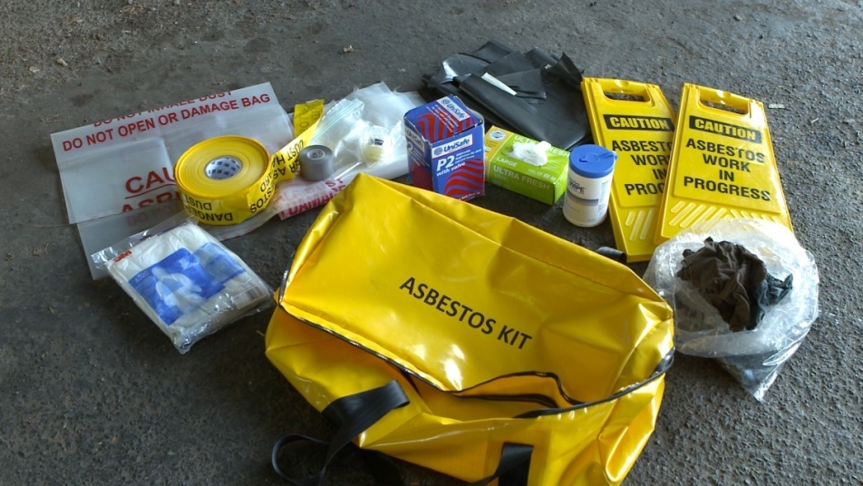

Key messages about how to make it work
Wayne, Geoff, Andrew, Justin and Jason recognise that adopting best practice requires a shift in culture, and changing culture takes time. Based on their experience of what has worked at Ergon Energy, they had a number of suggestions for other organisations trying to create a culture shift:
- Give staff ownership of the processes - include them in the decisions around safe work practices and tell them the benefits
- Keep talking about it, so that it’s not just flavour of the month and then drops away
- You need strong leaders that keep driving the practice and leading by example – that’s especially important for young apprentices and new starters because they see that it’s normal practice
- People are more likely to change their behaviour when they understand the consequences – you and your staff need to understand ‘the why’
- Make the message personal – help staff and management to understand where asbestos is in their own workplace or home and what exposure could mean to them and their families.

“There is a cost. There is a monetary cost. However, it’s far outweighed by the improvement in productivity, the morale, the culture, the work from the guys. They feel safer; it’s a simple process. It also far outweighs the emotional cost of losing a team member, the cost of workers not feeling safe at work or the monetary cost of litigation and compensation for a worker who is diagnosed with an asbestos-related disease.” (Wayne Cullen, Asbestos Manager)

A series of videos on Asbestos safety at Ergon Energy can be found at https://www.youtube.com/playlist?list=PLlveHl1Dwr3rHCOlSZXifVco9ubXQ7KZX

