NSW GOVERNMENT

Strategy:
Best practice
Outcome:
(O2.1) Evidence-based best practice to minimise risks in targeted areas
Deliverable:
(D2.1) Identify opportunities to share best practice for initiatives related to the safe management of asbestos such as licensing, education, training and home renovations where ACMs may be present
Location: NSW

The issue
Naturally occurring asbestos (NOA) occurs within ten metres of the ground surface in as much as one per cent of NSW. While one per cent may not seem to be significant, it does affect the local government areas of thirty-seven NSW councils. Workers, families and the community are put at risk of asbestos exposure when
undertaking excavation for homes, pools or landscaping and roadworks. Property owners and managers are legally required under the NSW Work Health and Safety Regulations 2011 to develop an Asbestos Management Plan that addresses these risks to ensure NOA is safely managed. However councils had very little guidance material available for the business owners and residents who are affected by NOA.

Action taken
The Heads of Asbestos Coordination Authorities (HACA) developed a suite of guidance material to provide residents in regional NSW (where NOA occurs) with the tools and knowledge required to manage NOA safely and in accordance with Regulations. The guidance material includes:
NOA Asbestos Management Plan (AMP) Guide NOA AMP Property Risk Assessment Template NOA AMP – Site Specific Template
NOA Incident Procedures and Report Template
NOA Workers Training Requirements and Records Template
NOA Respiratory Protective Equipment and Personal Protective Equipment factsheet
NOA Decontamination Fact Sheet.
A media event was held in Orange on 16 October 2017 to launch the material. Orange is one of the regions where NOA exists. The launch had a great turn out with media in attendance, council representatives from four regional councils, students from the local TAFE and local tradespeople.
Flyers and posters were also developed to help promote and encourage uptake and use of the guidance material (Figure 18). Copies of the flyers, posters, the NOA AMP guide, factsheets and templates were also distributed to all NSW councils affected by NOA.

Results
SafeWork NSW – Naturally occurring asbestos guidance material
The media event was well covered by several targeted rural and regional media outlets including print, radio, television and online. A large number (3,700) of copies of the NOA package were printed and delivered to the 38 councils in areas that contain naturally occurring asbestos. On top of this, 3,588 NOA resources were downloaded from the website following the launch of the guidance material.

Outcomes
Feedback from Orange Council where the media launch was held was very positive. Due to the media coverage it received, members of the public had come into the council to get copies of the NOA material.
Some councils have also added links on their websites to the guidance material.

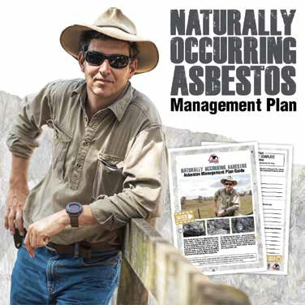Figure 18: Poster for the NOA Management Plan

Next steps
The NOA material will continue to be promoted through the website, through social media and through engagement with the councils where the local government area contains naturally occurring asbestos.

More information
The NOA guidance material can be found at
www.asbestosawareness.com.au/noa/

26 27

