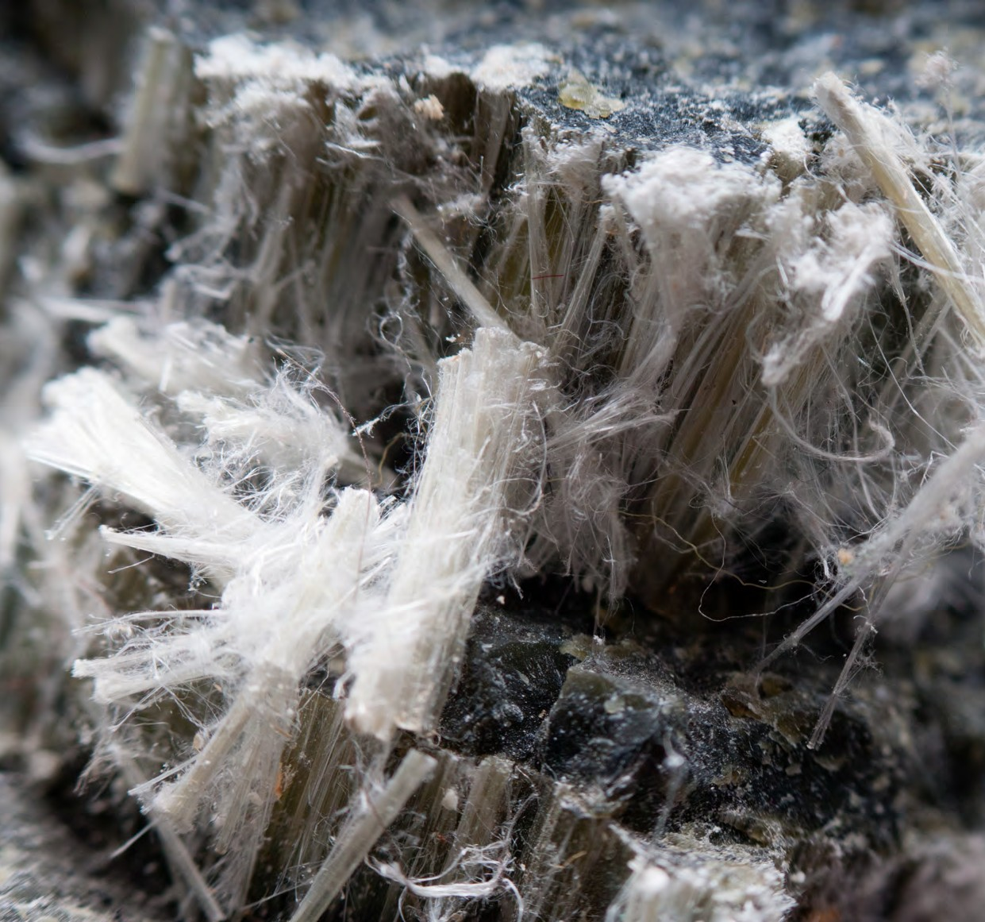
ASEAREPORTS

The economic burden of asbestos-related disease
EXECUTIVE SUMMARY

As prepared by The Centre For International Economics

COMMERCIAL IN CONFIDENCE

EXECUTIVE SUMMARY

Asbestos is part of Australia’s built environment, reflecting a long history of the use of asbestos as a building material. Due to this legacy, it is now a
confirmed cause of multiple asbestos-related diseases (ARDs), making it an important, potentially avoidable, public health issue in Australia.
This study quantifies some of the economic and social costs of ARD in Australia for 2015, and finds that there are large health system and productivity costs associated with the disease.
The population of ARD sufferers is not limited to current patients, due to long latency periods and a third wave of people contracting the disease from non- occupational exposure.
This report contributes to the evidence base for asbestos policy development, and by drawing on all relevant data available at the time of drafting, points to future research that would expand the understanding of the economic and social costs that ARDs leave
on patients, their families and carers, and the wider community and economy.

Deaths and disability in Australia due to asbestos-related disease
In 2015, there were an estimated 4,152 deaths in Australia due to ARDs, and 10,444 prevalent cases of disease.
This accounts for mesothelioma in addition to a broader range of ARDs such as lung cancer. While the majority of these cases are due to past occupational exposure, there is still a large number of people living with disease that have not had any workplace contact with asbestos.
The most common form of ARD is lung cancer. This study estimates that there are 4.2 lung cancer deaths for each mesothelioma death. Data limitations make it more difficult to estimate the number of prevalent cases of lung cancer for each case of mesothelioma, although this study has estimated this to be 5.2.
Given its long latency period, ARDs tend to come in ‘waves’. From its initial wave of exposure due to
asbestos mining through to the current third wave of cases expected to be associated with non-occupational exposure as home renovators in particular are exposed.
Chart 1 presents estimates of the health system and productivity costs of ARD in 2015.

Chart 1: Summary of health system costs and productivity losses
250
Productivity losses
Health system costs

200

150
$ Million

100

50
0
Mesothelioma

Asbestosis

Lung cancer Larynx cancer Ovarian cancer

Note: This chart does not show our estimates of the monetary value of lost quality-of-life because these estimates should not ba added to estimates of the value of lost productivity. Source: CIE.

1 CIE analysis using GBD data. See Appendix A for an explanation of the methodology for estimating the number of deaths due to lung cancer associated with asbestos exposure and mesothelioma based on data from the Global Burden of Disease Study: Institute for Health Metrics and Evaluation (IHME). GBD Compare Data Visualization. Seattle, WA: IHME, University of Washington, 2016. Available from http://vizhub. healthdata.org/gbd-compare.
2 The ratio of asbestos-related lung cancer deaths to mesothelioma deaths has been estimated using a combination of GBD data and CIE analysis. There is some uncertainty around this figure in the literature. Studies such as McCormack, et al. (2012) finding variation in this ratio among asbestos exposure cohorts and highlighting the difficulty of quantifying the asbestos-related lung cancer burden in the presence of this disease’s multiple causes.

Direct health system costs
Hospital and primary healthcare costs associated treating ARDs are estimated at $192 million for 2015. The largest expenditure item is costs for patients admitted to hospital, costing $53.7 million in 2015.3 Average costs per separation are highest for patients with asbestosis ($20 562) and lowest for patients with mesothelioma ($4 893). Outpatient costs are also sizeable, valued at $9.5 million, mostly relating to the treatment of lung cancer (73 per cent).
In the community, costs associated with General Practitioner (GP) consultations are estimated to be
$21.5 million, and spending on specialists and other health practitioners is valued at $48.4 million, again predominantly associated with care for lung cancer patients.
Spending on pharmaceuticals is estimated at $59.0 million, 83 per cent of which is due to Australian Government subsidies offered through the Pharmaceutical Benefits Scheme (PBS),4 with the remainder incurred by patients in out-of-pocket costs.

Costs to the workforce and broader economy
Living with an ARD compromises an individual’s ability to participate in the paid and unpaid workforce. Productivity losses also flow through to carers who are no longer able to participate in work and the community as they otherwise would.
These indirect effects are estimated at $321 million in 2015. Most losses (85 per cent) are due to disease caused by occupational exposure, with losses evenly
shared between paid and unpaid work. Overwhelming, these costs arise due to the premature death of a person, rather than their disability.

The burden to individuals living with an asbestos-related disease
Living with an ARD is a burden for patients and their families, who experience a compromised quality of life. The losses associated with reduced quality of life can be represented in Disability-Adjusted Life Years (DALYs),

3 Australian Institute of Health and Welfare (AIHW) data request, based on data from National Hospital Morbidity and Health Expenditure databases.
4 PBS Information Management Section, 2015, Expenditure and prescriptions twelve months to 30 June 2015, p.V, available at: http://www.pbs.gov.au/statistics/2014-2015-files/exp-prs- book-01-2014-15.pdf
which measure the sum of years lost to disability and years of life lost due to death. Over the lifetime of
all patients with an ARD, burden of disease losses are estimated to be 58,077 Disability-Adjusted Life Years (DALYs).5 This excludes losses associated with asbestosis, for which prevalence or DALY data is not
available. The estimated monetary value of lost quality of life is $10.8 billion in 2015.6 However, this estimate relies on a value for the value of a year of lost life which may be overstated for elderly sufferers of disease.

Compensation for monetary losses for individuals
Sufferers of ARDs often have a right to obtain monetary compensation for their loss due to the disease.
There are two main sources of compensation:
Statutory entitlements fulfilled by bodies such as icare Dust Diseases Care (in NSW) which provide a no fault workers compensation scheme following occupational exposure in NSW to scheduled dusts under the legislation.
Common law damages, subject to burden of proof requirements.
Compensation payments act as a lower bound estimate of the costs of ARD, as they are curtailed by statutory limits on payments, and difficultly in providing evidence of exposures that occurred many years ago. There are also much fewer settlements than instances of ARD.
Nonetheless, the amounts of compensation payments are a useful crosscheck on estimated costs associated with ARD. Not surprisingly, compensation costs are below the estimated costs of ARD derived in this study.
Mesothelioma claimants have received the highest average compensation payment at $31,960, followed by lung cancer ($19,517) and asbestosis claimants ($12,418), although there is a wide range in actual amounts paid.7 The claims are paid through icare and do not prohibit larger common law claims.

5 CIE analysis using GBD data: Institute for Health Metrics and Evalua- tion (IHME). GBD Compare Data Visualization. Seattle, WA: IHME, Uni- versity of Washington, 2016. Available from http://vizhub.healthdata. org/gbd-compare.
6 Assuming a Value of a Statistical Life Year (VSLY) of $186 640 (indexed to $2015-16) based on: Abelson, P. 2008, Establishing a Monetary Value for Lives Saved: Issues and Controversies, Working papers in cost bene- fit analysis, WP 2008 02, Office of Best Practice Regulation, Department of Finance and Deregulation.
7 Based on data provided by icare Dust Diseases Care for 2015/16.

Common law claims from companies such as James Hardie can be much larger. Average compensation payments by James Hardie were $295 000 for mesothelioma, $100 000 for asbestosis and $115 000 for lung cancer in 2015–16.8 Additionally, a number of claims paid by James Hardie have been in the multi- millions. However, James Hardie is only one defendant and many claims are settled and confidential.

Implications for future research and policy development
ARDs impose a substantial burden on suffers and the wider community and economy. Not all costs associated with ARD are known, and certainly not all costs are measurable based on data that is available today. Hence, this report provides a lower bound estimate of the financial burden of ARD in the Australian community.
Key areas where costs have not been quantified include the costs of mental ill health associated with ARDs, and the costs of the governance and reporting framework that surrounds the current footprint of asbestos in the Australian community. Further research in these areas would expand the understanding of the costs of ARD and contribute to asbestos policy development.
Policies that are able to reduce asbestos exposure and the incidence of ARDs would reduce health system and productivity costs associated with the disease and free up valuable resources for other health priorities.
There are a wide range of policy options, all of which impose different costs and have different funding implications. The costing work understanding as part of this study, and potential future work on other identifiable costs, will help guide policy analysis that
seeks to establish whether changes in asbestos policy will deliver net benefits for society.

8 KPMG, 2016, Valuation of asbestos-related disease liabilities of former James Hardie entities (“the liable entities”) to be met by the AICF Trust, prepared for Asbestos Injuries Compensation Fund Limited (“AICFL”), May, 2016, available at: http://www.ir.jameshardie.com.au/public/ download.jsp?id=5839&showOrig=t

