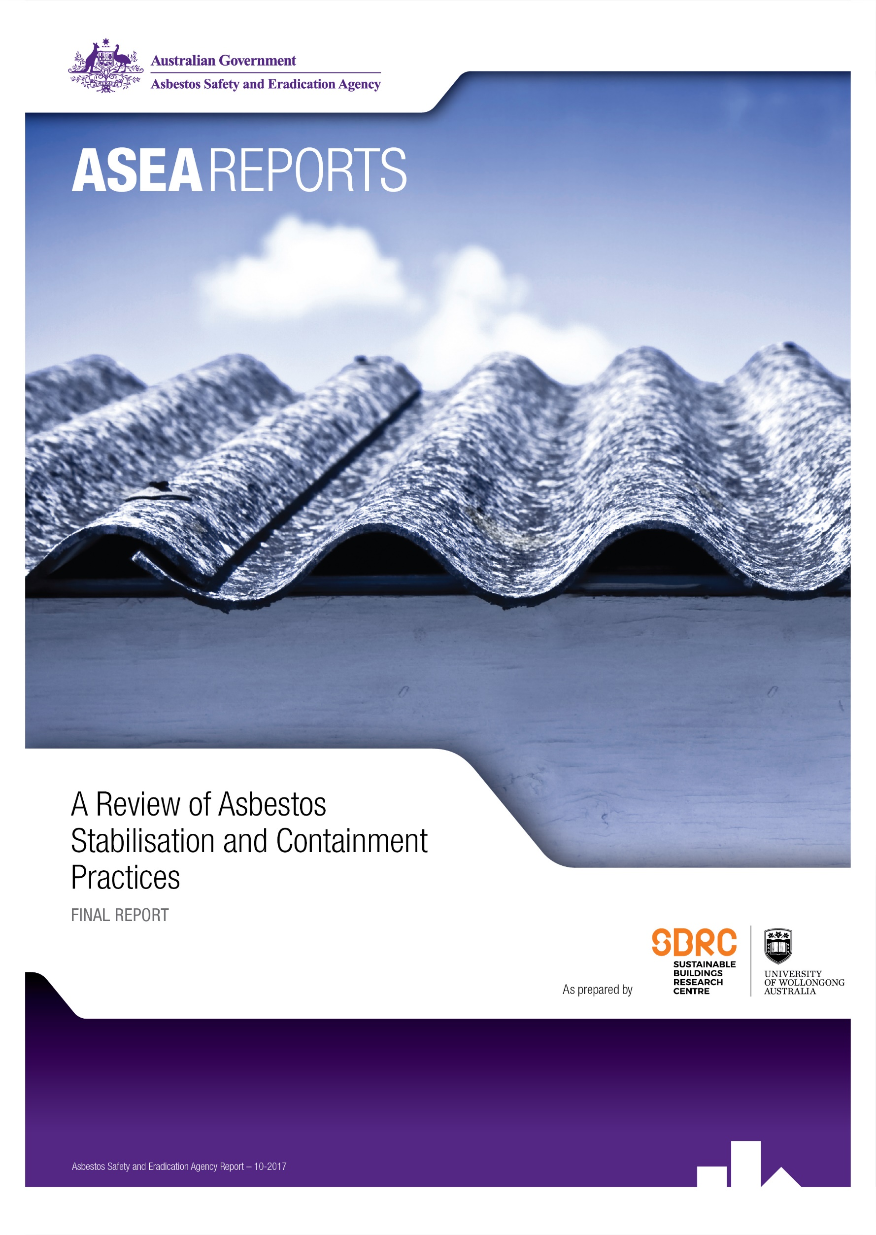
A Review of Asbestos Stabilisation and Containment Practices
Final report
18th May 2017

Authors
Dr Leela Kempton and Professor Tim Mccarthy
Sustainable Buildings Research Centre

© Commonwealth of Australia and University of Wollongong

Table of Contents
Executive summary 1
Introduction 2
Stabilisation and Containment Products 4
Decision Tree Analysis 16
Industry Perspectives 18
Conclusions 19
Appendix A: Interview Subject List 20
Appendix B – Interview Guide 21

Executive summary
There is a substantial legacy of in-situ asbestos containing materials (ACM) throughout the Australian built environment. Whilst considerable efforts have been made to remove ACMs, it is not currently practically or economically feasible to completely remove all asbestos from the built environment. Most of the remaining asbestos is contained in bonded form and when in good condition, does not pose a significant risk of releasing airborne fibres. However, the effects of age and weathering on exposed asbestos materials can cause degradation of the material and leave it in a potentially friable state. Stabilisation processes such as encapsulation present a potential means to effectively manage ACMs in-situ pending longer-term removal. There are also benefits to using these products in the asbestos removal process to minimise or prevent the release of airborne fibres.
The aim of this study was to identify the current products and practices in use for containing and stabilising asbestos either to assist in the removal of ACM, or to maintain the ACM in-situ. Telephone interviews of stakeholders in the asbestos industry including those supplying or using containment products were conducted to seek information regarding the practice and the risks associated with these products and the need for and benefits of these products.
Findings from this study show there are a variety of containment products on the market and being used throughout Australia. There is a particular focus on encapsulating asbestos roofs due to its prevalence, particularly in the industrial sector as well as residential housing. This is also due to the exposed nature of roofing, leading to greater deterioration of the asbestos product and higher likelihood for airborne fibre release from the roof. The high cost of removing an asbestos roof and replacing it with another product is also a strong factor in uptake of encapsulation.
There is a strong preference in those responsible for the management of ACM for removal of ACMs as a first step. However, in those situations where removal is not possible, stabilisation and encapsulation can provide a potential solution. Most particularly of these is in areas where the asbestos is exposed to weathering or potential damage. Additionally, these methods are useful when the asbestos needs to be contained as an interim measure for the short term until removal can be achieved. Stringent management of the containment process as well as the ongoing maintenance and management of the material also needs to be considered.
This report is not intended to advocate or endorse any particular product. It is also not intended to provide an exhaustive list. Readers should be advised that it is not intended as regulatory guidance, and the use of any product/process outlined will not automatically equate to compliance with WHS regulations concerning asbestos. Anyone intending to use the products/processes outlined should consult their WHS regulator for further information particularly with regard to any working with asbestos training or licencing requirements that may apply.

Introduction
Background
The issues surrounding asbestos are well known, with data from the World Health Organization (WHO), indicating that more than 107,000 people die annually from asbestos-related diseases including lung cancer, mesothelioma and asbestosis. Even though the use of asbestos was completely prohibited in Australia from 31 December 2003, there remains a considerable but unquantifiable quantity of asbestos in the current building stock in Australia.
In its bonded form, asbestos containing materials (ACMs) are considered relatively stable. However, they can pose a health risk in the case of weathering, age or disturbance. In this case, asbestos fibres have a much greater likelihood of becoming airborne. A common area of concern is asbestos roofing, which due to its exposed nature can experience substantial weathering over time. Recent research conducted to determine the current state of in-situ asbestos in the built environment highlighted that asbestos roofs make up a significant proportion of asbestos in the environment and these are often not removed because of cost or safety issues in the removal of the roof.
Whilst removal is the ultimate goal, removal of ACMs is not always practically possible and the financial considerations can be prohibitive. One potential approach to this issue is the field of asbestos stabilisation and containment; that is treating ACM in-situ in order to prevent the release of asbestos fibres in the future.
The National Strategic Plan for Asbestos Management and Awareness 2014-2018 includes the outcome (3.2) of “Improved stabilisation and containment practices for ACMs in poor conditions”. This requires understanding of the products and processes available for stabilisation and containment practices, and how these are being currently employed.
Research Objectives
The aim of this research project is to determine and review the asbestos stabilisation and containment practices currently available and in use in Australia and overseas. This includes the following:
- Determining the products available for stabilisation or containment of asbestos materials on the market
- Understanding the limitations and risks of encapsulating ACMs over the lifetime use of the product
- Developing a decision tree for when containment practices may be preferred (and which type)
Methodology
This research consisted of a desktop review of asbestos containment and stabilisation practices and products available, as well as semi-structured interviews conducted with a range of stakeholders. Stakeholders were identified through contacts provided by the Asbestos Safety and Eradication Agency (ASEA), as well as online searches for related companies. Fourteen interviews were carried out with a broad range of stakeholders was sought to gain a comprehensive understanding from varying viewpoints, including:
- Asbestos removalists
- Trade union OHS officers
- Occupational hygiene
- Buildings facility maintenance
- Local council representative
- Stabilisation product suppliers
Key Research Questions
Some of the key research questions considered in this study include:
- What containment or stabilisation products and practices are currently being used?
- What advantages do they offer over conventional methods for dealing with asbestos?
- How effective are they at containing or stabilising the ACM?
- What risks are involved in using or encouraging the use of these products?
A copy of the interview guide used is given in Appendix B. The questions used were dependant on the interview subject and their sector, not all questions were asked of each interview subject. These questions were intended as conversation starters in the semi-structured interviews.
Stabilisation and Containment Products
Overview
Whenever dealing with hazards, it is important to consider the hierarchy of control in managing the hazard. For asbestos, the safest and most effective control is always to eliminate – to physically remove the asbestos completely. If this is not possible, then Safe Work Australia (SWA) defines two aspects of control measures for dealing with asbestos – enclosure and encapsulation or sealing. Enclosure uses a physical barrier to protect from exposure to airborne fibres and can only be used on non-friable asbestos where removal is not reasonably practicable. Often, it is used as temporary measure while work is being undertaken. Encapsulation or sealing involves coating the material with a protective coating that is either a bridging (surface) or a penetrative covering to encapsulate the asbestos fibres and prevent loose fibres from becoming airborne. Another type of encapsulant used is a lockdown encapsulant, used to contain asbestos fibres during the removal process.
Enclosure
Overview
Enclosure is defined as “the creation of a structure built around the asbestos so that it is completely covered to prevent exposure of the asbestos to air and other substances”. It is considered by Safe Work Australia as the preferred alternative control measure when it is not reasonably practicable to remove the asbestos. The structure built around the asbestos is often plywood or other strong material, with the main aim being the protection from mechanical impact or damage. Normally board or sheet materials should not be fixed through the asbestos material. However, if the assessment shows that the best method for mechanical protection requires screw fixing through the asbestos material, appropriate controls should be put in place to minimise fibre release and spread of contamination.
Examples of Use
The Safe Work Australia guidelines include the following example of use of enclosure as a control measure:
EXAMPLE OF ENCLOSURE OF ASBESTOS AS A CONTROL MEASURE:
A large dockside warehouse used for temporarily storing quantities of grain and stockfeed has walls made from a variety of materials, including AC sheet. Apart from the driver of a large front end loader that is briefly driven into the warehouse to load or unload the feed, there are no other workers who work in the warehouse. An inspection of the AC sheet identifies that it is in good condition and noted that areas of previous minor damage (broken sheets) have been repaired appropriately and there is minimal risk of fibre release. However, it is decided there is a chance the sheets may be damaged again and if so, a risk to health may occur if fibres are released. A solid false wall is constructed to enclose the AC sheet and bollards are erected in front of the new wall to prevent collisions that may occur when the front-end loader is operating inside the warehouse. These changes are included in the asbestos register. The condition of the AC sheet is also monitored as well as the newly installed control measure.

Another example encountered during this study was a refurbishment project at Hamer Hall in Melbourne. During this refurbishment, the walls in the plant room were identified as being lined with asbestos sheeting. As the outside walls in this section did not need to be penetrated, and there was no work being done to the walls themselves in this area, it was not deemed practical to remove the asbestos. However, as workers needed to access the plant room and move equipment around the room to perform other tasks, the asbestos lined walls posed a significant risk that needed to be addressed. It was decided to coat the walls in PVA glue and then cover with 20mm plywood to protect the walls against impact. The plywood stayed in place throughout the construction process for around 12-14 months until work was completed, and was then removed. An inspection following this showed that the ply had absorbed minor damage in a few places; however the asbestos sheeting was not damaged at all.
An enclosure can also be used to contain friable asbestos material such as fire rating insulation material in a plant space, through the use of rigid boarding to create a false ceiling. Temporary enclosure using 200µm thick plastic has also been suggested by Ausgrid for situations where maintenance activities are proposed in the vicinity of asbestos material. This is particularly useful for asbestos bandaged cables, however care needs to be taken to ensure that the wrapped cables are not impacted during the work undertaken.

Advantages / Risks
A summary of the advantages and risks of using enclosure as a method for dealing with ACM is given in Table 1.
Table 1: Advantages and Risks of Enclosure
Advantages | Risks
Provides a physical barrier between a worker and the ACM to protect against accidental disturbance | Need to ensure that asbestos sheeting is not damaged during installation or removal of the enclosure
Can be used as a temporary measure during construction | Asbestos needs to be fully contained to be effective
Minimise disturbance to occupants | Enclosure needs to be regularly maintained if being left in place
 | Need to remove enclosure before removing asbestos
When is Enclosure Recommended?
Enclosure is recommended if the ACM is in good condition and removal is not reasonably practicable. However, additional protection is required to prevent mechanical damage to the ACM. Another circumstance in which enclosure may be recommended is when ACM has been damaged and needs to be isolated and made safe immediately as an interim measure, until it is able to be removed at a later date.
Encapsulation
Overview
Encapsulation is the process of covering the ACM in a penetrative or bridging compound to contain the fibres in a resilient matrix to prevent the release of airborne fibres. It is designed to help protect the asbestos from mechanical damage, increases the length of serviceability of the ACM product and may also be used to prevent the release of airborne asbestos during the removal process.
The condition of the ACM is important in considering encapsulation. If the ACM being considered is a sprayed asbestos or thermal insulation, then encapsulation should only be considered if the ACM is adhering firmly to the substrate and is in a viable state. In the case of roofing materials, for example, the existing strength of the material needs to be considered as well. Although the encapsulant matrix adds some strength to the material, it also adds considerable weight to the structure of the roof and if the supporting systems for the roof are not in good condition and able to withstand the additional load, then it may not be viable to consider encapsulating.
It is important when considering encapsulation that the coating is appropriate to the material to be sealed and has the required fire resistance, thermal insulation and ultraviolet (UV) properties necessary for it to be an effective control. The coating will deteriorate if it is exposed to chemicals, extreme heat or cold, wet or dry conditions or physical impacts. For example, epoxy-based paints offer better durability and strength than other paints.
Encapsulation products are also widely used in the asbestos removal process to contain and lockdown fibres that may otherwise be released.
Products Available
There is a wide range of encapsulant products available. Many of them are particularly designed or suited to specific applications. There are four general types – adhesive sealants, mastic compounds, foam encapsulation or membrane coatings.
Adhesive Sealants
The most common method of containing asbestos in-situ is through the use of encapsulating sealants. Usually these sealants consist of a multi-stage system with a penetrative primer designed to penetrate the surface of the ACM, then covered with a topcoat, which also has protective qualities. There are a large number of products available within Australia and overseas. The Australian Paint Approval Scheme has a paint specification APAS1720 which provides guidelines for an encapsulation system for asbestos cement sheeting. A summary of some of the main products that are available and in use within Australia are detailed below.
Asbestos Binding Compound - ABC (Fiberlock)
ABC is an asbestos binding compound, manufactured in the USA and widely available in Australia and New Zealand. It is a multipurpose compound which can be diluted to serve different purposes - a penetrative sealant (1-3:1 water to product ratio), bridging sealant (1:1) or a lockdown sealant (5-10:1). It is generally used indoors but can be used as an outdoor penetrative sealant in conjunction with a different topcoat (either TBC or Griptack – see below). It is also available in an air-less spray can, which can provide maintenance personnel of public or industrial facilities with an effective, easy to use and readily available system for quickly containing potentially friable material which might be disturbed by brush painting.
Transite Barrier Compound - TBC (Fiberlock)
TBC is an elastomeric thermoplastic water based copolymer, blended specifically to seal interior and exterior asbestos containing industrial fibre cement board (Transite). It is typically used as a bridging encapsulant for outdoor applications. A distinct advantage of TBC is the ability to have it tinted like house paint to achieve a final surface colour.
Fibroseal (Crommelin)
The Fibroseal system was developed in 1989 by Crommelin, following a request to paint an asbestos roof. The primer was developed to encapsulate the asbestos and replace the voids left in the cement matrix by lichen damage. It also included a mineral based fungicide to inhibit the growth of organic compounds. In the mid 1990’s, the primer was changed from a solvent base to a water based primer using a silicate plus and organic binder and penetrant. It is applied in one coat to the point of ensure there is sufficient penetration into the material. Then an acrylic membrane topcoat is applied.
Asbestos Sealer (NuTech Paints)
Nutech asbestos sealer is designed to penetrate and seal the surface of new and weathered asbestos cement sheeting. It utilises an alkaline curing functionality, which achieves greater bonding compared to standard acrylic and co-polymer emulsion sealers. When used externally a pigmented top coat system should be applied such as Nuflex, Tileflex or NXT Cool Zone to obtain maximum UV resistance and durability.
Asbestoseal (Insultec)
Asbestoseal is an acrylic resin with anti-mould and anti-fungus agents, designed to penetrate into fibro asbestos and seal the surface. It is used in conjunction with a top coat polymer based product with glass beading throughout it, designed specifically for the Australian conditions.
Rivett (Astec Paints)
Astec Paints have a three part asbestos sealing system that is been in use for over 20 years. Firstly, Barrier is a bacterial, algal and fungal wash designed to clean and treat the mould on the surface of the material before the sealant is applied. Secondly, Rivett is a clear solvent based solution designed to penetrate aged asbestos sheeting. Finally, it is then covered with a topcoat that has improved thermal performance.
Mastic Compound
There are some situations in which a liquid sealant is insufficient to seal or contain ACM. In these situations, a mastic compound provides an alternative way of dealing with the problem. Serpimastic, manufactured by Fiberlock, is a durable, chemically resistant and tough compound that is available as a trowelable or sprayable form. It can be used to fill large holes or divots in ACM to provide a suitable surface for further encapsulation.
Another option which is used for remediation purposes is Griptack, which is provides a soft, tacky, flexible membrane, which locks down asbestos fibres to ensure final clearance after the removal of asbestos. This is known as a demolition adhesive. It can also be used as a primer for TBC or Serpimastic.
Foam Encapsulation
Foamshield is a product developed for the asbestos abatement industry which acts as a wetting agent and fibre containment system. It is designed to inhibit the release of airborne particles at the point of disturbance by colliding particles with foam, thus saturating and encapsulating the particles so they are not released into the air. The foam blanket creates the containment required. It also eliminates the spread of asbestos fibres in run-off as all the material is contained on site. Visibility of the foam blanket ensures the chance of missing areas or weak spots is reduced, and the required clean-up is easier and more contained.
Membrane Coating
Another option that has been developed specifically for pipe lagging is a re-wettable membrane cloth developed by Fiberlock called Lag Kloth. Firstly, the surface needs to be prepared by applying a bridging encapsulant such as Serpimastic, which can fill divots in the lagging and deal with ragged edges. Then the membrane cloth is dipped in water to activate the adhesive fibreglass yarn. It is then wrapped around the surface of the pipe lagging and smoothed in place. A bridging encapsulant such as Serpimastic is applied as a final step to seal it in place. The Lag Kloth is designed to provide a surface suitable for an encapsulant to be applied to it. It is not designed to be used on its own. It is also heat resistant up to 300°C.
Liquid membrane coatings such as Emerclad (developed by ParChem) have also been used to provide a waterproof coating to encapsulate damaged asbestos materials such as wall sheeting. It is also suggested as a sealant for broken or damaged non-friable asbestos materials by the Ausgrid Network Standard.
Examples of use
As an Encapsulant
By far, the largest use of encapsulation on ACM in Australia is on roofing materials. One manufacturer suggested that greater than 80% of their workload is on roofs. Examples of the application of an encapsulation system to a typical roof can be seen in Figure 1. There are two main contributing factors to this – firstly, the cost involved in removing and replacing an asbestos roof may be financially prohibitive. Secondly, roofing materials are exposed to the greatest weathering conditions and thus have the greatest potential for deterioration. Encapsulation of roofing also often provides the dual benefit of improving waterproofing of asbestos roofs as the sheeting can be prone to hairline cracks. It can also improve the thermal performance of the roof. Another advantage of encapsulating roofs is the ability to encapsulate the roof without needing to stop operations or evacuate the premises, particularly for industrial or commercial sites where operational needs are important.

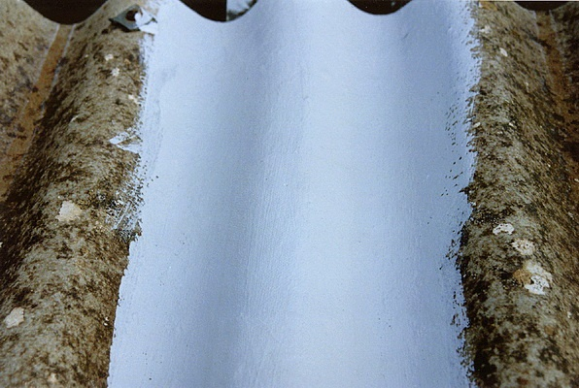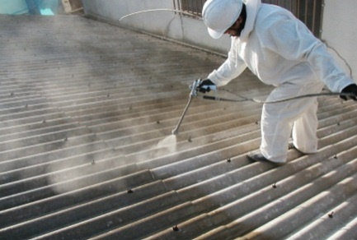
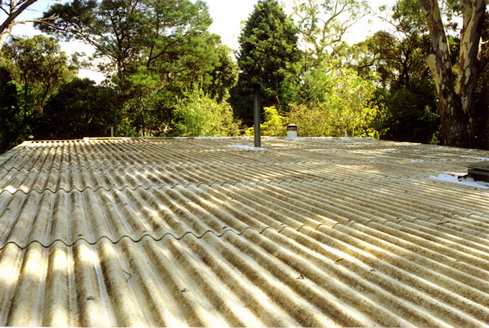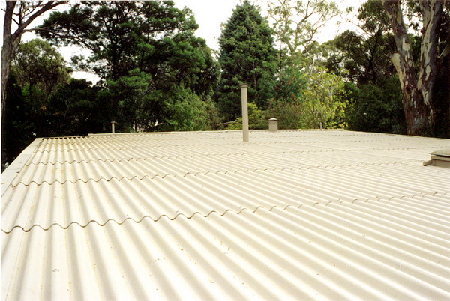
Figure 1: Photographs showing the application of an encapsulation product to an asbestos roof
The estimated lifespan of the encapsulation depends on the condition of the roof, the environment is exposed to and the application of the product. Some of the manufactures provide warranties on the encapsulation of a roof of up to 10 years, if it is applied by certified contractors. However, the typical lifespan may exceed this. One company interviewed commented that they had a request to respray a roof 11 years after the first coating, as an audit identified fibres in the gutters. Inspection of the roof showed a few minor areas where the coating was peeling off. Another company noted that the roof of the QLD observatory was encapsulated in 1991, and a recent inspection showed it still reflecting around 85% of original qualities and the sealant is in 100% condition.
One example of another use of encapsulant given was a brick wall in Western Australia, which had been sprayed with asbestos insulation then had wood applied for decoration. When the wood was removed the asbestos attached to the brickwork was exposed. Rather than removing the entire brick wall, the asbestos was encapsulated.
Encapsulation can also provide an interim solution for containing asbestos when immediate removal is not possible. An example given was in a 50 storey high lift shaft in a commercial building. The building was coming up for a major refurbishment in a few years. Asbestos was discovered in the fire rating insulation blankets in the liftwell and it posed a risk for technicians entering the lift. It was not feasible to shut down the shaft in order to remove the asbestos material on its own, so instead it was encapsulated using a liquid membrane product, which will remain in place until the ACM is removed during the building refurbishment. An inspection was done recently and it is still performing well.
For Lockdown
During the removal of asbestos, it is critical to ensure containment of any fibres that may be released during the remediation process. At a minimum this is achieved by wetting down the material prior to removal. However, this in itself poses certain risks – firstly, any water runoff may be contaminated. Secondly, wetting with water may not be a sufficient means of coating the surface due to either the environment conditions, such as high temperatures causing evaporation, or due to the material itself, as some ACMs can be hydrophobic. In these cases, a sprayed on sealant provides more effective protection. A dilute PVA solution is generally used for most applications. However, there are some applications here the penetrative sealants have been used.
There are also special circumstances in which lockdown sealants are required. Firstly in the case of fire damaged houses containing asbestos – in this circumstance, after an inspection is undertaken a PVA sealant is applied as a temporary measure. This is also a circumstance in which a product like Foamshield can be highly beneficial, as it can contain any friable fibres without the need for the erection of a full enclosure. An example showing the use of Foamshield to contain asbestos material in a fire damaged house is given in Figure 2. In this example, the house internal walls were a mixture of asbestos sheeting and plasterboard. Air monitoring results obtained during the removal process confirmed a fibre count of <0.01 f/m. In addition, by using the Foamshield, contaminated water run-off from the site was eliminated.
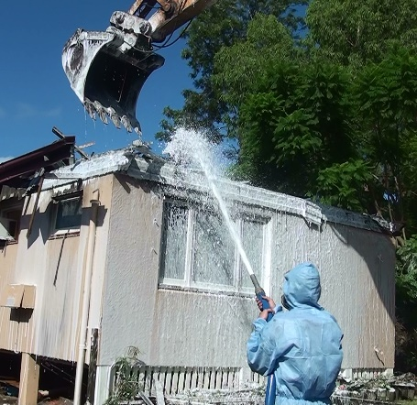
Figure 2: Use of Foamshield to encapsulate a fire damaged house prior to and during demolition
The use of lockdown encapsulants following the removal of friable material is also very common. This works to seal the entire removal area before the final clearance monitoring is carried out. An example of this was given of a building at the University of Wollongong, where friable asbestos insulation was removed from the ceiling cavity by vacuum. Aglue was then sprayed into the cavity and walls to encapsulate any fibres that had been missed in the ceiling or walls. The note was then made on the register that the walls may contain asbestos.
Lockdown encapsulants can also provide additional safety in the case of Illegal dump sites. Reference was made by one of the interview participants to the use of an encapsulant as a first response where illegal asbestos dump sites have been detected to seal and contain any potentially exposed fibres before proper removal could be affected. It is difficult to quantify the extent of illegal dumping, however a report from the ASEA has estimated it to be around 6,300 tonnes of illegally dumped ACMs per annum across Australia.
Specific uses of encapsulant resins for difficult removal situations have also been noted in literature. One example given was of old ventilation extract filters containing asbestos at a UK radioactive research facility which required disposal as part of decommissioning. The key challenge was the prevention of the spread of asbestos filter material during sectioning for disposal. The technique adopted was to pour a fluid epoxy resin into the filter body such that the internal contents were stabilized enabling the filters to be cut without releasing radiological or asbestos contamination.
Advantages / Risks
A summary of the advantages and risks of encapsulating in-situ asbestos materials is given in Table 2.
Table 2: Advantages and risk of encapsulation in-situ
Advantages | Risks
Reduces the risk of airborne fibre release due to deteriorating condition of the ACM | Applying the sealant incorrectly can cause release of airborne fibres
More cost effective than removal | Insufficient application may deteriorate over time
Can provide additional benefits such as thermal performance to the roof | Complacency regarding the asbestos hazard. Continued management of the ACM is required
Can be used to fill in hairline cracks or minor damage to the asbestos sheeting | High pressure cleaning cannot be done on asbestos roofs, therefore the compound needs to be able to be applied to dirty roofs and still be effective
Can increase the strength of a roof material | Safety risks of applying the product to weathered or deteriorated asbestos need to be considered

A summary of the advantages and risks of using lockdown encapsulants is given in Table 3.
Table 3: Advantages and risks of encapsulating for lockdown
Advantages | Risks
More efficient containment of dust generated during removal process | Need to consider future use of area – any application of new insulation needs a good surface to adhere to
Easily accessible products | Specialised products may be more expensive that standard PVA option
Contains waste products more easily – prevents runoff
When is Encapsulation Recommended?
Encapsulation is recommended in circumstances where it is not practicable to remove the ACM, but the ACM is in a weathered or exposed state. If the ACM is in good condition and not exposed, then it is considered safer to leave it untouched and instead monitor for deterioration. However, ACM which is exposed or damaged will benefit from being encapsulated to prevent any release of airborne fibres over time. Encapsulating products should also be considered during removal processes when there is potential for the ACM being removed to be damaged or to produce airborne fibres. Encapsulation will provide additional protection to those removing the asbestos.
There are some circumstances that have been noted where it is not recommended to use encapsulation. Particularly in roofing, the condition of the roof needs to be considered as it needs to be able to withstand the additional weight of the encapsulant applied to the roof. Safety risks of accessing deteriorated roofs also need to be considered as weathered roofs can become very brittle and dangerous to work on. Wire netting is sometimes installed inside the building to protect workers. Encapsulation is also not recommended on roofs which have been previously painted, as the paint may interfere with the ability of the encapsulant to penetrate the ACM.
Summary of Products Available
A summary of the different products used for stabilisation or containment of asbestos containing materials encountered during this study is given in Table 4.
Table 4: Summary of stabilisation and containment products available
Name (Manufacturer) | Type of Product | Description | Recommended applications | Lifespan of application
PVA glue diluted with water | Generic | Acts as a surface encapsulant to protect the surface and prevent release of fibres | Sprayed onto ACM before immediate or short term removal | Very limited in exposed conditions. In protected conditions, lifespan may be longer
Standard paint | Generic | Acts as a surface encapsulant to protect the surface and prevent release of fibres | Covering surfaces of good condition ACM | Dependant on the environment
Enclosure | Plywood | Plywood enclosures can be built around ACM to protect it from impact or damage. | Good condition ACMs not being removed, but when work is being done in the vicinity surrounding them | Limited – only for when work is being conducted, months to a year
Fibroseal  (Crommelin) | Water-based encapsulants | Penetrative primer with a topcoat | Roofing, also used on fences and walls | Guaranteed with trained applicators for 10 years
Asbestos Binding Compound (ABC)  (Fiberlock) | Encapsulant – can be used as a bridging, penetrative or lockdown encapsulant | ABC is a high solids asbestos encapsulant/sealant, designed to encapsulate friable ACM such as fireproofing and insulation material | Penetrative encapsulant for fireproofing, celling plasters etc.  Lockdown encapsulant after removal | In indoor applications when applied correctly can be >20years
Transite Barrier Compound (TBC)  (Fiberlock) | Bridging Encapsulant | TBC is an elastomeric thermoplastic water based copolymer, blended specifically to seal interior and exterior asbestos containing Industrial Fiber Cement Board | Bridging encapsulant for indoor and outdoor use | 10-20years depending on the environment and application
Griptack  (Fiberlock) | Putty / Sticky glue | A soft, tacky, flexible membrane, which locks down asbestos fibres to insure final clearance after the removal | Applied during remediation, any dust generated during the remediation process sticks to the surface of the glue | For remediation purposes only
Serpimastic  (Fiberlock) | Sprayable or trowelable encapsulant | Super tough and exceptionally durable, high solids, water-based, high performance mastic coating | Indoor and outdoor applications, trafficable surfaces | ~10yrs depending on application and environment
Lag Kloth (Fiberlock) | Membrane coating – rewettable cloth | Lag-Kloth is a woven fabric impregnated with an inorganic adhesive, designed to repair and/or cover existing asbestos insulation on pipes, boilers etc. Needs to be covered with an encapsulant to provide full protection | Asbestos lagging on pipes, boilers etc. | 10-20yrs when applied correctly with full system
Asbestoseal  (Insultec) | Encapsulant | Penetrative encapsulant | Roofing | 10 years guaranteed
Asbestos Sealer (Nutech Paints) | Encapsulant | Penetrative encapsulant designed to adhere to weathered and porous asbestos surfaces | Roofing | Uncertain
Foamshield  (Foamshield) | Foam | Foam sprayed onto surfaces to be removed, particles collide with foam, become saturated and are encapsulated so they are not released into the air. The foam blanket becomes the containment and the need for excessive protection methods is reduced | During removal of asbestos in areas that are difficult to contain / enclose, or for removal of friable asbestos | For remediation purposes only
Rivett  (Astec Paints) | Solvent based encapsulant - part of a 3 stage system | Barrier is a bacterial, algal and fungal wash designed to clean and treat the mould on the surface of the material before the sealant is applied. Rivett is a clear solvent based solution designed to penetrate aged asbestos sheeting. Finally it is covered with a topcoat that has improved thermal performance | Roofs – can fill in the hairline cracks in roofs | No estimate on lifespan provided

Decision Tree Analysis
There are many aspects to be considered when investigating potential options for managing ACMs. It is important to understand that there is no single solution to the problem. Each individual situation needs to be considered separately and assessed by a competent person to understand the best course of action. It is recommended that this person is a trained occupational hygienist. Additionally, the incorrect application of some strategies can cause the release of significant airborne fibres which can cause greater problems than leaving it untouched. However, it is important to note situations in which stabilisation products may be considered useful, particularly in highlighting the options available to those guiding the decisions about how to manage the ACM.

Firstly, the type and condition of asbestos needs to be considered and removal needs to be assessed as the first step. Where removal is not practically possible, then other alternatives may be considered.

Factors which should be considered in assessing the options available include:
- Usage of the building/space
  - residential building,
  - public building – which may have high traffic or high needs of the occupants,
  - industrial / commercial building, which may have continuous operational needs
- Type of asbestos
  - Friable – may need encapsulation before removal to prevent spread of fibres
  - Non-friable – depends on condition and location – if exposed to weather, then consider encapsulation. If in good condition and not exposed it can be left in place and monitored for deterioration. If any renovations to be done or likely to be disturbed in some way then one may need to look at removing or encapsulating
- Exposure of the ACM – exposure to weathering can significantly degrade the material over time and encapsulation can reduce the impact of weathering on the material
- Removal – for those situations where removal involves breaking or disturbing the ACM, encapsulation products may be of use. Or where timeframe is not immediate and works need to be done, then temporary containment may be used as an interim measure
Figure 3 shows a decision tree for the major situations in which asbestos stabilisation or containment products should be considered.
It is practical to remove the ACM?

Can the ACM be removed with minimal potential for damage?
Is the location in a public area or requires more stringent control measures?
Consider the use of a containment product like spray foam or putty to increase the safety of the removal process
ce
Refer to the SWA Code of Practice on How to Safely Remove Asbestos
Y
N
Y
Y
N
N
Is the building residential or commercial /industrial?
R
C/I
Is it in a high traffic area or has an increased likelihood of being damaged?
Is there work to be done in the area that could potentially disturb the asbestos?
Is the asbestos in good condition, with no dirt, build-up or weathering?
Is the asbestos exposed to weather conditions?
Consider enclosing the asbestos using plywood or other material to prevent future damage
Y
N
Y
N
Encapsulation of the product using a penetrative sealant should be considered
Y
N
Y
N
Refer to the SWA Code of Practice on How to Manage and Control Asbestos in the Workplace
Products to be used in conjunction with removal
CONTAINMENT
ENCAPSULATION
ENCLOSURE
Monitor and consider options for future removal. Ensure location of ACM is recorded in the asbestos register (required if a workplace) and consider signing if appropriate. This is particularly important if application could mask identification

Figure 3: Decision tree for considering asbestos stabilisation products
Industry Perspectives
Whilst the overwhelming preference among those without a commercial interest in the use of stabilisation and containment products is to first work towards complete removal of ACMs, there is an acknowledgement that there is a strong need and place for the use of stabilising and containment practices for ACM, particularly as ACM ages and deteriorates. There was also the opinion that the issue of asbestos exposure from roofs is understated, as it was one contractor’s experience that they often get higher readings while working on a roof just because it is a windy day than what they would during a standard removal.
“Asbestos containing materials are going to age and deteriorate. They are never going to get less friable unless you do something – they are only going to get more friable. Encapsulation, which is relatively rapid and comparatively inexpensive and simple should be encouraged because it can extend the useable life of service…
Encapsulation is vastly preferable to doing nothing in the near term, even if the eventual goal is to become asbestos free. It is the simplest, most cost effective way of achieving abatement” - C, Fiberlock
There was, however, a strong feeling amongst those involved in the remediation work that the industry would benefit from a government incentive towards dealing with and managing asbestos. The high cost associated with removal means that removal is not highly sought after, but neither is support given for the alternatives for managing the ACM in-situ.
“The abatement industry will never achieve what it needs to without directive from above. The UK has tax relief for private companies undertaking remediation work. There needs to be some incentive for people to do something about it or relief for those who are doing something.” – P Metro Roof Restorations
“I think if we had some initiatives for some of the larger factories who have quite large areas to give them an incentive to get the products coated – such as money back or a government rebate to contain these products… it would make the environment much safer.” R, Abyss Industries
The issue of labelling ACM, particularly in the public environment was also raised. It was noted that hysteria can be created by labelling products as ACM, but perhaps there are alternatives that may need to be considered, such as QR codes location on the materials on site that would link back to specific reports.

Conclusions
There is a wide variety of products available for the stabilisation and containment of ACMs in Australia. The first preference solution when removal of the ACM is not practical is the use of enclosure. Enclosure provides a good solution to protect workers in the event of working around ACM which cannot be removed. The second preference in managing ACM is the use of encapsulation. Encapsulating sealants have been seen to be used both in managing ACM in situ, and also during the remediation process as a lockdown encapsulant.
Interviews with industry representatives have highlighted the extensive use of encapsulation products, particularly in the roofing industry, both industrial / commercial and residential. Due to the significant cost associated with the removal and replacement of an asbestos roof, encapsulation is seen to be a viable option to extend the life of an existing structure.
A decision tree has been developed to assist in identifying when stabilisation and containment methods may be appropriate to be considered. However, it is vital to note that each situation needs to be carefully monitored and assessed by a competent person, such as a qualified occupational hygienist to determine the best could of action for that particular situation. There is no single or overriding solution to a particular situation.
Finally, there is a feeling amongst the industry that there is a need for incentive or government support to encourage the used to stabilisation practices as an interim measure for the short term, until complete removal of ACM can be achieved.

Appendix A: Interview Subject List
Table 5: List of interview subjects
Name | Company | Role / Description | Date Interviewed
P | ASEA | CEO | 6/3/17
B | Asbestos Removalist Contractors Association NSW (ARCA) / BEasy Removals | Asbestos Removalist | 23/3/17
C | Plumbing Trades Employee Union | OH&S Safety officer | 16/3/17
C | Local Government, NSW | Buildings and Facilities Sustainability Planner | 17/3/17
P | Metro Roof Restorations | Asbestos Roof Encapsulation | 2/3/17
L | University of Wollongong | Occupational Hygienist | 7/3/17
M | AWARE | Asbestos Removalist | 20/3/17
M | University of Wollongong | Maintenance Supervisor and OH&S Co-ordinator | 20/3/17
L | Allens Industrial Products | Supplier of asbestos related products | 16/3/17
R | Abyss Industries | Asbestos Encapsulation | 30/3/17
J | Crommelin | Manufacturer of Asbestos Encapsulant | 23/3/17
C | Fiberlock | Manufacturer of Asbestos Encapsulant | 30/3/17
C | Pure Contracting | Asbestos Removal | 27/3/17
T | Astec Paints | Manufacturer of Asbestos Encapsulant | 20/3/17
Appendix B – Interview Guide
We have been engaged by the Asbestos Safety and Eradication Agency to conduct a study of industry practices for the containment and stabilisation of asbestos containing materials. This includes a survey of companies providing or using such services, which as far as we are aware, includes your company.
The aim of this research project is to determine and review the asbestos stabilisation and containment practices currently available and in use in Australia and overseas. From this information, a report will be developed including a decision tree on when and where a product/process is suitable and recommended.
Questions for end users of asbestos containment products
- Questions about your company and your services:
- What services is your company involved in?
- What types of buildings, structures etc do you deal with? (e.g telecommunication pits, pipes, residential buildings, commercial etc.)
- What types of asbestos do you need to deal with?
- What has changed in your approach to asbestos in the last 5-10 years?

- Questions about your specific practices
- Have you been involved in using any products to contain or stabilise asbestos either in place or before demolition?
- Why did you use these products over other options like standard paint or PVA glue?
- Can you give examples of where the product has been used?
- Would you use the products again? Or if there was an alternative available would you use it? Why/why not?
- Do you foresee any risks in encouraging the use of these products?

- A) For those products used where the ACM was removed:
- How effective was the product or process at mitigating the risk of asbestos fibre release during demolition?
- Was there any analysis or monitoring done during the removal process to support this?
OR
B) For those products used where the ACM is left in place:
- How are asbestos containing materials on site labelled? Does this change following the containment?
- How often are inspections conducted of the contained areas?
- What is the estimated lifespan of the application?
- How has the application performed so far?
- Are there any impacts of the application on the future removal of the ACM?

- Do you have any further information or thoughts that you would like to provide or any questions to ask?
Questions for interviews with asbestos containment product providers:
- Questions about your company and your services:
- How long has your company been in operation? / How long have you been providing asbestos related services?
- What geographical locations do you service?
- What types of buildings, structures etc do you deal with? (e.g telecommunication pits, pipes, residential buildings, commercial etc.)
- What is the largest contract asbestos job your company has undertaken?
- What has changed in the last 10 years in your company?
- Are there any new developments on the horizon?

- Questions about your specific practices
- What are the main products or processes used in your services?
- What is the approximate cost of the product or process (per m²)?
- Are there limitations on the size which can be safely covered?
- What are the circumstances in which this product would be recommended?
- When would this product not be appropriate to use?
- Can you give examples of where the product has been used?
- What are the safety risks taken when using these products?

- A) For those products used where the ACM is then removed:
- How effective is the product or process at mitigating the risk of asbestos fibre release during demolition?
- Has there been any technical analysis or testing done to ascertain this decreased risk?
OR
B) For those products used where the ACM is left in place:
- How often are inspections required following the application?
- How effective is the product or process at mitigating the risk of asbestos fibre release?
- Do you test the surface after application to ensure that the coating is sufficient?
- Has there been any technical analysis or testing done by yourselves or the manufacturers to ascertain this decreased risk?
- What is the estimated lifespan of the application?
- How is the material labelled / identified following containment?
- Are there any impacts of the application on the future removal of the ACM?

- Do you have any further information or thoughts that you would like to provide or any questions to ask?

World Health Organisation, (2014), Elimination of Asbestos-related Diseases, http://www.who.int/ipcs/assessment/public_health/asbestos_related_diseases/en/, accessed 30/3/17
Gray, C. and Carey, R. and Reid, A. (2016), “Current and future risks of asbestos exposure in the Australian community”. International Journal of Occupational and Environmental Health: pp. 1-8
Brown, S. K. (1987), Asbestos Exposure During Renovation and Demolition of Asbestos-Cement Clad Buildings, Am. Ind. Hyg Assoc. J, 49 (5), p478-486
Gray, C. and Carey, R. and Reid, A. (2016), “Current and future risks of asbestos exposure in the Australian community”. International Journal of Occupational and Environmental Health: pp. 1-8
Safe Work Australia (2016). “How to Manage and Control Asbestos in the Workplace”, http://www.safeworkaustralia.gov.au/sites/swa/about/publications/pages/manage-control-asbestos-cop, accessed 17/1/2017
Safe Work Australia (2016). “How to Manage and Control Asbestos in the Workplace”, http://www.safeworkaustralia.gov.au/sites/swa/about/publications/pages/manage-control-asbestos-cop, accessed 17/1/2017
Asbestos Removal Contractors Association, (2015), “Guidance for the Encapsulation of Asbestos Containing Materials”, ARCA Guidance Note, UK, http://www.arca.org.uk/download/ARCA%20GN010-V0715-Encapsulation%20of%20Asbestos%20Containing%20Materials.pdf, accessed 13/2/17
Example given by C, Plumbers Trade Employee Union
Example given by C, Pure Contracting
Ausgrid (2016), “NS211 Working with Asbestos Products”, http://www.ausgrid.com.au/~/media/Files/Network/Documents/NS%20and%20NUS/NS211.pdf, Accessed 06/04/17
Asbestos Removal Contractors Association, (2015), “Guidance for the Encapsulation of Asbestos Containing Materials”, ARCA Guidance Note, UK, http://www.arca.org.uk/download/ARCA%20GN010-V0715-Encapsulation%20of%20Asbestos%20Containing%20Materials.pdf, accessed 13/2/17
Safe Work Australia (2016). “How to Manage and Control Asbestos in the Workplace”, http://www.safeworkaustralia.gov.au/sites/swa/about/publications/pages/manage-control-asbestos-cop, accessed 17/1/2017
Australian Paint Approval Scheme (2007), Specification 1720: Encapsulation System for Asbestos Cement Sheeting., www.apas.gov.au/PDFs/1720.pdf, accessed 16/1/17
http://www.parchem.com.au/construction/product/i/202/t/emer-clad-waterproofing/
Ausgrid (2016), “NS211 Working with Asbestos Products”, http://www.ausgrid.com.au/~/media/Files/Network/Documents/NS%20and%20NUS/NS211.pdf, Accessed 06/04/17
Brown, S. K. (1987), Asbestos Exposure During Renovation and Demolition of Asbestos-Cement Clad Buildings, Am. Ind. Hyg Assoc. J, 49 (5), p478-486
Photos obtained from Astec Paints, http://www.astecpaints.com.au/projects/ocean-isles/project/13, accessed 6/4/17
Information provided by P, Metro Roof Restorations
Example provided by R, Abyss Industries
Example provided by L, Allens Industrial Products
Example provided by C, Pure Contracting
Image obtained from Foamshield, http://foamshield.com.au/project-kelly-st-fire-damaged-house, accessed 6/4/17
Example given by M, UOW
Example given by L, Allens Industrial Products
Asbestos Safety and Eradication Agency, (2016), “Illegal asbestos dumping; Review of issues and initiatives”
Pritchard, P., (2012), “Decommissioning & Demolition of a Redundant UK Research Facility at AWE Aldermaston – 12453”, WM2012 Conference, Phoenix, Arizona, USA.
Comment made by C, Local Government Officer, NSW
De-identified

