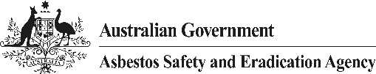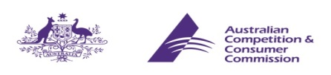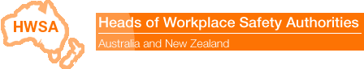

CONSUMER / RETAILER ALERT – ASBESTOS IDENTIFIED IN CRAYONS SOLD WITHIN AUSTRALIA
Trace amounts of asbestos have been detected in some brands of children’s crayons that have been imported into Australia. The crayon products in which asbestos has been identified are as follows:

- Dora the Explorer Personalized 32 pack crayons (Figure 1)
- Dora the Explorer Jumbo crayons (Figure 2)
- Arti Crafti 16 piece crayons (Figure 3)
- Peppa Pig 8 wax crayons (Figure 4)
- Disney ‘Frozen’ Jumbo Crayons (Figure 5)
- Disney ‘Mickey Mouse and Friends’ Crayons (Figure 6).

RISK OF EXPOSURE TO ASBESTOS FIBRES
The traces of asbestos that have been detected in the crayons are fully bound in the crayon wax. Studies have shown that as a result, asbestos fibres would not be released during normal use or as a result of ingestion. This is because the melting point of crayon wax is well above body temperature. Accordingly, these goods are considered to pose a very low risk to humans.

Despite the low risk, the Australian Government as well as State and Territory Governments are taking a precautionary and coordinated approach to this incident, through the HWSA Imported Materials with Asbestos Working Group.

CONSUMERS (INCLUDING SCHOOLS AND CHILD CARE CENTRES) - WHAT SHOULD I DO IF I HAVE PURCHASED THE CONTAMINATED CRAYONS?
If you are concerned you have purchased the affected crayons, you can return them to the place of purchase for a refund or replacement. In line with good practice procedures in handling asbestos containing materials, it is recommended that the crayons be placed in a plastic bag, such as a zip lock bag or in the original packaging if possible, for return. Personal Protective Equipment is not required to be worn.

If not returned to your supplier, affected products should be taken to an asbestos disposal facility. Your nearest asbestos disposal facility can be located using the online tool on the Asbestos Safety and Eradication Agency (ASEA) website: http://asbestossafety.gov.au/search-disposal-facilities

RETAILERS AND SUPPLIERS
Where the presence of asbestos has been confirmed, suppliers have been notified of test results. These suppliers must cease supply. Suppliers should offer a refund or replace the product with another free of asbestos contamination.

RETAILERS AND SUPPLIERS – TRANSPORTATION, DISPOSAL AND PERSONAL PROTECTIVE EQUIPMENT
In anticipation of products being returned, retailers should prepare a bin or similar container for disposal of returned products. A normal bin, fitted with a garbage bag 200 micrometres thick will be sufficient. Once the receptacle is three quarters full the garbage bag should be sealed, inserted into another garbage bag, and then firmly tied. The goose tied garbage bag should be labelled as asbestos waste. Personal protective equipment is not required to be worn during this process.

The asbestos waste should then be transported to an asbestos disposal facility. Your nearest asbestos disposal facility can be located using the online tool on the Asbestos Safety and Eradication Agency (ASEA) website: http://asbestossafety.gov.au/search-disposal-facilities

Environmental protection laws in all states and territories prohibit the disposal of asbestos via standard garbage. If you are unsure of the legislative requirements relating to the transport or disposal of asbestos in your state or territory you should contact the relevant Environmental Protection Agency (EPA) in your jurisdiction for further information. Contact details for the EPA in your state or territory can be found on ASEA’s website:
http://asbestossafety.gov.au/organisation-links#regulators

ASBESTOS PROHIBITION
All forms of asbestos were prohibited in Australian workplaces from 31 December 2003. This ban is reflected in work health and safety (WHS) laws in all jurisdictions. The prohibition on the use of asbestos in Australia is supplemented by the Customs (Prohibited Imports) Regulations 1956 (the Regulations), which bans the importation of all types of asbestos and products containing asbestos, except under limited circumstances.

Consumer goods that contain asbestos, even in trace amounts that do not present any health risk, would fail the Australian Consumer Law test of acceptable quality.

STOPPING GOODS WITH ASBESTOS FROM ENTERING AUSTRALIA
The Department of Immigration and Border Protection and the Australian Border Force (ABF) continue to target children’s toys that may be at risk of containing asbestos. Importantly, the ABF has made a recent decision to detain imports of crayons from China that may contain asbestos fibres, until adequate assurance is provided that the products are free from asbestos. The ABF will also continue to target high risk entities, including particular manufacturers and certain import and distribution companies, both overseas and in Australia.

Any information about imported products of concern can be reported to the Department of Immigration and Border Protection on 1800 009 623. Concerns about products available in retail shops or questions about the handling of products that have been found to contain asbestos should be addressed to the relevant State/Territory workplace health and safety authority.

Consumers who experience any difficulties in obtaining a refund or replacement of goods that contain asbestos can make an online complaint to the Australian Competition and Consumer Commission via:
http://www.productsafety.gov.au/content/index.phtml/tag/ReportAnUnsafeProduct

Further information about what the Australian Government is doing to stop asbestos entering Australia is available on the ASEA website: http://asbestossafety.gov.au/managing-importation-asbestos-australia

Figure 1: Figure 2: Figure 3: 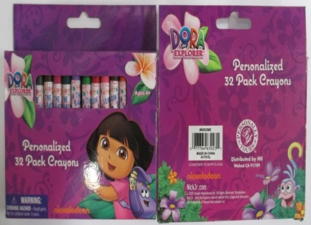 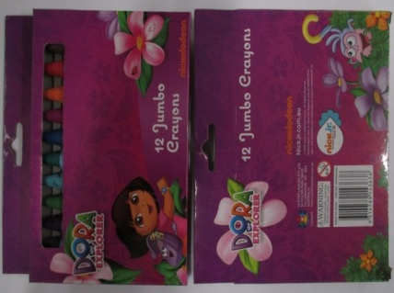 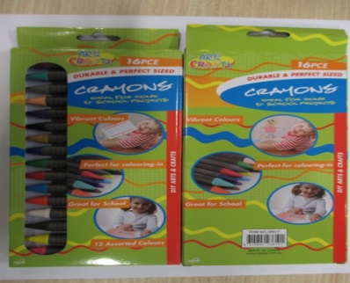

Figure 4: Figure 5: Figure 6:
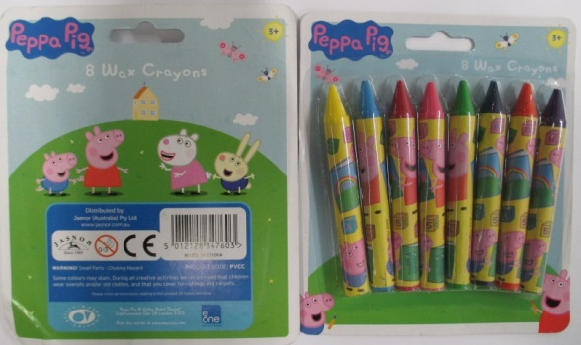
This Consumer / Retailer Alert has been developed by the Heads of Workplace Safety Authorities (HWSA) Imported Materials with Asbestos Working Group, whose membership comprises representatives from: Asbestos Safety and Eradication Agency, Workplace Health and Safety Queensland, Australian Competition & Consumer Commission, WorkSafe Australian Capital Territory, Department of Immigration and Border Protection, WorkSafe Northern Territory, SafeWork SA, WorkSafe Tasmania, Safe Work Australia, WorkSafe Victoria, Safe Work NSW, WorkSafe Western Australia.

