AUSTRALIAN GOVERNMENT

Cox Peninsula remediation

Link to the National Strategic Plan:
Strategy: Removal
Deliverable:
Develop and conduct projects in various locations and conditions where ACMs are in poor condition or likely to cause risks to ensure removal approaches are effective
Outcome:
Options to remove asbestos in poor condition are practical, evidence- based and targeted towards sources of asbestos-related disease
Location:
Northern Territory, Cox Peninsula
The issue
The Australian Government owns several parcels of land on the Cox Peninsula that have been used for over 70 years for maritime, communications and defence purposes. A range of contaminants, including asbestos were present at the site and the Commonwealth committed to remediate the land and return the land to a similar condition, as best as possible, to that prior to its maritime use. This included removal of all buildings, communication towers and infrastructure, remediation of several tip sites across the land and protection of Indigenous and European heritage sites.

Action taken
Initially, environmental consultants undertook extensive sampling on the contamination covering approximately 1,000 locations. All samples were analysed by NATA accredited laboratories with the overall site assessment works overseen by an independent Site Auditor.
It was estimated that approximately 28,000 m³ of contaminated material was present and a remediation plan was developed.
The remediation plan for the site involved several phases:
the demolition and removal of existing structures, including recycling of waste where possible
treatment of soils containing Polychlorinated Biphenyls (PCBs) and pesticides via a thermal desorption unit
placement of ACMs and other inert wastes, including materials currently stored within shipping containers on site, into an engineered containment cell
rehabilitation of the remediated areas and ongoing monitoring of the containment cell.
The majority of the areas will be remediated to an open space land environmental use standard, meaning the land will be returned to its natural state without any residual contaminants. The former Radio Australia Transmitter Station, where the containment cell is located, will be remediated to a commercial / industrial land environmental use standard.
The asbestos management program for the Cox Peninsula was undertaken over a 12-month period from March 2016 to March 2017. A permanent containment cell was constructed on the site to encapsulate the contaminated materials measuring approximately 100 metres by 100 metres in size, and to a depth of up to
8 metres. Before excavation works began, redundant underground cables, including some asbestos pipes, were excavated and removed. The area was excavated below ground and the base was lined with low permeability membranes. A collection system was installed to collect liquid that may leach out of the waste over time. Only inert materials were deposited in the cell, meaning very small quantities of leachate are likely to be generated. The containment cell was designed to mitigate leachate generation and to
minimise leachate escaping. Once the containment cell was filled, a cap was constructed over the top of the cell to encapsulate the material. The cap consisted of a low permeability membrane and a clay layer. The cell was then covered with some of the clean soil that was initially excavated to construct the cell.

Results
The decision to remediate the Cox Peninsula was driven by the need to protect the local community from potential exposure to hazardous materials and to meet the requirements of an Indigenous Land Claim requiring the Commonwealth to hand back the land in a condition that was suitable for use by the local indigenous communities and potential future development. There was strong community and political support to fund what was ultimately a large remediation project. The benefits to the community through reduced risk and the return of land to its traditional owners was deemed to justify the required investment in the project.

Outcomes
The project presented a range of challenges, most notably the working conditions for contractors and meeting the expectations of stakeholders, including the traditional landowners who will progressively receive the land as localised areas of contamination are remediated. During the works, stringent measures
to monitor and protect the health of site workers and the local environment were adopted. Approximately 100,000 work hours were completed on the project, with no lost time injury recorded. In addition, the project was subject to several independent safety and environmental audits.
One major challenge experienced during the project was the high level of mixed contaminants within
the soils excavated from some of the tip sites. The project plan was to treat this soil for PCB and pesticide contamination using a direct thermal desorption unit. However, this was not possible for some of the tip soils due to the high level of asbestos present that would have introduced exposure risks.
Equally, the levels of PCB and pesticide contamination meant that the soil was also not appropriate for encapsulation within the containment cell that had been constructed. The most suitable method of management for this material was disposal to the City of Darwin’s Shoal Bay Waste Management Facility, which had appropriate containment facilities.

Next steps
Site works at Cox Peninsula were completed ahead of schedule by March 2017. Following project completion, the Commonwealth (through the Department of Finance) will be responsible for the initial phase of
site monitoring and groundwater testing to validate the remediation of the land and the performance of the containment cell. The land will be managed by the Commonwealth in accordance with the Site Management Plans throughout 2017-18.
Once Environmental Site Auditor approval has been obtained, the land will be ready for transfer to the Traditional Owners as part of the Kenbi land claim.

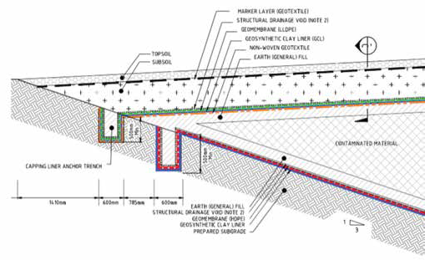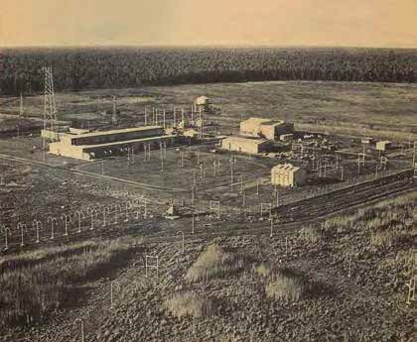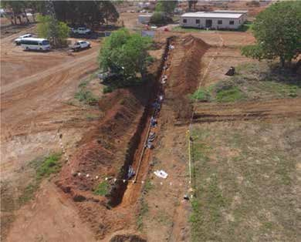
Figure 14: Concept diagram of contain-
ment cell liner and cap
Figure 16: Removal of buried
asbestos conduit
Figure 15: Original
Communications Station
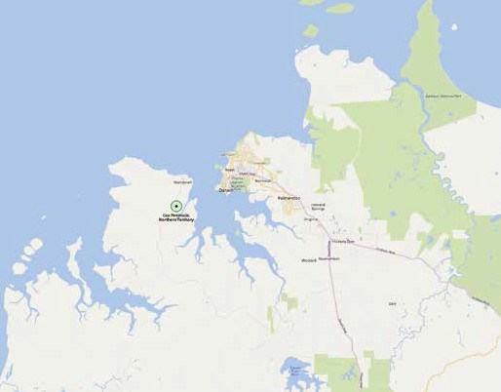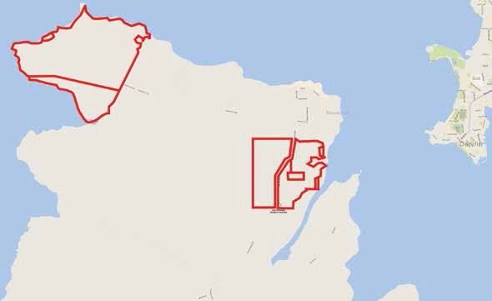
WAGAIT SHIRE COMMUNITY
BELYUEN

Figure 17: Commonwealth-owned areas of Cox Peninsula indicated in red

