ACT GOVERNMENT

Loose-fill Asbestos Eradication Scheme

Link to the National Strategic Plan:
Strategy: Removal
Deliverable:
Develop and conduct projects in various locations and conditions where ACMs are in poor condition or likely to cause risk to ensure removal approaches are effective
Outcome:
Options to remove asbestos in poor condition are practical, evidence- based and targeted towards sources of asbestos related disease
Location: ACT
The issue
The Asbestos Response Taskforce was established in June 2014 to deliver an enduring, coordinated, comprehensive and compassionate response to assist homeowners and their families directly affected by the legacy of loose fill asbestos
insulation in the ACT. Loose fill asbestos insulation, commonly referred to as “Mr Fluffy”, was installed into approximately 1100 Canberra homes between 1968 and 1979 and comprised of pure, raw asbestos (mostly amosite but in some cases
crocidolite) that was crushed and blown into the roof spaces as thermal insulation material.
The Taskforce is responsible for delivering the Loose Fill Asbestos Insulation Eradication Scheme which is the ACT Government’s commitment to eradicate the legacy of Mr Fluffy from 1,023 of Canberra’s residential homes. The
taskforce engages with homeowners and tenants, neighbours, community, industry and other jurisdictions to efficiently, effectively and safely deliver the eradication scheme.

Action taken
The ACT Government announced the formation of the taskforce, along with an emergency financial assistance package for resident owners and tenants of affected homes on 25 June 2014. The assistance comprised grants of $10,000 per household (plus $2,000 per dependant) for emergency accommodation and replacement of essential household items. Another key element of this emergency package was the facilitation of asbestos assessments of the properties by the Taskforce to manage market demand; ease financial costs to owners; and to ensure the Government had access to the resulting information on contamination quickly to assist policy and program design.
A key focus for the taskforce in these early stages was to support homeowners and tenants, particularly those with concerns about health, relocation and financial issues. A dedicated team was formed within the taskforce to provide personalised support and advice. The taskforce also engaged with the wider community to gather their views and inform them about Mr Fluffy Loose fill asbestos insulation, and the government’s response to the issue. A Community and Expert Reference Group made up of homeowners, industry groups and unions, and senior government officials including the Work Safety Commissioner and Chief Health Officer, was
formed to provide additional guidance and support to the taskforce. This period also saw activity from community-led groups advocating on behalf of affected owners.
In light of the Long Term Management of Loose Fill Asbestos Insulation in Canberra Homes report prepared by the Taskforce, the ACT Government reached the conclusion that demolition of all affected houses was the only enduring solution to the health risks posed
to residents, visitors and workers by the continuing presence of loose fill asbestos insulation, and their attendant social, financial and practical consequences.
On 28 October 2014, the ACT Government announced the eradication scheme under which it offered to voluntarily acquire all houses affected by loose fill asbestos insulation in the ACT with the view to demolishing the affected homes and selling the remediated blocks. Delivery of the eradication scheme was supported by a $1 billion loan to the ACT Government by the Australian Government.
The Eradication Scheme Voluntary Buyback Program commenced on 28 October 2014 and closed on 30 June 2015. On 1 July 2015, the definitive list of loose fill asbestos insulation affected homes was published for the first time and the Taskforce’s Pilot Demolition Program commenced the same week. The Indicative Demolition Schedule was first published at the end of August 2015 and has been updated and published for
the fifth time on 7 July 2017. Arrangements for the sale of remediated blocks were released in September 2015 and sales of the first lot of remediated blocks occurred in April 2016.

Results
As at 2 August 2017 – less than three years since the eradication scheme’s announcement:
the owners of 995 of the 1,023 affected houses have agreed to participate in the eradication scheme
11 eligible impacted properties have been identified and all owners are participating in the Scheme
933 houses have been acquired (including eight of the 11 eligible impacted properties)
783 properties have been demolished, 764 of these through the ACT Government Demolition Program
The ACT Government has sold 373 remediated blocks.

The last 12 months has seen a significant increase in the pace of demolitions. Demolition programming is currently indicating the bulk of the taskforce’s
demolitions will be complete by the end of 2017, some six months ahead of previously revised programming. The significant progress in completion of demolition activity is primarily due to the strong working relationships established with industry, and the innovative, efficient and safe practices that have developed over time.
Safety remains the key consideration for the taskforce during asbestos removal and demolition works. To ensure the health and wellbeing of workers and the wider community, licensed asbestos removalists and assessors, demolition contractors, WorkSafe ACT inspectors and
the taskforce work together with well practiced and implemented processes firmly in place.
After focussing on ensuring the safety of workers, neighbours and the wider community, demolition programming and delivery also considers efficiency and minimising disruptions to the community through the demolition process and transportation of demolition waste. Efficiencies in delivering the overall eradication scheme have been gained as its implementation has progressed, with particular savings being achieved through the demolition program, which will result in the eradication scheme being delivered ahead of schedule and under budget.
Throughout demolition program delivery the taskforce also maintained ongoing and regular engagement with former homeowners and tenants, neighbours, and the wider Canberra community about demolition timing and the sorts of activities people will see on site during works. Stakeholder engagement has been a key activity of the taskforce and has been a critical element to successful delivery of the scheme. Recognition that the personal impact for each homeowner as they progress through the scheme will vary for each individual, and each demolition is an individual experience for every neighbour, has underpinned the taskforce’s community engagement and communications approaches.

Homeowner, tenant and community engagement is continuously being reviewed to ensure its effectiveness and has taken a variety of forms, from formal correspondence, community meetings, eNewsletters, social media posts, on-site signage, face-to-face conversations. Communications and engagement review has encompassed:
ongoing evaluations and refinement of the communications strategy and materials in response to emerging issues and maturation of the scheme
identification and mapping of gaps in information and materials through various feedback mechanisms including community engagement activities, social media, phone calls, email and an ongoing online- survey
attendance at community council meetings, community events and public forums

community service organisations providing support to affected home owners
health care providers specialising in psychological and social support.

Outcomes
Delivery of the eradication scheme remains on budget and the demolition program continues to track ahead of schedule, with safety for workers and the broader community continuing to be the demolition program’s key focus.
Planned performance audits of the taskforce’s delivery of the scheme are currently not reflected in the ACT Auditor-General’s forward work program. This may be in part due to the findings from the ACT Auditor-General’s first performance audit of the taskforce’s governance, financial management and risk management frameworks for delivery of the scheme reflecting “...

require ongoing support in assisting their transition will continue to receive personalised support and referral to appropriate community service providers.
Resale of remediated blocks will become the more prevalent activity as the demolition program winds down. The sale of remediated blocks is an established part of the real estate market in Canberra, and rebuilding of new houses on the remediated blocks is becoming more prevalent, signalling the renewal and psychological regrowth that was intended in the design of the eradication scheme.

More information
http://www.asbestostaskforce.act.gov.au/

door knocking and face-to-face engagement

social media engagement.

Working collaboratively with all stakeholders has enabled the taskforce’s delivery against the ACT Government’s goal of providing an enduring solution to an issue that has affected Canberra and people living in Canberra for nearly 50 years. Stakeholders have engaged actively with the taskforce to support the safe delivery of the eradication scheme and have included representatives across:
the ACT public service

national public sector and academic asbestos experts
property valuers

contractors and regulators with regard to enhancing safe and efficient demolition practices
experts in contaminated land for the provision of soil clearances against agreed requirements
regulators and industry leaders in framing and codifying medium term asbestos management plan arrangements
industry peak bodies and educational institutions in relation to training and workforce capacity needs and development opportunities
better practice”. In light of its commitment to ensure openness and transparency in delivery of the scheme, arrangements for independent auditors to evaluate the effectiveness of the taskforce’s implementation and delivery of the eradication scheme are currently being made. The audit will evaluate taskforce performance across all four phases of the eradication scheme’s delivery and focus on benefits realisation and measuring success in achieving the ACT Government’s objectives of the scheme.

Next steps
The taskforce will continue to pursue the demolition program with a focus on safety, and engage with contractors and regulators to share better practice along the way. The majority of houses acquired by the ACT Government are expected to be demolished by the end of 2017, six months ahead of the previously revised demolition schedule, with the balance of demolitions to occur through 2018 to after 30 June 2020 (at the end of the deferred settlement period).
Processes for formally closing affected homeowner case files where they have moved through the scheme completely and are no longer in need of and/or desiring contact or assistance from the taskforce has commenced and will continue as the final stages of the taskforce’s work in delivering the eradication scheme are realised. Affected owners and their families who
Figure 28 and 29: Asbestos Response Taskforce Community Consultation Event

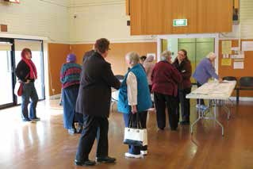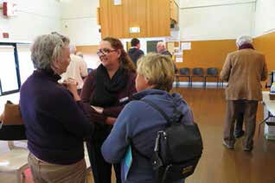

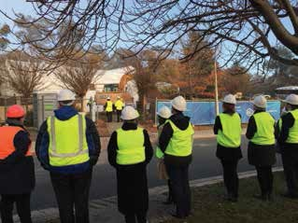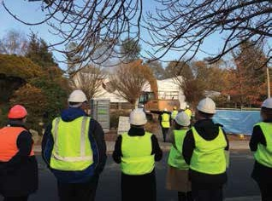Figure 30 and 31: ASEC meeting at house demolition

