Asbestos Safety and Eradication Council
The work of the agency is supported by the Asbestos Safety and Eradication Council.
The Council is made up of a Chairperson and nine members who have been selected for their experience and expertise with asbestos safety, public health, corporate governance or the representation of people with asbestos-related diseases (ARDs) and their families. One position is reserved for a Commonwealth representative and four positions reserved for a state, territory or local government representative.
The Council will provide advice to the CEO and the Minister on the National Strategic Plan for Asbestos Management and Awareness (NSP) and other asbestos safety matters.
The Chair and council members below were appointed by the Minister for Employment on 14 December 2016 for a period of three years.

Chair
Diane Smith-Gander is non-executive director AGL Energy Limited, Wesfarmers Limited, Chair of Safe Work Australia, a board member of Keystart Loans, Henry Davis York, CEDA and immediate past President of Chief Executive Women. Diane has held a wide range of non-executive roles in the past including Chairman of Broadspectrum, Deputy Chair of NBNCo, non-executive director of the CBH Group and commissioner of Tourism WA. Diane’s last executive role was as a group executive at Westpac banking Corporation. Prior to re-joining Westpac Diane was a partner of McKinsey & Company in the United States serving clients in diverse industries globally. Diane became a senior advisor to McKinsey in Australia in 2016. Diane is a fellow of the AICD and Governance Institute of Australia and adjunct professor of Corporate Governance at UWA where she serves on the advisory board of the Business School.

Council Members

Commonwealth
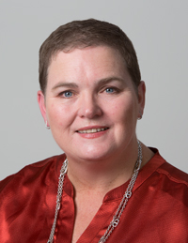 | Michelle Baxter has been the Chief Executive Officer of Safe Work Australia since 2014 having acted in the position for 12 months before that. Before her appointment Ms Baxter held Senior Executive roles including in the Department of Employment and the Office of the Fair Work Ombudsman. Ms Baxter is a member of Safe Work Australia and the Safety, Rehabilitation and Compensation Commission. She holds bachelor degrees in Arts and Laws from the Australian National University and was admitted as a Barrister and Solicitor in the Supreme Court of the Australian Capital Territory in 1988.

State, Territory and Local Government
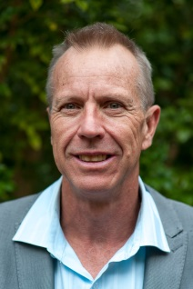 | Jim Dodds is the Director of Environmental Health at the Department of Health Western Australia in the Public Health Division. He is also a member of the Food Regulatory Standing Committee and a Council Member and Executive Member of the enHealth Council. Mr Dodds is undertaking a Master of Health Science and holds a number of qualifications including a Graduate Diploma in Occupational Health and Safety and a Master of Engineering Science – Waste Management. Mr Dodds’ previous roles include Project Lead of a Reform Program in the Department of Health, Director of Strategy and Environment, Chair of the enHealth Council and various roles in Shire Councils. Mr Dodds was previously the Chair of the enHealth Council and has co-authored nine journal articles in the last 16 years.
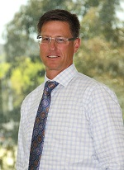 | Chris Reynolds has held a number of senior executive roles since joining the ACT Government in 2006. During this time Chris has had a range of responsibilities associated with the delivery policy objectives associated with land release, sustainability and housing affordability. Chris has built and led high performing teams, formed effective partnerships across community, industry and government agencies. He has developed skills around solving complex problems associated with policy delivery and maintaining a commercial focus. Chris's current role within Environment, Planning and Sustainable Development Directorate has been to establish the business, governance and capability branch, a newly formed stream that supports the Directorate and responsible ministers to set, monitor and oversee the performance and business practices of the Environment, Planning and Sustainable Development Directorate including the City Renewal Authority and Suburban Land Agency.
 | Julie Nielsen is the Executive Director of Compliance and Business Engagement in the Office of Industrial Relations, Queensland Treasury. Ms Nielsen’s previous roles include Regional Director for the Brisbane North Sunshine Coast at Workplace Health and Safety Queensland in the Department of Justice and Attorney General. Before joining the Queensland Public Service, Ms Nielsen worked at the Queensland Chamber of Commerce and Industry.
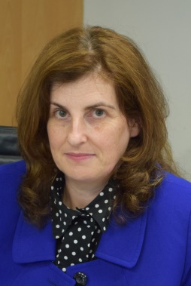 | Marnie Williams is the Executive Director of Health and Safety at WorkSafe Victoria. Ms Williams’ previous roles include Chief Executive Officer of the Taxi Services Commission; General Manager of the Victorian Taxi Directorate, Department of Transport, Planning and Local Infrastructure and various roles at the Victorian WorkCover Authority and WorkSafe Victoria, including as General Manager of the Strategic Programs Division and as a Chemical Technologist.

Employee representative
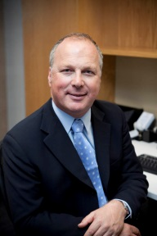 | Michael Borowick was elected as Assistant Secretary of the Australian Council of Trade Unions in 2010. Between 1990 and 2010 he held various elected and other positions in The Australian Workers’ Union and its predecessor organisations. Mr Borowick is on a number of boards including Safe Work Australia; the Safety, Rehabilitation and Compensation Commission; the National Workplace Relations Consultative Council and the Defence Reserves Support Council. Mr Borowick is also a Director of HESTA, the industry superannuation fund for the health and community sector. HESTA has 834,000 members and $40B of funds under management.

Employer representative
Tracey Browne is the Manager of National Safety and Workers’ Compensation Policy and Membership Services at the Australian Industry Group (Ai Group). Ms Browne has held a number of roles at Ai Group since 2001. Before joining Ai Group, Ms Browne was the Group Manager for Health Safety and Environment at Bendix Mintex and an Occupational Health and Safety Coordinator for ACI Glass Packaging. She has also held academic, consulting and human resources roles. Ms Browne is qualified with a Bachelor of Business, a Graduate Diploma in Occupational Hazard Management and is a Master of Applied Science (Occupational Health and Safety). She is a former President and Treasurer of the Rotary Club of South Bank.

Other members
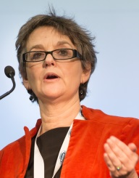 | Carolyn Davis is an independent consultant and a former director of the Australian Chamber of Commerce and Industry (ACCI). Before joining ACCI, Carolyn was a senior manager in various organisations and a consultant on occupational health and safety and workers’ compensation matters. Carolyn has also lectured in occupational health and safety in Chemistry department. She is a former Member of Safe Work Australia and has been an ‘observer’ at Council meetings since 2013. Carolyn has a Bachelor of Science (Hons), an Education Diploma, a Graduate Diploma in Occupational Hygiene and is a member of Resolution Institute (alternative dispute resolution).
 | Nancy Milne OAM has extensive business experience as a non-executive director and lawyer and expertise in risk management. She was a lawyer for over 30 years specialising in insurance, corporate governance, risk management and commercial dispute resolution. Nancy acted for the underfunded trust created by James Hardie before and during the Jackson Special Commission of Enquiry, acted in disputes involving asbestos claims and has advised on matters relating to insurance arrangements for asbestos liability coverage. Nancy retired from her partnership at Clayton Utz in 2003 and continued to work as a consultant to Clayton Utz until 2014. Nancy is currently a director of ALC Property Group Limited, Securities Exchange Guarantee Corporation Limited (chair since 2012), Superannuation Administration Corporation and the State Insurance Regulatory Authority. Previous directorships include State Super Financial Services Australian Limited, Greenstone Limited and Novion Property Group. Nancy was awarded the Order of Australia Medal for services to the legal sector (particularly in insurance law) and to the community.

Observers
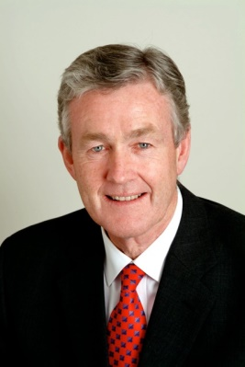 | Dr Robert Walters is a General Medical Practitioner, part-time member of the Administrative Appeals Tribunal and Colonel in the Royal Australian Army Medical Corps. Dr Walters has been a General Practice Consultant to the Surgeon General, Australian Defence Force (ADF) since 1995 and has held positions in the ADF as a Senior Medical Officer, Director of Medical Services (Tasmania Region) and Military Compensation Adviser for Tasmania. His board memberships include Chair, Ministerial Asbestos Steering Committee; Medical Member of WorkSafe Tasmania Board, Headspace; and Chair of the General Practice Consultative Group, ADF. Dr Walters was also a state and territory representative on the first Asbestos Safety and Eradication Council, 2013 to 2016.
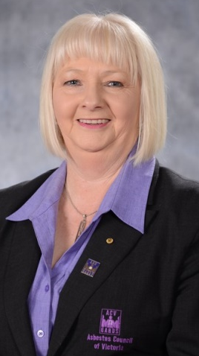 | Vicki Hamilton OAM is the Chief Executive Officer and Secretary of Asbestos Council of Victoria/GARDS and has been an Executive Member of the organisation since 2000. Vicki has had two of her family members pass away from asbestos-related disease - her father with asbestos lung cancer and her grandfather with asbestosis. Vicki is the support group co-ordinator for asbestos sufferers and their families which involves monthly meetings, home and hospital visits and provision of medical equipment as needed. Vicki conducts asbestos awareness sessions for Medical students, Nursing students, Allied health students, TAFE students in trades such as Painting and Decorating, plumbing, carpentry etc. Community groups & work places. Current Chair of the Gippsland Regional Integrated Cancer Service Consumer Reference Group and current member of the Community Advisory Committee at Latrobe Regional Hospital since the group’s inception in 2005. Vick was awarded the Citizen of the Year for Latrobe City in 2005 and an Order of Australia Medal (OAM) in the Australia Day Awards 2014 for her service to the community through support for people with asbestos related disease.

Chief Executive Officer
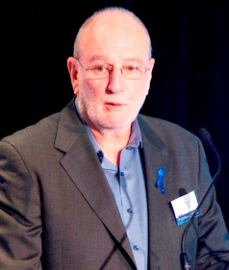 | Peter Tighe was appointed Chief Executive Officer in August 2013 for a period of five years. Peter was National Secretary of the Communications, Electrical, Plumbing Union from 1995 to 2013 and was also National Secretary of the Electrical Trades Union and Executive Member of the Australian Council of Trade Unions from 1991 to 2013. Mr Tighe was also chair of EE-Oz Energy Skills Australia, E-Profiling Pty Ltd, the National Electrical and Electronic Industry Training Council and trustee/board member of CBUS Superannuation. Mr Tighe has extensive experience in workplace health and safety issues and in tackling the hazards of asbestos containing materials.  The position of Chief Executive Officer is a statutory appointment and is made following a merit based selection process.

