eRecruit Applicant User Guide

Contents
Registering and Logging In 3
Registering 3
Logging In 5
Forgotten Password 5
Finding a Job 6
Jobs 6
Jobs List 6
Job Details 7
How to Apply 7
Privacy Policy 7
Register or Login 7
The Application Form 8
Response and Resume 10
Preview and Submit 11
My Application History and Withdrawing an Application 13
Emails 14

Registering and Logging In

Registering
- Go to www.asbestossafety.gov.au
- Select the ‘About Us’ tab and scroll down the page and click on Working with the agency hyperlink. Once in the Working in the Agency page select ‘View current vacancies’ hyperlink.
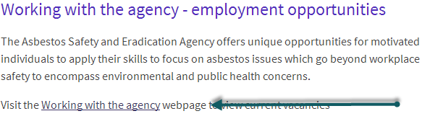
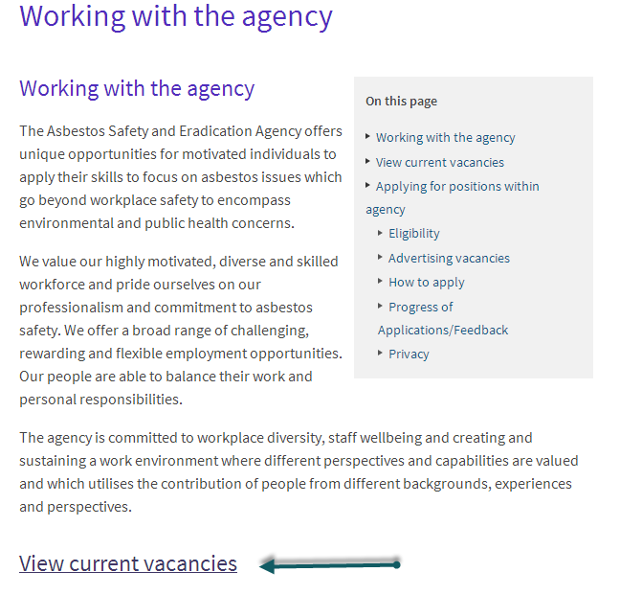
- The Jobs List Screen should now be open.
This list includes:
- Current Vacancies
- Jobs list

- Now you need to register with eRecruitment – to do so click on Start New Application on the position you want to apply for. You will first be taken to a screen that provides details about the job, scroll to the bottom of the page and click on Begin. Next you will see a Privacy Statement that you must read and accept. Once you have read it click “I Accept”.
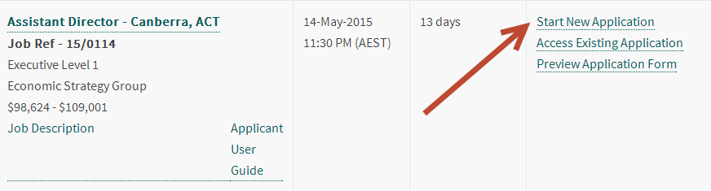
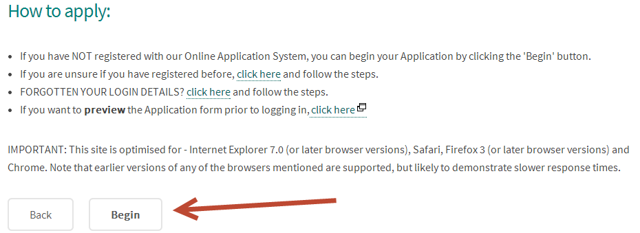
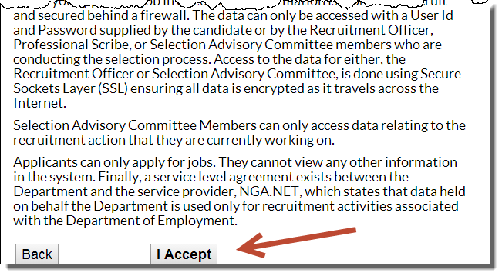
- Once you have accepted the privacy statement you will be asked a number of pre-employment questions relating to the minimum requirements for working in the Australian Public Service (APS). Upon completing these questions, if you have met the minimum requirements, you will be asked to register.

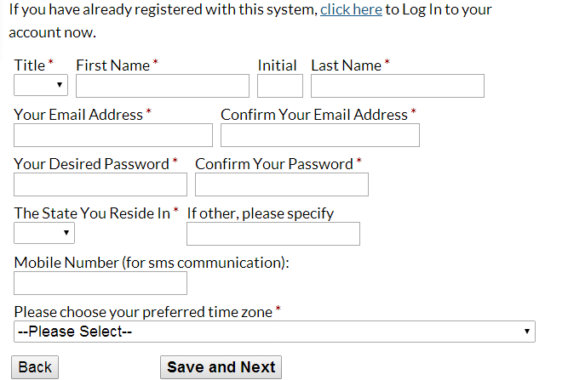

- Click Save and Continue. You will be taken to a confirmation screen. An email will be sent to you to confirm your access details. Please make a note of your user name and password. If you forget your password, you will need to reset it using the reset function. An email will be sent to you to confirm your access details.

Logging In
You need to Login to eRecruitment to apply for a position, edit /change your details or to access you application history. Your ID is the email address you registered with.
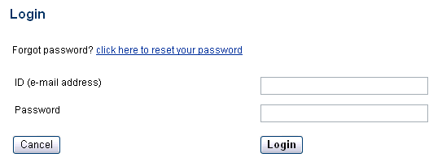

Forgotten Password
If you’ve forgotten your login details, click the link provided on the login page. Enter your email address and click Submit.
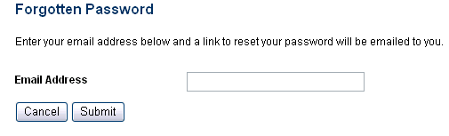
You can also access this function by looking at any of the advertised jobs and clicking the link provided under How to apply.
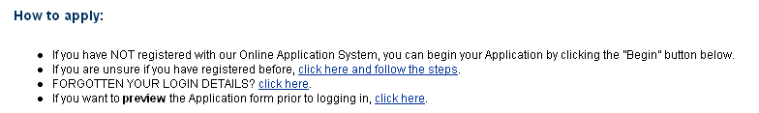
Please note: You can only change your password once every 24 hours.

Finding a Job

Jobs
- The first page of the e-Recruitment system displays the following groups of vacancies.
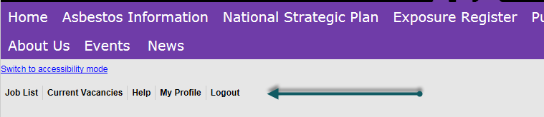

Job List
- Selecting Job list will take you to a list of corresponding vacancies.

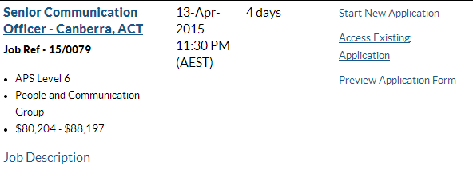

Click the job name to view the Job details. You can also start a new application, access your previous application, preview the application form or email the job to a friend using the links on the right.

Note that if there are currently no vacancies a message will appear on the job board advising you of this.

Job Details
- The job details page provides detailed information about the vacancy. From here you can view the Job Description, preview the application form or begin your application.
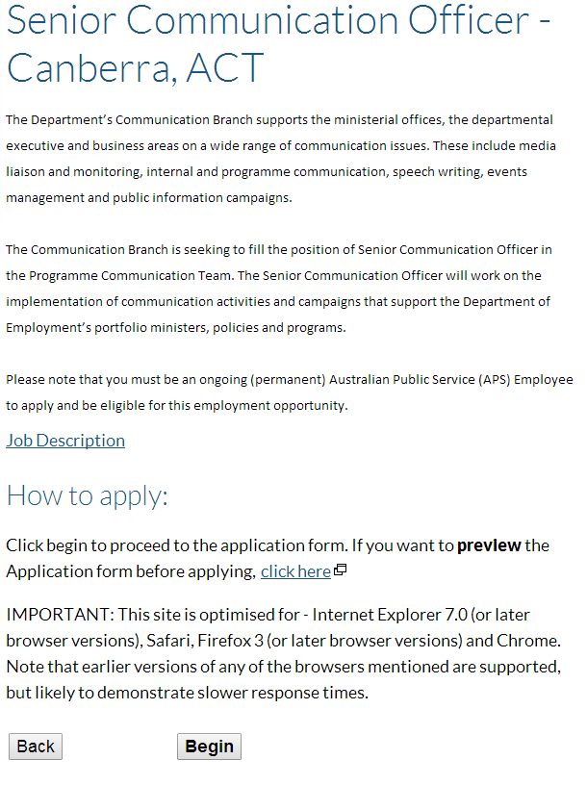
Click this link to download the Job Description.

- Click the Begin button to start your application.

How to Apply
Please note: The system will automatically disconnect after 20 minutes, if there is no activity. Typing information onto a screen will not prevent you from disconnecting – you must save or send to maintain your connection.

Privacy Policy
- When you start an application you will provided a link to the Departmental Privacy Policy. Once read If you accept the policy, click the I Accept button

Register or Login
- If you haven’t registered before, register by filling in the form provided and click the Save & Continue button to register. If you’ve already registered, click the link provided to login.
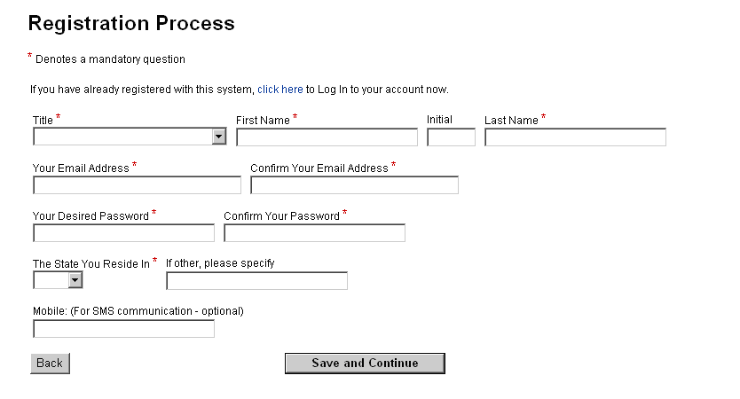
Any field with an * is a mandatory field.
- If you’ve just logged in you will go straight to the application form. If you’ve just registered, you will be taken to a confirmation screen. An email will be sent to you to confirm your access details. Click the Save & Continue button to begin the application form.
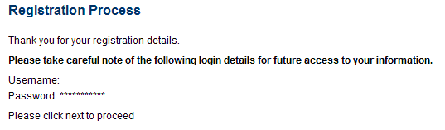

The Application Form
- Work your way through the application form by filling in the various fields and clicking Save and Continue at the bottom of each page. You can also click Save if you haven’t completed a page but would like to save your progress.

Please note: You will be unable to submit your application unless you have clicked Save and Continue for each page of the application form. Remember to click Save your application regularly. Remember that the system will automatically disconnect after 20 minutes, if there is no activity. Typing information onto a screen will not prevent you from disconnecting – you must save or send to maintain your connection.

Now that you have begun your application, it will appear in My Profile If you logout and come back to the application form at a later stage, login first and then go to My Profile to access the form.

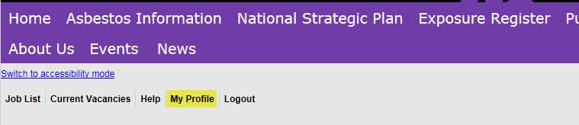

Please Note: Some questions are mandatory and are marked with an *. Mandatory questions must be answered before you can move onto the next page. If you have missed a mandatory question you will be notified when you click Save and Continue.

Response and Resume
- A part of the application form asks for your response to the vacancy or to each selection criteria. Note that each response has a word limit as specified on the application form and in the Job Description. If your response is over this word limit you will not be able to submit your application.

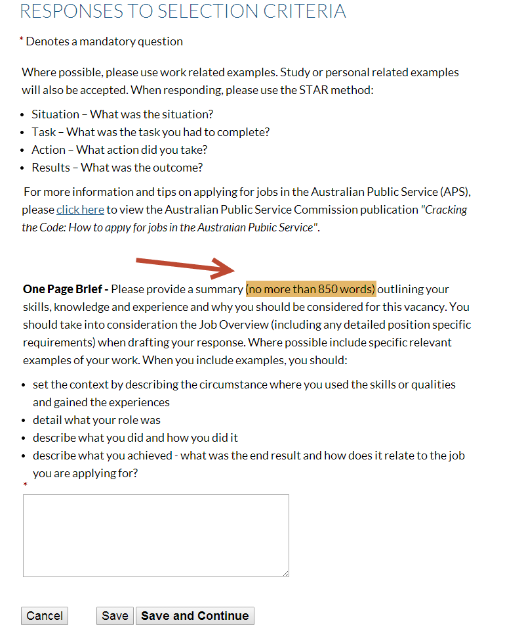

Please note: Prepare your response in a word document before copying and pasting into this box. Ensure that you only use plain text, and do not include any bullet points, underlines, bolding or italics. If you do want to use bullet points please indicated this using * or – instead.
- You will also be asked to upload your resume. Click the Browse button and locate your resume. The resume will upload when you click Save or Save and Continue
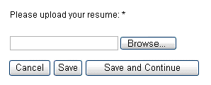

Preview and Submit
- The preview and submit step allows you to review your responses and edit them if required.
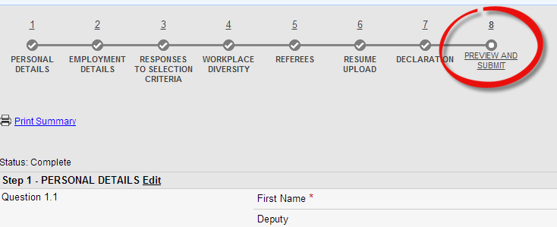

If you can’t see Submit Application Now at the top of the screen, check that you have answered all of the mandatory questions, and that all steps are complete. If any mandatory questions and/or steps are incomplete, click the relevant step number at the top of the page, add any answers required, and click Save and Continue.

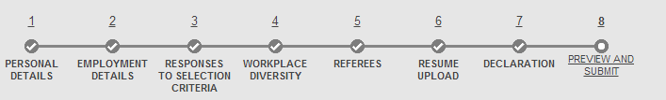

- You should now be able to submit your application. Click Submit Application Now at the top (or the bottom) of the Preview and Submit page.
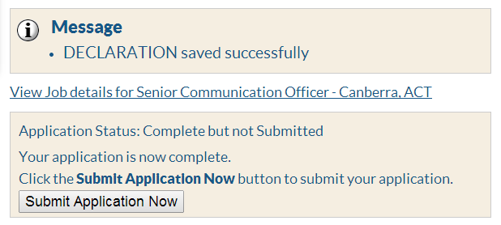
- You will now see a confirmation screen. This is your last chance to go back and change any information on your application, as you will not be able to edit your application once it has been submitted.

Please note: You cannot withdraw your application to make edits, and then re-submit.

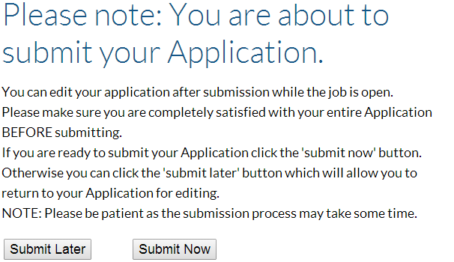

Submit your application by clicking Submit Now.

- The final page will confirm that your application has been received.
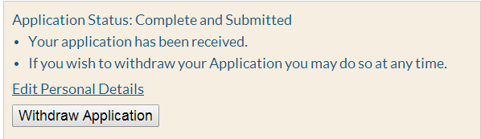
An email will be sent to you to confirm that your application has been accepted. You can also go to My Profile to check that your application is submitted and not incomplete.

My Application History and Withdrawing an Application
You can access any incomplete or submitted applications by using the My Profile function.
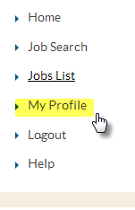
Select My Profile from the left hand menu. You must be logged in to do this. This allows you to see all the jobs you have applied for and the details.
From this screen you will be able to see whether your application is incomplete or submitted, withdraw a submitted application, access any emails that have been sent about the vacancy and edit your personal details.

If you need to continue an incomplete application, or withdraw a submitted application, click View my application summary for that job.
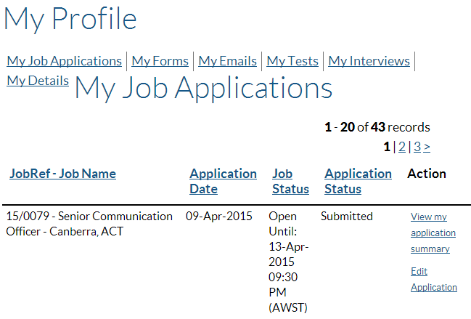

Click View my emails to access any emails sent to you from e-Recruitment regarding a particular job.
If you have submitted an application, but no longer wish to be considered for the position,
you will need to withdraw your application within e-Recruitment.

Please note: Once you withdraw your application you will be unable to re-submit it or submit
another application for this vacancy.

- Select My Profile from the left hand side menu. You must be logged in to do this.
- Find the relevant application in your history and click View my application summary for that job.
Click Withdraw Application if you no longer wish to be considered for this role.
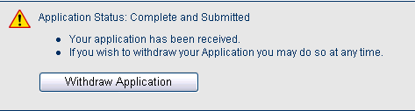

- You will now be taken to a confirmation screen. If you are sure you would like to withdraw, provide some details in the text box provided.

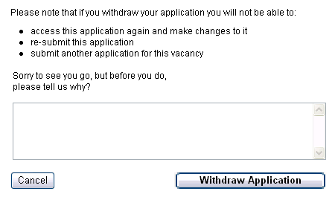
- Click Withdraw Application to confirm that you are withdrawing your application.
You have now withdrawn your application.

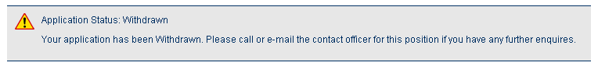

Emails

- Emails from eRecruitment will be sent to your nominated email address
Emails relating to a vacancy can also be accessed through My Profile. This will mean that you will never miss any correspondence from eRecruitment as long as you regularly check My Profile.

