CASE STUDY SEVEN

Plumbing Industry Climate Action Centre – Targeting Training
The Plumbing Industry Climate Action Centre (known as PICAC) is a hive of activity. A screen on the wall in the reception area lists a dozen or more training courses taking place in any week – from gas appliance servicing, welding and green plumbing, through to OH&S and other legislative and licensing requirements.
One of the large training spaces in the centre of the building hosts a group of plumbers gathered around large constructions of pipes, while in another part of the space, the ‘sandpit’ is being prepared for a training exercise involving underground pipes.
This is a highly authentic, specialised, state-of-the art training environment developed in partnership between industry and unions, where plumbers from across Victoria come to develop and refresh their knowledge and skills in a wide range of plumbing and safety-related areas. And one of the areas in which they come along to develop and refresh their knowledge and skills is in working with asbestos.

What have they done?

Developed an authentic, hands-on learning environment
Plumbers are often the first people to identify asbestos in a building. It’s a material that was used extensively in bathrooms, toilets and laundries and in insulating pipes and heaters – all places that plumbers are likely to be working. So PICAC has built a mock house, complete with a bathroom and all the places where a plumber is likely to encounter asbestos, so that those doing the training have opportunities for ‘hands-on’ identification and handling of asbestos. The house even has a decontamination unit attached to the entrance, so that experience can be gained in all of the safety procedures needed for handling asbestos.
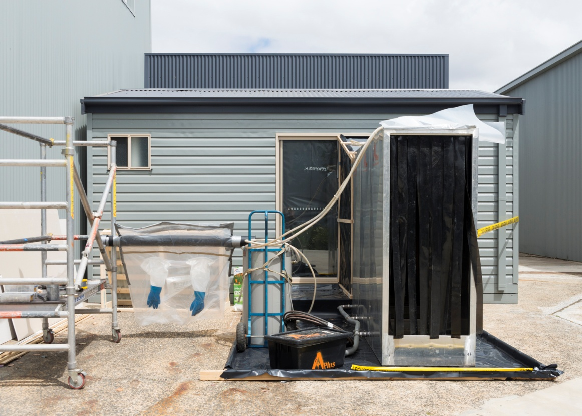

Developed training that suits a range of needs and purposes
Plumbers can choose from a number of different courses according to the extent to which they have to deal with asbestos in their day to day work. Most plumbers don’t have to handle friable asbestos, so the one-day course that provides participants with an understanding of the nature, health hazards and regulatory requirements for identification and handling of non-friable asbestos containing material (ACM) may be sufficient.
Those who are likely to have to handle friable asbestos or to supervise others who are working with ACM, can do the more intensive three day course. There are also refresher courses, so that those who have previously completed the one or three day courses (or those who have done previous training elsewhere), can ensure that their skills and knowledge stay up-to-date.
Unlike many generic asbestos safety and licensing courses, all of the training conducted by PICAC is tailored specifically to the plumbing industry. So participants are gaining a general understanding of asbestos-related issues, but more importantly, specific knowledge and skills around how this affects their daily work.

Ensured a consistent, guaranteed level of competency
PICAC have linked their tailored training to nationally-recognised competencies from the Building and Construction training package. Participants leave their training in the knowledge their skills and knowledge are at a nationally accepted standard and allow them to (with sufficient experience) also supervise the removal of ACM in a safe manner.
The training courses were developed in consultation with unions and with WorkSafe Victoria. On successful completion participants are also issued with a ‘blue card’ that has become an industry de facto standard in relation to ACM removal and can be carried on site as evidence of their competency to safely handle asbestos.

Challenges

Raising awareness
Like so many industries and organisations dealing with asbestos, the biggest challenge for PICAC is awareness. Young workers in particular don’t know about asbestos, or think that it’s a problem of past decades. They think:
...you don’t need to worry about that [i.e. asbestos]. It’s been sorted out. It’s not a problem.
Shayne La Combre, CEO of PICAC, says that “like all safety issues, you have to constantly reinforce it”. Asbestos is such a passive, latent risk, the effects of which don’t show up for 25 years, so keeping the issue prominent is even more essential. The centre aims to get as many plumbers as possible completing the asbestos courses, so that awareness is raised across the industry and that best practice becomes widespread.

Dealing with financial pressures
One of the big disincentives to best practice however, is financial pressure. When things are tight, competition for work can drive prices down, which in turn risks resulting in corners being cut around asbestos handling.
To help to counteract this, PICAC spreads the message through its training that “there is no such thing as safe asbestos” and highlights the consequences of unsafe practices – not only for the plumbers themselves, but also for those around them. They also use the DVD – Asbestos. The Hidden Killer – in which Kevin Sheedy (former footballer and plumber) talks about the hidden dangers of asbestos, to get the message across to young plumbers not to risk exposing themselves or their mates to asbestos fibres.
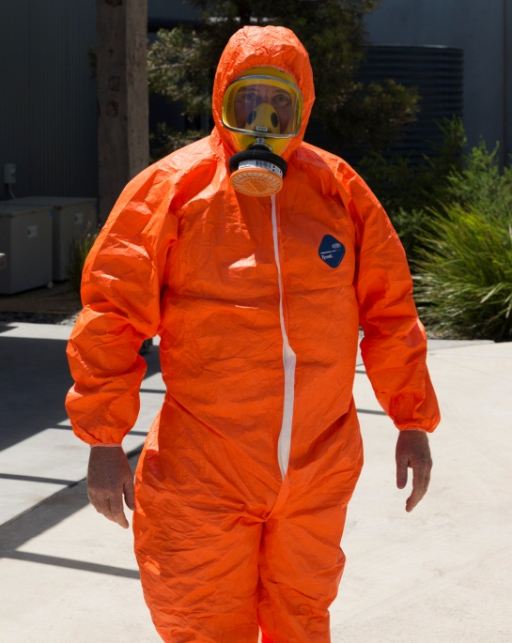

Key messages to the industry
Based on PICAC’s experience, Shayne suggests that other industries or organisations that are trying to improve practice in handling asbestos through delivering training programs need to take the following three steps:
- Be clear about the possibilities of encountering asbestos in your work and the consequences of exposure, and then communicate these widely. This immediately raises accountabilities.
- Identify those workers who might encounter asbestos, the level of risk involved, and the extent to which they need to manage this.
- Deliver training that is commensurate with the level of requirement for different groups of workers and tailor it as much as possible:
“Contextualising helps to better clarify the risks they will encounter.”

The relevant competency standards are: o CPCCDE3015A – Remove friable asbestos o CPCCDE3014A – Remove non-friable asbestos o CPCCBC4051A – Supervise asbestos removal
The DVD was produced by ASEA in collaboration with the Plumbing Trades Employees Union and the Electrical Trades Union

