CASE STUDY SIX

Building Leadership Simulation Centre – Creating Real Attitude and Behaviour Change
Because of the many variables involved in managing asbestos in building sites, it’s necessary for supervisors and managers to have a variety of what are often referred to as ‘core skills for work’: communicating with staff and clients, ensuring an appropriate attitude to the risk posed by asbestos, dealing with difficult situations, problem-solving, and so on. However these skills are rarely taught explicitly in trade training, and when tradespeople are promoted into supervisory and middle-management positions, the need for these skills beyond the technical becomes very apparent.
Developing core skills for work is of particular importance for supervisors and managers involved in managing situations involving asbestos.
The Building Leadership Simulation Centre, located in South Melbourne, was established by the Master Builders Association of Victoria to meet the need to develop these skills. It uses life-like simulation, and is one of only three such learning simulation centres in the world, the others being in Leeuwarden (the Netherlands) and in Coventry (UK). It opened in 2012 and has since run simulation exercises for 3000 participants.

What have they done?

Recognised the power of simulation to bring about real behaviour change
As Marc Lyons, General Manager of the Centre, puts it:
Real changes in attitudes, values and behaviour rarely come about as a result of classroom learning or paper-based learning, but almost always require some form of experience to become embedded.
The Centre’s simulation activities are based on this premise, which has a direct application to enhancing awareness of the skills needed to manage asbestos situations in the building and associated industries.

Codified the necessary skills
The Centre has codified the necessary non-technical skills, which have an obvious application to management of asbestos-related situations – for example:
- communication – especially effective questioning, active listening, use of appropriate questions
- problem solving -- how to obtain the right information, and how to evaluate and solve problems, without being distracted by the immediate presenting issues
- awareness of how a person’s actions can affect the dynamics of a situation – how to deal with people who are upset and how to diffuse emotionally-charged situations
- the importance of engaging and delegating effectively.

Constructed a fully-featured simulator
The Centre has
- a fully-featured three-projector simulator and parabolic screen, to create a life-like appearance of any situation
- programmed software including a variety of building sites at various stages of completion, enabling any participant to ‘enter’ the building at any point and ‘walk around’ it, zoom in and out, and examine particular features
- realistic break-out rooms mocked up as site offices or company offices, monitored by cameras
- a control room which enables trained personnel to view every interaction for the purpose of de-briefing.

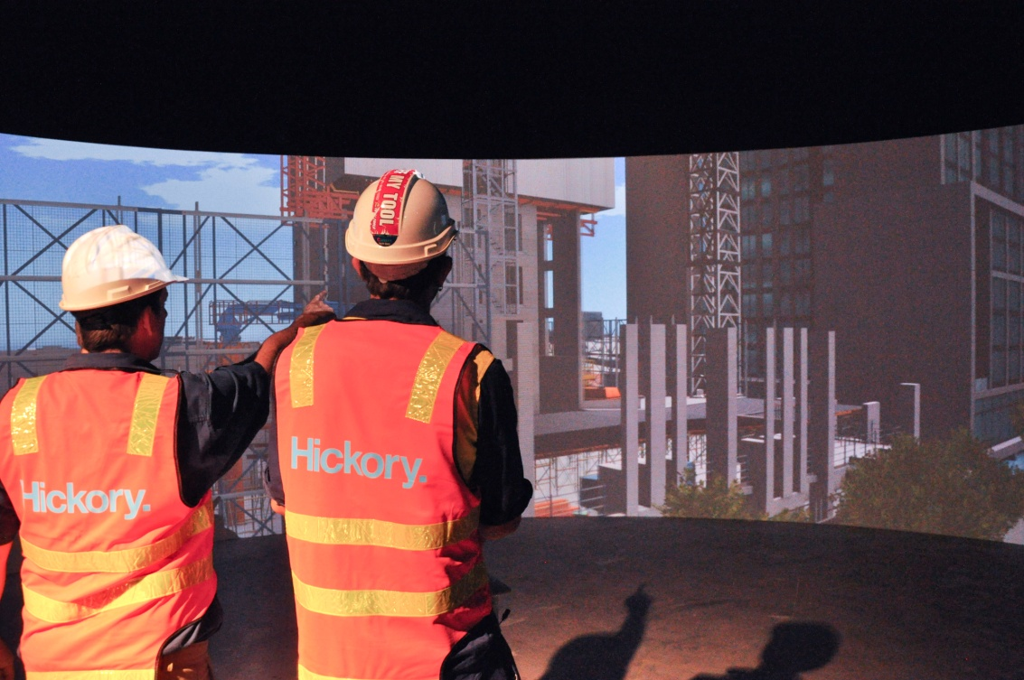
The centre also employs actors to realistically play various roles, to challenge participants by creating situations to which the participants need to respond.
A particularly powerful device used by the actors is to create realistic stressful situations, in order to demonstrate to participants how easily standard operating procedures can be forgotten in the heat of the moment – and the dangers of this.

Simulation as an aid to developing the skills of managing asbestos-related situations
The Centre has demonstrated how simulation can be used to sensitise supervisors and managers to the non-technical skills needed to manage asbestos-related situations. They include:
- creating a realistic environment by the use of panoramic projection and the ‘planting’ of a piece of material looking rather like asbestos in the driveway of a house
- having actors play various roles – e.g. an electrician who breached safety requirements; a neighbour who overheard the two tradesmen talking about suspected asbestos and became very concerned about the risk to her children; tradesman putting the site manager under pressure (‘what do we do now?”; do we cancel deliveries?”; “do we leave the site?”)
- obtaining feedback from both actors and the trainers
- filming the entire event for debriefing and analysis
This provides an experience which, to quote participants, “a notch above what you learn in a classroom” and “one of the most effective simulations I’ve ever been involved in”
The Centre now has evidence as to the effectiveness of its approach. Its simulation activities have been evaluated by a Monash University team, which examined the operations of the activities as well as carrying out before/after observations, over a twelve-month period. The team found that the simulated ‘real world’ experiences, combined with opportunities for immediate feedback and self-reflection, did have a positive impact on participants’ knowledge and understanding and their effectiveness in the workplace.
In addition, reports from client companies have indicated that as a result of their staff participating in simulation exercises, both reportable incidents and HR issues decrease.

Challenges
- The Centre could fairly be described as equipment- and labour-intensive, but incredibly powerful in terms of changing attitudes and developing the skills to respond effectively to real-life situations.
The challenge for any other training organisation would be how to design experiential activities with a more modest investment – but it can be done.

Key messages about how to make it work
Training organisations need to be aware that:
- Supervisors and middle-managers involved in asbestos management need a variety of ‘core skills for work’ to enable them to do their job effectively
- Development of these skills requires some form of experiential learning specifically tailored to professional adults – of which simulated experiences are a very powerful component.

There are many lists of such skills. The most recent framework, which is receiving considerable interest across all education and training sectors, is one developed by Ithaca Group on behalf of the Australian Government: https://education.gov.au/core-skills-work-developmental-framework
This is an indicative list only; the centre designs the program around a much more comprehensive list.
Holland, P., Allen, B. and Lenders, R. (2014) Building A Better Workforce: Assessing the Impact of the Experiential and Simulation-based Learning in the Australian Building and Construction Industry, Monash University, Melbourne (available online at http://www.mbav.com.au/vpLink.aspx?ID=3&N=YES&D=000000007429 )

