CASE STUDY FIVE

Thuroona Services – A Complex Removal Process
Proudly displayed in the car park of one of Perth’s most central stations is the historic Bakewell Steam Locomotive. Bakewell retired to the Westrail Centre (now the Public Transport Centre) in 1976 after nearly 30 years of service. It is one of only three examples of this type of train surviving in Australia today and was in desperate need of restoration. But first, it needed to be cleared of asbestos.
Western Australia’s Public Transport Authority (PTA) knew that the locomotive contained friable asbestos blankets. However a closer inspection after the removal process commenced found asbestos was much more widespread, in insulation around the boiler and loose fill fibre clumps on the firebox and packed around the front smoke stack. This would not be a simple task. The size of the train, its heritage value, its highly public location and the friable nature of the asbestos all presented challenges.
The PTA engaged Thuroona Services, a 40% Indigenous-owned removal company, to do the job. Thuroona thought through every aspect of the process in minute detail to ensure the safety of its workers and the general public. Thuroona used state-of-the-art equipment and put back-up measures in place at every stage of the removal process to be absolutely sure that not a single fibre would be missed.

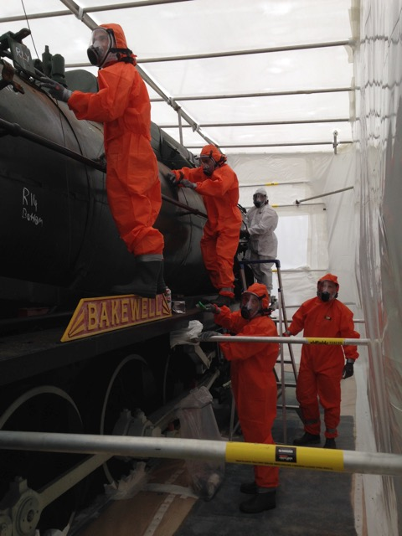

What did they do?

Isolating the site
The Public Transport Centre is a high traffic area and there is a childcare centre only 100 metres away. The locomotive is positioned right next to operational railway tracks, making it difficult to isolate. The PTA wanted the site to be both secure and out of view.
Thuroona erected a giant scaffold around the locomotive, as can be seen below. Knowing that heavy rain was predicted they decided on an extra safe construction method, using steel, instead of wood, bolting the scaffold to the ground and having the quality of the construction independently checked.
Thuroona then built a false floor around the train, hard up against the tracks, covered the floor in plastic and erected a double walled plastic enclosure (a bubble) around the whole train. The bubble was heat shrunk to make it airtight and smoke tested to ensure there were no leakages. They chose a thicker plastic than what is required by legislation because of the increased risks in a public location.
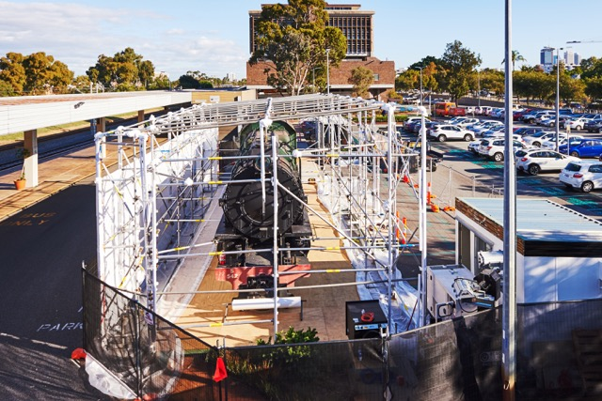
The enclosure was then put under negative pressure. This was to ensure it was completely sealed, so that all particles in the removal area could be sucked out through the filtration system. Thuroona used a manometer to consistently monitor the air pressure throughout the removal process, to ensure there were no leakages. A three door airlock prevented any air movement between the work area and outside.
Thuroona erected security fences around the whole site with asbestos warning signs every 10 metres. When staff were not on site, at night and on weekends, security officers were employed to protect the site.

State-of-the-art techniques and equipment
Thuroona used the most up-to-date processes to ensure high standards of safety.
- Thuroona is exclusively licensed in Western Australia by the developers of a proprietary foam, Foamshield. Foamshield is designed to encapsulate asbestos fibres on the surface, stopping them becoming airborne. This foam was sprayed throughout the locomotive during the removal process.
- The positive pressure masks worn by removalists were a new Australian design. The masks have a motor contained within the unit. This prevents accidents from having air lines running across a site or from battery packs getting caught on sharp metal edges.
- Thuroona also owns a high-tech 5 stage mobile decontamination unit. The unit has two airlocks and is self-contained with its own generator and water. It has two showers, change rooms and spare respirators and other equipment. This unit was sealed to the bubble, ensuring that no workers could exit the contaminated area without going through the full decontamination process.

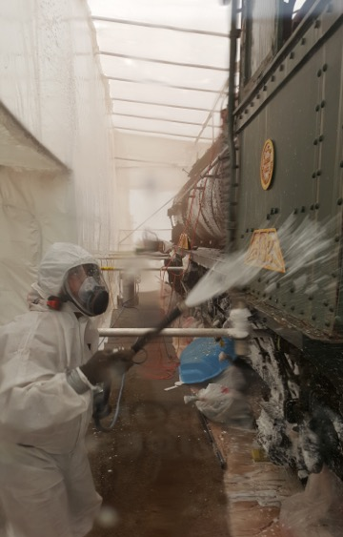

Safety processes on site
Workers entered and exited the site using separate openings from those used to remove the waste. This reduced the potential for any cross-contamination.
To reduce worker fatigue and risk of injury, shifts were monitored to ensure workers spent no more than three hours at a time in the enclosure. After each shift, the workers exited via the decontamination unit, then reassembled in a clean kit before re-entering the enclosure.
Every panel of the train was wire-brushed, vacuumed (with specialised hazardous material vacuums, fitted with HEPA filters), washed, coated with PVA glue, numbered and photographed before being removed through the three-stage air lock. Every piece was also visually inspected once outside to ensure there were no remaining fibres.
An independent hygienist was employed to conduct air monitoring and oversee the removal process. In addition, a Thuroona senior asbestos supervisor was stationed outside of the enclosure to monitor the site and maintain two way radio contact with the internal supervisor.
At the end of the project, the hygienist tested the rocks underneath the train. Two small asbestos fibres were found. To be absolutely sure the area was clean, Thuroona vacuum-cleaned it with an asbestos-grade hazardous vacuum cleaner, fitted with a HEPA filter, and glued the whole track bed from front to back.

Disposing of waste
All contaminated waste, including any water used on site, was scooped up and double bagged for disposal. All waste bags were photographed and tagged before being removed from site. The bags were photographed again at the disposal facility to ensure every bag reached its destination.
There is no requirement in WA to track asbestos waste during the transport and disposal process, but Thuroona felt that this was important to be able to demonstrate that safe disposal had occurred. Rather than outsource this process, Thuroona used its own vehicles which are ‘mine-specced’ (i.e. fitted with safety features such as signage and orange flashing lights). The vehicles also have GPS systems to track waste and cameras installed to provide video footage as an additional check in the event of an incident.

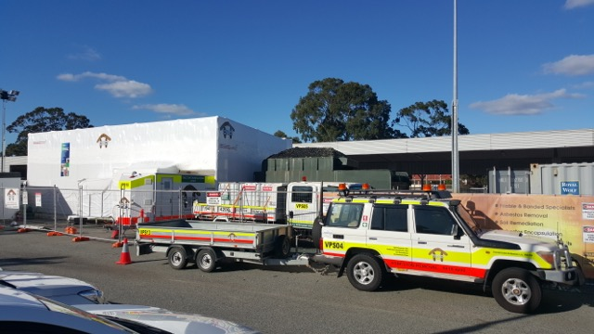

Challenges

Weather
A key challenge for a complex outdoor project such as this is ensuring safety in all weather conditions. Any damage to the enclosure could expose the public to asbestos. This project was affected by significant rain early on in the process. Spending the extra time and money on a solid scaffold and high quality plastic meant that the structure could withstand these challenging conditions.
It comes down to the risk to the public. These things cost a lot of money to do properly and could have been done cheaper using lower quality plastics and timber but the risk of something occurring - like the structure coming down in the rain - it’s just too great. Our structure was rock solid. (Director of Operations, Thuroona)

Community concerns
As a highly visible site in a busy public space, the project attracted considerable interest and some concern. The removalists worked in partnership with the hygienist and the PTA to alleviate community concerns. For example, prior to beginning the project, the three parties met with staff from the childcare centre located within the grounds of the train station to talk through how the project would run and the safety precautions that would be taken. They also invited staff to view the preparations. Thuroona ensured any queries from the public were passed on to the PTA.
When you’re having asbestos work done in an area that’s heavily occupied, it’s important to explain it and ensure people know it’s safe. In the past we’ve had this policy of silence because we don’t want to frighten people but we’ve turned that around. Now we encourage people to come and ask questions so that they don’t feel scared. (Project Manager, PTA)

Risk of breach by vandals
The public location meant the site was at risk of being breached by vandals. The walls of the bubble were constructed one metre apart to ensure that any penetration of the first wall would be most unlikely to reach the second wall. Extra thick plastic, solid fencing and employing security guards outside of work hours also helped to mitigate any security breaches.

Poor condition of structure
The locomotive is over 70 years old and as such was riddled with rust. Thuroona was concerned about physical risks to workers due to degradation of the structure. They were also concerned that the rust would stick to workers shoes and split the plastic on the floors. Workers were briefed on the particular risks involved in working within a rusty, fragile structure. Carpet strips were laid on the floors to prevent damage to the plastic floors. This was disposed of as contaminated waste at the end of the project.

Costs
This was an expensive project due to the detailed nature of the remediation process. Thuroona thought through the risks, the methodology and the costs very carefully prior to quoting on the job. This meant the budget was sufficient to implement all extra safety processes and no corners were cut.
Thuroona had done a lot of research. The methodology of how they were going to remove the asbestos and the precautions they were going to put in place were very detailed… right from the beginning they asked sensible questions and had already worked out how they were going to manage risks to the public. (Project manager, PTA)

Key messages about how to make it work
The high-risk nature of this job motivated the removalists to go the extra mile to be absolutely confident that current and future workers on the site, and the general public, would not be exposed to airborne asbestos fibres. Some key lessons from this project to guide other complex projects are:
- Spend time thinking through a detailed, customised methodology that covers all risks.
- Use an independent hygienist, employed by the client, not the contractor.
When we hire our own hygienist, we can be confident that all the angles are covered and we are getting independent advice. (Project Manager, PTA)
- Carefully research options and aim to acquire the highest quality equipment and materials.
- Go the extra mile to be confident about safety – don’t rely only on the minimum standards in legislation.
- Take pride in the work:
When we opened the firebox we found a newspaper from 1 December 1973 which was the date that the train was decommissioned. At end of the project we bought the newspaper from that day and put it back in the firebox along with the old one. Anyone who opens the firebox in the future will see both newspapers – it’s like a time capsule. (Operations Manager, Thuroona)

