CASE STUDY THREE

O’Shea Plumbing – Applying Sound Business Principles to Asbestos Management
Plumbing is a challenging trade: a good plumber needs to understand hydrostatics and hydrodynamics, have all the necessary skills as well as a good dose of common-sense, and be prepared to work in some unpleasant environments. Plumbers who work on existing housing stock also have the additional challenge of working with asbestos.
O’Shea Plumbing is a family-owned plumbing company located in Melbourne’s eastern suburbs, mainly carrying out work on private homes. The owner and managing director, Lawrie O’Shea, has developed an even more cautious approach to handling asbestos than in the past, prompted by Master Plumbers (Victoria) who alerted plumbing companies to the technical and financial risks of working with asbestos.

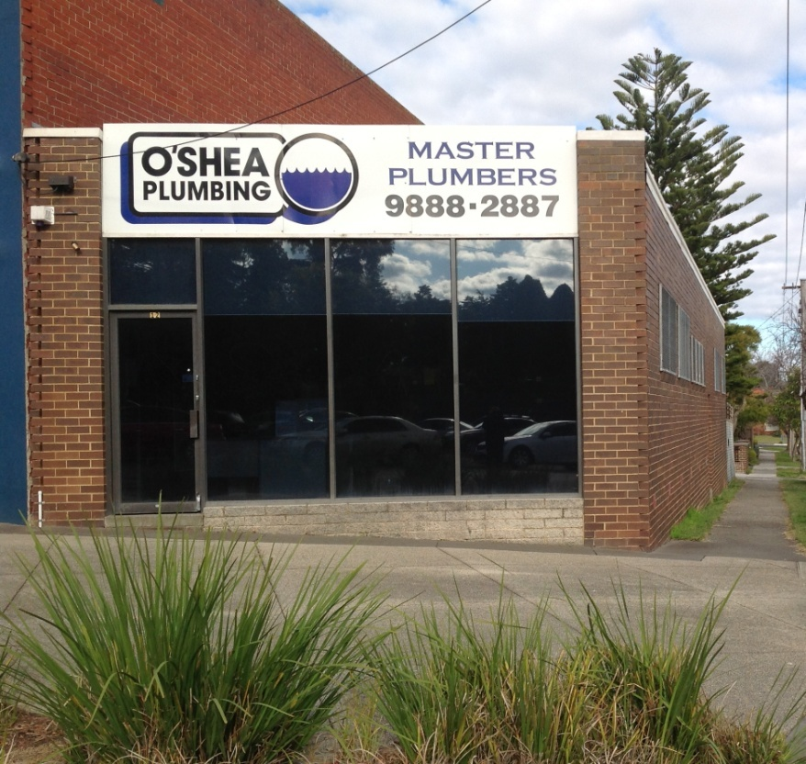

What have they done?

Processes which make ‘best practice’ the easiest practice
The company has a number of simple but effective processes to make it easy for the company’s plumbers to act appropriately if asbestos is suspected:
- all staff have the occupational hygienist’s and the asbestos removal contractor’s phone numbers pre-programmed in their phones
- disposable masks and overalls are standard issue and easily accessible in all company vehicles
- the company uses scheduling software to minimise the chances of employees being “too rushed, too busy, too little time between jobs” to follow the company processes for dealing with asbestos
- the owner is always available to be consulted on ambiguous situations.

A methodical approach
O’Shea Plumbing has an extremely logical approach to working with asbestos or in sites which potentially contain asbestos. It is often hidden – for example, under tiles which might need to be cut in order to carry out plumbing work – and cannot be identified until the work begins.
They prioritise identification and management in advance, so that other trades don’t lose a day unnecessarily due to the last-minute identification of asbestos, and the client sees that the company is looking after their health.
O’Shea Plumbing Asbestos Management Decision Tree

Effective financial practices
Apart from being personally committed to best practice in asbestos handling, the owner says it’s the only possible strategic financial decision: “it’s a business-based decision as well as a compliance-based decision”, due to the potential financial liability (not covered by insurance) if a client or staff member fell ill even years later.
One risk to companies that undertake best-practice is that they could be underquoted by less careful or less scrupulous companies. O’Shea Plumbing gets around this problem by ensuring that asbestos testing or removal/disposal is always separately identified on any quote, so that a client can differentiate between the plumbing cost and the asbestos-related cost: when quoting, staff bring up the asbestos issue very early with clients – and ensure that the client is well-briefed before work starts.
To ensure that best practice is followed,
- the company has designed a quoting template that makes it easy to separately identify the cost of asbestos-related work;
- staff have a series of standard clauses for quotations relating to asbestos risk pre-filled in on their iPads.
The careful approach (and the separate invoicing) has paid off well for O’Shea Plumbing: their clients are delighted to see they care about this issue and are doing everything they can to protect their clients’ health, and their staff and other trades know that they can be sure they’re working on a site that is completely free of asbestos.

Part of a broader message
The company has made the ‘asbestos message’ as part of a broader ‘safety message’: it’s not justified to take risks with asbestos, just as it’s not necessary to crawl under low floors and risk damage to your back.
This broad safety message is continually emphasised during their regular weekly team meetings.

Challenges
- Many tradies are young, and the young are invincible. It’s necessary to keep emphasising the dangers of asbestos: some younger plumbers can still have too much of the “I’ve got to die of something, so why worry” mentality.
- There are still relatively low levels of community awareness of the potential risks of asbestos – the message keeps needing to be given.

Key messages about how to make it work
O’Shea Plumbing’s practices have demonstrated how even a relatively small company can achieve best practice. The key to its success is:
- making ‘best practice’ the easiest practice
- having a standard, methodical, company-wide approach to working with asbestos, which incorporates the ‘asbestos message’ as part of a broader ‘safety message’
- developing business practices that ensure that a best-practice company is not financially disadvantaged.

