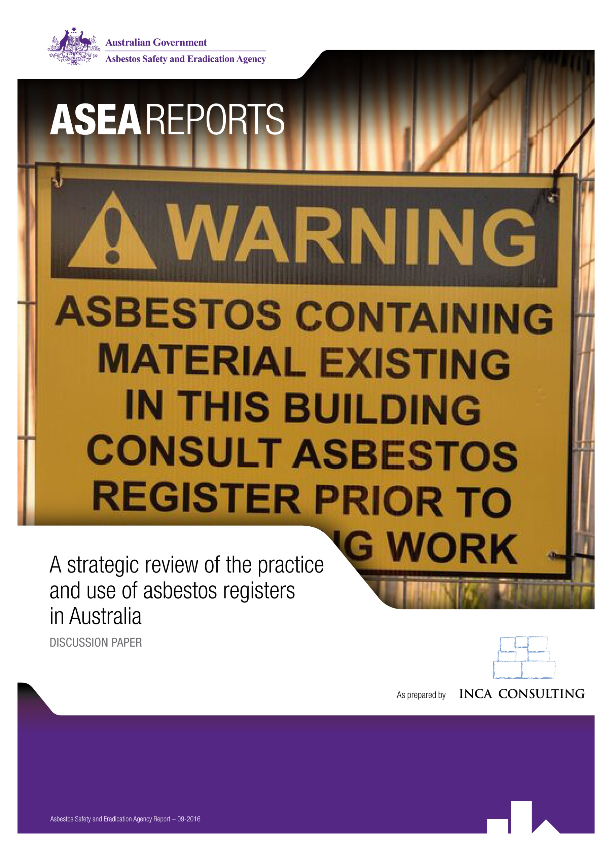

Contents

**EXECUTIVE SUMMARY 1**

1. **INTRODUCTION 6**
   1. Background to the review 6
   2. Review methodology 6
   3. Key research questions 7
2. **RANGE OF APPROACHES TO ASBESTOS REGISTERS 8**
   1. Variations in legislative and regulatory guidance 8
   2. Variations in the format and content of asbestos registers 10
   3. Variation in the supporting processes 13
   4. Factors that influence an organisation’s approach 18
   5. Use of asbestos registers by PCBUs 19
   6. Use of asbestos registers by tradespeople 20
3. **TOWARDS BETTER PRACTICE 25**
   1. Components of better practice 25
   2. What encourages an organisation to strive for better practice? 28
   3. What limits an organisation striving for better practice? 32
   4. Conclusion 34

**APPENDIX A:** Sample asbestos register from Model Code of Practice 36

**APPENDIX B:** Organisations consulted 37

**APPENDIX C:** Discussion guide – Organisations 38

**APPENDIX D:** Discussion guide – Stakeholders 40

**APPENDIX E:** Tradespeople survey results 42

**APPENDIX F:** Tradespeople survey questionnaire 56

List of acronyms

|  |  |
| --- | --- |
| **ACM** | Asbestos Containing Material |
| **ACT** | Australian Capital Territory |
| **BEMIR** | Built Environment Materials Information Register (Queensland) |
| **CATI** | Computer Assisted Telephone Interviewing |
| **CSIRO** | Commonwealth Scientific and Industrial Research Organisation |
| **DET** | Department of Education and Training (Queensland) |
| **IMR** | Incident Management Report |
| **NATA** | National Association of Testing Authorities |
| **NFC** | Near Field Communication |
| **NOHSC** | National Occupational Health and Safety Commission |
| **NSW** | New South Wales |
| **NT** | Northern Territory |
| **OHS** | Occupational Health and Safety |
| **PCBU** | Person Conducting a Business or Undertaking |
| **PMC** | Person Managing or Controlling a Workplace |
| **QR** | Quick Response (code) |
| **SA** | South Australia |
| **WA** | Western Australia |
| **WAAP** | Work Area Access Permit |
| **WHS** | Work Health and Safety |

Executive Summary

Research objectives

The 2011 Work Health and Safety Regulations (Chapter 8, Part 8.3, Clause 425) require that workplaces built prior to 2004 (or prior to 1990 in Queensland) prepare, maintain and update an asbestos register that identifies any asbestos containing materials (ACMs) located at a workplace, and that the register be made available to staff, contractors or other visitors. In order to better understand how organisations are responding to these requirements, the Asbestos Safety and Eradication Agency commissioned qualitative and quantitative research with public and private sector organisations and tradespeople to explore how and why organisations have responded the way they have, and to identify what better practice might look like.

The key research questions were:

* What variation is there in the approaches taken by Australian organisations to developing and maintaining asbestos registers?
* What are the advantages and disadvantages of the various approaches?
* Why do they take the approach they do?
* Are register owners aware of requirements to identify asbestos containing material beyond building structures?
* How are asbestos registers used?
* How aware are tradespeople of asbestos registers? What are their experiences, perceptions and preferences when it comes to asbestos registers?
* What does better practice look like?
* What factors drive or limit the pursuit of better practice?

Methodology

The research program included:

* A desktop review of current asbestos registers in the public domain across a broad range of sectors (including overseas);
* Primary qualitative research (semi-structured in-depth interviews conducted either face-to-face or by phone) with 46 organisations and stakeholders across a range of sectors, government and non-government;
* A national random Computer Assisted Telephone Interview (CATI) survey of 150 tradespeople.

Areas of variation in asbestos registers

Three groups of asbestos register types can be identified: basic registers, which fulfil the regulatory requirements but are not necessarily linked to broader asbestos management processes; fit for purpose registers, which go beyond the minimum and are specifically designed for the organisation to manage its asbestos safety obligations; and innovative practice, which takes a comprehensive register a step further to become a complete asbestos management solution (see figure below).

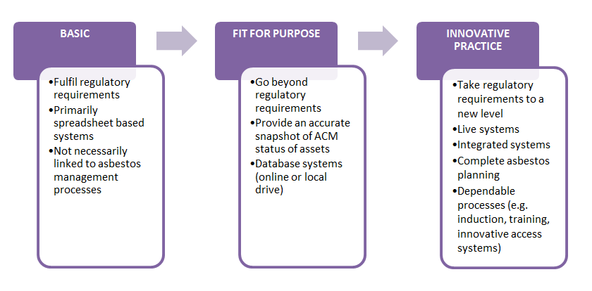

In Australian organisations there is considerable variation in terms of:

* *Legislative requirements* for asbestos registers. The national regulations apply in all States/Territories except Victoria and Western Australia, which are covered by their own WHS legislation. Variations to the national regulations also apply in Queensland (where the trigger date is 31 December 1989 or before) and ACT (around definitional issues of a ‘competent person’ and assumption of the presence of asbestos where indicated).
* *Format, content and outputs*. The major distinction is between static registers (e.g. spreadsheet format such as MS Excel or other document format such as MS Word or PDF) and database systems (either online/hosted systems or local server-based systems). Paper based systems are simple, easy to read, inexpensive and require no additional software or training. Disadvantages include currency (they are in effect out of date as soon as printed), difficult to update, tend to have limited data fields, may be lost or removed and inclusion of related documents make them unwieldy. As data entry is completed post-audit, they are also more prone to error. Live database systems tend to have a more comprehensive range of data fields (including photos, diagrams), collate related documents together, provide access to historical information, utilise data that is entered on-site (less likely to suffer human error in data entry) and have several useful tools such as alerts for reinspection. Disadvantages are that these systems incur ongoing management fees and require some training to use.
* *Supporting processes*. An important procedural variable is the thoroughness and *quality of asbestos auditing*. For a number of organisations, the perceived quality of the audit was a key factor in determining their level of trust in the asbestos register. A key issue is that the regulations do not identify a standard of qualification and practice for those who carry out the audits. The lack of an effective accreditation scheme for asbestos assessors and the variable quality that exists in the industry were key issues raised.

A contentious aspect of the auditing process is *how asbestos is identified*. Ideally asbestos should be confirmed by sampling and testing, however in many of the registers reviewed, asbestos was often ‘presumed’ or ‘assumed’. The *quality of laboratory testing* was another variable that affected the quality of the registers. Whether *data is entered* in real time or post-audit (‘double handling’ of data) has been identified as a factor that can affect the accuracy of register information. *Frequency of review* may also affect the accuracy of the register.

Having a *clear point of accountability* (via someone who takes responsibility for asbestos issues within an organisation) makes a difference to the focus on asbestos within the organisation. A final variable relates to the processes in place to *action findings* from an audit. In the more comprehensive registers, actions for removal, remediation or monitoring were identified, alongside a clear timeframe.

Factors that influence an organisation’s approach

* *Size of the organisation* - large organisations tend to have dedicated WHS/OHS teams to oversee risk management, including asbestos safety, whereas smaller organisations tend to include these responsibilities in the roles of a Management or Human Resources position.
* *Size of building portfolio* – only organisations with larger portfolios (e.g. with 50+ buildings) tended to have sophisticated web-based database systems, which is likely a function of practicality as well as cost/preparedness to invest. At the other end of the spectrum, organisations with small portfolios, such as the NT Legislative Assembly (with one building) or the State Library of NSW (with two buildings) tended to have simple paper-based registers in Word or Excel format.
* *‘We’ve always done it this way’* - some organisations do their asbestos register a particular way because that is how it has always been done and they have seen no need to change.
* *Organisational structure* - large organisations (public or private sector) may have an asbestos register consolidated at an organisational level, at a regional level or at a site level, depending on their structure.
* *Potential to cause harm* - the scale and risk rating of the asbestos an organisation has also influences their approach, as does the potential to harm the reputation and brand through possible negative publicity.

Use of asbestos registers

* *By PCBUs* (persons conducting a business or undertaking) – providing access to asbestos information about a site to work teams; identifying priority actions for remediation or removal; providing hazard information to tenderers and prospective buyers/tenants of a site.
* *By tradespeople*: our survey of tradespeople revealed a range of practices and attitudes to asbestos registers:
  + Tradespeople rated highly their knowledge about how to work safely around asbestos, but less than half had ever seen a register.
  + Those who do work with asbestos registers saw them as an important precaution that gives them greater confidence in doing their work.
  + Few had undertaken training courses in asbestos awareness or removal.
  + There is quite a difference between PCBUs *providing access* to the register to work teams/tradespeople, and *ensuring* they access, understand and use it. It is not usual for tradespeople to ask to see the asbestos register before starting work or quoting on a job.
  + While the majority thought that asbestos registers and the risk ratings used in them were fairly clear and contained the information they need to do their work, they were less positive about the accuracy and currency of the registers they see.
  + Where asbestos is ‘assumed’ rather than confirmed, the tradespeople tend to err on the side of caution, while some will seek confirmation from a competent person.
  + Factors that make a good quality register, according to the tradespeople, were clarity, level of detail, inclusion of visual cues (e.g. photos, diagrams, colour coding), accuracy and currency, and accessibility.
  + Use of the web- and app-based systems appears not to be very widespread at present. The tradespeople were split between those who don’t mind which format a register comes in, as long as it is accessible and correct; and those who prefer a paper or PDF document they could easily read and understand.

What does better practice look like?

When seeking to identify better practice, we need to look at three domains (figure below).

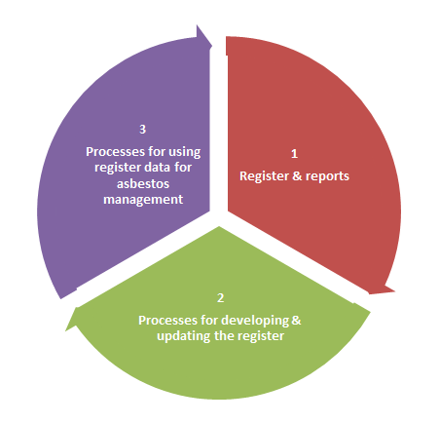

* *Register & reports*
  + Comprehensive information
  + Format – web based database systems offer clear advantages, but even spreadsheets can work well with good management processes
  + Easily accessible
  + Access to linked information – photos, audit reports, clearance certificates, historical reports
  + Clarity – plain English, use of visual cues (e.g. colour coding)
* *Processes for developing & updating the register*
  + Quality auditing
  + Real-time data entry to reduce human error
  + More regular review if high risk asbestos is present
  + Communication & training to ensure updating occurs
  + Clear processes for inducting staff/contractors
  + Single point of contact & accountability
* *Processes for using data for asbestos management* 
  + Regular review of the register to identify priority removal/remediation projects
  + Use of the register to plan asbestos management over time
  + Inclusion of the register in tender documentation, work orders and asset sale documents.

What encourages organisations to strive for better practice?

Why do some organisations go above and beyond their statutory requirements, while others are satisfied to simply meet them? Our research has revealed several factors that contribute to an organisation striving to implement good practice, summarised below.

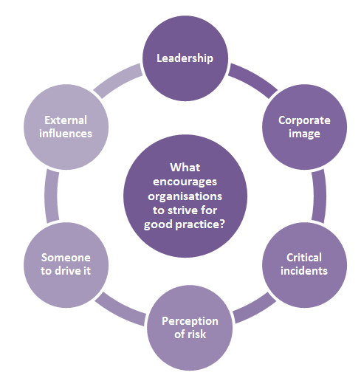

1. Introduction
   1. Background to the review

The Asbestos Safety and Eradication Agency (the agency) is a Commonwealth statutory authority, which aims to provide a national focus on asbestos issues in order to drive change across all levels of government. In 2015 the agency commissioned a review of current practices in relation to the development, maintenance and use of asbestos registers in Australia and overseas, in order to assist the agency to develop and promote best practice approaches in this area.

In 2011 new national Work Health and Safety Regulations were introduced to support the duties set out in the Work Health and Safety Act 2010, The Commonwealth and all states and territories (except Victoria and Western Australia) became signatories. The harmonisation of work health and safety laws form part of the Council of Australian Governments’ National Reform Agenda aimed at reducing regulatory burden and creating a seamless economy.

The regulations require that workplaces built prior to 2004 (or prior to 1990 in Queensland) prepare, maintain and update an asbestos register that identifies any asbestos containing materials (ACMs) located within the buildings, and that the register be made available to staff, contractors or other visitors. While Victoria and Western Australia are not signatories to the national regulations, similar state-based rules also mandate the keeping of asbestos registers.

Through its preliminary research, the agency was aware that there appears to be considerable variation in the content, type and format of asbestos registers being used in the public and private sectors. It appeared that while some organisations are simply meeting the minimum standard to fulfil the regulatory requirements, others are going well beyond the minimum standard. The agency wished to better understand how organisations are responding to the legislative requirements, what the attitudes of organisations are to the maintenance of registers, how they use asbestos registers and what their drivers are for responding in the way they do.

* 1. Review methodology

This discussion paper is based on the findings of qualitative research with a wide cross-section of organisations. The research consisted of:

* A desktop review of current asbestos registers in the public domain across a broad range of sectors (including overseas)
* Primary qualitative research (semi-structured in-depth interviews conducted either face-to-face or by phone) with 46 organisations and stakeholders across a range of sectors, including:
  + Commonwealth government agencies
  + State/Territory government agencies
  + Local and Regional Councils
  + Large corporate organisations
  + Educational institutions
  + Health agencies
  + Asbestos consultants
  + Other stakeholders (e.g. business peaks).

Responses to each question were entered into a database to allow for systematic analysis across each question.

* A random Computer Assisted Telephone Interview (CATI) survey of 150 tradespeople conducted nationwide.

The review also drew on key documents and reports, including the recent Western Australian Auditor General’s Report *Asbestos Management in Public Sector Agencies* (2015), the Victorian Compliance Code (2008) and the Cambridge University *Good Practice Guide for the Asbestos Register* (2015).

* 1. Key research questions

The key research questions were:

* What variation is there in the approaches taken by Australian organisations to developing and maintaining asbestos registers?
* What are the advantages and disadvantages of the various approaches?
* Why do they take the approach they do?
* Are register owners aware of requirements to identify asbestos containing material beyond building structures?
* How aware are tradespeople of asbestos registers? What are their experiences, perceptions and preferences when it comes to asbestos registers?
* What does better practice look like?
* What factors drive or limit the pursuit of better practice?

1. Range of approaches to asbestos registers

|  |
| --- |
| * What variation is there in the approaches taken by Australian organisations to developing and maintaining asbestos registers? * What are the advantages and disadvantages of the various approaches? * Why do organisations take the approach they do? * How are asbestos registers used? * How aware are tradespeople of asbestos registers? What are their perceptions and preferences when it comes to asbestos registers? |

* 1. Variations in legislative and regulatory guidance

National regulations

New national Work Health and Safety Regulations came into effect in 2011. Chapter 8 of the regulations requires that workplaces built prior to 2004 prepare, maintain and update an asbestos register. The register must:

* record any asbestos or ACM identified at the workplace under regulation 422, or likely to be present at the workplace from time to time including:

1. the date on which the asbestos or ACM was identified; and
2. the location, type and condition of the asbestos or ACM; or

* state that no asbestos or ACM is identified at the workplace if the person knows that no asbestos or ACM is identified, or is likely to be present from time to time, at the workplace[1] .

The asbestos register must be made available to any worker (or their representative) who carries out, or intends to carry out work at the workplace. Penalties apply for non-compliance, ranging from $3,600 for individuals to $18,000 for corporate bodies.

While the regulations provide some basic guidance, they do not direct how the asbestos register should be kept (i.e. in what format), how often it needs to be updated or specifically what is to be included in the register. To assist implementation a model code of practice entitled *How to Manage and Control Asbestos in the Workplace* was developed by Safe Work Australia under the Council of Australian Governments’ Inter-Governmental Agreement for Regulatory and Operational Reform in Occupational Health and Safety for adoption by the Commonwealth, state and territory governments and was endorsed by the Workplace Relations Ministers’ Council on 10 August 2011. This document provides further guidance to persons conducting a business or undertaking (PCBUs) about such things as who should identify asbestos, what should be included in an asbestos register, and how often the register should be reviewed (at least every five years). It also includes in an appendix an asbestos register template, which encourages the systematic recording of information to meet the minimum requirements of the regulation (see Appendix A)[2].

The Commonwealth and all states and territories except Victoria and Western Australia adopted the new regulations, with two jurisdictional variations in relation to asbestos registers:

* In Queensland, asbestos registers must be kept for buildings constructed before 1990 (rather than before 2004).
* In the ACT, the regulations were amended to (a) replace references to ‘competent person’ with ‘licensed asbestos assessor’ to clarify that all asbestos assessment, clearance inspections and air monitoring must be provided by a licensed asbestos assessor; and (b) require that a person with management or control of a workplace must assume asbestos is present if an approved warning sign is present (e.g. this will be the case if the premises are known to have contained loose fill asbestos).

Victorian regulations

The Victorian *Occupational Health and Safety Regulations 2007* require the person who manages or controls a workplace (PMC) where asbestos is fixed or installed to maintain an asbestos register. The register must record the location of the asbestos at the workplace, the type and condition of any ACM (including whether it is friable or non-friable), and any activities carried out in the workplace that are likely to damage or disturb the asbestos. The register must also detail any inaccessible areas that are likely to contain asbestos.

Before any demolition or refurbishment occurs, the PMC must review the asbestos register in light of the proposed works. The PMC must ensure the register has adequate information to allow the person performing the work to effectively manage the risks from asbestos in the building or structure. If it does not, the regulations require that the register be revised.

Western Australian regulations

Under the Western Australian *Occupational Safety and Health Regulations 1996*, an employer, main contractor, self-employed person or person in control of the workplace must identify the presence and location of asbestos at the workplace, and assess the health risks. This identification and assessment is to be in accordance with the *Code of Practice for Management and Control of Asbestos in Workplaces* [NOHSC: 2018(2005)]. The information from this assessment needs to be recorded in an asbestos register. If the ACM presents a health risk, the employer or person in control of the workplace has a duty of care under the Occupational Safety and Health Act 1984 to implement controls.

The asbestos register is used to communicate the hazard before work is done on the asbestos containing material. Information must also be provided to workers in relation to ACMs at the workplace. The level of information needs to suit the person’s role; for example workers who do not have a direct involvement with the asbestos containing materials may only require awareness that the workplace contains asbestos and that there is an asbestos register; however workers who maintain such materials or organise contractors to work on them need an understanding of asbestos hazards and the asbestos management system. Labels and signs must be used where practicable, as part of a safe system of work.

In October 2014, a new *Work Health and Safety Bill 2014* was introduced in the Western Australian Legislative Assembly by the Minister for Commerce, and is currently undergoing review. If passed, the legislation will repeal the earlier *Occupational Safety and Health Act 1984* and *Occupational Safety and Health Regulations 1996*.

* 1. Variations in the format and content of asbestos registers

There is considerable variation in the format, content and outputs of asbestos registers developed by Australian organisations.

Format

The major distinction is between static registers (e.g. spreadsheet format such as MS Excel or other document format such as MS Word or PDF) and database systems (either online/hosted systems or local server-based systems).

The most basic registers have been developed using spreadsheet or word processing software (such as Excel or Word) which may also be presented in a portable document format (PDF). They are static in the sense that once printed in order to provide access, they cannot be changed without reprinting.

Database systems tend to include more comprehensive information and are capable of holding a variety of related documents such as assessment reports, clearance certificates, work permits and site photos. These systems may be hosted locally on the organisation’s own server, or may be hosted by an external company that provides an integrated system for asbestos management.

The advantages and disadvantages of the various formats are summarised in Table 1.

**Table 1: Format advantages and disadvantages**

|  |  |  |
| --- | --- | --- |
| Format | Advantages | Disadvantages |
| Word processed document  (MS Word, PDF) | * Simple, easy to read * Inexpensive * Requires no additional software or training * Easy to send data (e.g. to contractors) | * Tends to include limited data fields * Tends not to be updated until next inspection * No guarantee of up-to-date document * Historical information not trackable * Printed register may be removed or lost and therefore not available when needed * Incapable of including related documents * Data entry is done post-assessment and more prone to error |
| Spreadsheet document  (e.g. MS Excel) | * Simple, easy to read data * Inexpensive * Requires no additional software or training * Easy to extract and send data (e.g. to contractors) | * Tends to include limited data fields * No guarantee of up-to-date document * Printed register may be removed or lost and therefore not available when needed * Unlikely (though not impossible) to include photos * Incapable of including related documents * Combined register may be very large in size and therefore unwieldy * Data entry is done post-assessment and more prone to error |
| Database  (local server) | * Comprehensive range of data fields * Likely to include photos * Collates related documents together (eg work permits, asbestos assessment reports, clearance certificates) * Includes historical information * Alerts can be set up e.g. for reinspection or removal | * Training required to access and use |
| Database  (hosted online) | * Comprehensive range of data fields * Likely to include photos * Collates related documents together (eg work permits, asbestos assessment reports, clearance certificates) * Includes historical information * Real time data entry directly by assessors reduces data entry error * Alerts can be set up eg for reinspection or removal * Effective and trackable access options such as QR codes | * More expensive option (typically an ongoing monthly/annual fee) |

The survey of tradespeople revealed that paper-based documents may still be the most widely used format, at least this was the view ‘on the ground’. Indeed, 80% of our sample of tradespeople had never seen a web-based database system, while 44% had never accessed an electronic document such as an Excel spreadsheet.

Detail and inclusions

Another variable in asbestos registers is the level of detail provided. Registers range from the most basic, providing only the information required by the Model Regulations, through to a comprehensive recording of data.

**Table 2: Data inclusions of basic and comprehensive asbestos registers**

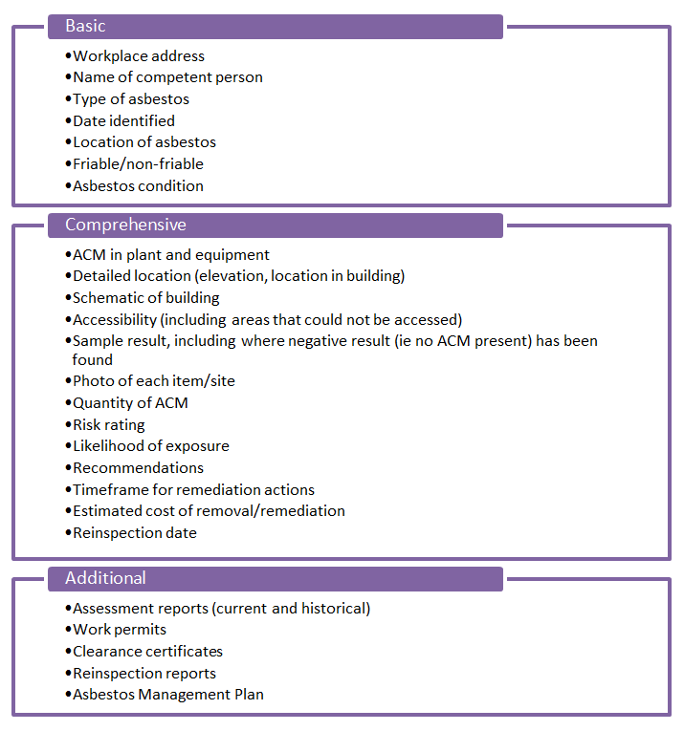

Outputs

There is also variation in the outputs from asbestos registers.

Registers in Word and PDF format tend to be printed to provide access to works personnel and others. Many organisations also provide a copy on the public website and/or staff intranet. Copies of the organisation’s Asbestos Management Plan and asbestos assessment reports are also typically provided in this way.

Spreadsheet registers are typically kept on an organisation’s server and used by relevant staff as needed. Depending on the size of the document, organisations may also print the asbestos register (or extracted data) in order to provide access to works personnel.

Database systems provide the option of extracting only the required entries for print purposes (this also applies to the appended documents such as assessment reports). Some organisations provide on-site access to the database through the organisation’s intranet, or the register may be downloaded on to a mobile device such as a tablet, but unless the systems are online, they generally require the information to be printed for use.

Online or ‘live’ database systems offer additional output and access options with direct access to the database through 3G or 4G enabled mobile devices/tablets. Some systems also use QR codes, near field communication (NFC) chips and weblinks on site labels to enable works personnel to instantly access the asbestos register for that site (see Section 2.4).

* 1. Variation in the supporting processes

Asbestos auditing

An important procedural variable identified in the review was the thoroughness and quality of asbestos auditing to produce a register. For a number of organisations, the perceived quality of the audit was a key factor in determining their level of trust in the asbestos register. Examples were given in the research of poor quality audits, resulting in inaccurate or incomplete asbestos registers.

An important issue is that the regulations do not identify a standard of qualification, training and practice for those who carry out the audits. The *Model Code of Practice* states that a ‘competent person’ must identify any asbestos contained in a building. A competent person is defined as someone who is:

* trained to handle and take asbestos samples, have the knowledge and experience to identify suspected asbestos and be able to determine risk and control measures
* familiar with building and construction practices to determine where asbestos is likely to be present
* able to determine that material may be friable or non-friable asbestos and evaluate its condition.

The Code notes if someone within the organisation is not sufficiently competent, then the organisation should engage an external person such as:

* occupational hygienists who have experience with asbestos
* licensed asbestos assessors
* asbestos removal supervisors
* individuals who have a statement of attainment in the unit of competency for asbestos assessors
* a person working for an organisation accredited by the National Association of Testing Authorities (NATA) under AS/NZS ISO/IEC 17020: 2000 *General criteria for the operation of various types of bodies performing inspection for surveying asbestos*.

The regulations also note that an asbestos assessor licence is required for air monitoring, clearance inspections or the issuing of clearance certificates for class A asbestos removal work, while a competent person who is not a licensed asbestos assessor can carry out clearance inspections for non-friable asbestos.

Nearly all the organisations in the study engaged an external auditor, in a couple of cases because of the lack of a ‘competent person’ within the organisation, but mostly out of concern to have an independent assessment. It was widely agreed that the initial audit tended to be quite a costly exercise, but that the reinspections were not such a concern financially.

Issues were raised in the research about the lack of an effective accreditation scheme for asbestos assessors and the variable quality that exists in the industry. Many of the State/Territory WHS regulators enable a website search for licensed asbestos assessors. Asbestos assessor licensing was introduced in order to provide greater consistency and accuracy, but as one informant commented, *“You can do an asbestos assessor’s course in two days, it doesn’t mean you’re any good at it”.* Another commented, *“You can virtually get an assessor’s license out of Corn Flake packet”.* It was commonly thought that *“there are a lot of cowboys”* in the industry and that *“a register is only as good as the audit”*. It was suggested that some larger auditing firms may employ many auditors of varying experience and skill levels, and that the quality of their audits can be highly variable.

This issue was also raised in the WA Auditor General’s report, which found that performance levels of assessors could be inconsistent:

*‘We found examples where inspectors gave inconsistent risk ratings to asbestos items. For instance, in 2012 one inspector rated two items as ‘unsealed, coating damaged or severely weathered’. In 2014, a second inspector rated the same items as ‘sealed, coating in good condition and unweathered’. However, the agency had done no remediation work that would explain the 2014 rating’[3]*.

NATA has an accreditation scheme for asbestos inspectors, which includes assessment of documentation and observed practice against the international accreditation standard ISO/IEC 17020 (similar to the UK accreditation scheme for Asbestos Surveys[4]). However as accreditation is not mandated (as it is for asbestos testing), its use is very limited (at the time of writing, only eight organisations were accredited). NATA commented that as a voluntary scheme, its use is primarily driven by a few government agencies that make inspection accreditation a prerequisite of contracting or participation in prequalification schemes. NATA also identified the lack of a definitive guide for conducting an asbestos site survey in Australia as a factor limiting good practice.

While accreditation provides a good standard, it cannot be considered a failsafe measure for ensuring good work is done by assessors. It can also be an expensive process (around $10,000 for a medium sized firm) that could disadvantage qualified, competent independent assessors who do good work. In the absence of a widely used accreditation scheme that assesses the competency and experience of assessors, the best a PCBU can presently do (other than use an accredited assessor) is to follow a reliable recommendation. However a guide to what to look for and what to ask when engaging an assessor could be helpful.

Method of identification

A contentious aspect of the auditing process is how asbestos should be identified in an asbestos register. Some argue that presumption of asbestos (without testing) is inadequate and can lead to either too little or too much precaution being taken. Some feel that identifying asbestos as *presumed*, rather than *confirmed*, reduces the level of trust they place in a register:

*‘If it says ‘presumed’, it’s as useful as it saying ‘don’t know.’* (Local council)

*‘In the long run it’s worth it to get it tested because if it’s presumed, we have to treat it as though it is asbestos, when sometimes it’s not. If we can confirm it’s not asbestos then we save by not having to reinspect and take all the precautions.’* (State Government organisation)

On the other hand, others argue that testing everything would be prohibitively expensive and use up resources that could be spent elsewhere, and that asbestos is often presumed because of the difficulty in accessing some areas of a building.

Most registers include at least some items of presumed asbestos, particularly where there is restricted access to the site (e.g. in wall cavities, underneath floor coverings). This ‘hidden asbestos’ is of significant concern to some organisations. A little discussed issue around identifying hidden asbestos is asbestos in the soil after demolition or as a result of natural deterioration over time. One organisation that saw this as a significant risk insisted on having the soil samples tested and included in the asbestos register.

Another variable related to the identification process is the quality of the laboratories undertaking the testing. It was said that this was another area in which there was both good and poor quality work being done, and that it was important that testing is undertaken in NATA accredited laboratories. It is important to note that the regulations and the Model Code of Practice both state that only NATA- or regulator-approved laboratories be used, but in practice this might not always be followed.

The majority of organisations in the study relied on auditor advice, or construction date, to determine if a building does not contain asbestos.

Data entry

If accuracy in an asbestos register is a priority, then entry of correct data is critical. When undertaking an audit, assessors typically record their findings on paper forms, then transfer the data into a spreadsheet or Word document at a later time. We heard reports of assessors undertaking multi-site audits over several weeks, often transferring data in their hotel rooms at the end of the day before moving on to the next site the following day. Data entry conducted this way increases the risk of human error.

Live database systems have sought to eliminate this double-handling of data, which is inefficient, and as the WA Auditor General noted, more likely to result in data entry errors[5]. With live systems, assessors typically enter the data directly into the database, often using drop-down menus and pre-coded fields to further systematise the data. Information such as sample results can also be post-entered.

Frequency of review

The *Model Code of Practice* states that the asbestos register should be reviewed at least every five years (or every three years in WA), and many organisations use this as their guide, reviewing every five years. On the other hand a number of organisations across various sectors opt to reinspect and review the asbestos register more often – most commonly every three years, and some opt to review annually. Those who review more regularly than the required five years tend to be medium to large organisations, and have a significant portfolio of buildings with a high risk rating and/or a significant exposure risk, and/or have a rolling program of planned asbestos removal.

For example, several local councils said they review more often because there is significant interface in their properties with the public, including particularly vulnerable groups such as children and the elderly, and because they have many assets containing asbestos in publicly accessible areas. The ongoing frequent review cycle of two large corporate organisations had much to do with these organisations’ investment in comprehensive asbestos management and removal strategies, which make having up-to-date information important, as well as the perceived risk to the ‘brand’ of any potential exposure incident.

Generally speaking, smaller organisations (particularly in the private sector) are less likely to have a focused asbestos management strategy, or a dedicated person to focus on asbestos issues, or the willingness to invest in asbestos inspections more often than they are required.

**Updating the register**

The WA Auditor General’s Report identified significant issues regarding a lack of systematised processes in some agencies for updating the register (e.g. after asbestos has been remediated or removed, or after sample results have confirmed the presence of asbestos)[6] . The survey of tradespeople also identified the accuracy and currency of registers as an issue, with just 57% of the respondents agreeing that asbestos registers are usually accurate and up to date. An out-of-date register can result in inappropriate asbestos management decisions, including mistakenly treating, or not treating, a material as asbestos.

Often the asbestos register is not updated until the next reinspection or audit. A small number of organisations had systems in place for updating the register, although some of these admitted the systems were not failsafe. For example, the WHS unit at one university, which is responsible for the asbestos register, said that because building work is undertaken by Building Services, changes to the asbestos register are not necessarily communicated:

*It depends on whether we know the work is being done. Often we have to chase up Building Services to get a clearance certificate, but if we don't know they were doing the work, we don't know to chase them up.* (University)

Responsibility

Responsibility for ensuring asbestos registers are developed and updated may lie with any number of people within an organisation, and our review found the responsible people in a range of areas including:

* Work/Occupational Health and Safety
* Asset management
* Facilities management
* Compliance
* Environment
* Management (in smaller organisations).

In most cases, asbestos management is just one of the responsibilities of the designated officer. In two organisations that participated (one local council, one energy provider), the responsible person had a title such as Asbestos Manager, and this reflected a deliberate focus of the organisation in making asbestos safety a priority (as well as the size of the organisation).

It was clear that having a clearly identifiable person whose responsibility it is to manage asbestos issues within the organisation made a difference to the focus on asbestos within the organisation. These people are able to drive a progressive asbestos management agenda and focus on developing systems that work.

Actioning results

A final variable we found in the review related to the processes in place to action findings from an audit, as recorded in the asbestos register. In the more comprehensive registers, actions for removal, remediation or monitoring were identified, alongside a clear timeframe.

Some organisations have developed systematic processes for reviewing the asbestos register on a regular basis. The Queensland Department of Education uses the Queensland Government’s Built Environment Materials Information Register (BEMIR) spreadsheet-based register for its nearly 50,000 buildings. The document itself is huge, however a small working group meets every week to review the register and identify priority projects.

Some organisations have contracted out the entire asbestos management role, which means they rely on being informed by their contractor of any priority issues. Adelaide City Council has contracted a consultant as a Superintendent of Asbestos Works, who is managing the council’s progressive asbestos removal program. Council feels confident that they are in the hands of experts: *“The Superintendent process is gold - it’s so simple. You can't expect someone in an organisation to keep up with all the legislative requirements”.*

One large corporate organisation that also contracts out its asbestos management role, allocates an annual asbestos removal budget, and the asbestos manager identifies priority projects based on the information in the asbestos register.

* 1. Factors that influence an organisation’s approach

Size of the organisation

Large organisations tend to have dedicated WHS/OHS teams to oversee risk management, including asbestos safety, whereas smaller organisations tend to include this role amongst others.

Size of building portfolio

The organisations that took part in the research had building portfolios that ranged from one to 130,000 buildings. The organisations with the biggest portfolios were public housing agencies, followed by school education authorities. One agency with a very large portfolio, most of which were built prior to 2004, faced a significant challenge in developing a workable approach to asbestos management. The agency worked with the state’s work health and safety regulator to arrive at a determination that all buildings constructed prior to 1987[7] (some 80,000 in its portfolio) are *assumed* to contain asbestos. Contractors must assume there is asbestos and may have samples tested if the work involves disturbing suspected asbestos.

Only organisations with larger portfolios (e.g. with 50+ buildings) tended to have sophisticated web-based database systems, which is likely a function of practicality as well as cost/preparedness to invest. At the other end of the spectrum, organisations with small portfolios, such as the NT Legislative Assembly (with one building) or the State Library of NSW (with two buildings) tended to have simple paper-based registers in Word or Excel format.

‘We’ve always done it this way’

Some organisations do their asbestos register a particular way because that it how it has always been done and they have seen no need to change. Some organisations that participated are still using essentially the same template developed 20 years ago. A number of Queensland Government agencies continue to use the BEMIR spreadsheet template as was required when it was introduced, although a few (eg Queensland Health, and soon the Department of Education and Training) have migrated to bespoke systems in recent years.

Organisational structure

Large organisations (public or private sector) may have an asbestos register consolidated at an *organisational* level (examples include Queensland Department of Education, NT Courts, University of Wollongong, Adelaide City Council, Mackay City Council, Sutherland Shire Council, Public Transport Authority of WA), consolidated at a *regional* level (e.g. Commonwealth Department of Infrastructure, Queensland Health, NSW Health, Ergon Energy), or consolidated at a *site* level (e.g. NSW Department of Education, Ramsay Health Care).

Potential to cause harm

The scale and risk rating of the asbestos an organisation has also influences their approach. Most of the organisations in the study have risk level assessed by the auditor preparing their audit report and register, although a range of rating systems are used (e.g. P1-P4, Low through to Extreme, risk rating 1-5 or 1-7). Those that perceive a higher risk of exposure and who know they have asbestos with a high risk rating tend to take the asbestos register process very seriously. An organisation that stands to lose a great deal in terms of its reputation or negative publicity (e.g. education authorities, large consumer-dependent corporate organisations) also tend to have a comprehensive asbestos management approach.

* 1. Use of asbestos registers by PCBUs

Providing access to work teams

The WHS Regulations require that an organisation’s asbestos register is readily accessible to:

* a worker who has carried out, carries out or intends to carry out work at the workplace
* health and safety representatives who represent workers that carry out or intend to carry out work at the workplace
* a person conducting a business or undertaking who has carried out, carries out or intends to carry out work at the workplace, and
* a person conducting a business or undertaking who has required, requires or intends to require work to be carried out at the workplace[8].

The *Model Code of Practice* further states that a copy of the asbestos register should be kept at the workplace to ensure it is accessible.

Most commonly, organisations provide access to the register in the following ways:

* A printed copy for the site is kept at the organisation’s front desk, administration office or contractor sign-on area, available to any visitors including contractors or staff members.
* A soft copy may be located on the organisation’s intranet, available to all staff.
* A soft copy may be located on the organisation’s website (this is less common), though may be included with the organisation’s publicly available Asbestos Management Plan.

Some hosted online database systems have introduced several additional ways to access the asbestos register. These include labels affixed at the entrance to a site with a QR code, NFC chip and/or weblink to the register (see Figure 1). Works personnel or contractors can access the register by using their mobile device to scan a QR code or NFC chip, or via an individualised weblink. Some of these systems also have the capacity to track downloads, so that if required an organisation can check whether or not a contractor accessed the asbestos register (this could become important legally to the organisation should there be an exposure incident).

**Figure 1: Example of site labelling including QR code, NFC and weblink access**

Figure 1:  Example of site labelling including QR code, NFC and weblink access

Identifying priority actions

It is very common for organisations to use the asbestos register to inform their decisions about asbestos removal. Most of the organisations that participated included a risk rating (most commonly P1-P4 or Extreme to Low risk rating scales) and tended to act immediately to remove any high-risk asbestos. Many organisations use their register to develop a priority list to fit their asbestos removal budget.

Other uses

Asbestos registers are sometimes used by organisations for other purposes, including:

* Providing prospective tenderers for works or maintenance contracts with detailed information about the scope of works, including any work in areas containing asbestos. It is likely that this is limited, however, to larger contracts, as our survey of tradespeople found that this rarely occurred with individual tradespeople.
* Providing prospective buyers or tenants of an asset with full disclosure information about the asset.

* 1. Use of asbestos registers by tradespeople

Awareness of and attitudes to asbestos registers

Our research (see full survey analysis at Appendix E) found that while the vast majority of tradespeople highly rated their knowledge about how to work safely around asbestos, only 47% had ever come across an asbestos register, while only 59% knew what one was.

However, amongst those who *had* come across asbestos registers, nearly all (91%) agreed that the register was an important precaution when doing their work. Around three-quarters also agreed that they trust the information contained in asbestos registers, and that the registers give them confidence to do their work safely.

The majority of tradespeople in the research (73%) had undertaken no training courses in asbestos awareness or removal, and those who had did the course more than five years ago. While limitations of the sample size make it difficult to make definitive conclusions, the results suggest that those who had undertaken training were more reluctant to agree that asbestos registers were trustworthy, accurate, contained the information they need and gave them confidence to do their work safely. One inference could be that those who have been trained might be more alert to any deficiencies they see in the registers; however this would require further research to verify.

Use of asbestos registers

Our research underscores the difference between PCBUs *providing access* to the register to work teams/tradespeople, and PCBUs *ensuring* they access, understand and use it. For example, the survey found that:

* Asking to see an asbestos register is not particularly common practice: only about half of the tradespeople said they *always* or *usually* asked to see the register before starting work.
* Three-quarters said they were *always* or *usually* properly informed about whether the site contains asbestos, while two-thirds generally participated in an induction session.
* Viewing of the asbestos register when quoting on a job is a relatively uncommon practice.

Quality of asbestos registers

While the majority of tradespeople thought that asbestos registers and the risk ratings used in them were fairly clear and contained the information they need to do their work, they were less positive about the accuracy and currency of the registers they see (only 57% agreed that ‘asbestos registers are usually up to date and accurate’). It is also not very common to see registers that contain asbestos in plant and equipment.

They were also asked what difference it makes when a register notes that asbestos is ‘assumed’ rather than confirmed by sample testing. Most said they would generally treat ‘assumed asbestos’ as though asbestos were present and take the normal precautions:

*“Well we treat it with a lot more caution. We don't know if it's asbestos. We just treat it as if it is”.*

*“No difference at all. You approach it as if asbestos is there.”*

*“It would be treated the same as if it contained asbestos. Just as a precaution, because it's too late afterwards to find out the area has asbestos”*

*“I suppose you're a lot more careful. You're a lot more aware. If you know, you're a lot more wary of it, you're looking out for it”.*

*“No different. You treat it like it's there. You just put the gear on and treat it like an asbestos until we clear it”.*

Some said they get confirmation through testing by a qualified professional before commencing work:

*“We refuse to work on any sites that don't have one. We would get a specialist contractor in to come in and investigate it.”*

*“If it's assumed asbestos is in the building I would want further testing before anyone would start work”.*

*“We won't touch it. We are not asbestos specialists and unless it has been registered and tested, we won't take that chance”.*

*“I would get it checked I reckon / For example, a school job might have floor tiles that contain asbestos, they would need to be tested first before we removed them.”*

*“We don't live on assumptions. If we think there is asbestos, we pay for a sample to save a lot of mucking around”.*

The respondents identified government organisations, schools/universities, large commercial sites, hospitals, shopping centres and power stations as places to find better quality registers, while small businesses and smaller commercial sites were less likely to have a quality register. According to the tradespeople, a good asbestos register should:

* Be clear and easy to understand

*“Clarity. As long as it conveys the information we need it's a good register.”*

*“As long as it's accurate and clear. It gives the risks. Whether there is a blue asbestos for insulation or fire purpose.”*

*“Clear wording and images of the areas.”*

*“A front page summary. Then you can see at a glance whether you need to investigate deeper into the report.”*

*“Clear and concise content. Means that any person can read the register, understand the meaning and associated risk.”*

*“Accurate information, easy to interpret. Some of it is 70 pages long and doesn't make any sense, nobody reads it.”*

* Be detailed:

*“That everything is itemised clearly. That all information can be clearly understood.”*

*“Accuracy is the most important feature of a good quality asbestos register as in what type of asbestos and where it is located. In most registers information is way too general.”*

*“Let you know exactly what's happening on site. They let you know where the asbestos is and where it's not.”*

*“The problem with registers is that they don't specify the type of asbestos that's there and whether or not it's dangerous or whether or not you can work around it, they just tell you it's asbestos. There are many different types…Some of the registers go into detail that doesn't need to be gone into.”*

*“There should be room to put in the actual laboratory findings.”*

*“All the details relating to asbestos - all the facts about what is involved in the job and materials involved.”*

*“Isolate type and location, sheet and lagging.”*

* Include visual cues e.g. pictures, diagrams and colour coding:

*“More diagrams and pictures explaining exactly the area affected. It's easier to show someone on a diagram than to say in words.”*

*“Photographs of the exact location, a warning that asbestos is hidden behind another covering that might be non-asbestos and if any machinery is known to have asbestos.”*

*“Photos, dates, position. It tells you exactly where it is.”*

*“The zones might be accompanied by a map or floor plan*

*“Photographs and descriptions of what the picture is describing.”*

*“Provided in colour form. Something that highlights the worse areas. Has all the no-go zones listed first, so that you don't have to go through page after page, floor to floor, it just makes it so much easier to read through.”*

* Be accurate and up to date:

*“Accuracy - knowing that the site has been fully inspected.”*

*“Have them printed once every two years and by making someone accountable for it.”*

*“Clarity, up to date records, easy accessibility.”*

*“Current. Well, yearly or biannual. Once every two years. Current and signed so someone is accountable for it.”*

* Be accessible:

*“Just easy availability. If it's made known at the induction and there's a printed copy on site.”*

*“If they're displayed on the site of where asbestos to be.”*

*“Make sure they're all incorporated with the main safety documents. Because that's what we do – we look at the safety document. We have hazardous substance and hazard chemicals and we list it in our own OH&S documents.”*

*“Availability. If it's not available you can't use it.”*

Other suggestions for improvement include:

*“A universal format. Just a standard that every register is formatted to. Rather than having to interpret someone else's report, they can vary greatly and not have enough information provided.”*

*“If they could do away with registers and mark the product. In other words a sticker or an easy visual reference. They never remember the register, no one does.”*

Format preferences

Most of the tradespeople tended to access asbestos registers via a paper document, and use of the web- and app-based systems appears not to be very widespread at present. Those in the survey were split between those who don’t mind which format a register comes in, as long as it is accessible and correct; and those who prefer a paper or PDF document they could easily read and understand.

Some of the tradespeople commented that they were not too technologically-minded and so prefer a paper/downloadable PDF document:

*“Paper is what I usually find. It's more available onsite.”*

*“We find the paper register is normal the easiest format to use.”*

*“Paper based I think. Because it's permanent on site. You can't have a computer telling you what to do. It's a registered document that you have up.”*

*“I would say the paper based ones. Regardless of what happens, you have access to it”.*

*“Just the typed one on the wall at the entrance where you are working. You can see and you can browse it and make up your own assumptions.”*

*“Hard copy as I like to have it in front of me. I've been working with asbestos for thirty years or so.”*

*“I don't know. I don't use computers that much. I just prefer paper to be fine and updated. Because you're on site and I don't have my computers on site.”*

*“I prefer the written myself because I'm an old fogey. That's what I've been brought up with. I prefer to go from place to place and take it with me.”*

However, others didn't mind which format was used, or saw the advantages of electronic/online formats:

*“I think the reality is that it is going to go digital. I think the paper society is great because it's there for you, but the reality is that we are leaning towards electronics. With a download it's convenient, it’s fast.”*

*“Not really, they all show the same information. The paper copy is easier to lose though, because it is handled so much.”*

*“Electronic because you can print out the bits you need.”*

*“Personally I think it should be cloud based - each individual should have a portal where each person can submit changes and it goes to one central location.”*

*“A web format would be much more accessible and reliable. We should be able to rock up to the job site and access it that way, rather than arrive and find it's not there because it hasn't been passed onto the occupier.”*

*“I would find the QR one a lot easier so you wouldn't have to go searching for it. When you get there it can be in a locked cabinet where you have to get a key.”*

*“Format does not matter as long as it is clear.”*

*“As long as we get the correct information I don't care about the format.”*

1. Towards better practice

|  |
| --- |
| * **What does better practice look like?** * **What factors drive or limit the pursuit of better practice?** |

* 1. Components of better practice

When seeking to identify better practice, we need to look at three domains (Figure 2). Firstly there are the physical registers and the linked information (e.g. reports, photos, maps). Secondly there are the processes that allow the registers to be developed and support them. Thirdly, there are the processes in place for using the information in the registers to support asbestos management.

**Figure 2: Three domains for understanding better practice in asbestos registers**



We have drawn on the small amount of established good practice available from the Model Regulations, the Model Code of Practice and other sources (e.g. University of Cambridge, WA Auditors Report), then added to this based on the empirical evidence generated by this project. All respondents were asked to identify any practices they consider to be good practice, and why. A number of organisations identified practices they have developed in response to faults identified in their systems, or in a concerted effort to improve aspects of their systems. While this is not a definitive register of good practice, we suggest it is a starting point for discussion. Table 3 sets out these elements of better practice.

**Table 3: Suggested elements of good practice in asbestos registers**

| Domain | Better practice elements |
| --- | --- |
| Registers and reports | **Comprehensive information**   * The suggested data inclusions in the *Model Regulations* and *Model Code of Practice* should be viewed as a bare minimum. Comprehensive registers should include the items in Table 2 of this discussion paper. Many of these are also supported by the Victorian Compliance Code[9].   **Format**   * Live database systems offer some clear advantages over static document-based registers (e.g. a managed service, action reminders, real time updating, single-handling of data, technology-based access systems). * However not every organisation may be able to afford this level of service nor may be comfortable with ongoing fee commitments or security of information. Static spreadsheet formats can also be effective as long as they are supported by clear processes for management of the register, updating information, storage of linked documentation and using the information to prioritise asbestos remediation.   **Linked information**   * Live database systems are able to keep all information relating to a particular site in one place. This includes site photos, audit reports, previous register entries and reports, clearance certificates, warning labels and correspondence. * Static document systems can also include photos and reference linked reports, but an effective storage system needs to be in place in order to allow access to this additional information.   **Recommendations**   * Asbestos registers should include auditor’s recommendations for management of each asbestos item, e.g. immediate removal, remedial treatment and monitoring. * Inclusion of estimated costs of remediation/removal can help organisations to plan asbestos removal.   **Clarity**   * An asbestos register should be clear to those who need to use it. Many organizations have developed or modified their registers to ensure it is clear. Strategies include: * plain English * colour coding or traffic light systems for high risk items * a summary dashboard page (live database systems) or cover page (Word/Excel documents) |
| Processes for developing and updating the register | **Auditing**   * Under regulation 422, assessment of the presence (or absence) of asbestos must be undertaken by a ‘competent person’, who is defined as someone who has acquired the knowledge and skills to carry out the task through training, a qualification or experience. Asbestos assessor licensing schemes that now operate across Australia have not necessarily ensured the quality of work being undertaken. In the absence of a widely used and accepted accreditation scheme for assessors, PCBUs are best advised to choose an auditor who is accredited and who comes recommended. * The national, Victorian and Western Australian codes of practice all state that where asbestos is assumed to be present, there is no need to test a sample. However numerous organisations said that assumed/presumed asbestos was not necessarily helpful, and that confirmation would provide more peace of mind and provide a clearer caution to workers. As far as possible, identification of asbestos should be confirmed by sampling and testing using a NATA-approved laboratory. * Real-time, on-site data entry is more likely to reduce human errors resulting from data double-handling (*WA Auditors Report,* p.19).   **Regular review of registers**   * Regulation 426 requires that a register is reviewed/revised if (a) the asbestos management plan is reviewed; (b) further asbestos or ACM is identified at the workplace; or (c) asbestos is removed from or disturbed, sealed or enclosed at the workplace. * The *Model Code of Practice* further calls for a review at least every 5 years (section 3.2) * The research suggested that organisations with high-risk asbestos or an organisational focus on asbestos removal reviewed their registers more often (e.g. every 3 years or annually).   **Communication, consultation and training**   * PCBUs consult with and inform staff about asbestos risks and availability of the asbestos register (*Model Code of Practice* p.12) * PCBUs appropriately train staff regarding asbestos risk and include processes around the asbestos register in induction programs (*Model Code of Practice* p.12; *WA Auditor’s Report,* p.6) * Clear communication processes are important between those who manage the asbestos register, and those who manage building work in larger organisations. Failure to establish such processes runs the risk of the asbestos register not being updated.   **Access**  The regulatory requirement is that the asbestos register should be made available at the workplace. No further guidance is given regarding how access should be achieved. Better practice elements could include:   * Live database systems provide the best access, if only because they offer a range of access options in addition to a printed register (e.g. web access, delivery to mobile devices via QR code or NFC). * Staff or contractors who will conduct building or maintenance work on site should be provided with the asbestos register via the induction process, and guidance provided by their supervisor. It should be noted there is a big difference between *providing* access and *ensuring* contractors and staff access the register. * Printed registers should be available at multiple points – at a minimum at an organisation’s reception or point of entry, as well as the sign-on area for contractors (*Cambridge University Good Practice Guide for the Asbestos Register*, p.3) * Staff/contractors should confirm they have viewed and understand the information in the asbestos register prior to starting work, e.g. in the sign-on register (*Cambridge University Good Practice Guide for the Asbestos Register*, p.3) * Caution should be exercised in version control, as there is a risk that printed registers become outdated if the register is revised.   **Responsibility** **for asbestos registers**   * The research suggested that having a clear point of contact and accountability for the asbestos register was helpful in making sure all staff know who to go to about asbestos matters (e.g. reporting newly discovered asbestos), making sure the register is updated after remediation work, identifying priority removal projects, and driving asbestos safety within the organisation. |
| Processes for using  register data for  asbestos management | **Identification of high risk asbestos**   * High risk asbestos should be identified and prioritised for removal (*WA Auditors Report 2015*, p.6)   **Planning remediation and removal**   * Clear processes should be put in place for regularly reviewing the asbestos register and identifying priority removal or remediation projects. Some of the best examples in the research saw this take place on a weekly or monthly basis (e.g. a large organisation with many properties).   **Change management**   * The register and incident reports can be used by the organisation to initiate and drive improved asbestos management practices across the organisation.   **Informing tenderers**   * A number of public agencies include the asbestos register (or the relevant extract) in tender documentation for works or development contracts to ensure prospective tenderers take the presence of asbestos into consideration when quoting.   **Informing buyers/tenants**   * Regulation 428 requires that the asbestos register be transferred to the new owner or manager of a workplace. * Several organisations in the research provide the asbestos register during sale and tenancy negotiations in order to fulfil their duty of disclosure. |

* 1. What encourages an organisation to strive for better practice?

It is one thing to identify what better practice is; it is another to know how to promote it. Our review saw a wide range of approaches to asbestos registers, including the highly impressive (those who were going way beyond the minimum requirements) and the not-so-impressive (those who were doing the minimum to comply with the regulations). What makes the difference between these different approaches? Why do some organisations go above and beyond their statutory requirements, while others are satisfied to simply meet them?

Our research has revealed a number of factors that may contribute to an organisation striving to implement good practice, summarised in Figure 3.

**Figure 3: Factors that promote better practice in an organisation**



Leadership

Leadership needs to be provided by management, which means management needs to see asbestos management as a priority. It is at management level that budgets are allocated, staffing determined and priority projects defined. By setting asbestos awareness and management as a priority, managers can influence a positive culture around asbestos – one of understanding and progression, rather than fear and avoidance.

**Adelaide City Council**

Adelaide City Council has overhauled its asbestos management approach over the past four years, and under its new approach, Council plans to be completely asbestos-free by 2018. Council has worked with a local asbestos consultancy to re-audit all buildings and develop a new asbestos register, supported by a software program that rates the removal of asbestos within buildings in order of priority, from Category 1 to Category 4. *“We completed a comprehensive audit of all 174 Council buildings in 2014, and from there we have facilitated the removal of all category one and two asbestos hazards from our buildings”*(Corporate Manager of Infrastructure). The Council uses an online platform managed by the contracted consultancy and is in the process of installing QR coded labelling at all sites. It has also developed an Asbestos Change Management Plan to educate staff and the community.

*“The system we have in place lets us work effectively to remove asbestos and improve public safety across the city. During the process we have seen an amazing cultural shift within our organisation and in those we work with – where before people were reluctant to report asbestos, they are now on the front foot, approaching us for advice and assistance with its removal. And what’s more, we can easily provide it”.*

**CSIRO**

CSIRO has over 1,000 buildings across Australia, many of them old and containing asbestos. Until recently a separate register was maintained at each site. There wasn’t a uniform format and a high degree of variability. About four years ago they decided to move to a single register: *“We have in sight the removal of all asbestos so we had to tighten up our registers and get them working for us. We also wanted to ensure our staff had the most up to date information when managing asbestos and paper-based registers did not provide us with what we considered to be an acceptable level of oversight for the size and breadth of our organisation”*.

On this basis, CSIRO moved to an online register platform (RM3), under the control of one business unit, CSIRO Business & Infrastructure Services, which manages all the organisation’s infrastructure and real estate. *“In terms of ensuring our organisation applied a 21st century mindset, an online register assisted with our budgeting for asbestos removal and ongoing management.”*

Critical incidents

*‘He who is bitten by a snake avoids long grass.’* (Chinese proverb)

An incident involving inadvertent exposure to asbestos by a staff member or contractor is often enough to force an organisation to look critically at its systems.

Corporate image

Many organisations are driven by a desire to be seen as a good employer or to portray themselves as being serious about corporate responsibility. A number of organisations said they were primarily driven in their approach to asbestos management by their duty of care to employees and their desire to be seen as an employer of choice.

Other organisations (especially large corporates) may also be driven by the twin desire to be publicly seen as responsible, as well as concern for the devastation a negative incident might bring to their brand. It was said of Caltex, for example, that while responsibility for maintaining an asbestos register should lie with the franchisees (ie the owners of petrol stations), Caltex as an organisation coordinates and finances their comprehensive asbestos management strategy.

Perception of risk

There are a few factors that influence people’s perception of risk:

* *Awareness and knowledge* – despite years of awareness raising efforts and alarming news stories, understanding of the risk asbestos poses and how to handle the substance is far from universal. It was suggested that this is as true amongst tradespeople as it is amongst the general population. Some managers may not be aware of the risks, or worse, may not believe in the risks.
* *Risk of exposure* – some organisations operate closer to the ‘coalface’ of the general public than others. For example, local council properties often include childcare centres, community halls, sports clubhouses, public toilets and bowling club facilities. Their interface with the general public, including vulnerable groups such as children and the elderly, is high, and therefore any risk of exposure very serious. On the other hand, organisations that have unstaffed or rarely accessed facilities (e.g. high voltage plant rooms) might perceive exposure risk as being fairly low.
* *Asbestos risk rating* – the risk posed by particular items of asbestos should exposure occur also plays into an organisation’s overall perception of risk. Where high-risk asbestos (e.g. exposed, friable, poor condition) is identified, most organisations seem to treat this as a priority for removal. If asbestos is deemed to be medium or low risk, a ‘watch and act’ approach is often taken.

All three of these factors contribute to organisations’ perceptions of risk, which in turn has an influence on how actively they pursue practices that minimise risk.

Someone to drive good practice

It perhaps goes without saying that without someone to drive good practice, it is unlikely to happen. Very few organisations have a dedicated asbestos manager, but a number have an officer identified to be responsible for asbestos. While it may not be necessary to have a dedicated asbestos manager to drive good practice, it is important that someone is identified and given the responsibility, and that this is written into their job description.

**Queensland Department of Education and Training**

With nearly 2,611 sites (State Schools, Early Childhood Education and Care centres and DET-owned Housing) or approximately 47,000 improvements across Queensland, DET is the biggest agency user of the Built Environment Materials Information Register (BEMIR), the Excel-based register developed and maintained by the Department of Housing and Public Works.

DET's use of the BEMIR is an example of how a fairly basic system can be effective when managed appropriately. The currency of each site's BEMIR asbestos register is maintained through the one-in-three year Asbestos Audit program. Where the BEMIR 'Asbestos' Environmental Status indicates that DET-owned sites identified are assumed or confirmed to contain asbestos, employees assigned facilities management responsibilities are required to utilise BEMIR to issue Work Area Access Permits (WAAPs) to all service providers undertaking facilities-related work.

If damage to facilities is discovered or an incident occurs, the BEMIR asbestos register is checked and if the improvement is identified as assumed or confirmed asbestos-containing material (ACM) then an Incident Management Report (IMR) is lodged in BEMIR within one hour. The BEMIR system generates notifications to staff at both the Regional Office and Corporate Infrastructure Safety Team to ensure that appropriate resources can be assigned to assist the location to manage the incident.

DET's Infrastructure Safety Team refers to the register constantly and has clear business rules for identifying and actioning higher risk asbestos. The team develops a weekly report from BEMIR, identifying all the improvements where as a result of an asbestos audit or damage, ACMs assigned a physical state risk rating of 1 or 2, or a BEMIR score of 75 or more, are prioritised for removal within the department's Asbestos Removal Program. Additionally, progressive removal of ACM is considered for all capital and minor works projects involving the refurbishment and upgrade of existing facilities based on the likelihood of extensive disturbance of ACM.

Regional Infrastructure Teams provide regular Asbestos Management Team Training including a hands-on BEMIR workshop to staff assigned facilities management responsibilities. Central to the department's staff asbestos awareness strategy is ‘Asbestos management -your role’, informing staff of key requirements for all maintenance, installation, refurbishment and construction related works, undertaken in department-owned facilities, and communication of key safety messages.

**Ergon Energy**

Ergon Energy services about 95% of non-metropolitan Queensland. The organisation identified asbestos as a major hazard a few years ago. At that time they used the Government BEMIR system (spreadsheet based) which they found was often inaccurate and often out of date, and there was no one business unit that had responsibility for asbestos. The first step they took was to appoint an Asbestos Manager. Then they ordered a complete re-audit of all sites and moved to a web-based live database system.

They decided such a system was going to be an important part of their approach given the size of their portfolio, the risk of exposure and the distances work teams had to cover (some sites involve a six-hour drive to an unmanned substation, so it is important they have ready access to the asbestos register when they need it). The other key aspect to their approach is the role of the Asbestos Manager, whose job it is to manage and drive the transition to a comprehensively managed asbestos management system and removal program. This has the effect of both driving good practice and ensuring accountability: *“Having one point of accountability is a plus.”*

External influences

Public sector organisations may be influenced by directives from State/Territory or Commonwealth governments. One local council said that council had changed its asbestos policies and audit approach as a result of the NSW Government developing a local government model asbestos policy[10]. Changes in regulatory requirements also make a difference, as demonstrated by the change in the *Model Code of Practice* from review of the asbestos register every year to every five years. Many organisations took this at face value, shifting to a five-year review cycle.

* 1. What limits an organisation striving for better practice?

While there are a number of influences on an organisation that might encourage it to implement better practice, there are also factors that make this less likely in some organisations. These are summarised in Figure 4.

Lack of leadership and focus

The importance of leadership was discussed in the previous section. Conversely, management that does not rate asbestos safety as a priority will not invest in effective, modern systems and is less likely to allocate the role to a staff member (e.g. to a suitably qualified and placed person, allowing sufficient time amongst their other roles).

**Figure 4: Factors that limit good practice in organisations**

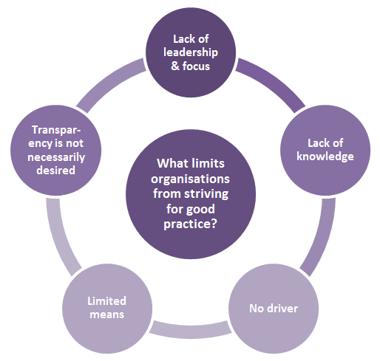

Lack of knowledge

For some organisations, it is a lack of awareness that they could be doing better and a lack of knowledge about how their systems could improve.

No driver

As already discussed, no car is driven without a driver. Without someone in the organisation who is interested, committed and resourced to drive good practice, and without a leadership that demands it, there is no imperative to pursue it.

Limited means

Not all organisations would be prepared to, or have the capacity to pay for the ‘gold-plated’ option of a managed, live database system, and perhaps their portfolio size may not warrant it. Most Australian businesses are small-medium sized, have limited financial resources, and do not have a dedicated asbestos manager, let alone a WHS or OHS manager. Often whoever manages the asbestos register also manages the organisation’s rosters, wages, accounts, human resources, and cleaning schedule. Organisations may need to be convinced of the benefits of adopting more comprehensive asbestos safety strategies that mean extra expense or extra work for a small management team.

Transparency is not necessarily desired

While some organisations are committed to seeing the whole picture, others may not be as keen to have it spelled out in black and white. As one stakeholder pointed out, “Once it’s written down, you are obliged to do something about it”. If an audit identifies extensive urgent removal is required, they might be required to spend a great deal of money to remediate it. Some organisations may believe a lack of transparency serves them better, at least in the short term.

* 1. Conclusion

Our review of asbestos registers suggests that organisations are fulfilling their obligations to have one, but that the way they are developed, what they contain, and how they are used, varies a great deal from one organisation to another. The differences cannot be discerned by level of government or whether they are private or public sector. The reasons for organisations taking the approaches they do are complex and varied, but we have identified several drivers and limiting factors that may influence their decisions.

Three groups of asbestos register types can be identified: basic registers, which fulfil the regulatory requirements but are not necessarily linked to broader asbestos management processes; fit for purpose registers, which go beyond the minimum and are specifically designed for the organisation to manage its asbestos safety obligations; and innovative practice, which takes a comprehensive register a step further to become a complete asbestos management solution (see Figure 5).

**Figure 5: Asbestos register types**



Appendices

APPENDIX A: Asbestos register template included in Model Code of Practice (2011)

|  |  |  |  |  |  |
| --- | --- | --- | --- | --- | --- |
| **ASBESTOS REGISTER** | | | | | |
| **Workplace address:** | | | Name of Competent Person: | | |
| Date of identification | Type of asbestos | Is it friable or non-friable? | Condition of asbestos | Specific location of asbestos | Is this an inaccessible area? |
|  |  |  |  |  |  |
|  |  |  |  |  |  |
|  |  |  |  |  |  |
|  |  |  |  |  |  |
|  |  |  |  |  |  |
|  |  |  |  |  |  |
|  |  |  |  |  |  |
|  |  |  |  |  |  |

*Source: Safe Work Australia (2011) Model Code of Practice - How to Manage and Control Asbestos in the Workplace*

APPENDIX B: Organisations consulted

|  |  |
| --- | --- |
| Sector | Organisation name |
| Commonwealth Government | Department of Defence  Immigration and Border Protection  Department of Infrastructure - Norfolk Island; Jervis Bay; Indian Ocean Territories  Department of Finance  CSIRO  National Association of Testing Authorities (NATA) |
| State/territory government | Northern Territory Department of Justice (NT Courts)  Northern Territory Department of Arts & Museums  NSW Land & Housing Corporation  Public Transport Authority of Western Australia  State Library of NSW  Housing Tasmania  Queensland Health  ACT Asbestos Response Taskforce  NSW Department of Education and Communities  Queensland Department of Education  Northern Territory Department of Education  Victorian Department of Education & Training |
| Local government | Adelaide City Council, SA  Break O’Day Council, Tasmania  Bundaberg Shire Council, Qld  Byron Shire Council, NSW  Copper Coast Council, SA  Mackay City Council, Qld  Shire of Kalamunda, WA  Sutherland Shire Council, NSW  Central Desert Regional Council, NT |
| Educational institutions | Wollongong University, NSW  University of Queensland, Qld  Great Southern Institute of Technology, WA |
| Private sector | Ergon Energy  Programmed Facility Management  PBS Building  Private Builder & MBA member  Australian Industry Group  Lupin Systems  Octfolio  Edge Group  Hart Safety  Ramsay Health |

APPENDIX C: Discussion guide - Organisations

Introduction

Inca Consulting has been engaged by the Asbestos Safety and Eradication Agency to undertake national research in order to understand the approaches organisations across different sectors take in relation to developing asbestos registers under the 2011 Work Health and Safety Regulations (or equivalent regulations for Vic and WA).

You should have received an email from the Asbestos Safety and Eradication Agency explaining the research and inviting you to participate.

The discussion will take about 20-30 minutes. Your responses will be treated confidentially. As a result of the discussions we have with around 50 organisations, we will develop a discussion paper for the Asbestos Safety and Eradication Agency, which sets out the current landscape and will help to develop models of good practice. This research is not intended to make any comments about compliance with the relevant regulations.

1. Could you start by telling me a bit about you and your role in the organisation?

Scale of asbestos issues in the organisation

1. How significant a problem is asbestos for your organisation? Is there an overarching organisational policy about asbestos management and removal?
2. How many buildings are in your organisation’s portfolio?
3. Does your organisation have a combined register, or are registers consolidated at building/property level only?
4. As you’re probably aware, an asbestos register is required for all buildings constructed prior to 2004, except where no Asbestos Containing Material (ACM) is present. How do you determine whether or not the building contains ACM?

Process for developing asbestos registers

1. How has your organisation gone about developing its asbestos register?
2. Who develops your register/s? (If internal – who has responsibility? If external – which consultant?)
3. Who conducts the site inspections?
4. Have you engaged a consultant to develop and/or manage your asbestos register?
5. If yes, what made you turn to this consultant for help? Was there an event or issue that triggered this action?
6. Is it costly to maintain an up-to-date asbestos register?
7. Does the register:
8. Identify the quantity of asbestos present
9. Identify risk level (e.g. low/medium/high)
10. Identify remediation priority
11. Include asbestos and asbestos-containing materials in *buildings*
12. Include asbestos and asbestos-containing materials in *plant and equipment*
13. Include photos of the affected sites
14. How is the data reported? For example, do you get a comprehensive report including recommendations for asbestos remediation & management? Or is data simply tabulated without recommendations?
15. What format is the asbestos register kept in? (e.g. Excel, PDF, Word, online)
16. How often is the register reviewed? Who does this?
17. Can the register be updated as things change (e.g. as remediation work is undertaken)? Is this systematically done, or is it left to the next review?

How the register is used

1. Who is provided access to the register? When? What is the process for providing access to the register?
2. Apart from fulfilling legislative requirements, is the asbestos register useful to the organisation? In what ways? (PROMPT: identifying risk; identifying priorities for remediation)
3. Do you feel the register provides you with sufficient, reliable information about the extent and condition of asbestos in the organisation’s buildings? If no, what else would you like the register to be able to do or include?
4. We are looking to identify elements of good practice around asbestos registers. Is there anything about your register that you feel works particularly well?
5. Would it be possible to obtain a copy of your asbestos register?

APPENDIX D: Discussion guide – Stakeholders

Introduction

Inca Consulting has been engaged by the Asbestos Safety and Eradication Agency to undertake national research in order to understand the approaches organisations across different sectors take in relation to developing asbestos registers under the 2011 Work Health and Safety Regulations (or equivalent regulations for VIC and WA).

This research is seeking to understand better:

• How organisations are responding to the legislative requirement of keeping asbestos registers

• What good practice might look like when it comes to asbestos registers

• What issues might influence an organisation’s approach to keeping asbestos registers.

We’d like to talk to you because you may have a perspective on some or all of these things. The discussion will take about 20-30 minutes. Your responses will be treated confidentially.

As a result of the discussions we have with around 50 stakeholders and organisations, we will write a discussion paper for the Asbestos Safety and Eradication Agency, which sets out the current landscape and will help to develop models of good practice. The research is not intended to make any comments about compliance with the relevant regulations.

Questions

1. Could you start by telling me a bit about your organisation, and your role there?
2. How familiar are you with organisations’ asbestos registers? How have you come to be familiar with these?
3. How comprehensive do you think organisation’s asbestos registers are? Have you seen good and bad examples?
4. What is a good one like?
5. What’s a not-so-good one like?
6. Do you think the organisations you deal with are clear about their responsibilities around keeping an asbestos register? For example do you think they know:
7. that all buildings constructed before 2004 need to be included in a register?
8. that the register needs to include plant and equipment as well?
9. that the register should be updated regularly?
10. As you’re probably aware, an asbestos register is not required for a pre-2004 building if no ACM (Asbestos Containing Material) is present. Do you know how organisations determine whether or not the building contains ACM?
11. How do you think organisations view the keeping of an asbestos register? Are they mainly fulfilling legislative requirements, or are they also using the registers to help them manage asbestos in their buildings and equipment?
12. Do you think the keeping of asbestos registers is improving the management of asbestos amongst organisations?
13. Bearing in mind the legislation specifies only a minimum requirement, what would you consider to be the features of an asbestos register that goes beyond the minimum requirements? What would best practice look like?
14. What would motivate an organisation to go beyond the minimum requirements and strive for good practice?
15. What factors might prevent them from striving for a best practice model? Is cost a significant factor?
16. What issues are there in accessing an asbestos register (by maintenance or building contractors/staff)?
17. Can you suggest any organisations whose registers it might be useful for us to look at for this review? Do you think they would be amenable to us contacting them (Who?)

APPENDIX E: Survey of tradespeople

Key findings

* Only 59% of tradespeople knew what an asbestos register was, and only 47% had ever come across one before.
* Only 28% of those surveyed had ever undertaken an asbestos training course (awareness, removal or both) and of these, 45% had done the course more than five years ago.
* Nevertheless, the tradespeople rated highly their knowledge about the dangers of working with asbestos (75% said their knowledge was *good* or *very good*) and their knowledge about working safely on sites containing asbestos (82% rated their knowledge as *good* or *very good*).
* Tradespeople who had undertaken an asbestos training course tended to rate their knowledge and awareness about working with asbestos more highly than those who had not undertaken a training course. However the survey also suggested they may be a little more circumspect regarding how much they trust and confidence they place in the registers to allow them to do their work safely.
* Asking to see an asbestos register is not particularly common practice amongst the tradespeople: only about half said they always or usually asked to view the register before starting work. However an asbestos register seems to be relatively easy to access when needed.
* Three-quarters of the tradespeople said they were always or usually properly informed about whether the site contains asbestos, while two-thirds generally participated in an induction session.
* Viewing of the asbestos register when quoting on a job is a relatively uncommon practice.
* About a third (31%) said that registers they see *always* or *usually* contain asbestos in plant and equipment, while another third (34%) said they *rarely* or *never* see this.
* There was a high degree of agreement about the importance of asbestos registers to working safely, although the accuracy and currency of the registers were an issue for a significant proportion.

Introduction

A telephone survey of 150 tradespeople was undertaken in October 2015. A random sample was drawn from a trades database (Dun & Bradstreet) to include a range of trades as well as a good spread across States and Territories and capital city/regional/remote areas.

A survey questionnaire was collaboratively designed with the agency to focus on key issues that emerged from the qualitative stage and desktop review. The survey questionnaire is included at Appendix F.

Who the respondents were

A filter question ensured that only tradespeople who worked at least some of the time on non-residential sites were interviewed.

A wide cross-section of tradespeople was interviewed. Electricians, carpenters/joiners, plasterers and plumbers accounted for half of the respondent group. The respondents were generally an experienced group, with more than half (53%) having been in their trade for more than 21 years (Figure A1). Just over one-quarter (27%) also had a second trade.

Table A1: Main trade of respondents in sample

|  |  |  |
| --- | --- | --- |
| Trade | Number | Percentage |
| Electrician | 25 | 16.7% |
| Carpenter/joiner | 22 | 14.7% |
| Plasterer | 14 | 9.3% |
| Plumber | 14 | 9.3% |
| Builder | 13 | 8.7% |
| Air conditioning installer/repairer | 9 | 6.0% |
| Painter/decorator | 8 | 5.3% |
| Tiler | 8 | 5.3% |
| Bricklayer | 7 | 4.7% |
| Stonemason | 7 | 4.7% |
| Roofer/roof tiler | 5 | 3.3% |
| Ceiling contractor | 3 | 2.0% |
| Metalworker | 2 | 1.3% |
| Shopfitter | 2 | 1.3% |
| Other* | 11 | 7.3% |
| *Total answered* | *150* | *100.0%* |

*\*Other includes: engineer, ceiling/wall contractor, roller door/skylight installer, concreter, metal worker, garage/shed installer, gutter fixer, heavy duty mechanic, insulator, communications technician.*

Figure A1: Number of years respondents have been in their trade

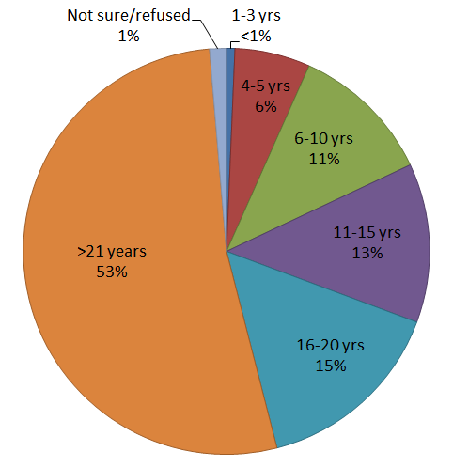

(N=150)

Around 33% of respondents were involved in construction, 12% were involved in maintenance, but the majority (53%) did a mix of both construction and maintenance. The majority (85%) were self-employed. The sample included tradespeople for whom non-residential work made up both a larger and a smaller proportion of their work (Figure A2).

Figure A2: Which of the following describes how often you work on non-residential sites?

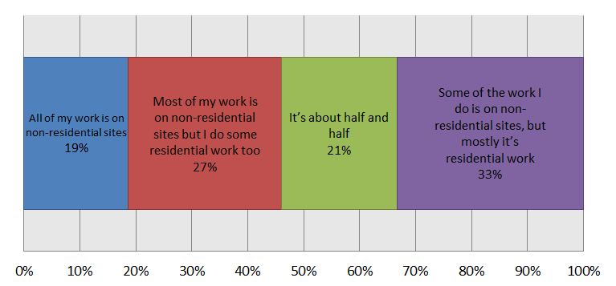

(N=150)

Figure A3: Respondents by state/territory

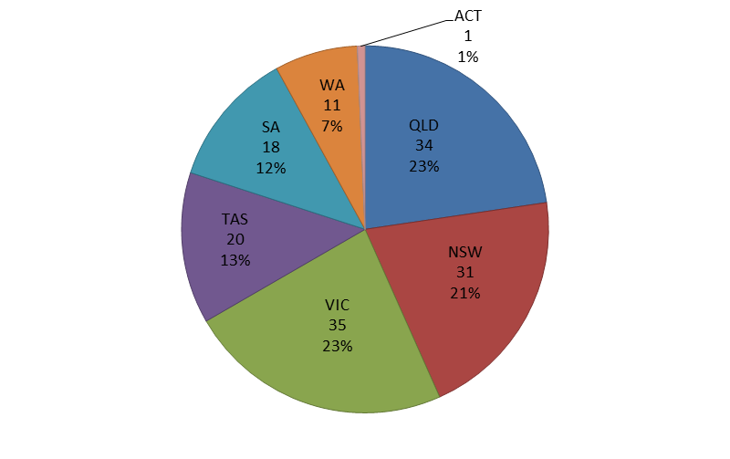

(N=150)

Figure A4: Main work location

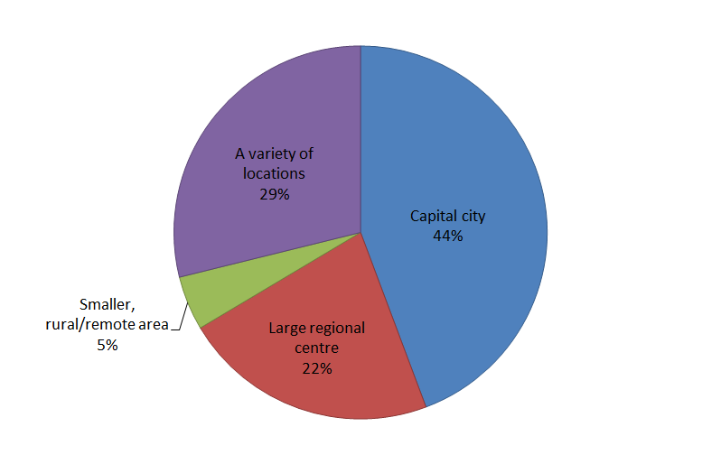

(N=150)

Awareness and knowledge about asbestos

Three-quarters (75%) of the tradespeople surveyed rated their knowledge about the dangers of working with asbestos as *good* or *very good*, while 82% rated their knowledge about working safely on sites containing asbestos as *good* or *very good* (Figures A5 and A6).

Only 28% of those surveyed had ever undertaken an asbestos training course, and of those who had, 45% had done the course more than five years ago (Figures A7 and A8).

As might be expected, a much higher proportion of those who had undertaken a training course said their knowledge was *good/very good* about the dangers of working with asbestos (94% compared with 66% of those who had not undertaken training) and working safely on sites containing asbestos (98% compared with 77% who had not undertaken training) (Figures A9 and A10)

Figure A5: How would you describe your knowledge and awareness of the dangers of working with asbestos?

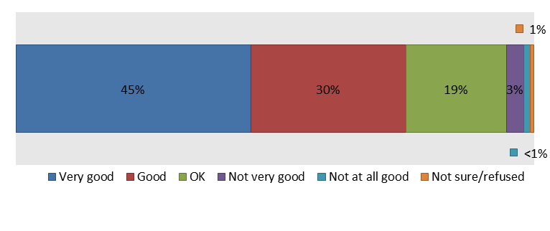

(N=150)

Figure A6: How would you describe your knowledge about how to work safely on sites where there is asbestos present?

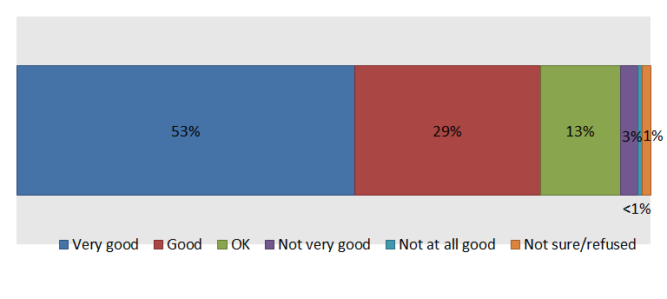

(N=150)

Figure A7: Asbestos training courses undertaken

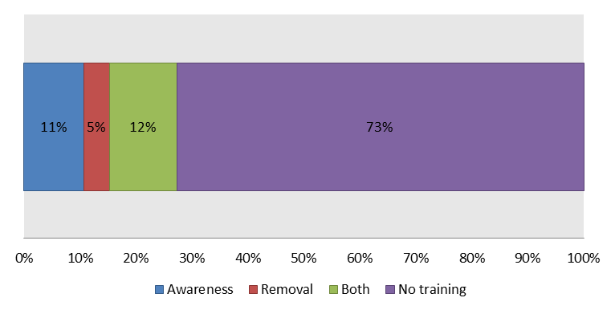

(N=150)

Figure A8: How long ago did you undertake the asbestos training course?

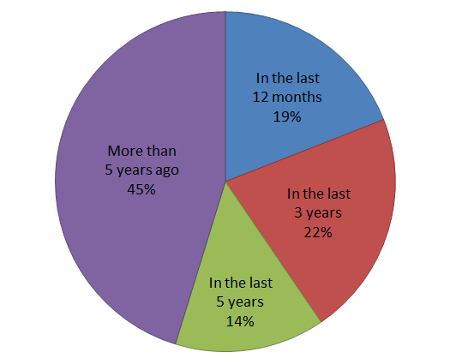

(N=42)

Figure A9: Knowledge and awareness of the dangers of working with asbestos by asbestos training status

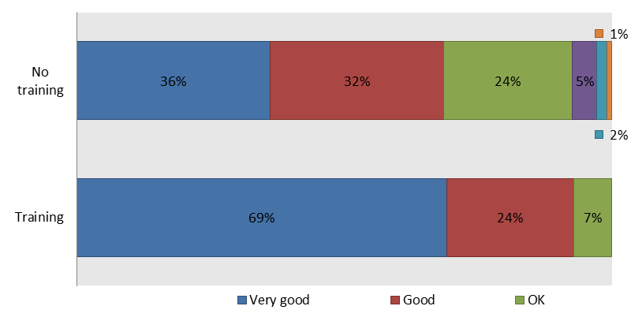

(N=150)

Figure A10: Knowledge about how to work safely on sites where there is asbestos present by asbestos training status

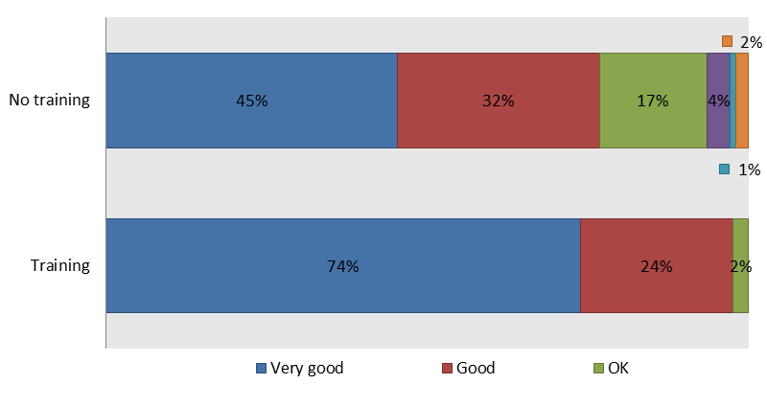

(N=150)

Awareness of asbestos registers

Only 59% of tradespeople knew what an asbestos register was, and even fewer (47%) had ever come across one (Figure A11). Of the 88 who knew what an asbestos register was, the majority (83%) also knew that all non-residential buildings were required by law to have an asbestos register, unless it has been determined that no asbestos is present.

Figure A11: Awareness and experience of asbestos registers

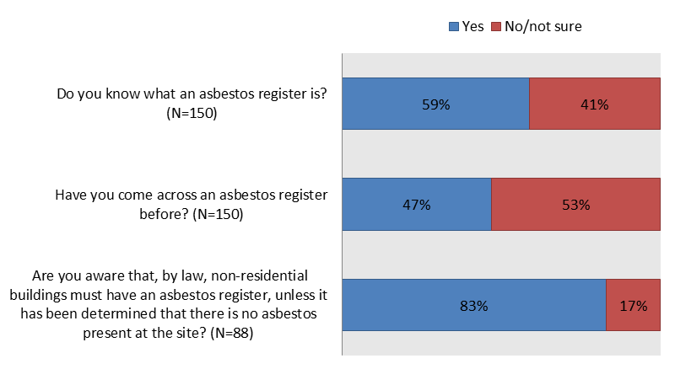

Access to and use of asbestos registers

The 70 respondents who indicated they had come across an asbestos register before were asked about how they accessed and used the register. One-third (34%) said they *always* asked to see the asbestos register before commencing work, and 21% said they *usually but not always* asked to see it. The remaining 45% of respondents asked to see it *about half the time* (8%), *only sometimes* (18%) or *never* (18%) (Figure A12).

When asked how often they have been unable to access an asbestos register when they needed to, 60% said *never*, 21% said *once or twice*, 10% said *sometimes*, and 1% (one person) said *often* (Figure A13).

Most respondents (74%) said it was *easy* or *very easy* to access the asbestos register when they have needed to (Figure A14).

Figure A12: When you start work on a non-residential site, how often would you (or one of your workmates) ask to see the asbestos register before commencing work?

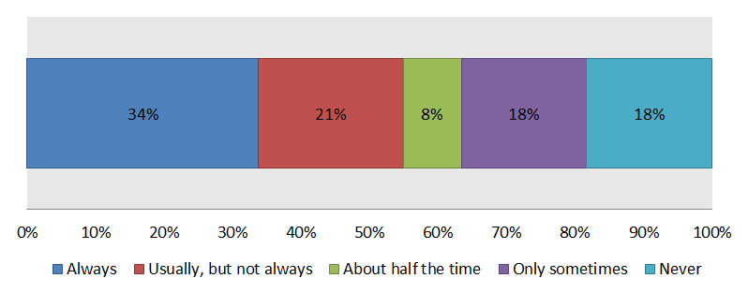

(N=70)

Figure A13: How often is it the case that you have been unable to access an asbestos register when you’ve needed it?

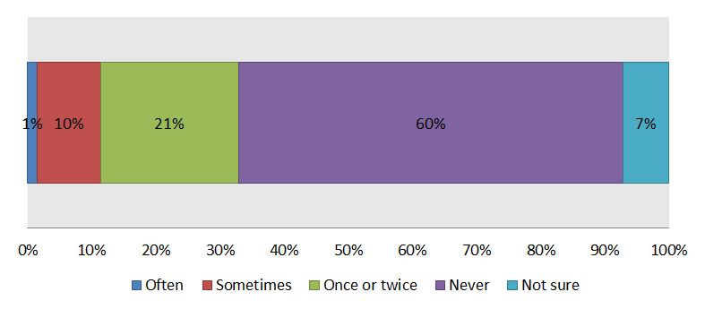

(N=70)

Figure A14: How easy is it to access an asbestos register when you need to?

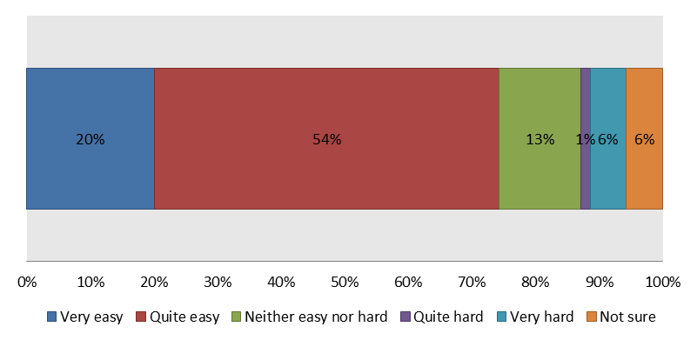

(N=70)

Figure A15 presents the results concerning some of the tradespeople’s practices concerning asbestos registers. The majority (77%) of respondents said they were *always* or *usually* able to access the register at the actual work site, rather than just the office (23% said they were *sometimes* or *never* able to do so).

Three-quarters (75%) said they were *always* or *usually* properly informed about whether the site contains asbestos (25% said they were *sometimes* or *never* properly informed).

Two-thirds (66%) said they always or usually participated in an induction session that includes the asbestos register prior to commencing work (34% *sometimes* or *never* did so).

Only 30% said they *always* or *usually* accessed the asbestos register when quoting on a job (27% *sometimes* did so, while 43% *never* did so).

Figure A15: How often do you do the following?

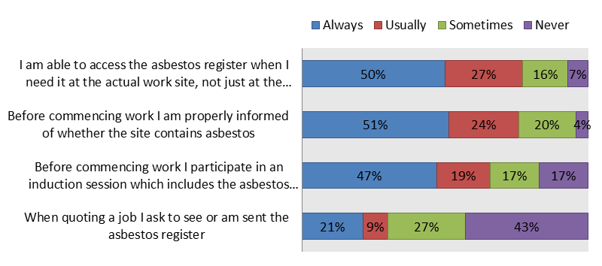

(N=70)

Views about asbestos registers

While the majority of respondents thought that asbestos registers and the risk ratings used in them were fairly clear and contained the information they need to do their work, they were less likely to agree that asbestos registers are accurate and up to date (57% agreed while 24% disagreed that asbestos registers are usually up to date and accurate; 19% did not know/neither agreed nor disagreed) (Figure A16).

There was a high degree of agreement about the importance of asbestos registers to working safely: 76% *agreed/strongly agreed* that the register gives them confidence that they could do their work safely. Some 91% agreed that looking at the asbestos register is an important precaution, with 49% *strongly agreeing* with this statement (Figure A17 provides detail on the strength of agreement/disagreement with the statements).

Figure A16: Do you agree or disagree with the following statements?

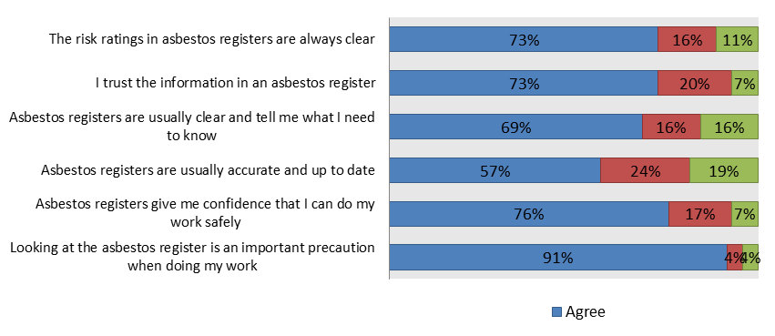

(N=70)

**Figure A17: How strongly do you agree or disagree with the following statements?**

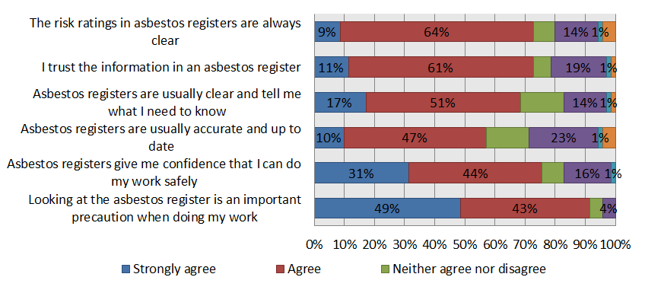

Due to the small sample size, statistically significant differences between sub-groups cannot be determined with a high degree of confidence. However there does appear to be a pattern in the responses of those who *have* and those who *have not* undertaken some kind of asbestos training. The results in Figure A18 suggest that those who have done some asbestos training were more reluctant to agree on most of the statements. One inference could be that those who have been trained might be more alert to any deficiencies they see in the registers, however this would require further research to verify.

**Figure A18: Those who agree or strongly agree by asbestos training status**

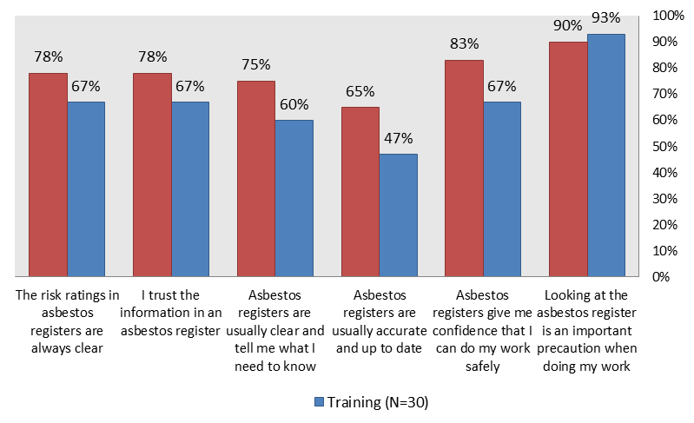

(N=70)

Format and inclusions of asbestos registers

According to the tradespeople in the survey, it is not very common to see registers that contain asbestos in plant and equipment. About a third (31%) said that registers they see *always* or *usually* contain asbestos in plant and equipment, while another third (34%) said they *rarely* or *never* see this (Figure A19).

**Figure A19: Do the asbestos registers you see also include asbestos in plant and equipment?**

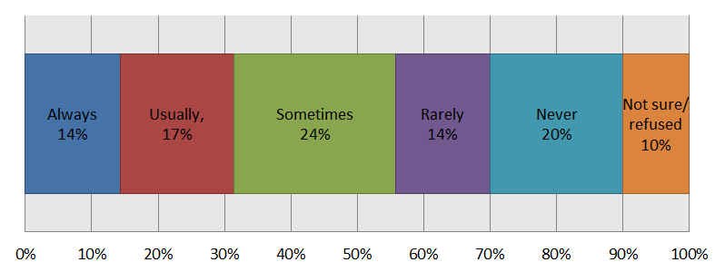

(N=70)

By far the most common format seen is a printed paper document, followed by an electronic document (e.g. an Excel spreadsheet document). Web-based database systems were fairly rare (Figure A20)

**Figure A20: How often have you seen asbestos registers in the following formats?**

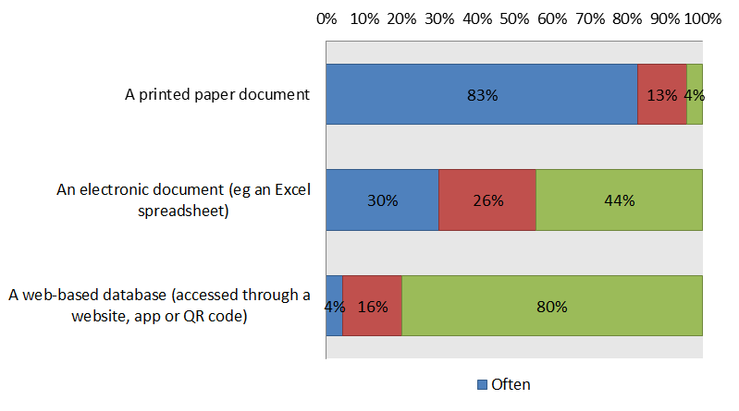

(N=70)

The respondents were split between those who didn't mind which format the registers came in, as long as it was available and correct, and those who preferred a paper or PDF document they could easily read and understand. Some of the tradespeople commented that they were not too technologically-minded. Some of the comments from those who preferred a paper/downloadable PDF format included:

*“Paper is what I usually find. It's more available onsite.”*

*“We find the paper register is normal the easiest format to use. Well, it's a written register that defines act item on site.”*

*“Paper based I think. Because it's permanent on site. You can't have a computer telling you what to do. It's a registered document that you have up.”*

*“I would say the paper based ones. Regardless of what happens, you have access to it.”*

*“Just the typed one on the wall at the entrance where you are working. You can see and you can browse it and make up your own assumptions.”*

*“Hard copy as I like to have it in front of me. I've been working with asbestos for thirty years or so.”*

*“No. I don't know. I don't use computers that much. I just prefer paper to be fine and updated. Because you're on site and I don't have my computers on site.”*

*“I prefer the written myself because I'm an old fogey. That's what I've been brought up with. I prefer to go from place to place and take it with me.”*

*“I don't know. Because I've only ever seen in a written format really.”*

However, the other part of the respondent group didn't mind which format was used, or preferred the electronic/online formats:

*“I think the reality is that it is going to go digital. I think the paper society is great because it's there for you, but the reality is that we are leaning towards electronics. With a download it's convenient, it’s fast.”*

*“Not really, they all show the same information. The paper copy is easier to lose though, because it is handled so much.”*

*“Electronic because you can print out the bits you need.”*

*“Personally I think it should be cloud based - each individual should have a portal where each person can submit changes and it goes to one central location.”*

*“A web format would be much more accessible and reliable. We should be able to rock up to the job sight and access it that way, rather than arrive and find it's not there because it hasn't been passed onto the occupier.”*

*“I would find the QR one a lot easier so you wouldn't have to go searching for it. When you get there it can be in a locked cabinet where you have to get a key.”*

*“Format does not matter as long as it is clear.”*

*“Not really. As long as we get the correct information I don't care about the format.”*

What constitutes a good quality asbestos register?

When asked what the features of a good quality asbestos register are, respondents most commonly identified:

* Clarity, easy to understand

*“Clarity. As long as it conveys the information we need, it's a good register.”*

*“As long as it's accurate and clear. It gives the risks. Whether there is a blue asbestos for insulation or fire purpose.”*

*“Clear wording and images of the areas.”*

* Level of detail
* Visual cues e.g. pictures and colour coding
* Accuracy and currency

Respondents were asked whether they thought there were particular site types that were more or less likely to have a good, reliable asbestos register. In response, 76% thought there were sites more likely to have a good register, and 69% thought there were sites less likely to have one. The main site types identified by the respondents are listed in Table 2.

**Table A2: Sites more/less likely to have a good reliable asbestos register**

|  |  |
| --- | --- |
| Sites *more* likely to have a good, reliable register | Sites *less* likely to have a good, reliable register |
| Government sites  Schools  Large industrial or commercial sites  Multi-storey office buildings  Hospitals  Universities  Shopping centres  Power stations | Small businesses  Private companies  Small offices and commercial buildings  Older/rundown buildings  Warehouses  Shops  Smaller buildings managed by those who own it |

Assumed vs confirmed asbestos

Respondents were asked what difference it makes when an asbestos register notes that asbestos is ‘assumed’ rather than confirmed by sample testing. Most respondents said they would generally treat ‘assumed asbestos’ as though asbestos were present and take the normal precautions around asbestos:

*“We’ll we treat it with a lot more caution. We don't know if it's asbestos. We just treat it as if it is.”*

*“No difference at all. You approach it as if asbestos is there.”*

*“It would be treated the same as if it contained asbestos. Just as a precaution, because it's too late afterwards to find out the area has asbestos.”*

*“I suppose you're a lot more careful. You're a lot more aware. Well if you know what it's about you're a lot more wary of it, you're looking out for it.”*

*“No different. You treat it like it's there. You just put the gear on and treat it like an asbestos until we clear it”.*

Some said they get confirmation through testing by a qualified hygienist before commencing work:

*“We refuse to work on any sites that don't have one. We would get a specialist contractor in to come in and investigate it.”*

*“If it's assumed asbestos is in the building I would want further testing before anyone would start work.”*

*“We won't touch it. We are not asbestos specialists and unless it has been registered and tested, we won't take that chance.”*

*“I would get it checked I reckon. For example, a school job might have floor tiles that contain asbestos, they would need to be tested first before we removed them.”*

*“We don't live on assumptions. If we think there is asbestos, we pay for a sample to save a lot of mucking around.”*

APPENDIX F: Tradespeople Survey Questionnaire

Introduction

Good morning/afternoon/evening. I am calling from CanvasU. We are conducting a short survey on behalf of the Asbestos Safety and Eradication Agency. The survey is designed to understand how tradespeople make use of Asbestos Registers when undertaking construction or maintenance work on non-residential building sites. The survey is totally anonymous and you will not be identified in the research report. The survey will take about 10 minutes of your time. If now is not a convenient time, we can call you back at a time that suits you.

Screener:

**Firstly, can I please confirm that you have undertaken construction or maintenance work on a non-residential building site at some point in the last 12 months? By this, I mean that you have personally undertaken work on-site and not just played a managerial role.**

1**. Yes** – continue with survey

2**. No** – Terminate interview saying ‘thank you, but we only need to speak with tradespeople who have recently worked on non-residential sites.

Firstly, I would like to ask a few questions about you, to make sure we speak to a good cross section of people.

**1. What is your main trade?**

***DO NOT READ OUT. SINGLE RESPONSE***

1. Air conditioning installer/repairer
2. Bricklayer
3. Builder
4. Carpenter/joiner
5. Electrician
6. Engineer
7. Handyman/general maintenance
8. Painter/decorator
9. Plasterer
10. Plumber
11. Roof tiler
12. Shopfitter
13. Signer
14. Stonemason
15. Tiler
16. Other (specify)

**2. How long have you been licensed in this trade?**

***READ OUT. SINGLE RESPONSE***

1. Less than a year
2. 1-3 years
3. 4-5 years
4. 6-10 years
5. 11-15 years
6. 16-20 years
7. More than 21 years
8. Not sure/refused

**3a. Do you have another trade?**

1. Yes
2. No

**3b. If YES: What other trades do you have?**

***DO NOT READ OUT. MULTIPLE RESPONSE.***

1. Air conditioning installer/repairer
2. Bricklayer
3. Builder
4. Carpenter/joiner
5. Electrician
6. Engineer
7. Handyman/general maintenance
8. Painter/decorator
9. Plasterer
10. Plumber
11. Roof tiler
12. Shopfitter
13. Signer
14. Stonemason
15. Tiler
16. Other (Specify)

**4. Which of the following describes how often you work on non-residential sites?**

***READ OUT. SINGLE RESPONSE***

1. All of my work is on non-residential sites
2. Most of my work is on non-residential sites but I do some residential work too
3. It’s about half and half
4. Some of the work I do is on non-residential sites, but mostly it’s residential work
5. Not sure/refused

**5. Which of the following do you do?**

***READ OUT. SINGLE RESPONSE***

1. Construction work
2. Maintenance work
3. A mix of both
4. Something else (specify)

**6. Do you have an employer (e.g. a company) or are you self-employed?**

***SINGLE RESPONSE***

1. I have an employer
2. I’m self-employed
3. Other (specify)

**All the questions in this survey relate to your work on non-residential sites.**

Awareness of asbestos risk

**7. How would you describe your knowledge about the dangers of working with asbestos?**

***READ OUT. SINGLE RESPONSE***

1. Very good
2. Good
3. OK
4. Not very good
5. Not at all good
6. Not sure/refused

**8. How would you describe your knowledge about how to work safely on sites where there is asbestos present?**

***READ OUT. SINGLE RESPONSE***

1. Very good
2. Good
3. OK
4. Not very good
5. Not at all good
6. Not sure/refused

**9a. Have you ever undertaken an asbestos training course?**

1. Yes
2. No

**9b. [If yes] W hat kind of course was it?**

1. Awareness
2. Removal
3. Both
4. Other (specify)

**9c. [If yes] When did you do the training?**

1. In the last 12 months
2. In the last 3 years
3. In the last 5 years
4. More than 5 years ago

Awareness and knowledge of asbestos registers

**10a. Do you know what an asbestos register is?**

1. Yes
2. No/not sure

**10b. IF YES to Q10a, Are you aware that, by law, most non-residential buildings must have an asbestos register, unless it has been determined that there is no asbestos present at the site?**

1. Yes
2. No/not sure

**If NO to Q10a or Q10b**: *Explain* - an asbestos register must be kept by law by any organisation that has a building constructed before 2004 (or 1990 in some states/territories). It details the type and location of asbestos containing materials in each building and in any plant or equipment.]

**10c. Have you come across an asbestos register before?**

1. Yes
2. No – SKIP TO DEMOGRAPHICS

Accessing asbestos registers

**11. When you start work on a non-residential site, how often would you (or one of your workmates) ask to see the asbestos register before commencing work?**

***READ OUT. SINGLE RESPONSE***

1. Always
2. Usually, but not always
3. About half the time
4. Only sometimes
5. Never
6. Not sure/refused

**12. Generally, how easy is it to access an asbestos register when you need to?**

***READ OUT. SINGLE RESPONSE***

1. Very easy
2. Quite easy
3. Neither easy nor hard
4. Quite hard
5. Very hard
6. Not sure

**13a. How often is it the case that you have been unable to access an asbestos register when you’ve needed it?**

***READ OUT. SINGLE RESPONSE.***

1. Often
2. Sometimes
3. Once or twice
4. Never
5. Not sure

**13b. [If Often, Sometimes or Once or twice] What has prevented you from accessing the asbestos**

**register on these occasions?**

***RECORD VERBATIM***

Use of asbestos registers

**14. How often do you do the following things? In each case, please say whether you always, sometimes or never do these things.**

***READ OUT STATEMENTS***

|  |  |  |  |  |
| --- | --- | --- | --- | --- |
|  | Always | Usually | Sometimes | Never |
| 1. When quoting a job I ask to see or am sent the asbestos register |  |  |  |  |
| 1. Before commencing work I participate in an induction session which includes the asbestos register |  |  |  |  |
| 1. Before commencing work I am properly informed of whether the site contains asbestos |  |  |  |  |
| 1. I am able to access the asbestos register when I need it at the actual work site, not just at the office |  |  |  |  |

**15. How strongly do you agree or disagree with the following statements? In each case, please say**

**whether you strongly agree, agree, disagree or strongly disagree. Please also tell me if you neither**

**agree nor disagree or if you are unsure.**

***READ OUT***

|  |  |  |  |  |  |  |
| --- | --- | --- | --- | --- | --- | --- |
|  | Strongly agree | Agree | Neither agree nor disagree | Disagree | Strongly disagree | Not sure |
| 1. Looking at the asbestos register is an important precaution when doing my work |  |  |  |  |  |  |
| 1. Asbestos registers give me confidence that I can do my work safely |  |  |  |  |  |  |
| 1. Asbestos registers are usually accurate and up to date |  |  |  |  |  |  |
| 1. Asbestos registers are usually clear and tell me what I need to know |  |  |  |  |  |  |
| 1. I trust the information in an asbestos register |  |  |  |  |  |  |
| 1. The risk ratings in asbestos registers are always clear |  |  |  |  |  |  |

**16. Do the asbestos registers you see also include asbestos in plant and equipment (e.g. machinery)?**

1. Always
2. Usually
3. Sometimes
4. Rarely
5. Never
6. Not sure/refused

**17. When an asbestos register notes that asbestos is ‘assumed’ rather than confirmed by sample testing, what (if any) difference does this make to the way you approach this area of work?**

***RECORD VERBATIM***

**18a. How often have you seen asbestos registers in the following formats? For each answer often, not very often, or never.**

|  |  |  |  |
| --- | --- | --- | --- |
|  | Often | Not very often | Never |
| A printed paper document |  |  |  |
| An electronic document (e.g. an Excel spreadsheet) |  |  |  |
| A web-based database (accessed through a website, app or QR code) |  |  |  |

**18b. Do you find there is any advantage of one format over another?**

***RECORD VERBATIM***

**19. What do you think are the main features of a good quality asbestos register?**

***RECORD VERBATIM.***

**20. If there were a couple of things that could make asbestos registers better, to make it easier and safer for you to do your work, what would they be?**

***RECORD VERBATIM.***

**21. In your experience are there particular building site types that are more likely to have a good, reliable asbestos register?**

1. No
2. Yes – provide details: _________________

***RECORD VERBATIM. INTERVIEWER NOTE: WE ARE LOOKING FOR BUILDING TYPES (E.G. SCHOOLS, SHOPPING CENTRES, LIBRARIES, SMALL SHOPS, FACTORIES, OFFICE BUILDINGS ETC. NOT SPECIFIC BUILDING NAMES)***

**22. And are there particular building site types that are less likely to have a good, reliable asbestos register?**

1. No
2. Yes – provide details:

***RECORD VERBATIM***

Demographics

**23. Which state or territory do you mainly work in?**

***SINGLE RESPONSE***

1. Queensland
2. NSW
3. Victoria
4. Tasmania
5. South Australia
6. Western Australia
7. Northern Territory
8. ACT

**24. Do you mainly work in…**

***READ OUT. SINGLE RESPONSE***

1. A capital city
2. A large regional centre
3. A smaller, rural or remote area
4. A variety of locations
5. Not sure/refused

1. Work Health and Safety Regulations 2011, Regulation 425(3).
2. The information in the Code of Practice is aimed at all types of PCBUs, including small businesses. It is important to note that this research is not a review of the effectiveness of the Code of Practice. Rather, it seeks to describe and explain the variation in practices under the Code and focuses on PCBUs with significant property portfolios.
3. Western Australian Auditor General (2015) *Asbestos Management in Public Sector Agencies*, p.17.
4. United Kingdom Accreditation Service (2015) *Inspection body accreditation*, [http://www.ukas.com/services/accreditation-services/inspection-body-accreditation](http://www.ukas.com/services/accreditation-services/inspection-body-accreditation/)/
5. Ibid, p.19
6. Ibid, p.20
7. This date was determined by the agency, despite the later date recommended in the Model Code of Practice.
8. Work Health and Safety Regulations 2011, Regulation 427.
9. WorkSafe Victoria (2008) *Managing asbestos in workplaces*.
10. NSW Department of Premier and Cabinet (2012) *Model Asbestos Policy for NSW Councils*.