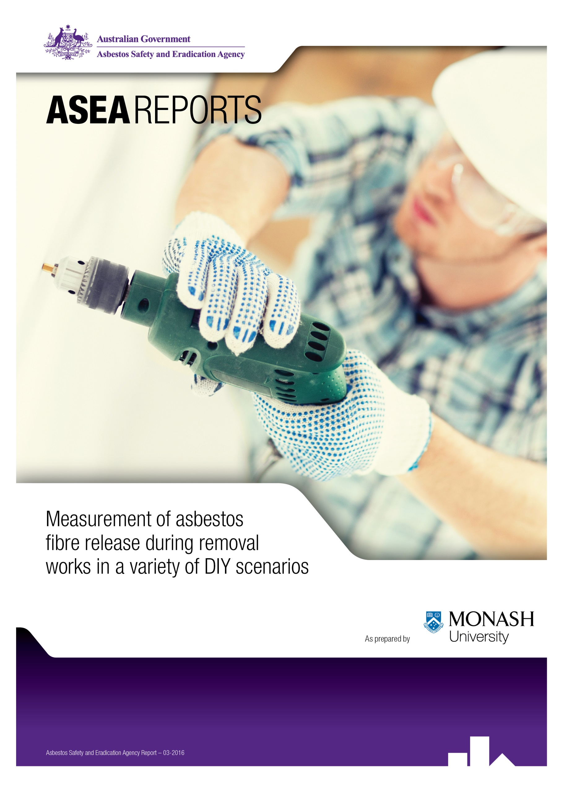

Table of Contents

Executive Summary 3
Non occupational asbestos exposure: an overview 6
Fibre release in DIY removal of asbestos in renovation and maintenance 7
Bulk sample results 10
Task results 11
Monitoring results by asbestos fibre type 22

Executive Summary
This study highlights the potential risks of do-it-yourself (DIY) work involving asbestos. Asbestos cement (AC) sheeting is commonly encountered in DIY renovation and maintenance in Australian residences. The removal or disturbance of AC sheeting has the potential for fibre release which may lead to an asbestos-related disease.
Recent research has suggested that there may be many millions of Australian residents undertaking renovations and maintenance involving asbestos exposure (Park et al, 2013). The Asbestos Safety and Eradication Agency (the agency) has identified this as an area of concern and recognize there is a need to clarify the likely exposure to residential renovators to improve information of the needs for controls during renovation works. Whilst asbestos containing materials (ACMs) often encountered during renovations includes many asbestos products, this study focuses on AC sheeting because AC sheeting is overwhelmingly the largest volume asbestos building product found in residences in Australia (Brown, 1987).
The scope of this report was to quantify the asbestos fibre release and potential exposure during DIY home renovation involving the disturbance or removal of AC sheeting. Nine common tasks undertaken during renovation and maintenance were simulated inside a specially constructed enclosure. Simulations were necessary to enable a controlled environment for safety and containment of fibre release during monitoring. Both personal and static monitoring were undertaken and analysis of samples involved both phase contrast and electron microscopy.
The results of the monitoring of the simulated tasks clearly indicated that if power tools were not used and there was minimal breakage of AC sheets, then exposure was generally low compared to reported historical occupational exposure (Hyland et al, 2010). However, for tasks that were in relatively confined areas with little ventilation, the use of power tools and breaking of AC sheeting prior to bagging could result in personal exposures unacceptable (above 0.02 f/ml) in current occupational scenarios. Work involving corrugated AC sheeting for external applications was likely to produce more cement dust, due to its greater thickness, but not necessarily more asbestos fibre exposure possibly due to its lower overall asbestos content.
Static sampling results were found to be always less and often less than half the exposure from simultaneous personal monitoring during a particular task. A finding with significant implications for the monitoring conducted, in both DIY renovators and work involving professional removalists, Personal monitoring is rarely conducted during professional asbestos removal, the vast majority of monitoring currently undertaken being para-occupational control and clearance monitoring, which is static monitoring. While the purpose of clearance and control monitoring, which in non-friable removal operations very rarely returns results exceeding 0.01f/ml, is not directly related to occupational exposure, it would seem that there is an argument for more personal monitoring to provide a more accurate indication of the efficacy of the controls employed. A guaranteed result of less than 0.01f/ml, for non-friable asbestos removal, almost regardless of removal technique, provides little incentive to employ as low as reasonably practicable controls and no relative assessment of the efficacy of different control methods supporting continual improvement.

The simulations provide supporting evidence for existing recommendations for work with non-friable asbestos materials generally and DIY works in particular that:
- the use of power tools is avoided;
- breaking up of AC sheeting is minimised;
- where sheeting needs to be broken up, this elevates the risk and professional services should be considered.
- within the overriding constraints of containing contamination from other occupied areas, DIY renovators should maximise ventilation during work e.g. by working outside.
- DIY renovators should wear PPE at all times and particularly when working indoors.
Dissemination of this information to the target DIY audience requires a strategy that takes into account the DIY worker’s position outside traditional lines of WHS/OHS communication, education and enforcement. This should be a focus of further investigation by the agency.

Scope
The Asbestos Safety and Eradication Agency (the agency) was established on 1 July 2013 to provide a national focus on asbestos issues which goes beyond workplace safety to encompass environmental and public health concerns.
Exposure to asbestos during do-it-yourself (DIY) renovation and maintenance by residents in residential premises has been identified as an issue of concern for all levels of government. Surprisingly, little has been published on the measurement of asbestos fibre release during removal works in a variety of DIY asbestos removal scenarios. There have been a few reports of fibre release during removal by professional removalists, but these have not been scenarios/tasks that are typical of DIY activities.
The scope of this study was to simulate tasks and exposure scenarios in DIY renovation and maintenance. The main tasks and fibre exposure release scenarios simulated were:
- removal of asbestos cement (AC) flat external wall sheeting in dry conditions
- removal of asbestos AC corrugated (e.g. Super Six) external roof sheeting in dry conditions
- removal of a small outdoor shed constructed of flat and corrugated AC sheeting
- removal of asbestos cement support materials (to ceramic tiles) in sink splash-backs inside
- removal of AC wall panels and ceilings in bathrooms and kitchens
- removal of small sections of AC corrugated sheet to create penetrations e.g. for fans or flues
- removal of small sections of AC flat sheet to create penetrations (e.g. for an air conditioner)
- drilling and screwing into asbestos cement sheet (e.g. to fix hooks, strapping, shelving, etc.)
- stacking, wrapping and bagging of AC sheeting for disposal

Simulations were considered to be representative of credible, worst case conditions for each of the scenarios based on previous reported literature. There are no requirements for asbestos registers (reports on the location and condition of asbestos materials required under Occupational/Work Health and Safety Legislation) for homes unless the home becomes a workplace. Currently there is guidance that may be accessed online for DIY renovators from enHealth (enHealth, 2013). The Asbestos Codes and other documentation available have been calibrated to the workplace which is subject to strict legislative controls and targeted towards those with an occupational understanding of asbestos.
Quantitative exposure assessment of DIY tasks involving asbestos will inform risk assessment for DIY renovators, identify the major determinants of exposure and enable the production of controls calibrated to the DIY environment. Dissemination of this information to the target audience requires a strategy that takes into account the DIY worker’s position, outside traditional lines of WHS/OHS communication, education and enforcement. This could be a worthy focus of further investigation by the agency.

Background

Non occupational asbestos exposure: an overview
The banning of the use, exportation and importation of asbestos and ACMs in Australia in 2003 has drastically reduced the exposure to asbestos in Australian workplaces. It may be argued that brief exposures from in situ materials, professional removalists, iron ore miner sin Western Australia and exposures by tradesmen are probably the only remaining significant occupational exposures. There is much less known about exposure risks in the non-occupational (DIY) sector.
Following World War Two, and until the mid-1980s asbestos containing building materials were widely used in residential homes. The housing shortages of the 1950s and 1960s were a driving force for the use of AC exterior cladding, roofing and internal walls in wet areas. It has been estimated that up to 680,000 private dwellings in Australia had been constructed with AC external walls (Brown, 1997). The externally exposed AC products were often corrugated and up to 10mm thick. The internal AC sheets were usually flat and less than half the thickness of external cladding. Other asbestos containing building materials such as asbestos containing flooring, specialist mouldings, compressed asbestos cement, backing to heating systems, plumbing fixtures and electrical power boards and other electrical components generally pose a lower risk of fibre release compared to the potential exposure to AC sheeting in homes.
From the 1970s onwards renovation and maintenance in residences that contained AC sheeting began to increase. In particular, external AC cladding and roofing were often replaced with products such as brick and corrugated iron. Indoors, AC sheeting in wet areas was often replaced with ceramic tiles, and such improvements were often undertaken by the householder.
Increasingly, since the 1980s onwards, removal of asbestos materials throughout Australia has been carried out by licensed businesses with personnel trained and equipped to carry out the works so as to minimise potential for occupational and environmental exposure. Non-occupational exposure to asbestos however, remains an area of concern from a public health perspective (Olsen et al, 2011). Recent reports from Western Australia and the Australian Mesothelioma Registry (AMR) suggest that exposures to (primarily)AC from DIY renovation and maintenance by residents in the 1960s, 1970s and 1980s are beginning to surface in the Australian mesothelioma statistics (Sim et al, 2014). The impact of DIY exposures on the incidence of other asbestos related diseases (ARDs) such as lung cancer is unknown, since risk factors other than asbestos are involved and the fraction attributable to DIY asbestos exposure may be masked in historical incidence rates.

Fibre release in DIY removal of asbestos in renovation and maintenance
There is a lack of published literature describing fibre release in DIY home renovation and maintenance work. Publications by Kirsch (1983) and Brown (1987) documenting fibre exposure from specific tasks involving the handling of AC sheeting relate to professional removalists and were not specific to the usual tasks encountered in the DIY situation contexts typical of Australian residences. The more recent publication of fibre exposures for various tasks in Australian workplaces also does not represent the typical DIY exposure scenarios (Hyland et al, 2010).
The early results by Brown (1987), for various tasks relating to loading and unloading of trucks containing both dry and wet AC sheeting. Brown found fibre exposure to be consistently less than 1 f/ml. This work was done outdoors and mostly with wet AC sheeting. The reported cutting, drilling, handling, grinding and clean-up by sweeping of AC cement products by Hyland (2010) ranged from 2 to 5.2 f/ml. However, all the tasks/scenarios reported were from industry sources, some dating back 30 years. A recent New Zealand report (CPHR, 2010) prepared by the Centre for Public Health Research (CPHR), Massey University, investigated a variety of asbestos demolition projects across NZ and found median exposure across nine projects to be 0.03 f/ml, well below the NZ workplace exposure standard (WES-TWA). They also found samples analysed by electron microscopy tended to result in higher levels than those analysed by light microscopy. Once again, the tasks described in the CPHR report were undertaken by professional removalists.
In Australia, the workplace exposure standard (WES) for asbestos exposure is 0.1 f/ml. The recently published Model Work Health and Safety Regulations have recommended further restrictions for Class A licenced asbestos removalists. A licenced removalist must stop asbestos removal work when the recorded respirable asbestos fibre level exceeds 0.02 fibres/ml. The removalist cannot resume removal work until air monitoring shows that the recorded respirable asbestos fibre level is below 0.01 fibres/ml.(Part 8.8 Asbestos removal requiring Class A Licence: Model Work Health and Safety Regulations, 2014).
What are the scenarios/tasks that residents undertake in DIY renovation and maintenance activities? What are typical fibre exposure levels for these scenarios/tasks and how do they relate to historical occupational asbestos exposure levels for comparable tasks? These questions need to be answered in light of the recent publication by Park et al (2013). Park et al (2013) where it was found in a self-reported survey that 23.8% of respondents identified themselves as DIY renovators and that a further 61.4% of these renovators reported asbestos exposure during their renovation activities. They also found that 31.6% of these renovators reported using no respiratory protection. These results indicate that DIY renovations are fairly common in Australia and that a substantial proportion of renovators may have potential for exposure to asbestos. The exposures of DIY renovators can be expected to vary depending upon the tasks undertaken and the control measures in place.

Methodology
Simulation of nine tasks commonly undertaken in the DIY renovation and maintenance of residential homes was undertaken over a 5 day period from 25th May to 29th May, 2015. Some tasks were undertaken in the open and others were undertaken inside a purpose built enclosure.
The purpose built enclosure or “bubble” was constructed on the days leading up to the simulation measurements. It was specifically designed to simulate the approximate size of a small bathroom or laundry in a 1960s constructed house. The enclosure (pictured below in Fig 1) had the dimensions 3.6m length, 1.35m in width and 2.6m in height with total volume of 12.7m3. No mechanical extraction was used and it was not under negative pressure.
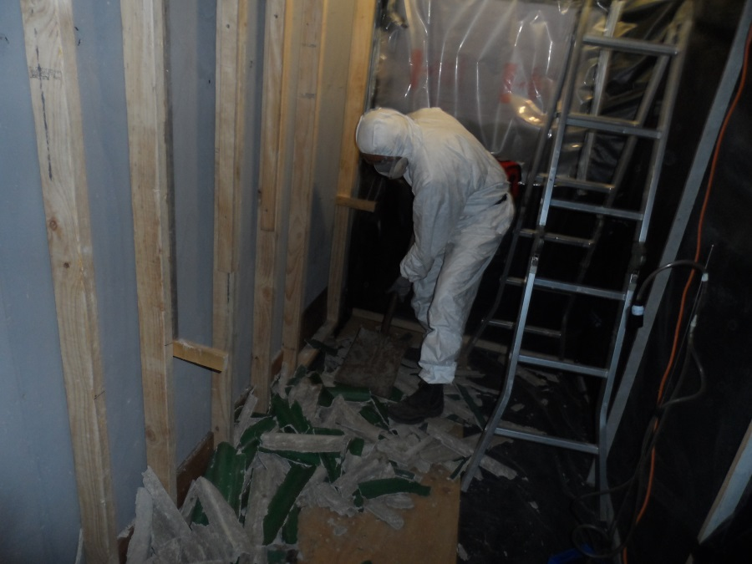
Figure 1 Enclosure used for simulation tasks
The simulations were undertaken by the authors, both of who have previous occupational and DIY AC removal experience. The tasks were undertaken in accordance with the relevant provisions for asbestos removal under the Victoria OHS Regulations and Removing Asbestos in Workplaces Compliance Code modified to reflect expected DIY conditions based on the assumption that DIY renovators are untrained, do not have an asbestos register for their property and have not read, or do not apply recommendations of the literature which would impose significant additional cost or inconvenience. The containment for specific tasks was constructed with non-structural containment walls and ceiling of 200 micron plastic fixed to timber framing, a structural timber wall clad with plywood for fixing the sheets for the simulations and a removable plywood floor set over plastic sheeting. The enclosure structure was constructed by a qualified carpenter under supervision of a certified occupational hygienist. This hygienist is also a class A licensed asbestos assessor with 30 years’ experience in asbestos removal project management and supervision, training of asbestos removalists and development of procedures for asbestos removal, including procedures for removal of AC sheet and drilling and cutting AC materials.
All asbestos related works including; fixing, removing, cutting, clean up, bagging and wrapping and the collapse of the enclosure were conducted in disposable Dupont Tyvek coveralls, type 5 and half face respiratory protection meeting AS/NZS 1716:2003 (Respiratory protective devices) and AS/NZS 1715:1994 (Selection, use and maintenance of respiratory protective devices) and manufacturer’s instructions. Decontamination at the completion of each task simulation was in accordance with the Victorian Asbestos Compliance Code.
Tools for the tasks were selected from the normal suite of tools likely to be readily available to a DIY removalist including hammer, pinch bar, power drill and angle grinder (100mm), shovel, dust-pan brush and broom. The power tools were both mains-powered devices (e.g. 100mm Makita-brand angle grinder) and battery powered Bosch drills. While the Victorian Asbestos Compliance Code prohibits the use of power tools on asbestos in workplaces (except in controlled circumstances), this may not affect DIY works as: the Code does not apply to DIY home renovators; they may not be aware the materials they are working with contain asbestos; DIY renovators may know that the Code prohibits the use of power tools but that it doesn’t apply to them or simply don’t care.
Materials used for wrapping and bagging the removed materials were in accordance with the recommendations of the Compliance Code (i.e. 200 micron plastic sheeting and 200 micron plastic bags labelled as asbestos materials). Asbestos materials were wrapped or bagged as per the requirements of the Compliance Code and disposed of at sites authorised to accept asbestos waste.
AC sheeting and roof cladding for the simulation tasks were sourced from Australia Wide Asbestos Removal Encapsulation Pty Ltd (AWARE). The flat sheet asbestos was sourced from an existing outdoor shed at the site. The flat asbestos cement sheeting, green painted small corrugated sheeting, brown painted thick corrugated sheeting and flues used for the simulations were analysed using polarized light microscopy (PLM) with dispersion staining for type of asbestos in accordance with AS4964-2004 (Method for the qualitative identification of asbestos in bulk samples).Bulk sample analysis was undertaken by a NATA accredited laboratory.
The air sampling of asbestos fibre exposure was undertaken in accordance with the NOHSC Guidance Note on the membrane filter method for estimating airborne asbestos fibres 2nd Edition. A total of 18 samples were undertaken over the 5 days of monitoring. Each task involved one stationary sample and one personal sample. Sampling air-pumps used were SKC AirChek XR5000 and SKC Universal Standard. Two pumps were used for each sample head/filter combination, due to the relatively high flow rates required and to ensure steady flow rates were achieved over the measurement period. Four blank filters were set aside as controls. Each sample involved a minimum volume of air of 720 litres. This high volume was sampled at flow rates typically about 7 litres/minute.
All 9 personal samples together with 4 static samples were analysed by the Institute of Occupational Medicine (IOM), Edinburgh, UK and authorised by C McGongle, Senior Chemist. Fibre counting was undertaken using scanning electron microscopy (SEM) with fibre identification by Energy Dispersive X-ray Spectroscopy (EDXS). The method for analysis was ISO-2002: 14966. Samples which were sampled by SEM have been described as either personal (PSEM) or stationary (SSEM) in this report, for clear identification of method of analysis and type of sample. The limit of detection ranged from 0.002 f/ml upwards, depending upon volume sampled and number of fields searched.
A further 5 static samples were analysed by phase contrast microscopy (PCM) by AEC Environmental Pty Ltd, a laboratory certified through the National Association of Testing Authorities (NATA) for fibre counting. These samples were described as SPCM so that the method of analysis could be identified. The limit of detection for the PCM analysis was 0.01 f/ml.
Results

Bulk sample results
The asbestos bulk sampling results are tabulated below. The relevant task number for which the asbestos cement sheeting was used has also been provided. In Australia, AC sheeting produced after World War 2 would not only contain chrysotile, but could also contain amosite and for a period until the early 1970s, crocidolite. Crocidolite was phased out as a component of AC sheeting first, followed by amosite then lastly - chrysotile. For example, Goliath cement in Tasmania used only chrysotile after the early 1970s (MacFarlane et al, 2013).
With SEM, all three commercial types of asbestos can be identified in the one sample and a concentration of each type (if present) and the total fibre count can be determined. The World Health Organisation and the International Agency for Research on Cancer both state that all forms of asbestos fibres cause cancer which is why a total of all asbestos forms is given here. For a technical breakdown, please refer to the appendices.
Task number used | Sample | Description | Fibre type detected by PLM
1 Removal of AC corrugated external roof sheeting in dry conditions | Small corrugated sheets (green paint) | Cement sheet | Chrysotile &Amosite
2 Removal of AC flat external wall sheeting in dry conditions | Small corrugated sheets (green paint) | Cement sheet | Chrysotile &Amosite
3 Removal of flues and small sections of AC corrugated sheet to create penetrations e.g. for installation offans and flues | Rear of Toilet, Flat sheet | Cement sheet | Chrysotile
4. Removal of AC support materials in sink splashback | Large corrugated sheet (brown paint) | Cement sheet | Chrysotile &Amosite
5 Removal of small sections of AC flat sheet to create penetrations (e.g. to accommodate an air conditioner) | Flue | Fibrocement | Chrysotile
6 Drilling and screwing into AC sheet (e.g. to fix hooks, strapping, shelves etc.) | Large corrugated sheet (brown paint) | Cement sheet | Chrysotile &Amosite
7 Removal of AC wall panels in bathrooms | Large corrugated sheet (brown paint) | Cement sheet | Chrysotile &Amosite
8 Clean-up after task | Large corrugated sheet (brown paint) | Cement sheet | Chrysotile &Amosite
9 Removal of a small outdoor shed constructed of flat and corrugated AC sheeting | Toilet, corrugated sheet | Cement sheet | Chrysotile

Task results
Task results are expressed in fibres per millilitre of air (f/ml) as time weighted average concentrations measured over the sample period. It is noted that these cannot be compared directly to the eight hour time weighted average (8hr TWA) concentration referenced by the 0.1 f/ml exposure standard. However, this was seen to be a better way to communicate the exposures relative to each other and the standard than any attempt to estimate 8hr TWAs from relatively short sample times. It is also noted that in non-friable asbestos removal and non-friable asbestos work control generally 0.01 f/ml is seen as a reasonably practicable exposure control level regardless of task duration.

Task 1: Removal of AC corrugated external roof sheeting in dry conditions
This task involved removal of two corrugated external roof sheets fixed with roofing screws to a timber horizontal frame outside the enclosure. Removal involved the removal of the fixing screws and minimum sheet breakage. Stacking of the sheets was also included during the monitoring. No wetting of the sheets was carried out. The static sampler was located within 2 metres of the worker undertaking the task.
The task was completed in 18 minutes
The personal exposure PSEM01: Total fibre concentration was 0.215 f/ml.
The static sampling was SPCM01: Total fibre concentration was 0.01 f/ml.

Task 2: Removal of AC flat external wall sheeting in dry conditions
Recycled sheets from simulation task 1 fixed to a vertical frame inside the enclosure using self-drilling screws were removed using a hammer to break the sheets followed by clean-up and bagging of the resultant debris using a shovel and small brush. No wetting of the sheets was carried out. The static sampler was located within 2 metres of the worker undertaking the task.
Removal was completed in 8 minutes. Clean-up and bagging of sheets to fit into disposal bags was completed in 31 minutes.
The personal exposure PSEM02: Total fibre concentration was 0.213 f/ml.
The static sampling SSEM02: Total fibre concentration was 0.103 f/ml.

Task 3: Removal of flues and small sections of AC corrugated sheet to create penetrations e.g. for installation of fans and flues
Cutting asbestos cement flue (three cuts) with a Makita-brand 100mmgrinder fitted with an abrasive disk.(see Figures 2and 3).Cutting a 100 mm circular penetration for a flue in corrugated roof sheeting with a drill mounted hole saw. The cutting was carried out outside with a breeze of about 5 to 10 kilometres per hour. The static sampler was located within 2 metres of the worker undertaking the task. The flue cutting was completed in two minutes.

The 100 mm circular penetration cutting was completed in two minutes.
The personal exposure PSEM03: Total fibre concentration was 2.788 f/ml.
The static sampling was SSEM03: Total fibre concentration was 0.148 f/ml.
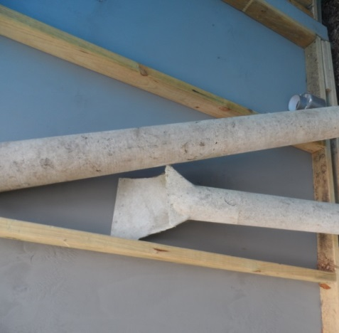
Figure 2- AC Flues

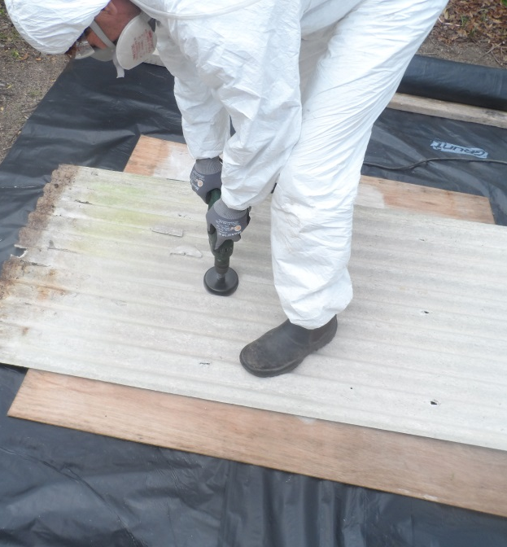
Figure 3 Flue Penetration in AC Sheeting

Task 4: Removal of AC support materials in sink splashback
Removal of AC sheet fixed to a vertical wall frame inside the enclosure using a hammer to break the sheet with no prior removal of fixing nails. The static sampler was located within 2 metres of the worker undertaking the task.
Task time for removal of the sheeting was 12 minutes.
Clean-up and bagging was an additional 24 minutes.
The personal exposure PSEM04: Total fibre concentration was 1.057 f/ml.
The static sampling was SPCM04: Total fibre concentration was0.03 f/ml.
Task 5: Removal of small sections of AC flat sheet to create penetrations (e.g. to accommodate an air conditioner)
Cutting of penetrations into AC sheeting fixed to a vertical frame inside the enclosure using a Makita-brand angle grinder fitted with a 100mm abrasive disc. Cuts totalled about 1.5 metres in length (see Figure 4). The static sampler was located within 1.5 metres of the worker undertaking the task.
The cutting was completed in 5 minutes.
The personal exposure PSEM05: Total fibre concentration was 13.231 f/ml.
The static sampling was SPCM05: Total fibre concentration was0.01 f/ml.

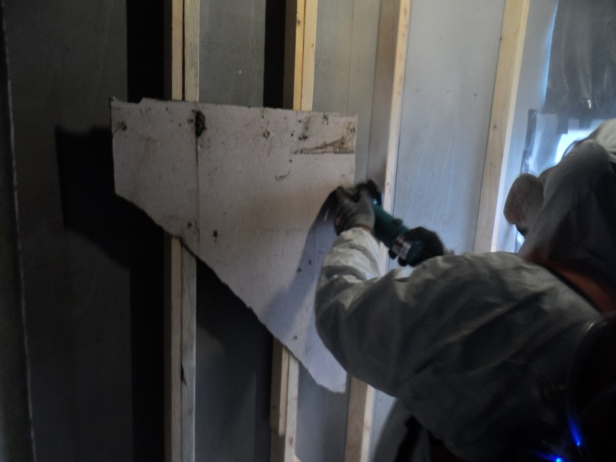
Figure 4- Cutting AC sheeting

Task 6: Drilling and screwing into AC sheet (e.g. to fix hooks, strapping, shelves etc.)
Drilling holes and inserting self-drilling screws into AC fixed to a frame without controls conducted inside the enclosure. The static sampler was located within 2 metres of the worker undertaking the task.
Drilling and screwing of 20 holes and screw insertions completed in about 15 minutes.
The personal exposure PSEM06: Total fibre concentration was 0.062 f/ml.
The static sampling SSEM06: Total fibre concentration was 0.055 f/ml.

Task 7: Removal of AC wall panels in bathrooms
Removal of 10 square metres of AC sheet fixed to a vertical frame conducted inside the enclosure using a hammer to break sheet – no prior removal of fixing nails. The static sampler was located within 2 metres of the worker undertaking the task.
The AC removal was completed in 15 minutes.
The personal exposure PSEM07: Total fibre concentration was 0.663 f/ml.
The static sampling was SPCM07: Total fibre concentration 0.02 f/ml.
Task 8: Clean-up after task
Dry sweeping up and double bagging of debris from simulation task 7 with no controls conducted inside the enclosure.
The sweeping and bagging was completed in 35 minutes.
The personal exposure PSEM08: Total fibre concentration was 0.898 f/ml.
The static sampling was SPCM08: Total fibre concentration 0.03 f/ml.

Task 9: Removal of a small outdoor shed constructed of flat and corrugated AC sheeting
Removal of approximately 6.3 square metres of wall and roof sheeting fixed to a timber framed outdoor shed with minimum breakage of the AC (see Figure 5). Removal of fixing nails by hammer and pinch bar or by breaking surrounding sheet where nailheads were missing, breaking of sheets around plumbing fixtures to enable removal, stacking and wrapping of sheets as they were removed. Debris was cleaned and swept up dry and bagged after removal.
Removal of sheeting was completed in 48 minutes. Clean up, bagging and wrapping was completed in 20 minutes. The static sampler was located within 3 metres of the worker undertaking the task, this varied due to the shape of the shed.
The personal exposure PSEM09: Total fibre concentration was 0.124 f/ml.
The static sampling was SSEM09: Total fibre concentration was 0.028 f/ml.

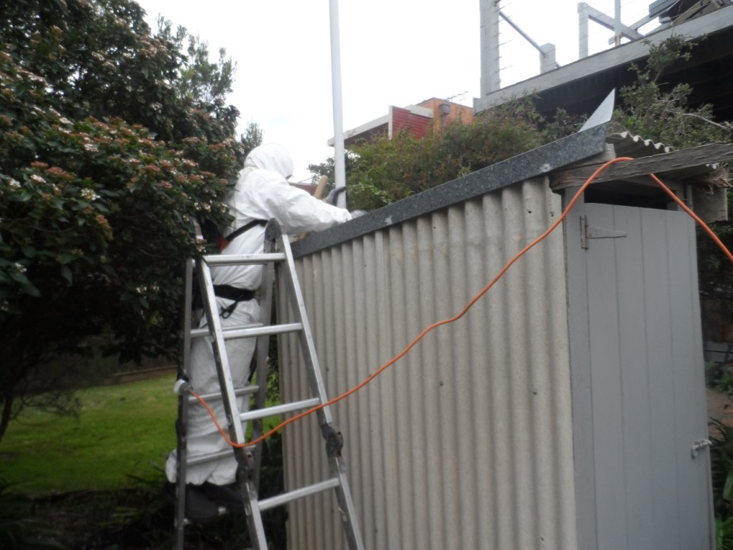
Figure 5- Removal of Asbestos Sheeting from small shed

Discussion and Conclusions

Little has been reported regarding the asbestos fibre release during scenarios/tasks routinely undertaken during home renovation and maintenance by residents. In this project, tasks commonly performed were simulated and the asbestos fibre release sampled. Fibre exposures from the simulations were monitored by both stationary and personal sampling, and analysis was undertaken using both PCM for 5 static samples and SEM for the nine personal and the five remaining static samples. It is important to note that results from PCM are nearly always lower than SEM, due to the counting methodology. The SEM also was undertaken as it has a lower LOD compared to PCM and it was considered likely some tasks would have exposures below 0.01 f/ml.

For seven of the nine tasks the static monitoring fibre release were found to be low e.g. less than 0.1 fibre/ml. Two static monitoring samples were in excess of the Australian workplace eight hour time weighted average (TWA) occupational exposure standard. A number of factors need to be appreciated when assessing the DIY exposure results against the workplace exposure standard:
- These results reflected worst case conditions and based on the time taken to complete the simulated tasks, a home renovator would be exposed to this level of fibre release for about 2 hours during a renovation, not 8 hours per day, 5 days per week, 48 weeks per year as is presupposed by the TWA exposure standard.
- Irrespective of these findings, it needs to be recognised that in addition to the mandatory exposure standard, all Australian jurisdictions require asbestos fibre exposures to be controlled as far as reasonably practicable in occupational environments.
- These provisions may not apply to DIY jobs where no employment contract is involved.
- In this context, a professional removal job, generating an exposure exceeding 0.01 f/ml would require action by state regulators as it has been demonstrated that 0.01 f/ml is readily achievable in all common non friable removal tasks and therefore the exposures measured in the simulations are elevated.
The tasks for the two highest static sampling results, task 2 and task 3, both involved the generation of significant cement dust and were performed inside the enclosure. The results are slightly above the 0.1 f/ml occupational exposure standard. Task two involved considerable violent smashing of the AC sheeting with a claw hammer and task 3, the highest static sample result of all the simulations, involved cutting with an angle grinder. The highest personal sample result was for task 5 and this involved cutting with an angle grinder inside the bubble without ventilation, which is the worst case scenario for dust and fibre release. It is possible, even probable, that a home renovator would use these methods to remove asbestos in a bathroom, laundry or kitchen, particularly when renovators are unware asbestos may be present. In the enclosure, there was no forced ventilation and no significant openings so it could be argued that the findings are representative of worst case, since many renovators would be expected to undertake these tasks with at least the doors or windows open. On the other hand, in a family home, they may well close off sources of ventilation to contain any fibre or dust release to the work area.

All tasks where the static sample was analysed by PCM resulted in relatively low fibre release findings. This is firstly likely due to the counting methodology, where SEM normally results in higher levels, but also because the static PCM samplers were always a greater distance from the point of generation of the dust.

The personal samples were analysed by SEM a priori in the study protocol as it was seen as important to accurately quantify exposures below 0.01 f/ml. As discussed above, the fibre counts from personal samples were all higher than the respective static sampling for each task. This is to be expected given the local nature of the dust cloud observed during the tasks. Some samples had significant cement dust loading on the filters. The only task with an exposure measurement less than 0.1 f/ml was task six. This task involved drilling which was observed to generate minimal visual dust.

It is clear from the results and observations that fibre release may be high during tasks involving the use of power cutting tools, breaking of AC sheeting and the dry clean-up of asbestos materials. The highest fibre count was for task five which involved the use of an angle grinder. During this task the sampling head was within 50 cm of the cutting surface and it is possible that impaction of dust may have occurred. The static sampler, which was located about 1.5 metres from the cutting surface, was only slightly above the limit of detection so impaction was unlikely. These results also indicate the probable local nature of significant fibre plumes from these tasks.

The results of tasks three and four were high due to the use of power tools and smashing of AC sheeting prior to bagging. The personal sampling result for task nine was as expected since this task was primarily undertaken out-doors with minimal visible dust. The dry sweeping in task eight was similar to the results published in the occupational setting (Hyland et al, 2010).

The simulations are limited by analytical interference from high cement dust loads on some of the filters; the small numbers of samples, insufficient for statistical analysis and lack of data on whether or not the type of asbestos used was representative of asbestos being disturbed or removed in the majority of home renovations and maintenance tasks (the asbestos cement used contained only chrysotile and amosite). The significance of this limitation is difficult to determine because it has been reported that the majority of asbestos used by at least one AC factory in Australia post 1970 was primarily chrysotile (MacFarlane et al, 2013).However, AC sheeting produced prior to 1970 also contained significant concentrations of the amphiboles amosite and crocidolite at this plant, and this may be the case for the industry in general.

Due to small sample numbers it was not possible to investigate whether renovation of only roofing would incur additional fibre release compared to wall cladding or indoor flat sheets. Brown (1987) found that weathering was an important factor influencing exposure, with weathered roofing providing more fibre release. The results for task nine could not support these findings since, although there was considerable weathering of the thin corrugated sheets employed, the fibre exposure levels were found to be low and we did not have a second low weathered building to compare with.

Wetting was not undertaken in any of the simulations, the results therefore are likely to be worst case. Past occupational exposure studies have demonstrated a reduction in exposure when wetting is undertaken prior to disturbance, handling or removal of AC sheets (Brown, 1987). Since there is no evidence in the literature that the typical DIY renovator performs wetting prior to removal or maintenance, it can be assumed that the results of these simulation tasks may be an accurate reflection of possible exposures.

The results of the simulated tasks, all possible in the renovation of a residence, or even only a bathroom, kitchen or laundry containing asbestos, supports many of the recommendations and legislative requirements currently in place for occupational asbestos removal jobs. The results also point to the importance of proper ventilation by opening doors or windows during removal, with results for out-door tasks relatively low compared to the indoor ‘restricted space’ environment of many small residential bathrooms, laundries and kitchens. Removal of AC corrugated sheets from roofs and flat sheets from eaves may not involve the high exposures we measured in a simulated, small, poorly ventilated room.

This gives rise to the need to specifically address future information to potential renovators warning of the high exposures associated with the use of power tools, smashing of AC sheeting, dry clean-up and confined and poorly ventilated work areas; as opposed to the careful removal techniques and clean up using wet methods or vacuum cleaners that meet the relevant standard (AS/NZS 60335.2.69 Dust Class H) required for the occupational environment. The practicality of these recommendations for the average householder needs to be considered with issues such as the additional time and skill required for careful removal versus the smash and bash approach, the lack of availability of suitable vacuum cleaners and the additional work and potential water damage issues associated with wet clean-up of more than very minor quantities of asbestos material.

The finding that static sampling results were always less and often less than half the exposure from simultaneous personal monitoring during a particular task. has significant implications for the monitoring conducted, in both DIY renovators and work involving professional removalists, Personal monitoring is rarely conducted during professional asbestos removal, the vast majority of monitoring currently undertaken being para-occupational control and clearance monitoring, which is static monitoring. The purpose of clearance and control monitoring, which in non-friable removal operations very rarely returns results exceeding 0.01f/ml, is not directly related to occupational exposure; however it would seem here that there is an argument for more personal monitoring to provide a more accurate indication of the efficacy of the controls employed. A guaranteed result of less than 0.01f/ml, for non-friable asbestos removal, almost regardless of removal technique, provides little incentive to employ as low as reasonably practicable controls and no relative assessment of the efficacy of different control methods to support continual improvement.

References
Asbestos International Association (1984).Method for the determination of airborne asbestos fibres and other inorganic fibres by Scanning Electron Microscopy. Recommended Technical Method No. 2 (RTM2): AIA, London.

Brown SK. Indoor air quality. In: Department of Environment Sport and Territories Canberra, ed. Australia: State of the Environment Technical Paper Series (Atmosphere): Central Queensland University Publishing Unit, 1997.

Brown SK. Asbestos exposure during renovation and demolition of asbestos-cement clad buildings. American Industrial Hygiene Association journal 1987;48(5):478-86.

Centre for Public Health Research: Measurement of asbestos exposure levels in a sample of demolition, trade and maintenance work sites. RFP Number 264: The Workplace Group of the Department of Labour. Final Report 3/09/2010.

Environmental Health Standing Committee (enHealth), Asbestos: A guide for householders and the general public, Australian Health Protection Principal Committee, Canberra, 2013

Hyland RA, Yates DH, Benke G, et al. Occupational exposure to asbestos in New South Wales, Australia (1970-1989): development of an asbestos task exposure matrix. Occup Environ Med 2010;67(3):201-6.

International Standards Organisation (2002). International Standard ISO 14966. Ambient Air: Determination of numerical concentration of inorganic fibrous particles- Scanning electron microscopy method.

Kirsch LS. Behind Closed Doors: The Problem of Indoor Pollutants. Environment: Science and Policy for Sustainable Development 1983;25(2):16-42.

MacFarlane E, Gwini S, Del Monaco A, Benke G and Sim M. Mesothelioma in a cohort of cement production workers. The Australia Institute of Occupational Hygienists (AIOH).Sydney (2013).

Model Work Health and Safety Regulations: Safe Work Australia http://www.safeworkaustralia.gov.au/sites/swa/about/publications/pages/model-whs-regulations

NOHSC: National Code of Practice for the Management and Control of Asbestos in Workplaces[NOHSC:2018 (2005)].

NOHSC: CODE OF PRACTICE FOR THE SAFE REMOVAL OF ASBESTOS 2ND
Edition [NOHSC:2002(2005)].

Olsen NJ, Franklin PJ, Reid A, et al. Increasing incidence of malignant mesothelioma after exposure to asbestos during home maintenance and renovation. Med J Aust 2011;195(5):271-4.

Park EK, Yates DH, Hyland RA, et al. Asbestos exposure during home renovation in New South Wales. Med J Aust 2013;199(6):410-3

Sim M, Benke G, MacFarlane E, Kee E. The Management of Asbestos in the Non-Occupational Environment. EnHealthCouncil. RFQ DoHA402/1213 (2014) pp39.

Standards Australia: AS/NZS 1715:1994 Selection, use and maintenance of respiratory protective devices and manufacturer’s instructions.

Standards Australia: AS/NZS 1716:2003 Respiratory protective devices.

Standards Australia: AS4964-2004; Method for the qualitative identification of asbestos in bulk samples.

Victorian Government, Occupational Health and Safety Regulations 2007.

Victorian Government, Compliance Code – Removing Asbestos in Workplaces.

Appendices
Date May 2015 | Pump No.s | Pre Cal (s/500 ml) |  |  | Flow Rate | Sample Head No. | Sample Start | Task End | Clean-up End | Sample End | Post Cal (s/500ml) |  |  | Av. Flow Rate | Wind Speed | Min Sample Time¹ | Sample time (h:m) | Sample time (m) | Sample Vol
 |  | 1 | 2 | 3 |  |  |  |  |  |  | 1 | 2 | 3
26 | 55/61 | 4.4 | 4.3 | 4.2 | 7.0 | PSEM09 | 14:34 | 15:22 | 15:42 | 16:22 | 4.2 | 4.3 | 4.3 | 7.0 | < 1mps | 103.04 | 1:48:00 | 108 | 759.7
26 | P3/P4 | 5.1 | 5.0 | 4.9 | 6.0 | SSEM09 | 14:37 | 15:22 | 15:42 | 16:44 | 5.2 | 5.2 | 5.2 | 5.9 | < 1mps | 119.76 | 2:07:00 | 123 | 724.5
26 | 55/61 | 4.2 | 4.3 | 4.3 | 7.1 | PSEM04 | 18:11 | 18:18 | 18:42 | 20:10 | 4.2 | 4.5 | 4.3 | 7.1 | < 1mps | 101.68 | 1:59:00 | 119 | 842.6
26 | P5/P6 | 4.6 | 4.8 | 4.7 | 6.4 | SPCM04 | 18:06 | 18:18 | 18:42 | 20:11 | 4.7 | 4.7 | 4.8 | 6.4 | < 1mps | 112.4 | 2:05:00 | 125 | 800.7
27 | 55/61 | 4.1 | 4.2 | 4.3 | 7.2 | PSEM05 | 9:03 | 9:09 | 9:09 | 11:03 | 4.3 | 4.4 | 4.1 | 7.2 | 5 mps | 100.4 | 2:00:00 | 120 | 860.6
27 | P3/P4 | 5.1 | 5.1 | 5.1 | 5.9 | SPCM05 | 9:04 | 9:09 | 9:09 | 11:14 | 5.1 | 5.1 | 5.2 | 5.9 | 5 mps | 121.92 | 2:10:00 | 130 | 767.7
27 | 19/60 | 4.3 | 4.2 | 4.3 | 7.1 | PSEM03 | 10:39 | 12:37 | 12:37 | 12:37 | 4.1 | 4.3 | 4.2 | 7.1 | 5 mps | 101.92 | 1:58:00 | 118 | 833.6
27 | P3/P4 | 4.7 | 4.9 | 4.9 | 4.7 | SSEM03 | 10:37 | 12:49 | 12:49 | 12:49 | 5.1 | 5.1 | 5.2 | 5.5 | 5 mps | 152.22 | 2:12:00 | 132 | 722.4
27 | 61/55 | 4.3 | 4.4 | 4.1 | 7.1 | PSEM07 | 16:28 | 16:43 | 16:43 | 18:32 | 4.5 | 4.4 | 4.2 | 7.1 | < 1ms | 101.84 | 2:04:00 | 124 | 876.7
27 | P5/P6 | 5.1 | 5.1 | 5.2 | 5.9 | SPCM07 | 16:28 | 16:43 | 16:43 | 18:45 | 5.1 | 5.2 | 5.3 | 5.9 | < 1ms | 122.48 | 2:17:00 | 137 | 805.4
27 | 61/55 | 4.3 | 4.4 | 4.1 | 7.1 | PSEM06 | 15:46 | 16:18 | 16:18 | 16:18 | 4.5 | 4.4 | 4.2 | 7.1 | < 1ms | 101.84 | 0:32:00 | 32 | 226.2
27 | P5/P6 | 5.1 | 5.1 | 5.2 | 5.9 | SSEM06 | 15:46 | 16:18 | 16:18 | 16:18 | 5.1 | 5.2 | 5.3 | 5.9 | < 1ms | 122.48 | 0:32:00 | 32 | 188.1
27 | 19/60 | 4.1 | 4.3 | 4.2 | 7.2 | PSEM08 | 17:19 | 17:54 | 17:54 | 19:35 | 4.1 | 4.1 | 4.2 | 7.2 | < 1ms | 100.48 | 2:16:00 | 136 | 974.5
27 | P3/P4 | 5.1 | 5.1 | 5.2 | 5.9 | SPCM08 | 17:19 | 17:54 | 17:54 | 19:40 | 4.9 | 4.7 | 4.7 | 5.9 | < 1ms | 122.48 | 2:21:00 | 141 | 828.9
28 | 61/55 | 4.5 | 4.4 | 4.2 | 6.8 | PSEM06 | 9:24 | 9:55 | 9:55 | 9:55 | 4.3 | 4.1 | 4.2 | 6.8 | < 1ms | 105.2 | 0:31:00 | 31 | 212.2
28 | P5/P6 | 5.1 | 5.2 | 5.3 | 5.8 | SPCM06 | 9:24 | 9:55 | 9:55 | 9:55 | 4.7 | 4.6 | 4.6 | 5.8 | < 1ms | 125.2 | 0:31:00 | 31 | 178.3
28 | 61/55 | 4.5 | 4.4 | 4.2 | 6.8 | PSEM02 | 10:10 | 10:18 | 10:49 | 12:16 | 4.3 | 4.1 | 4.2 | 6.8 | < 1ms | 105.2 | 2:06:00 | 126 | 862.4
28 | P5/P6 | 5.1 | 5.2 | 5.3 | 5.8 | SSEM02 | 10:07 | 10:18 | 10:49 | 12:16 | 4.7 | 4.6 | 4.6 | 5.8 | < 1ms | 125.2 | 2:09:00 | 129 | 741.9
28 | 61/55 | 4.3 | 4.1 | 4.2 | 7.1 | PSEM06 | 14:02 | 15:06 | 15:06 | 15:06 | 4.1 | 4.1 | 4.3 | 7.1 | < 1ms | 100.96 | 1:04:00 | 64 | 456.4
28 | P5/P6 | 4.7 | 4.6 | 4.6 | 6.5 | SSEM06 | 14:02 | 15:06 | 15:06 | 15:06 | 4.8 | 4.8 | 4.9 | 6.5 | < 1ms | 111.44 | 1:04:00 | 64 | 413.5
28 | 19/60 | 4.1 | 4.0 | 4.3 | 7.2 | PSEM01 | 13:19 | 13:40 | 13:57 | 15:18 | 4.1 | 4.1 | 4.1 | 7.2 | < 1ms | 99.36 | 1:59:00 | 119 | 862.3
28 | P3/P4 | 4.2 | 4.5 | 4.5 | 6.9 | SPCM01 | 13:19 | 13:40 | 13:57 | 15:18 | 4.8 | 4.7 | 4.9 | 6.9 | < 1ms | 104.88 | 1:59:00 | 119 | 816.9
^{1.} Min sample time: minimum sampling time to achieve a volume of 720 litres of air based on the average flow rate.

Monitoring results by asbestos fibre type
Units in f/ml
Task | Amphibole | Chrysotile | Total
Task 1 – PSEM01 | 0.096 | 0.119 | 0.215
Task 1 – SPCM01 | † | † | 0.01
Task 2 – PSEM02 | 0.092 | 0.122 | 0.213
Task 2 – SSEM02 | 0.057 | 0.046 | 0.103
Task 3 – PSEM03 | <0.043 (none detected) | 2.788 | 2.788
Task 3 – SSEM03 | <0.005 (none detected) | 0.148 | 0.148
Task 4 – PSEM04 | 0.777 | 0.280 | 1.057
Task 4 – SPCM04 | † | † | 0.03
Task 5 – PSEM05 | <0.410 (none detected) | 13.231 | 13.231
Task 5 – SPCM05 | † | † | 0.01
Task 6 – PSEM06 | 0.019 | 0.043 | 0.062
Task 6 – SSEM06 | 0.016 | 0.039 | 0.055
Task 7 – PSEM07 | 0.212 | 0.451 | 0.663
Task 7 – SPCM07 | † | † | 0.02
Task 8 – PSEM08 | 0.315 | 0.563 | 0.898
Task 8 – SPCM08 | † | † | 0.03
Task 9 – PSEM09 | <0.008 (none detected) | 0.124 | 0.124
Task 9 – SSEM09 | <0.002 (none detected) | 0.028 | 0.028
† PCM analysis does not allow asbestos type to be identified.

The prohibitions outlined in the Victorian Occupational Health and Safety Regulations 2007 (the Regulations) relating to the use and re-use of asbestos containing materials do not apply to scientific analysis and research [regulation 4.3.10(1)}. The tasks undertaken for the purpose of undertaking this report are permitted by the Regulations.

