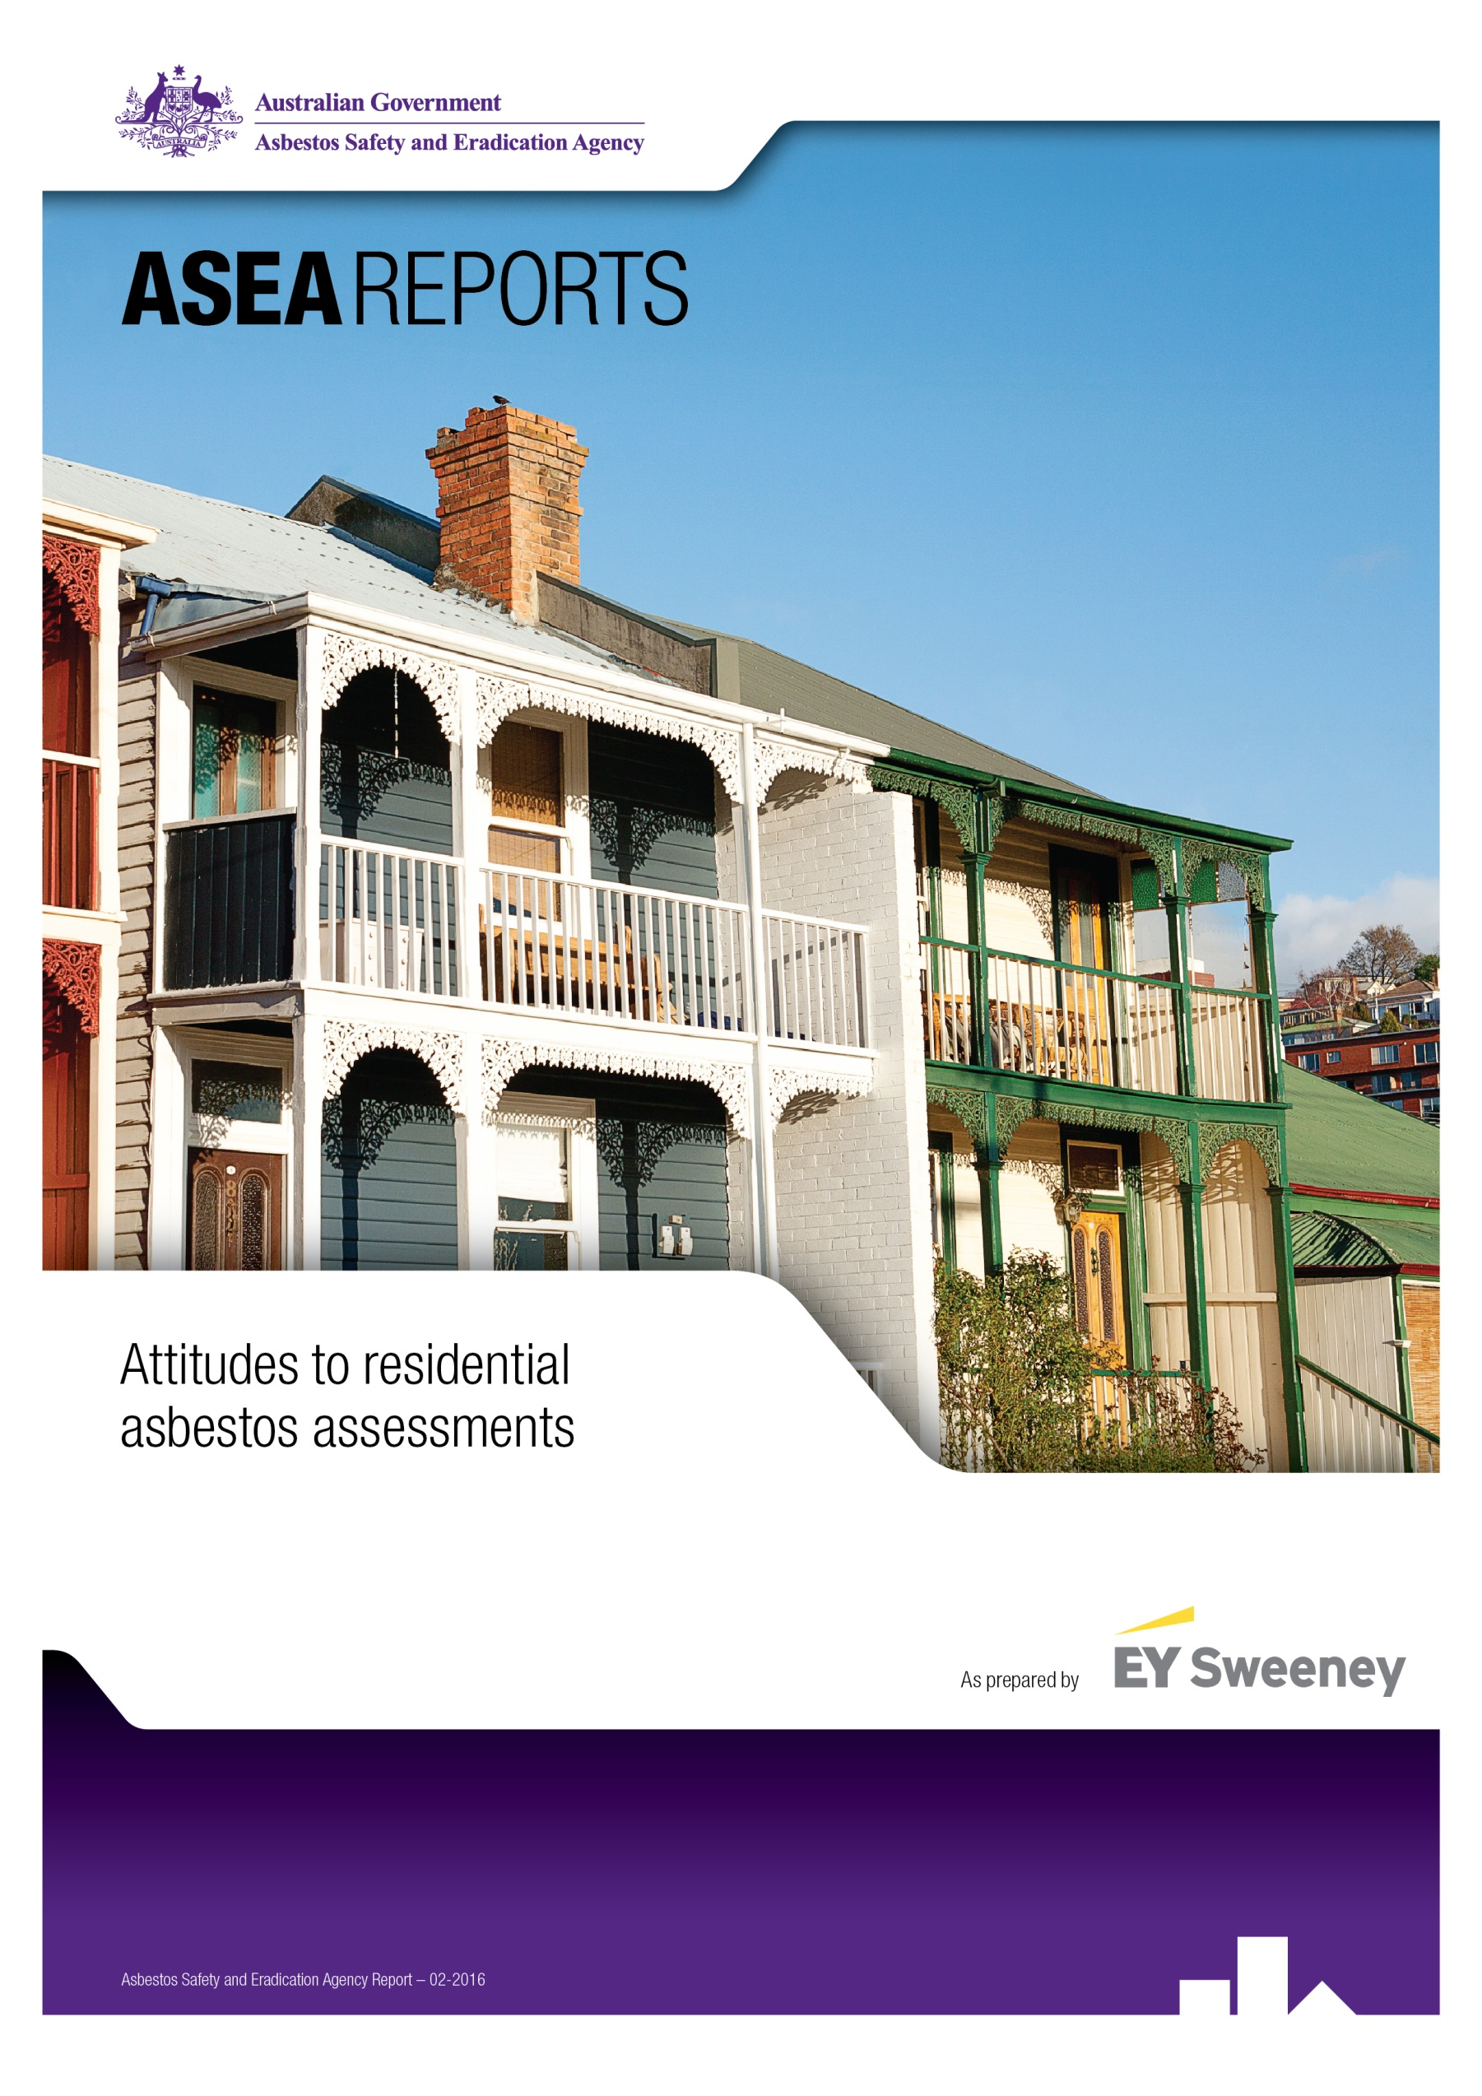
Foreword
The Asbestos Safety and Eradication Agency commissioned this report in order to better understand current availability and use of asbestos assessments in the residential sector. Whilst asbestos assessments (resulting in the compilation of an asbestos register) are required in workplaces in Australia, there is very little awareness in the community that they are also an effective way of protecting people from the risks of asbestos in their home.
The purpose of this report is to identify the current barriers to the use of asbestos assessments in the home and ways to better inform the market of the assessment services available and the benefits they provide.
In Australia, homes are one of the biggest financial investments people make in their lives. Whilst people think about getting building and pest inspections when buying a home, this research suggests the driver for this is to protect the home as a financial asset and asbestos is not generally seen as something that will impact a property’s value.
There is good awareness that asbestos can be dangerous, but most commonly people suggested they did not feel confident in their ability to identify where it may be present in their home. People have limited awareness that the condition of asbestos should be monitored over time in order to ensure it does not present a risk of exposure. People were surprised to discover that common renovation activities that they may undertake themselves, such as pulling up old vinyl flooring may lead to asbestos exposure. Assessors tell us that they are commonly only called after someone has damaged potential asbestos containing material. We need to encourage people to identify and monitor asbestos risks in their home before materials are disturbed.
To identify the best time to promote obtaining an asbestos assessment in the home, there are some practical difficulties that need to be considered, including:
- whether samples of materials are required to confirm the presence of asbestos
- vendor consent prior to the purchase of a property;
- whether reports can cover all materials present in and around a property due to issues of inaccessibility, eg access to wall cavities and sub-flooring; and
- the need to ensure appropriate training and ongoing quality assurance of service providers so that consumers are provided with a quality product that they see as a valuable tool to protect their health.
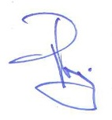
Overall, this research highlights that many Australians do feel that engaging a professional to provide an asbestos assessment on their home would better allow them to protect the health of them and their family during a renovation process. To address this, the agency will be working with state and territory governments to develop some practical guidance to potential users of these reports to allow them to make informed decisions when selecting a provider to perform services.

Peter Tighe
Chief Executive Officer
Table of Contents
Foreword 2
Executive Summary 4
Key Findings 4
Background 7
Objectives 8
Methodological approach 10
Key Findings 14
Overview of the home owner and renovator market 14
Awareness and perceptions of asbestos 18
Knowledge of asbestos in residential properties 25
Asbestos checks and inspections 32
Attitudes to residential asbestos assessments 40
Strategic considerations and recommendations 53
Appendix 54
Quantitative sample profile 54

Executive Summary
The Asbestos Safety and Eradication Agency (the agency) has been established to provide a national focus on asbestos issues which go beyond workplace safety to encompass environmental and public health issues. As part of a drive to raise awareness and action in relation to asbestos in the home, the agency commissioned EY Sweeney to undertake research to uncover the barriers that exist to further monitoring of asbestos by home buyers and owners. The research consisted of both qualitative and quantitative primary research which included…
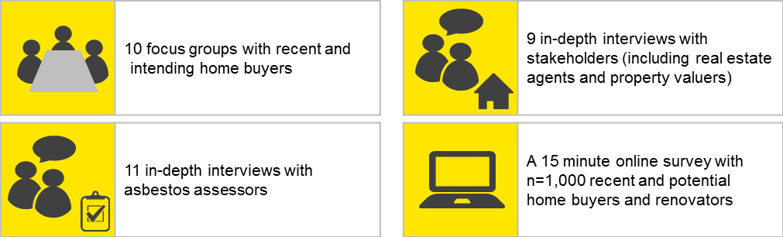
A summary of the key research findings and insights are provided within this executive summary.

Key Findings
Awareness of ‘asbestos’ is widespread and invokes intensely negative emotions amongst home owners
- Nearly all home buyers and renovators (99%) are aware of asbestos. Awareness has largely been driven by media and publicity surrounding the James Hardie law suits and via word of mouth. As such, education surrounding asbestos has been largely informal.
- Asbestos is known to be extremely dangerous, toxic and hazardous to your health. More than three quarters of home buyers and renovators (78%) are aware of asbestosis and 88% agree that asbestos is a hazard to the DIY renovator.
- Yet while asbestos is understood to be dangerous, it is not an issue that is front-of-mind for most, even when buying a home. Home buyers and DIY renovators believe there are other contaminants that asbestos ‘competes’ with for consideration such as lead paint, chemicals in treated pine and cleaning chemicals.
While home owners are aware of asbestos, detailed knowledge is lacking
- Without formal education few home owners feel confident in their understanding of exactly where asbestos is located in the home and what it looks like. Just 29% feel confident in their ability to identify asbestos in their home.
- There are also large gaps in understanding where asbestos can be found inside the home, for example in wet areas, under flooring and behind tiles. Just 14% of home buyers and renovators are aware that asbestos can come in putty form, 24% are aware that asbestos can be found under linoleum flooring and 22% are aware it can be under vinyl floor tiles.

- As a result, some home owners recognise the risk of asbestos exposure during major renovations, but many do not perceive there is a risk with minor DIY tasks. Greater understanding of where asbestos is located in the home and what it looks like would help home owners to undertake DIY tasks safely and with confidence.
Awareness without proper understanding has led to a state of denial towards asbestos
- Without knowing how to identify and manage asbestos, many home owners are fearful and feel disempowered. This leads to a state of denial.
- This state of denial is driven by its intangibility. The particles are small and airborne and the effects of being exposed are not immediate. As a result, home buyers and renovators can end up with an ‘out of sight, out of mind’ attitude.
- In addition, only a minority of home owners have proper management strategies for dealing with asbestos apart from being careful not to interfere with it. A small proportion (6%) also claims to have removed asbestos themselves.
- To overcome this state of denial, education is needed around not only the risk, form and location of asbestos in the home, but also how owners can manage it.
Australians defer and delegate responsibility of asbestos in the home
- Home buyers and renovators largely understand that it is their responsibility to know if asbestos is present in their home (67%). However the majority delegate responsibility for identification.
- Few home buyers realise that building inspectors are not responsible or qualified to identify asbestos in the home. Nearly three quarters of buyers (72%) believe asbestos identification is the responsibility of a building inspector.
- While they may defer responsibility, nearly all home buyers and renovators (89%) believe it is important to know if there is asbestos when buying a home, suggesting there is an appetite for asbestos assessments. This research suggests that clarification around who is responsible and qualified to conduct asbestos assessments is required.
Current perceptions are likely to pose a barrier to asbestos assessments
- Three in five home buyers (63%) believe a building inspection includes a check for asbestos. Those conducting renovations believe tradespeople will tell them if they come across it. These assumptions mean few owners recognise the value in conducting a separate asbestos assessment.
- At the time of purchase buyers also tend to be more interested in the emotional and financial aspects of buying a home and are less likely to consider longer term health risks. They resent the idea of having to pay extra for asbestos assessments when the threat is not perceived to be immediate.
- Perceptions of cost may also be a barrier to uptake of assessments. The expectation of how much an assessment would cost differs considerably from the average amount spent (the expectation is to pay on average $340; most have claimed to have paid on average $779 for an assessment). This price discrepancy will need to be carefully managed. Potential consultation with the industry could be considered with the aim of reducing fees in residential assessments.

Communication surrounding asbestos assessments should aim to educate as well as reassure home owners
- Educating home owners on the risks of asbestos in the home and what their responsibilities are is an important step to increasing asbestos assessments. Greater awareness and understanding will help empower Australians to confidently address and manage asbestos in their home.
- The issue of asbestos in the home is emotionally charged. As such, offering ‘peace of mind’ is acknowledged by nearly nine in ten owners (86%) as a key benefit of the asbestos assessments value proposition. Messaging that speaks to this sentiment of protecting owners and their families is likely to resonate strongly with home buyers and renovators.

Background
Australia has one of the highest life expectancy rates in the world (inside the top ten); however, it has the second-highest rate of mesothelioma deaths behind the United Kingdom with more than 10,000 deaths resulting from the disease. In the next 40 years, an additional 25,000 people are expected to die from mesothelioma according to the Australian Institute of Health and Welfare.
The agency currently estimates that one in three homes in Australia contains asbestos if built prior to 1990. However, robust data does not exist on this issue and the extent of this safety hazard is unknown. Workplaces are currently regulated to keep an update on asbestos in the workplace (presence and condition) but no legislation exists for the monitoring of asbestos in the home. Following a review, the Australian Government does not consider regulation in this space essential but wishes to encourage home owners to increasingly identify asbestos in their homes.
As part of this drive to raise awareness and action in relation to asbestos in the home, the agency wished to undertake strategic, attitudinal research to uncover the barriers that exist to conducting asbestos assessments.
In 2014 the agency conducted research to uncover some fundamental attitudes to asbestos among tradespeople, DIY home renovators, real estate agents, landlords and the general public. This research indicated that all cohorts believed it was important to know about asbestos and its related dangers (76%) but that only 17% felt confident in their ability to identify asbestos related materials. Only 22% felt confident to identify situations where asbestos exposure could pose a risk. Approximately half of these target groups felt they were under-informed about domestic asbestos dangers and rated their current knowledge as poor.
This report details the responses of home buyers, renovators, real estate agents, property valuers and asbestos assessors to the concept of conducting asbestos assessments prior to purchasing a home.

Objectives
The overall objective of this project is…
To uncover opportunities to increase professional asbestos assessment when purchasing a home
Specifically, the research aims to address the following …
Uncover and explore all attitudes and behaviours surrounding asbestos inspections/reports in Australia among priority cohorts |  | - Measure awareness of asbestos inspections and reports among different stakeholders  - Explore general perceptions of asbestos inspections/reports  - Explore all rational and irrational factors such as price, fear, myths, social norms and any other attitudes raised across cohorts in relation to asbestos assessment reports  - Understand what drives inertia, for example, do home buyers know asbestos assessments are available? Are they considered to be a standard part of building inspections such as those of Architecture?  - To what extent does the inertia of banks and insurers drive the inertia of home buyers?  - Explore perceptions of DIYers regarding asbestos inspections and whether they would have more confidence in renovating had an asbestos inspection been carried out

Examine all issues surrounding current consumption of asbestos inspection reports in Australia among all relevant cohorts |  |  |  | - Explore the gap between awareness and action. Is this an extensive gap? How hard would it be to close the gap? What factors would overcome barriers to change? What issues might inform strategies to close the gap? Does change require communication? If so what messages and themes might be significant? Which authorities might be credible in driving change?  - What emotional factors might drive change, for example, overcoming fear?  - What education is needed and where might this learning come from?
Understand all the factors that might drive change in relation to the uptake of asbestos reports in the housing market |  |  | - Understand what drives awareness (or lack of awareness) of asbestos in the home and understand why this awareness does not convert into action in the form of reporting  - Determine the factors that currently drive the consumption of asbestos assessment reports  - Identify the barriers to purchase of asbestos inspection reports  - Explore the current appetite of all cohorts in terms of purchasing asbestos assessment reports  - Do buyers imagine asbestos assessments might affect property values? What other factors drive the current appetite among relevant cohorts?

Understand the practices of stakeholders such as real estate agents and property valuers and asbestos assessors in relation to asbestos assessment reports |  | - What characterises the opinions of stakeholders in regard to encouraging an ethos of asbestos assessments prior to purchasing a home?  - Do property valuers currently consider asbestos a risk to property values over time?  - What other factors, both rational and irrational, are relevant to this cohort’s attitudes and beliefs?  - What might drive change? How difficult might this task be? What barriers need to be overcome?

Methodological approach
To achieve the objectives, a six stage research program was completed as follows…
Stage 2: Focus group discussions with home buyers
Stage 2 of the research (after the Stage 1 project setup and orientation) ensured the project began with the most important stakeholder first – those who potentially live with asbestos. The sample structure and methodology for Stage 2 is outlined below….
Home buyers focus groups
Target market | NSW | VIC | SA | WA | QLD | TAS | ACT | NT | Total
First home buyers |  | 1 |  | 1 |  |  |  | 1 | 3
Buyers of a home other than a first home | 1 |  |  |  | 1 |  | 1 |  | 3
Recent home buyers | 1 | 1 | 1 |  |  | 1 |  |  | 4
Total | 2 | 2 | 1 | 1 | 1 | 1 | 1 | 1 | 10

The following issues also informed the structure of the groups…
- The groups included a 50/50 spilt of male and female to be representative of gender
- All those buying a home were actively looking to buy a home in the next six months and had been to at least two home inspections
- Approximately 50% of respondents planned to do some renovations on their home
- All respondents agreed with the statement; “I am most interested in purchasing a home built before 1990” or – ‘I have purchased a home built before 1990.” A breadth of 20th century home preferences were included (before 1990)
- The first home buyers groups contained a mix of singles and couples
- The experienced home buyers groups contained a mix of double income no kids couples (DINKS) and couples with children
- First home buyers were under the age of 45 years. A mix of ages were aimed for in these groups
- The experienced home buyers were aged between 35 to 60 years. A mix of ages were included in these groups
- Two of the home owners groups were conducted with people aged 30 to 45 years and two of these groups were conducted with people over the age of 46

Stage 3: In-depth interviews with real estate agents and financial professionals
Stage 3 of the research program sought to build a picture of the dynamics driving behaviour. The sample structure and methodology for Stage 3 is outlined below….
In-depth interviews with stakeholders
Target market | NSW | VIC | TAS | QLD | NT | WA | SA
Principal real estate agents | 1 | 1 | 1 |  | 1 |  | 1
Senior real estate sales agents | 1 | 1 |  | 1 |  | 1
Property valuers | 4 | 3 |  | 1 |  | 1
Total | 2 | 2 | 1 | 1 | 1 | 1 | 1

Further criteria for this sample were as follows…
- Principal real estate agents were defined as those who own their real estate business and employed staff. These real estate principals may have operated an independent agency or a franchise for a larger brand. And were actively involved in management of the business. Those who were not involved in day-to-day operations were excluded. A range of businesses were included in a variety of suburbs across Australia i.e. a mix of inner city and suburban real estate principles were selected.
- Senior sales agents were defined as sales agents of over 10 years’ experience in selling real estate but not a business owner or proprietor. These senior sales agents were selected from a mix of inner city and suburban areas.
- An approximate 50/50 split male/female was aimed for when recruiting this sample to ensure gender representation.

Stage 4: In-depth interviews with asbestos assessors
Stage 4 of the research ensured the research was informed by experts in the field who have an understanding of the ‘coalface’. The sample structure and methodology for Stage 3 is outlined below….
In-depth interviews with asbestos assessors
Target market
NSW | 2
VIC | 2
TAS | 1
QLD | 2
NT | 1
WA | 1
SA | 1
ACT | 1
Total | 11

Further criteria
- All those participating were licensed asbestos assessors
- All the asbestos assessors had at least five years’ experience in the industry

Stage 5: Quantitative research with home buyers and renovators
Following the qualitative research, quantitative research was conducted to build on learnings from the qualitative phase and measure the most important levers for change. The research consisted of an online survey with n=1,003 home buyers and renovators across Australia. The sample structure for Stage 5 is outlined below….
Participant sample structure
n | Renovators | Home buyers | Total
Recent or intending
Recent (renovator/home buyer) | 493 | 201 | 790
Intending (renovator/home buyer) | 488 | 285 | 861
Both | 379 | 85 | 648
State
NSW | 190 | 136 | 326
ACT | 23 | 9 | 32
VIC | 136 | 113 | 249
QLD | 111 | 56 | 167
WA | 70 | 33 | 103
SA | 43 | 35 | 78
TAS | 6 | 1 | 7
NT | 23 | 18 | 41
Total | 602 | 401 | 1,003

Data collection and weighting
- Respondents were recruited via Research Now online research panel
- All survey starters were weighted to be representative of the Australian population over the age of 18 years by gender, age and state, to determine the true profile of home buyers an renovators
- Average questionnaire length: 15 minutes
- Fieldwork conducted 15th May – 5th June

Key Findings

Overview of the home owner and renovator market
This section of the document provides an overview of the current housing market in relation to home owners, home buyers and renovators. Using data from the quantitative phase of the research, we analysed the responses of all who started the survey (i.e. all those who completed the survey as well as those who were screened-out). This data was then weighted to be representative of the total Australian population which enabled us to establish the true incidence of property ownership and renovating in Australia.
Property buyers
Almost one fifth of Australians (19%) over the age of 18 years have purchased a property within the last 2 years. Chart 1 below shows the proportion of both recent and intended property purchase. Amongst this proportion of recent buyers, 12% bought a property to live in and 9% purchased an investment property and 2% of recent buyers purchased both a home and an investment property. Residents in NSW were significantly more likely than residents in any other state to have recently purchased property (21% vs. 19% total population). In contrast, residents in QLD were least likely to have purchased property in the last 24 months (14% vs. 19% total population).
Looking ahead, just under one quarter of Australians (24%) intend to purchase a property in the next 2 years. This cohort is evenly split by those intending to purchase a home (14%) and those intending to purchase an investment property (14%), with 4% planning to purchase both a home and an investment property. Again, NSW residents were more likely to be planning to buy, with 28% intending to buy in the next 2 years compared to 24% of the total population.

Chart 1: Proportion of recent and intended property purchase (%)
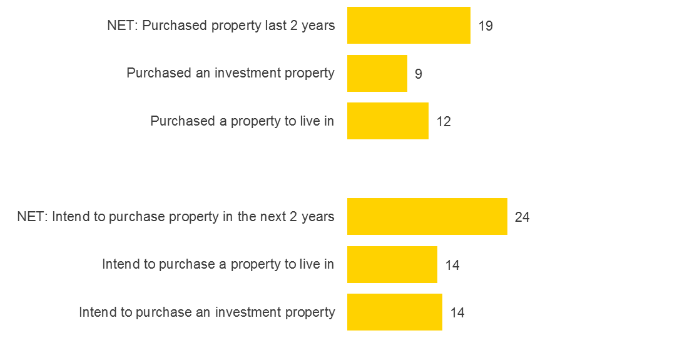
Base: All survey starters, n=6,617
S7. Please indicate which, if any, of the following you have done in the past 2 years? S8. And in the next 2 years are you…?
All values shown in percentages. Weighted data

Chart 2 shows the age of properties bought or intending to be bought amongst property buyers. Amongst recent property buyers, one fifth (22%, or 3% of all Australians) bought a property built before 1990. For those looking to buy in the next 2 years, 13% (or 2% of all Australians) said they would consider purchasing a property built before 1990. This represents a considerable proportion of the Australian property market that could be exposed to asbestos at some point in the future.

Chart 2: Age of property (either bought or are intending to buy) (%)
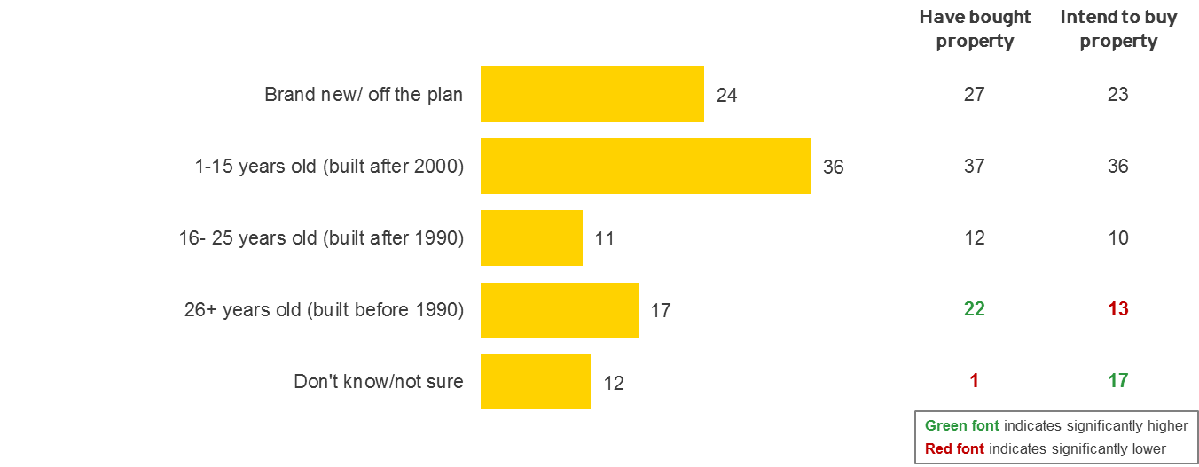
Base: All survey starters, n=6,617, Have bought property, n=812, Intend to buy property, n=958
S10. Roughly how old is the property you have recently bought/are planning to buy?
All values shown in percentages. Weighted data

Renovators
Chart 3 below shows the proportion of recent and intending renovators amongst Australians. Almost two in five (37%) of Australians conducted some form of DIY renovations (i.e. renovations involving more than basic cosmetic changes) to a property in the last 2 years. By and large, the majority of renovators made changes to their own home (37%) and just 1% renovated both their own home and an investment property.
In the next 24 months, 36% of Australians plan to undertake DIY renovations, with 35% intending to renovate their home and 1% planning to make renovations to an investment property.
There is also an indication that many Australians undertake renovations over an extended period of time. More than a quarter of the total population (27%) has both recently completed a renovation and also has plans to undertake more renovations in the 2 years.

Chart 3: Proportion of recent and intended renovation (%)
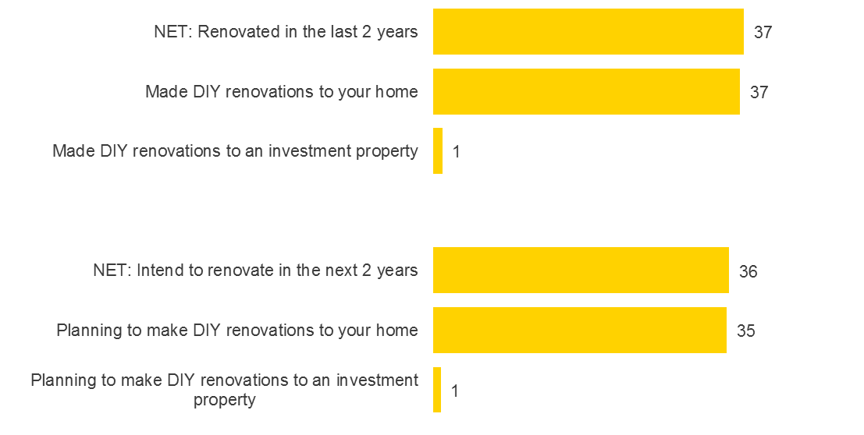
Base: All survey starters, n=6,304
S7. Please indicate which, if any, of the following you have done in the past 2 years? S8. And in the next 2 years are you…?
All values shown in percentages. Weighted data

Chart 4 shows the age of properties renovated in Australia, either recently or intended for the future. Almost half of all renovations (46%), both completed and intended, take place in homes built before 1990. This represents roughly 17% of the total population who are conducting renovations themselves in homes that could potentially contain asbestos. Residents in NSW and ACT are significantly more likely compared to other states to renovate homes built before 1990 (52% and 64% respectively, vs. 46% total population) and are potentially more at risk to asbestos exposure.

Chart 4: Age of property (renovated or intending to renovate) (%)
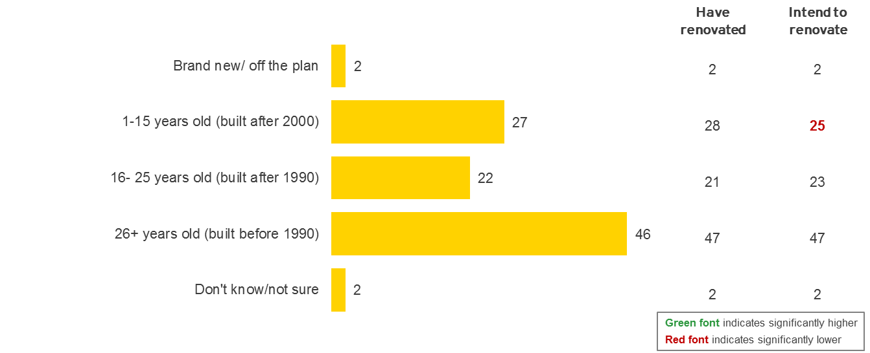
Base: All survey starters, n=2,357, Have renovated, n=1,918, Intend to renovate, n=1,811
S13. Roughly how old is the property you have recently renovated/are planning to renovate?
All values shown in percentages. Weighted data

Summary
There are indications that both home buyers and renovators represent a sizeable proportion of the Australian population that is either currently, or likely to be exposed to asbestos in the residential environment.
Over 1 in 10 property buyers (13%) planning to buy in the next 2 years will consider a home built before 1990. This equates to 3% of the Australian population. In addition, over one third of Australians (36%) plan to renovate in the next 2 years. Of this proportion nearly half (47%) plan to undertake renovations on properties built before 1990 which equates to a further 17% of all Australians.
Understanding the nature and size of the population that could be affected by asbestos is an important step in developing a clear strategy for increasing asbestos assessments.

Awareness and perceptions of asbestos
This section of the document discusses attitudes of Australians towards asbestos and perceptions of the potential health risks associated with asbestos in the home.
The particular areas included and key objectives covered in this section are…
- Overall awareness of asbestos
- What drives awareness of and education about asbestos
- Awareness of health effects of asbestos exposure and the perceived risk

Australians’ underlying thoughts and feelings about asbestos strongly shape their attitudes towards conducting residential asbestos assessments. It is important to understand these values and associations when embarking on changing attitudes to residential asbestos assessments. Overall, Australians’ attitudes to asbestos are driven by fear, a lack of education and a lack of awareness of management strategies. Emotions surrounding the concept of asbestos include fear and denial. Asbestos in the home is far from top-of-mind as home owners busy themselves with other things before, during and after acquiring a property. Asbestos in the home is not a salient issue. Many of these underlying attitudes and emotions need to change before Australian home owners will be open to an ethos of voluntary asbestos assessment in the residential purchase process.

Awareness of asbestos
The research found that most Australians are aware of the concept of asbestos with 99% of all Australian home buyers and renovators claiming to have heard of asbestos. This level of awareness was evident across all age groups and cohorts covered by both the qualitative and quantitative phases of the research. Those home buyers who did not intend to renovate were equally aware of asbestos along with those who did intend to renovate. Experienced home buyers were as aware of the concept of asbestos as first home buyers. As such, awareness of the word ‘asbestos’ is widespread.

Social discourse (as opposed to formal education) has driven awareness
Awareness of the concept of asbestos is driven by various social conversations. Chart 5 represents the various sources from which Australians have gained their knowledge of asbestos. The most common source of knowledge is the media cited by six in ten of home buyers and renovators (60%). The publicised James Hardie law suits have generated much media publicity and awareness and word of mouth has developed around the concept.
Tradespeople (i.e. builders, plumbers, carpenters etc.) are also a common source of knowledge for 42%, as are Government websites/publications (36%). A further one quarter (25%) knows about asbestos through conversations with their parents and other family members, with one in five (19%) also citing friends.

There are some key demographic differences in sources used to understand asbestos. Males are more likely than females to cite primary resources like tradespeople (47% vs. 42% total sample) and Government websites (42% vs. 36% total sample) as the basis of their asbestos knowledge. Females on the other hand are more likely than males to discuss asbestos with the people closest to them, for example their partner (23% vs. 13% total sample) and their parents or other family members (29% vs. 25% total sample).
Life stage also influences where Australians gather their information on asbestos. Those aged 18 to 29 years are significantly more likely to claim their understanding of asbestos comes from their parents or other family members (41% vs. 25% total sample). While those over 50 years are significantly more likely to turn to tradespeople (47% vs. 42% total sample) and government websites/publications (44% vs. 36% total sample) for information.

Chart 5: Sources for awareness of asbestos (%)
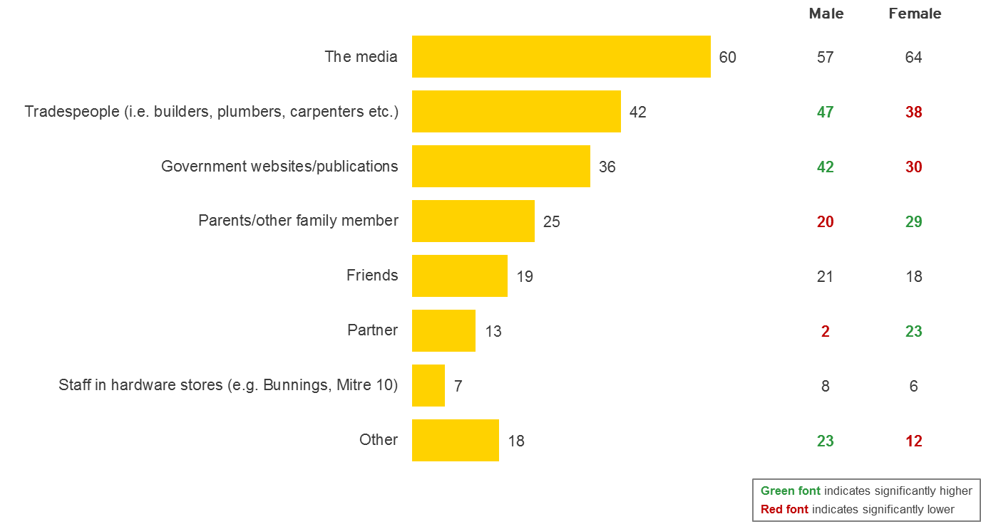
Base: All respondents, n=993, Male, n=485, Female, n=508
Q12. Where would you say your knowledge of asbestos comes from?
All values shown in percentages. Weighted data

The qualitative research uncovered that few people have any formal education about asbestos, apart from tradespeople and those in administration in the workplace where they are directly responsible for managing asbestos. Some people’s knowledge comes from personal experiences with asbestos, such as relatives who have died of mesothelioma. Older Australians remember personal experiences with asbestos including using it in the home, playing with it as a child and being exposed to it through DIY home renovations.
“I’ve heard of the older generation getting compensation claims and finally settling.” (Sydney Home Buyer)

Emotions surrounding asbestos
The concept of asbestos carries intensely negative emotions. Asbestos is associated with danger and is considered ‘toxic’ and ‘hazardous’. Some people, especially in inner city Sydney and Melbourne, are shocked to think it might actually be in their home. They fear for the health of their children.
Yet, asbestos is part of a wider environmental ‘fear load’. Home buyers ‘map’ environmental fears in their worlds from car accidents through to shark attack, contaminated foods, passive smoking, sun exposure, pollution and cancer. Asbestos is low on the list of fears and concerns because it is something that might affect them many years from now. Home buyers and DIY renovators believe there are other contaminants that asbestos ‘competes’ with for consideration such as lead paint and chemicals in treated pine and cleaning chemicals.
“If it’s in me, it’s already in me now. There are a lot of other things that could get me.” (Brisbane Home Buyer)
“Too many other things kill you faster like smoking. People worry too much. There’s fear but I don’t think it’s real. They were just working in the factories and got covered in dust.” (Melbourne Home Buyer)
“There’s so much fear in our lives and on the scale of fear where is asbestos?” (Melbourne Home Buyer)
“There’s more chance of dying from a kangaroo on the road.” (Canberra Home Buyer)
“What about pesticides on fruit and vegetables for the next 20 years?” (Melbourne Home Buyer)
“How do we know melamine isn’t bad for us?” (Melbourne Home Buyer)
“If you think about everything, you’d kill yourself.” (Melbourne Home Buyer)

Asbestos and health issues
The research showed that the majority of Australians know that asbestos is bad for your health.
Chart 6 shows the attitudes of home buyers and renovators towards asbestos. Nearly nine in ten (88%) agree (net of ‘agree’ and ‘strongly agree’) that asbestos is a health hazard to the DIY renovator. A further 62% also agree that asbestos is dangerous in any form. Awareness of the health problems associated with asbestos has been largely driven by a history of the James Hardie victims in legal disputes appearing on television. Some Australians have had friends and family affected by the disease and developed awareness in a personal way. As such, Australians do recognise that asbestos is an important issue. Just 12% agree that asbestos ‘used to be a big issue but not any more ‘ and only 6% believe that is rare.

Chart 6: Attitudes to asbestos (%)
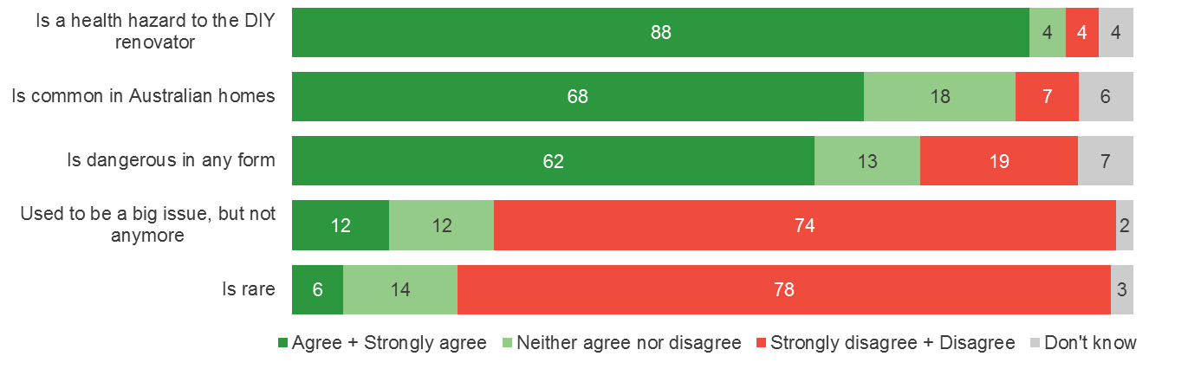
Base: All respondents, n=1,003
Q8. Please select how strongly you agree or disagree with each of the following. ‘Asbestos…”
All values shown in percentages. Weighted data

Australians are also fairly confident in their understanding of what health risks are related to asbestos exposure.
Chart 7 shows the degree of confidence Australians have in their knowledge of asbestos. Seven in ten home buyers and renovators (72%) are confident (net ‘confident’ or ‘very confident’) in their understanding of the dangers of asbestos. A further 71% are also confident in their knowledge of the effects asbestos can have on their health. Just around half of all home buyers and renovators (53%) stated that they are confident they know enough about the degree to which asbestos poses a threat in their home.

Chart 7: Degree of confidence relating to asbestos knowledge (%)
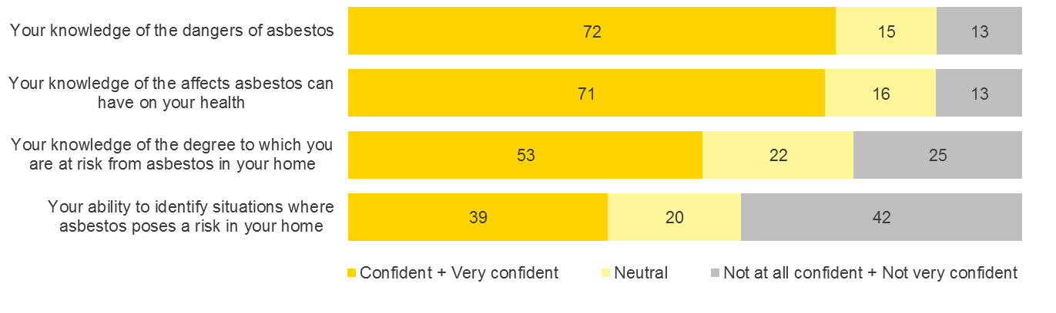
Base: All respondents, n=383 - 1,003
Q11. Looking at the following statements, please select how confident you are in…
All values shown in percentages. Weighted data

From the qualitative stage of research asbestos was known to affect the lungs and can result in death through ‘cancer’. Some Australians understand that there are ‘barbs’ in asbestos that lodge in and damage the lungs.
Chart 8 represents awareness of health problems related to asbestos exposure. Almost four in five home buyers and renovators (78%) say they are aware that asbestos can cause asbestosis. Two thirds (67%) believe exposure can lead to lung cancer and three fifths (61%) are aware of mesothelioma.
Renovators are more likely to be aware of asbestosis, mesothelioma and pleural disorders than home buyers. Furthermore, one in ten home buyers (11%) feel they don’t know or are unsure what health problems are associated with asbestos exposure, compared to only 3% of renovators. Renovators are likely to be more engaged and knowledgeable about asbestos than home buyers because they are more aware of coming in contact with it during the renovating process.

Chart 8: Awareness of health problems related to asbestos (%)
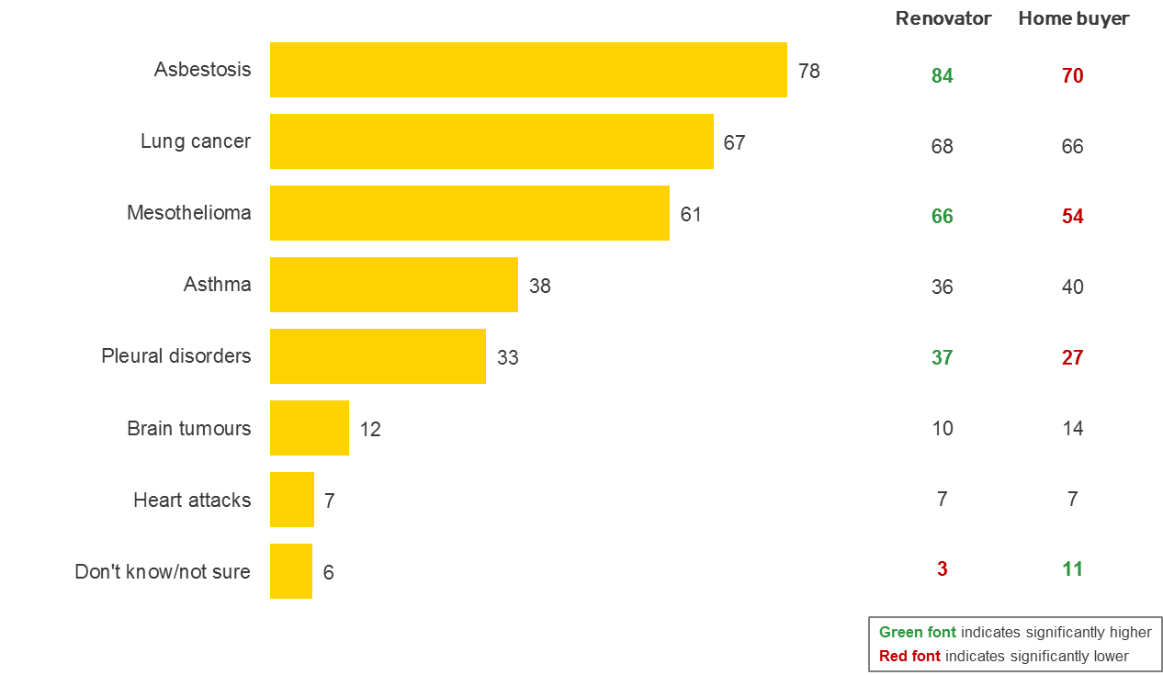
Base: All respondents, n=1,003, Renovator, n=602, Home buyer, n=401
Q9. What health problems are you aware of that are related to asbestos exposure?
All values shown in percentages. Weighted data

Although many acknowledge asbestos can cause health issues, it is rare to fully appreciate what these terms mean or what these illnesses involve.
Chart 9 indicates the perceived health risk of asbestos in the home. Less than half of all home buyers and renovators (47%) believe that if asbestos was found in a home, it would pose a high or very high risk to health. Nearly one fifth (17%) actually feel asbestos in the home poses a low to very low health risk. Males are significantly less likely than females to agree that asbestos poses a health risk. Although males are more confident in their knowledge of the affects asbestos can have on their health (77% vs. 65% of females), just 38% believe asbestos in the home poses a high or very high risk, compared to 55% of females. This potentially indicates a difference in the perception of risk between males and females.

Chart 9: Perceived health risk of asbestos in the home (%)
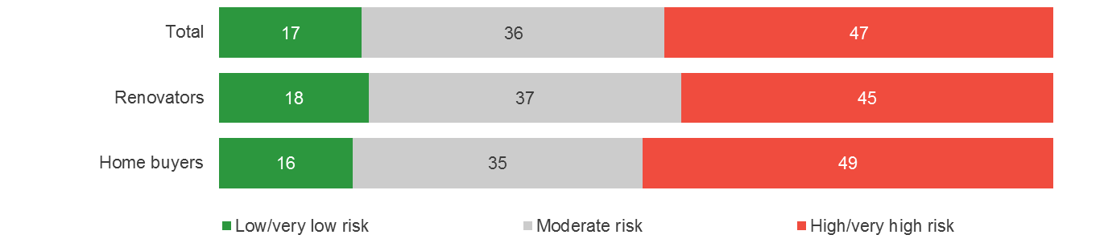
Base: All respondents, n=1,003
Q10. If asbestos was found in a home, how much of a health risk do you think it poses?
All values shown in percentages. Weighted data
The degree of risk can vary and depends on many factors (i.e. amount of asbestos in the home, degree deterioration, degree of exposure etc.). However the results from the qualitative research do indicate that the dangers of asbestos in the home can be slightly downplayed by some Australians.
Some people in the qualitative research began their discussions of asbestos with statements of denial. Without knowing how to manage asbestos it was common for some people to trivialise it, deny it was an issue or believe asbestos is over-rated by people who are overly sensitive. It was common to believe asbestos is just something that we have to live with because it is so prevalent and we cannot do anything about it. Denial was present even among older Australians who had friends and relatives with asbestos related disease or who had lost relatives from asbestos related illness.
“Too much hype in Australia. In India, it’s part of everyday life.” (Sydney Home Buyer)
“There are so many factors that lead to dying. It’s rare.” (Sydney Home Buyer)
“It’s only in fibro houses or weatherboard houses like old Queenslanders where you have to dispose of the whole house.” (Sydney Home Buyer)
“People lived in those homes and lived a long life and didn’t get affected and there was asbestos.” (Sydney Home Buyer)
“People are terrified of it but it’s not a big deal. It’s a freak of nature if you get it.” (Sydney Home Buyer)
“You might have been exposed anyway.” (Melbourne Home Buyer)
“It’s exaggerated in Australia. Not like in Russia where I come from.” (Melbourne Home buyer)
Summary
Awareness of asbestos is fairly widespread in Australia across all cohorts. Awareness is largely driven by the media and publicity surrounding the James Hardie law suits as well as through word of mouth via trade professionals or talking with family and friends. Key demographics such as gender and life stage also influence how people build their knowledge of asbestos.
Asbestos invokes intensely negative emotions, and is known for being ‘toxic’ and ‘hazardous.’ Australians give significant weight to the issue of asbestos and most feel confident in their own understanding of the associated illnesses and health problems of asbestos exposure.
Yet, the degree to which Australians fully appreciate the dangers and risk asbestos posed to them in their own world is minimised. Findings from the qualitative research suggest Australians currently have awareness without sufficient knowledge, which leads to a sense of denial. Creating a deeper level of understanding of asbestos and the dangers posed by exposure within the home is an important first step to changing attitudes towards asbestos assessments.

Knowledge of asbestos in residential properties
This section of the document covers Australian’s awareness of asbestos within the home - the depth of understanding in relation to where it may be located and what form it can take.
The specific areas included and key objectives covered in this section are…
- Levels of understanding about asbestos in the home
- Awareness of specific areas within the home where asbestos may be found
- Levels of understanding regarding what asbestos looks like and what form it can take
- Perceived importance of knowing if asbestos is present in the home

Levels of understanding
From the qualitative phase of the research it was apparent that while some people know what asbestos is, few have complete knowledge. Levels of understanding vary widely across Australia from a spectrum of total lack of understanding through to reasonably detailed understandings. It is only the expert tradesperson (e.g., a carpenter) that knows quite a lot about asbestos. However, the ‘lay’ person, such as the DIY home renovator, is still unaware of what asbestos is and how to identify it.
“It’s like the Lock Ness Monster – people talk about it and they think it’s out there, but they’ve never seen it.” (Melbourne Real Estate Agent)
“85% of DIY renovators interfere with asbestos because they don’t know where it could be and they think it’s all board and cement sheeting.” (Asbestos assessor Canberra)
Some people feel they can identify asbestos by sight others have no idea what it looks like. The older generation, people in trades, renovators and males generally feel more confident to identify asbestos, at least in sheet form.
Chart 10 represents how confident Australians feel in relation to their understanding of asbestos in the home. We know that at a broad level, Australians are confident in their knowledge that asbestos is dangerous and can cause health problems. At a more detailed level of understanding however, confidence varies quite considerably. For instance in Chart 10, we see that two fifths of home buyers and renovators (42%) feel confident (net ‘confident’ and ‘very confident’) in their knowledge of where asbestos is in their home. Yet almost the same proportion (41%), do not feel confident (net of ‘not at all confident’ and ‘not very confident’) they know where it is in their home.

Furthermore, more than half of home buyers and renovators (54%) say they are not confident in their ability to identify asbestos in their home and 50% do not feel confident they know what material containing asbestos look like. Two in five (42%) are also unconfident in their ability to identify situations where asbestos poses a risk. While Australians may be aware asbestos is dangerous and hazardous to their health, this data suggests knowledge and understanding of potential locations of asbestos around this home is limited. In such instances, home owners and renovators in particular could be putting themselves at risk of exposure.

Chart 10: Degree of confidence relating to asbestos knowledge (%)
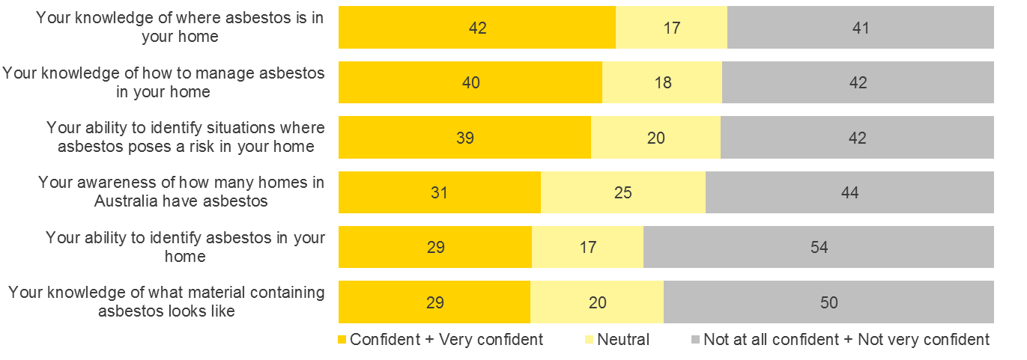
Base: All respondents, n=383 - 1,003
Q11. Looking at the following statements, please select how confident you are in…
All values shown in percentages. Weighted data

Awareness of where asbestos can be found
Some Australians think asbestos is not commonly found in the home and that it is only found in industrial locations. Home owners in the qualitative research tended to think of asbestos as affecting the workplace and tradespeople who might be working with it. It has an industrial image associated with construction, factories and blue collar workplaces.
“Industrial sites have hazardous materials.” (Sydney Home Buyer)
“Mostly workmen get affected.” (Sydney Home Buyer)
“It’s in factories and warehouses, not family homes.” (Sydney Home Buyer)
“We would be free of it now. It’s mostly an industrial thing.” (Sydney Home Buyer)
As such, most people have limited understanding of where asbestos is in the home. It is more typically believed to be outside the home in roofs, sheds and lean-tos although some more astute tradesperson and older Australians understand that it was used in building materials inside the home.
Chart 11 represents prompted awareness of locations where asbestos may be found in residential properties. When prompted, home buyers and renovators are aware that asbestos can be found in locations both inside and outside the home. Many are aware that asbestos can be found in wet areas (70%), in the kitchen (64%) and in living areas (57%). Yet qualitative findings suggest spontaneous awareness of asbestos in these areas is much lower.

Those aged over 50 years have a greater understanding of where asbestos can be located in the home. As shown in the table in Chart 11, those aged 50 years and over are significantly more likely be aware of the various locations around the home it may be found. Conversely, the younger demographic (18 to 39 year olds) are less likely to be aware that asbestos can be found inside the home. Half of all 18 to 29 year olds (50%) and 56% of 30 to 39 year olds are aware asbestos can be found in wet areas like the bathroom, toilet and laundry compared to 80% of those aged 50 years and over.

Chart 11: Awareness of where asbestos can be found in the home (%)
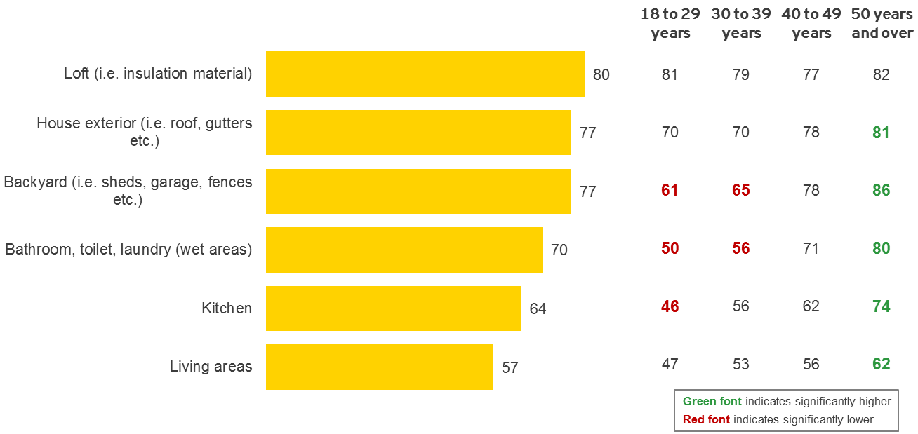
Base: All respondents, n=1,003, 18 to 29 years, n=77, 30 to 49, n=186, 40 to 49 years, n=220, 50 years and over, n=520
Q13. Thinking specifically about residential properties, where do you think asbestos could be located?
All values shown in percentages. Weighted data

Awareness of what asbestos looks like
Australians generally believe asbestos is typically found in grey sheet form that looks like concrete.
Chart 12 shows more specific areas or uses for asbestos in the home (i.e. as insulation, around pipes etc.) When prompted there are indications that asbestos is more strongly associated with areas outside the home. More than three quarters (78%) believe that asbestos is in cement sheeting used in walls, ceilings and floors, 75% believe it is used in roof insulation, 69% say asbestos can be found in lining under eaves and 68% think it is in garages and carports – all of which being locations outside of the home. Overall, renovators are more likely than home buyers to be aware of the various locations of asbestos. In particular, renovators are significantly more likely to be aware that asbestos can be found around hot water pipes (64% vs. 53% home buyers) and more likely to be aware it can be found around or behind tiles (61% vs. 49% home buyers). Those under the age of 50 are significantly less likely to know that asbestos is around or behind tiles (45%) compared to 64% of those aged over 50 years.

Chart 12: Specific locations in the home likely to contain asbestos (%)
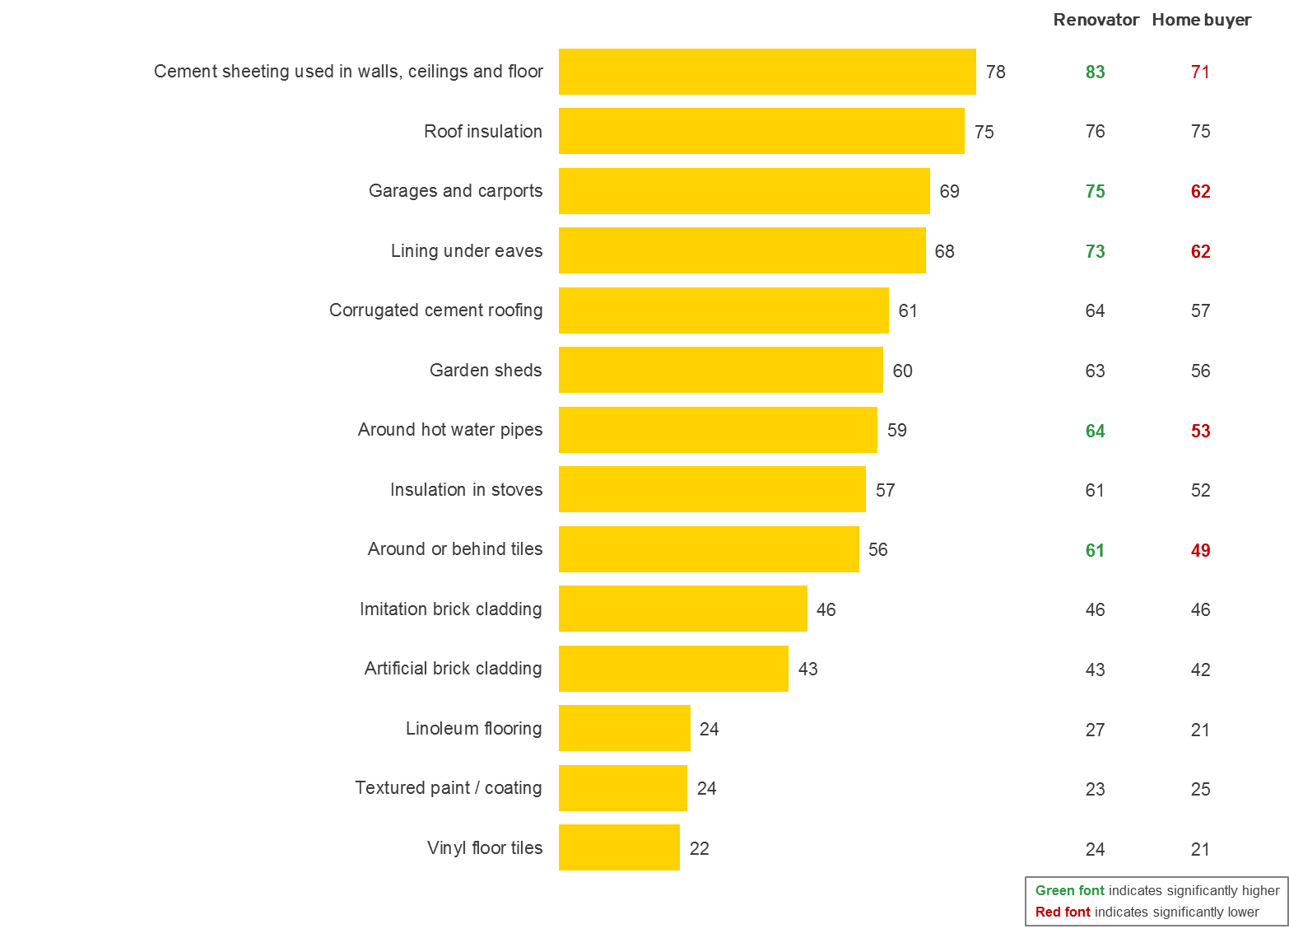
Base: All respondents, n=1,003, Renovator, n=602, Home buyer, n=401
Q14. Looking at the list below, where specifically do you think asbestos could be found in or around the home?
Mentions <5% not shown
All values shown in percentages. Weighted data

From both qualitative and quantitative research however, it is evident there is a significant gap in Australians awareness of asbestos being used under linoleum and under vinyl floor tiles. Just under a quarter of home buyers and renovators (24%) believe asbestos can be found in linoleum flooring, as textured paint /coating (also 24%) and just 22% believe it can be found under vinyl floor tiles.
Furthermore, very few Australians are aware asbestos can come in putty form.
Chart 13 represents awareness of various forms asbestos may take. While the majority of home buyers and renovators are aware asbestos comes as sheeting (81%), dust (65%) and insulation (64%), just 14% are aware that asbestos can be in putty form (i.e. used under lino or tiles). This perception is consistent across life stage and renovators and home buyers.
The qualitative research suggests that even the experienced DIY home renovator finds it hard to believe that asbestos is under lino. When asked, most home buyers and owners feel confident to pull up old lino from the 1970s and may have done so. When asked, many of the respondents in the groups felt confident to remove old tiles and pull up lino. An asbestos assessor said one of the greatest disappointments to the DIY renovator is that pulling up floorcoverings is not always safe and requires money to remove. Removing floor covering is perceived to be one of the cheapest and easiest ways to improve the look and value of a home.
“I’ve never seen anything on TV about lino.” (Melbourne Home Buyer)
The qualitative research also identified that different states and jurisdictions have different asbestos related histories and knowledge. For example, in Western Australia asbestos is strongly connected to fencing and in Canberra it is more often connected with insulation.
People in Canberra believe it was commonly used in wet areas such as bathrooms to back tiles in Government housing as well as for insulation. Canberra remains unique given the wide exposure of the Mr. Fluffy history. The awareness of asbestos has been raised in the ACT, although education is not always greater. Few inner city home buyers in Sydney and Melbourne associated asbestos with insulation in ceilings or wet areas.
“It’s an obsession in this town after Mr. Fluffy.” (Canberra Real Estate Agent)
While the depth of understanding of the various forms of asbestos differs across the population there is a proportion that feels they simply don’t know what asbestos looks like. In Chart 13 we see that one in ten home buyers and renovators (10%) say they are unsure what form asbestos can take.

Chart 13: Forms asbestos can take (%)
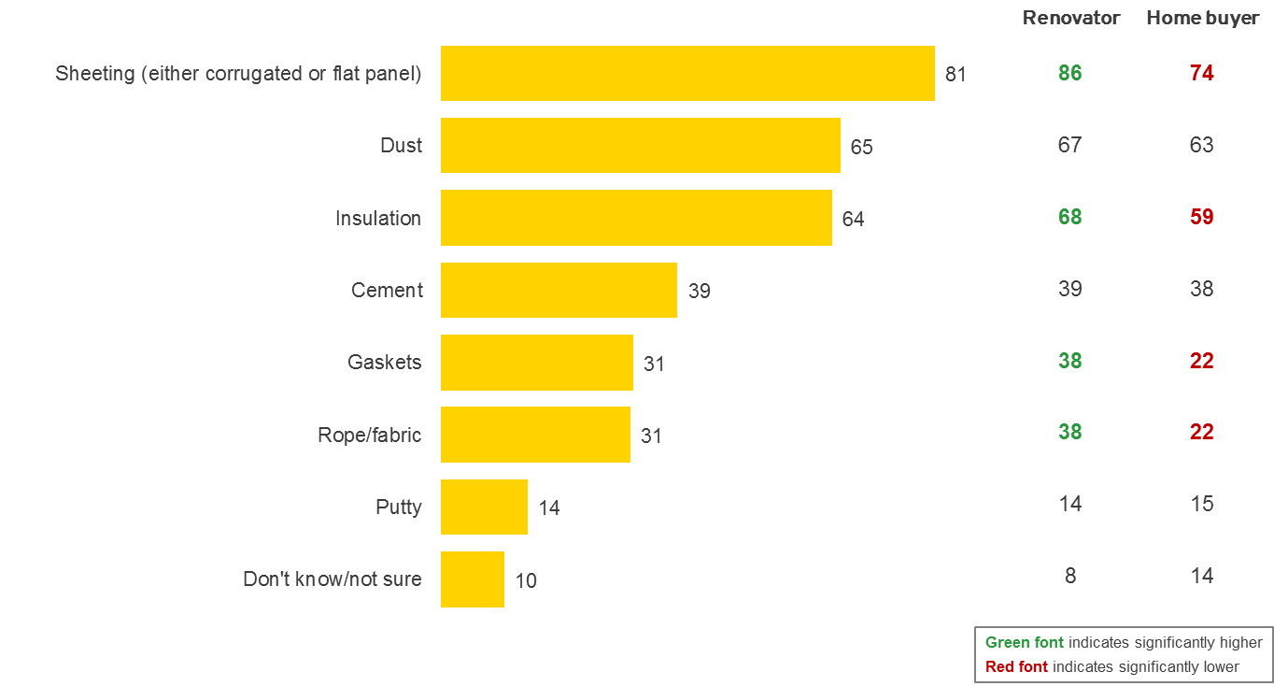
Base: All respondents, n=1,003, Renovator, n=602, Home buyer, n=401
Q15. What form does asbestos take, i.e. what does it look like?
Mentions <5% not shown
All values shown in percentages. Weighted data

Importance of knowing if asbestos is present
Although understanding of where asbestos is located in the home can fluctuate, nearly all home buyers and renovators feel it is important to know if it is present in a home.
Chart 14 represents attitudes toward knowing whether asbestos is present in a home prior to buying it and prior to conducting renovations.
Nearly nine in ten Australians (89%) believe it is important (net of ‘extremely important’ and ‘very important’) to know prior to purchasing a home if it contains asbestos. Similarly, 96% of home buyers and renovators believe it is important to know if asbestos is in a home prior to undertaking renovations.

Chart 14: Importance of knowing if asbestos is present in a home (%)
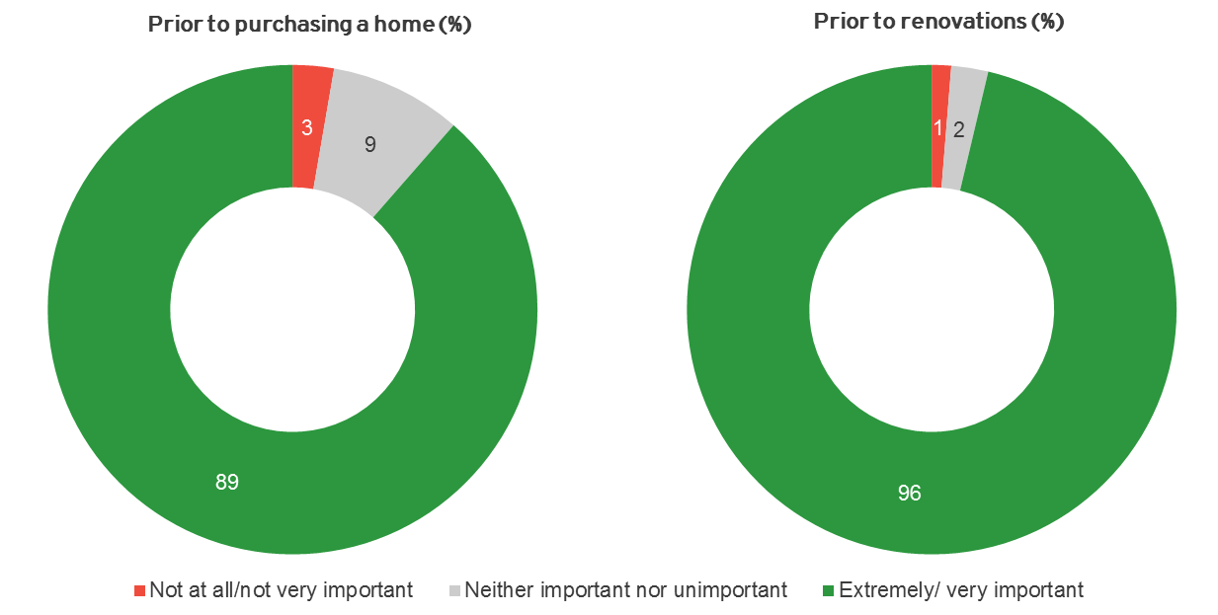
Base: All respondents, n=1,003
Q16. How important do you think it is to know whether there is asbestos in a home prior to purchasing?
Q18. How important do you think it is to know whether there is asbestos in a home before undertaking renovations?
All values shown in percentages. Weighted data

Summary
The levels of understanding about asbestos vary widely across Australia. While most acknowledge that asbestos is dangerous and can lead to health problems, few Australians are entirely confident in their understanding of exactly where it can be located and what it looks like. The majority of Australians are aware that asbestos comes in sheeting form and it is more strongly associated with areas outside the home. Some cohorts such as renovators and those aged 50 years and over are more likely to have a greater understanding of asbestos around the home.
There are however, large gaps in understanding that asbestos can be found inside the home (in particular amongst those under the age of 50). Specifically there is a lack of awareness that asbestos can be found in wet areas, under linoleum and vinyl floor tiling. This is a barrier to increasing asbestos assessments amongst renovators since most are unaware of any potential asbestos exposure. It is common to assume that ripping up vinyl and linoleum flooring or removing tiles in a bathroom is a cheap, safe and a relatively easy task they can do themselves. This lack of awareness places this group at considerable risk.
Yet regardless of their depth of understanding of asbestos, nearly all home buyers and renovators feel it is highly important to know if asbestos is in their home. This indicates an interest amongst Australians to increase their knowledge of asbestos and know if it is in their home.

Asbestos checks and inspections
This section of the document covers attitudes and behaviours in relation to the process of identifying asbestos in the home.
The particular areas included and key objectives covered in this section are…
- The process of identifying asbestos in the home
- Reactions and emotions surrounding asbestos in the home
- Strategies for asbestos management
- Perceived responsibility for asbestos

Identifying asbestos in the home
From the qualitative stages of the research it was apparent that levels of fear surrounding asbestos vary, with some people feeling afraid but not panicked and others feeling so afraid they would never contemplate buying a house with asbestos in it anywhere. It was also clear that how people react to the idea of asbestos being present in the home can differ quite dramatically between those who feel in control and those who don’t.
For many Australians, feeling in control of asbestos means knowing if it’s present and knowing how to manage it. Regardless of whether asbestos is present or not, qualitative and quantitative results suggest that having this knowledge helps to mitigate people’s fears. This could be due to a feeling of control or due to home owners post-rationalising their concerns. Yet the perceptions of those who know of asbestos in their home are different to those who are unaware. When faced with the ‘unknown’, Australians have a much greater sense of alarm at the prospect of any asbestos in the home.
In understanding the current attitudes and behaviours surrounding identifying asbestos in the home, we have analysed both perceived and actual experiences of Australians. By this we mean analysing the expectations and attitudes of those who are yet to go through the process of checking for asbestos in comparison to those who have.
Chart 15 represents the contrast in perceived and actual experience. For this analysis, ‘home owners’ represents those who own a home (i.e. those who have either recently purchased a home or are renovating). Those ‘intending to buy’ refers to our sample of people who are planning to buy in the next 2 years and their perceptions of what steps they will take to check the property they buy for asbestos.

Chart 15: Proportion who will or have checked for asbestos in their home (%)
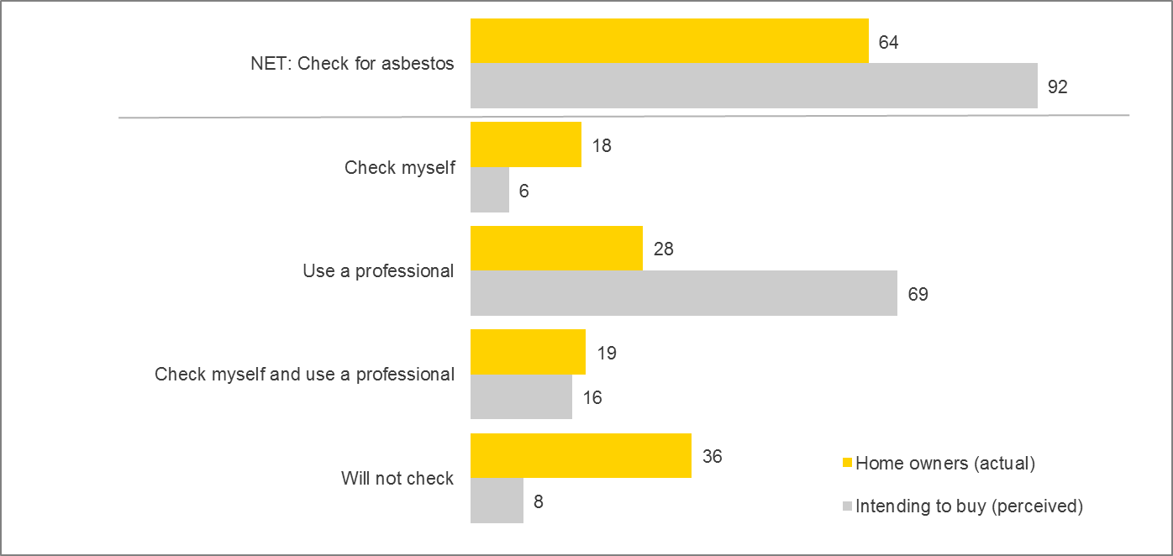
Base: Home owners, n=741, Intending to buy, n=262
Q19. Thinking about checking for asbestos in a home, which of the following applies to you?
Q20. Do you intend to check the home you will buy for asbestos?
All values shown in percentages. Weighted data

Nearly two thirds of home owners (64%) have checked their home for asbestos, either through a professional, by checking themselves or a combination of the two. There are also some demographic differences in the propensity to check for asbestos and the preferred method. Males for instance are significantly more likely to check for asbestos themselves (23% vs. 18% total), as are those aged 50 years and over (22% vs. 18% total). QLD residents are also more likely to check for asbestos themselves (28% vs. 18% total) while residents in ACT are significantly more likely to have used a professional to check for asbestos (52% vs. 28% total), most likely as a result of the publicity surrounding ‘Mr. Fluffy’ homes and the need for professional intervention.
When faced with the possibility of asbestos in the home, the vast majority of those planning to buy feel they would check for asbestos. Nine out of ten of those intending to buy (92%) believe they will check their new property for asbestos, compared to 64% of home owners who actually did. More than two thirds (69%) also believe they will use a professional to carry out these checks, compared to just 28% of home owners who have been through the process. This indicates a sentiment amongst home buyers may be a positive step towards increasing use of asbestos assessments - most home buyers are open to conducting checks for asbestos on properties they wish to purchase using a professional.

Reacting to asbestos in the home
Mentions of asbestos in the home invoke strong reactions from home owners and buyers. When asked hypothetically what they would do if asbestos was found in a property they were interested in purchasing, the majority of Australians feel it would change their perception. Nearly half of those surveyed (47%) claim they would want to pay a reduced price for a property if they knew it contained asbestos and 36% claim they would not want to buy at all.
In assessing in detail how people respond to asbestos in their home, we also analysed attitudes and behaviours of those who know that there is asbestos in their home in comparison to those who don’t. Nearly a third of home owners (29%) surveyed said that they know they have asbestos in their home. Half (47%) do not have asbestos in their home, while 25% say they do not know or are unsure whether there is asbestos present.
Interestingly, males are significantly more likely to say there is no asbestos in their home (53% vs. 47% total), while females and those aged 18 to 29 years are significantly more likely to be are unsure (33% and 45% respectively vs. 25% total).
Again, the level of concern over asbestos in the home differs dramatically between those who know it is present and those who are unaware.
Chart 16 shows the level of concern given to the notion of asbestos being present in the home.

Chart 16: Level of concern with asbestos in the home (%)
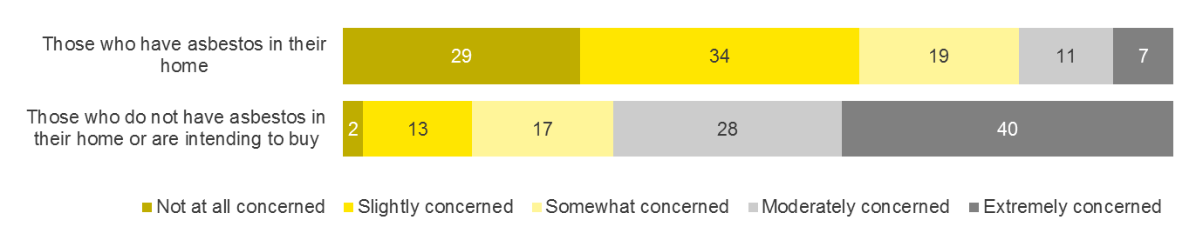

Base: Those who have asbestos in their home, n=214, Those who do not have asbestos in their home or are intending to buy, n=783
Q30. How concerned would you say you are about the asbestos in your home?
Q31. How concerned would you be if asbestos was present in your home or home you are intending to buy?
All values shown in percentages. Weighted data

For those who already know there is asbestos in their home, the reaction is largely subdued. One third (34%) feel slightly concerned about the asbestos in their home, while 29% say they are not at all concerned. This perception is collective across all demographics and cohorts. Amongst those home owners who are not at all concerned about the asbestos in their home, the majority (76%) say it is because they feel the asbestos is stable and is manageable.
Those who do not know if there is asbestos in their home however are more concerned at the idea of it being present. Two fifths of this cohort (40%) say they would be extremely concerned if asbestos was in their home. Feeling uninformed, combined with a perceived lack of control can intensify anxiety surrounding asbestos in the home. The majority (84%) of those who feel extremely concerned say it is because asbestos is a danger to themselves and their family.

Knowledge of asbestos management
Amongst home owners who know there is asbestos in their home, chart 17 shows who specifically identified it. Around a third (34%) claim they themselves identified the asbestos, one fifth (21%) say a tradesperson identified it and 18% claim a building inspector identified it. Males and those aged 50 years and over were significantly more likely to say they identified asbestos themselves (47% and 46% respectively vs. 34% total).

Chart 17: Who identified the asbestos (amongst those who have asbestos in their home) (%)
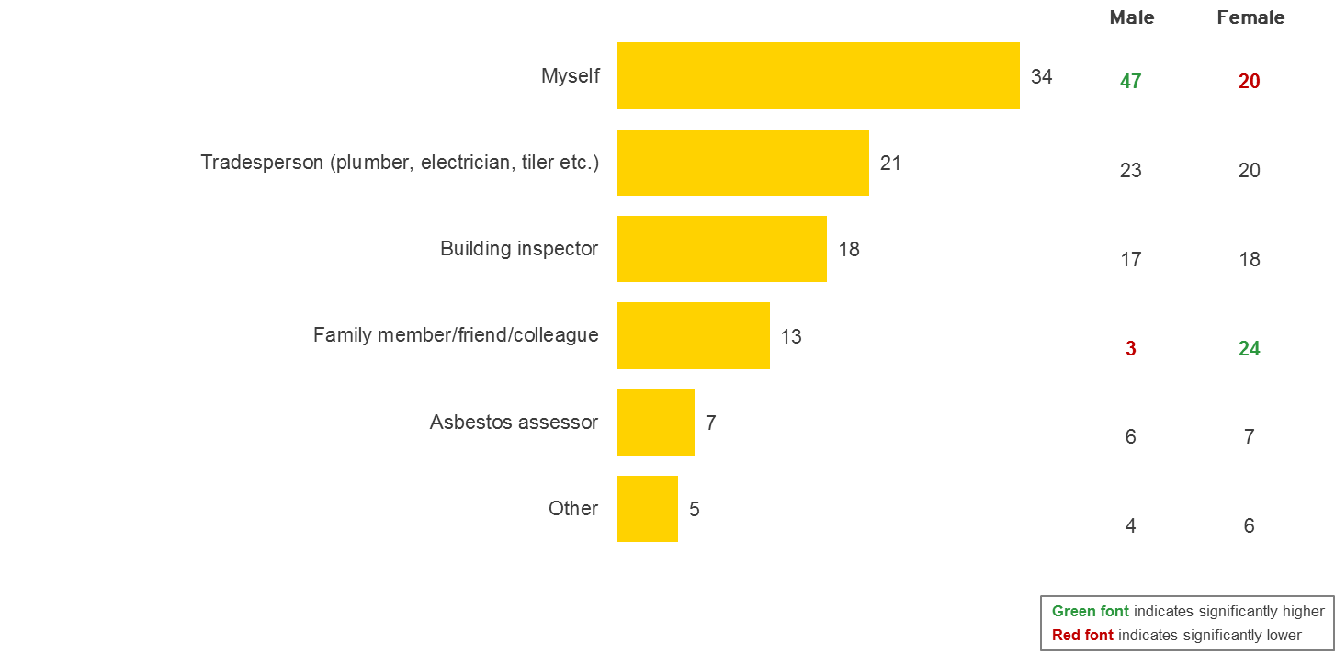
Base: Those with asbestos at home, n=214, Male, n=116, Female, n=98
Q25. Who identified the asbestos in your home?
All values shown in percentages. Weighted data

Knowledge of asbestos management is largely confined to believing it is safe if undisturbed. Most Australians understand that asbestos is fibrous and that breathing in the fibres is dangerous. This leads to an understanding that asbestos sheeting should not be interfered with by, for example, cutting or drilling. In the qualitative results, this was the only popular management strategy Australian home owners are widely aware of. They do not understand sealing or the dangers of deterioration over time such as cracking or exposure through weather, as these are not to do with human interference. It is not widely understood that asbestos deteriorates. This is also evident in the quantitative research as 60% of people claim that asbestos is only dangerous when interfered with. Some people even believe that it last for 100s of years and is almost indestructible.
“Asbestos is safe until you disrupt it.” (Sydney Home Buyer)
“Benign until it’s disturbed.” (Melbourne Home Buyer)
“Doesn’t present a problem until it’s drilled or filed.” (Canberra Real Estate Agent)
These findings are largely supported in the quantitative research.
Chart 18 shows what actions were taken by those home owners who know asbestos is in their home. When prompted, the most common actions taken are to simply leave it alone and to not interfere with it (30%), to seal the exposed areas (28%), to keep an eye on it to see if it deteriorates (24%) and to paint it (22%).
The type of management strategy taken is also influenced by who identified the asbestos. Alarmingly, those who identified the asbestos themselves are significantly more likely to say they removed it themselves (14% vs. 6% total). Those who had a tradesperson identify the asbestos were more likely have a tradesperson remove it (26% vs. 12% total). Those who claim a building inspector identified the asbestos are significantly more likely to say they have done nothing (51% vs. 30% total), perhaps indicating that many have falsely assumed an asbestos check was conducted by a building inspector.

Chart 18: Actions taken when asbestos is discovered (%)
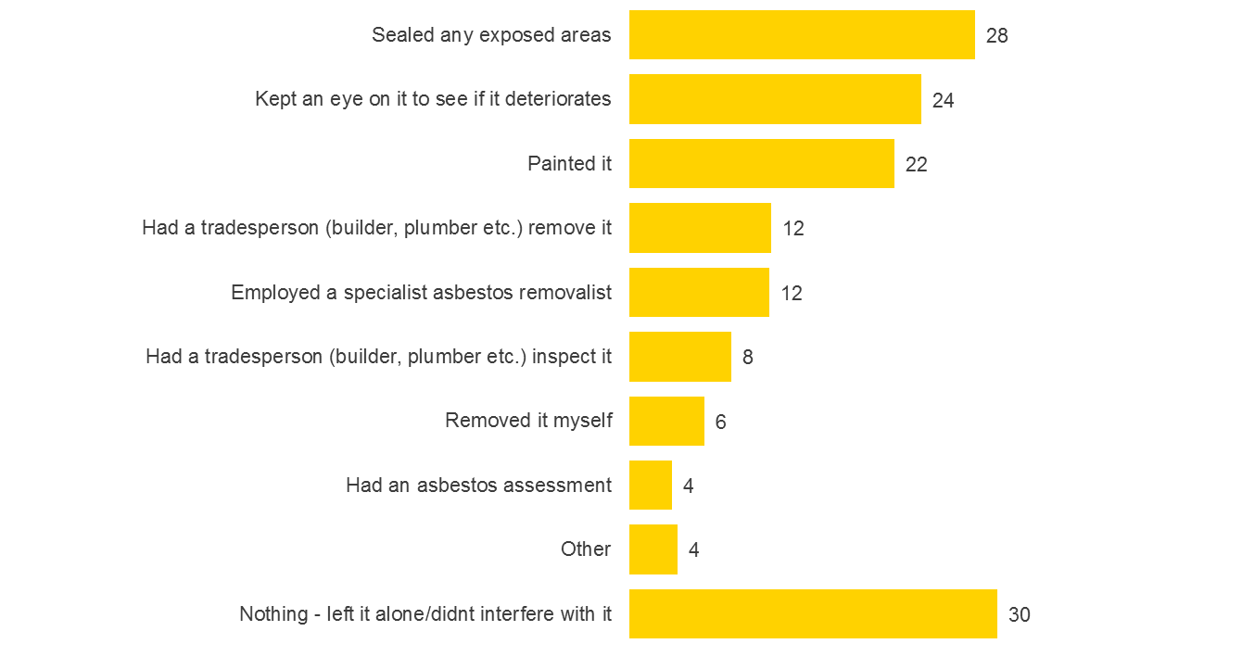
Base: Those with asbestos at home, n=214
Q27. What action did you take when you discovered asbestos in your home?
All values shown in percentages. Weighted data

Perceptions of how to best manage asbestos are fairly different between those who have been through the process of checking for asbestos and amongst those for whom it is unknown.
Chart 19 represents the different strategies Australians think will make people feel less concerned about asbestos in their home. Those who already know of the asbestos in their home are significantly more likely to say understanding how to manage asbestos would make home owners feel less concerned (73%). Those who are unaware of asbestos however are more inclined to have the asbestos removed to allay their fears (70%).
Chart 19: Strategies to ease concern of asbestos in the home (%)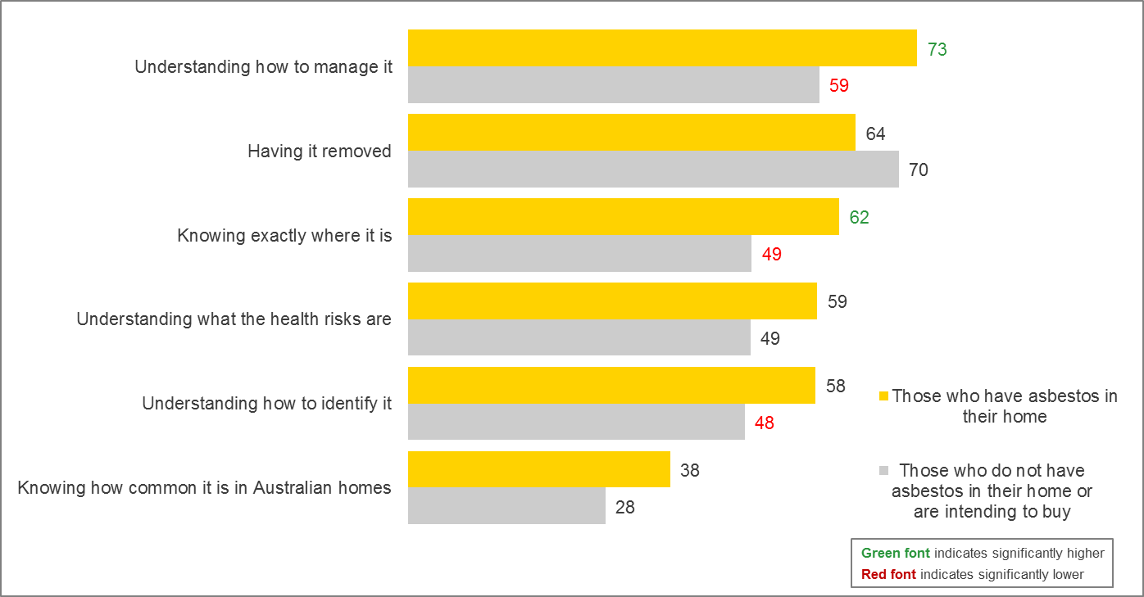
Base: Those who have asbestos in their home, n=214, Those who do not have asbestos in their home or are intending to buy, n=783
Q33. What do you think would make people feel less concerned about asbestos in their home?
All values shown in percentages. Weighted data

The issue of responsibility for asbestos in the home
Overall, the buyers and owners in this research, whether first home buyers or experienced home buyers, did not feel they were responsible for determining if there was asbestos in their property. Attitudinally they ‘delegated’ responsibility for asbestos awareness and management to other people and institutions, in particular, building inspectors, tradespeople, conveyancers, local Councils and sometimes sellers and real estate agents.
“People have to declare it when selling the house.” (Sydney Home Buyers)
“The Builder deals with it.” (Melbourne Home Buyer)
“I would rely on people who work in construction like tradies to manage asbestos.” (Brisbane Home Buyer)
“Isn’t this the responsibility of the council? Isn’t there someone official?” (Melbourne Home Buyer)
“The building inspection includes an asbestos assessment.” (Canberra Home Buyer)
One of the strongest myths unearthed by this research is that the home buyer believes the building inspector identifies and informs in regard to asbestos as a part of their role. Most home buyers think if there was asbestos in their home the building inspector would have told them. Many home owners are falsely under the belief that their house is clear of asbestos because there has been a building inspection.

It is a shock to most home buyers and owners that a building inspector is not qualified to assess asbestos and that it may have been overlooked. It makes home buyers angry to think that the inspection does not fully cover asbestos assessment.
“I paid 100’s of dollars for a building inspection so I would hope they would do it!” (Sydney Home Buyer)
“I assume they check for asbestos. Isn’t that what they’re paid to do?” (Melbourne Home Buyer)
“That’s what we pay the building inspector for.” (Sydney Home Buyer)

Chart 20 shows the list of people or organisations that are perceived to be responsible for informing home owners if there is asbestos in their home. Nearly three quarters (72%) believe it is the responsibility of the building inspector to tell a home owner about asbestos. Nearly half (49%) believe real estate agents are responsible and 47% believe the previous owner should inform the new owner. These perceptions are widely consistent across the population though there are some key differences. Those aged 18 to 29 years are significantly more likely to believe the Council is responsible to tell owners about asbestos (41% vs. 26% total).

Chart 20: Who checked for asbestos (amongst those who have asbestos in the home) (%)
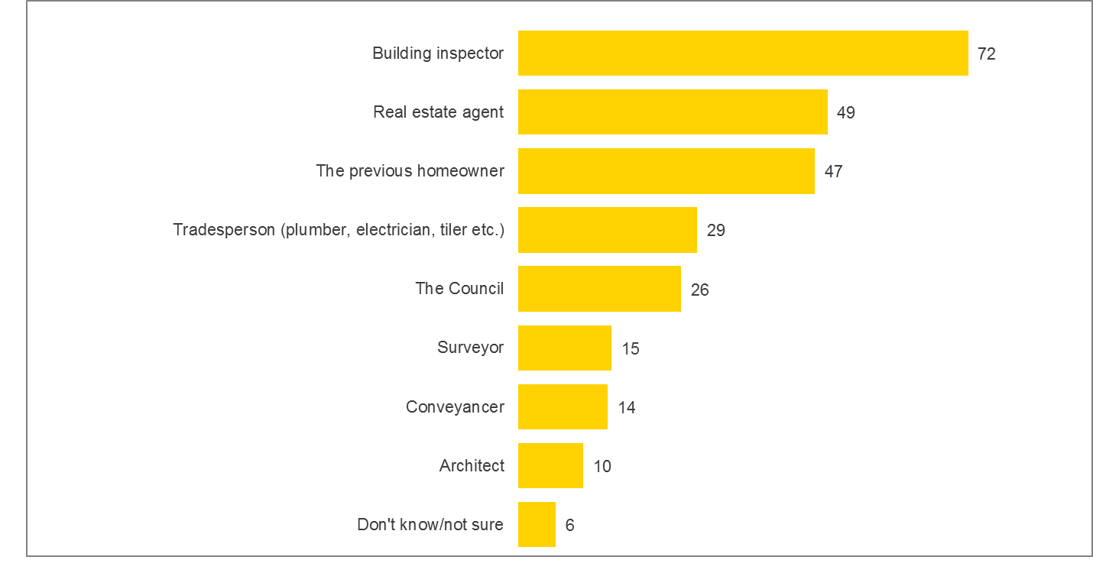
Base: All respondents, n=1,003
Q35. And who is responsible for telling the homeowner if there is asbestos in the home?
All values shown in percentages. Weighted data

In the qualitative research many home buyers believed the conveyancer will tell them about asbestos. Some home buyers perceive the conveyancer to be an authority on the history of the house. They believe that documentation about the history of the house would have asbestos explained – that it would be documented somewhere. Conveyancers also recommend building and pest inspections on their client’s behalf and have them conducted. They trust the conveyancer to know about the building more than anyone else.
“The conveyancer should know from previous years.” (Sydney Home Buyer)
“They do property searches and asbestos should be recorded in records of old.” (Sydney Home Buyer)

Many home owners believe the tradesperson will inform them of asbestos prior to any renovation and defer responsibility for identifying asbestos to the tradesperson, as he/she should know. They trust the tradesperson not to do anything wrong.
“I’d go through a tradesperson and they’d tell me about it.” (Canberra Home Buyer)
“Tradies differ – one said it was asbestos, one said it wasn’t.” (Sydney Home Buyer)

Most Australian home buyers are confused about who is liable for asbestos related diseases. Some believe James Hardie is liable, whilst others can imagine the landlord is liable. Others do not accept that a home owner is liable in any way. Few feel the disease is their responsibility as the origins of disease are untraceable. Some landlords feel that if the only management strategy for asbestos is not to interfere with it, then if a tenant is exposed they have damaged the landlord’s property. They consider themselves a victim in cases such as this, rather than liable or responsible
It is in this milieu of confusion fear and myth that the concept of the asbestos assessment is currently received.

Summary
When faced with asbestos in the home, a home owner’s reaction is largely dictated by their level of knowledge and their perceived level of control. By firstly understanding if asbestos is present in their home and then how best to manage it, homeowners are more likely to feel in control of the situation and have considerably diminished fears and anxieties. Conversely, those who feel they do not have adequate understanding of asbestos have a sense of fear without empowerment. This leads to an even more heightened emotional response to the idea of asbestos in their home. A deeper understanding of how to identify and manage asbestos is required.

Attitudes to residential asbestos assessments
This section of the document covers the spectrum of attitudes and behaviours relating to asbestos assessments.
The particular areas included and key objectives covered in this section are…
- Awareness and perceptions of asbestos assessments
- Triggers to undertaking asbestos assessments
- Barriers to asbestos assessments
- Mindsets of buyers and attitudes to conducting inspections prior to purchasing a home
- The role of property valuers in asbestos assessments
- Drivers of consideration and possible foundations for change

Awareness and perceptions of asbestos assessments
Over half of the participants in the quantitative survey (55%) indicated they had heard of asbestos assessments. However, from the qualitative research it was apparent that the concept of an asbestos assessment is ‘hazy’ for most Australian home buyers. People in the qualitative groups were widely unaware of the concept of an asbestos assessment, although upon hearing the term, they can easily assume that there are professionals who conduct asbestos removal. This response is likely to be the same amongst participants in the quantitative research when prompted with the term ‘asbestos assessment.’
On hearing about the idea of an asbestos assessment it sounds logical, but before exposure many Australians cannot conceptualise the nature of an asbestos assessment or what it involves. Home buyers are unaware of what procedures were required to conduct an assessment, including what qualifications are needed. They have a poor image of what an asbestos assessor does and this is even true of some people in trades and real estate agents.
In the quantitative research once provided with a definition, home buyers and renovators had a fairly positive response to the concept of an asbestos assessment.
Chart 21 shows attitudes towards asbestos assessments. Nearly nine in ten home buyers and renovators (86%) agree (net of ‘agree’ and ‘strongly agree’) that asbestos assessments will help them protect the health and wellbeing of their family. A further 86% also agree that assessments will help them identify safe and unsafe areas to conduct DIY and 86% believe they offer peace of mind.
Two fifths (62%) also acknowledge that asbestos assessments are likely to be expensive. On average, home buyers and renovators who have not previously had an asbestos assessment say they would expect to pay $340 for an assessment and only 20% claim an assessment is an additional cost they are not prepared to pay (20%). This indicates that most home buyers potentially would be open to paying for an asbestos assessment when purchasing a property. However, amongst those who claim to have had an asbestos assessment, the average cost was $779. There is a considerable difference in cost expectations of assessment and what the cost really is. Realigning expectations will be vitally important in the overall acceptance of asbestos assessments becoming part of the home buying process.

Chart 21: Attitudes towards asbestos assessments (%)
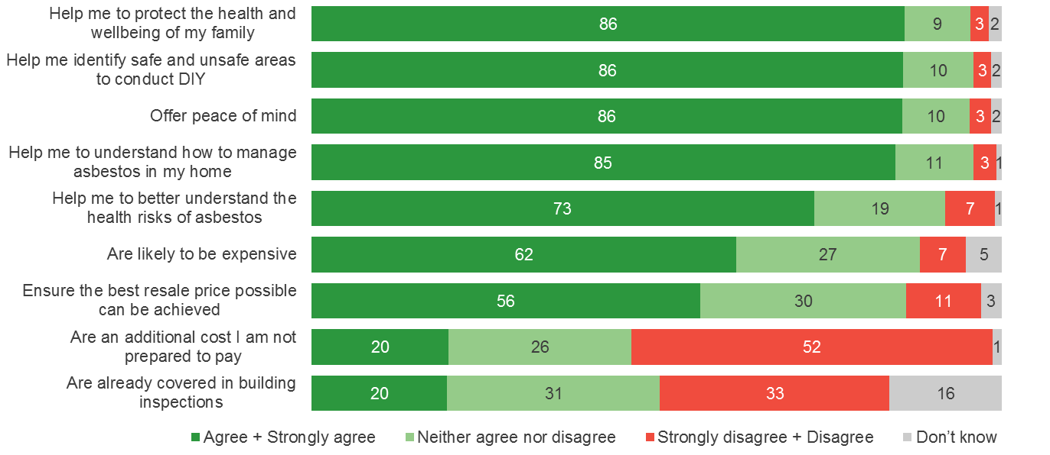
Base: All respondents, n=1,003
Q56. Please select how strongly you agree or disagree with each of the following statements. ‘Asbestos assessments…’
All values shown in percentages. Weighted data

From the quantitative research, just over one in ten home buyers and renovators (13%) claim they have had an assessment. Yet findings from the qualitative research (as well as verbatim responses from participants in the quantitative research) suggest that there are misconceptions and a strong degree of confusion surrounding assessments. For example many assume they have had an assessment because it is required by law or it has been carried out by the Government or Council. ACT residents in particular were likely to cite that jurisdictions in their territory required mandatory assessments. As such ACT residents are significantly more likely (89% vs. 55% total sample) to be aware of asbestos assessments and were significantly more likely to have had an asbestos assessment (43% vs. 13% total sample). Some of these misconceptions held by residents in quantitative research are listed below:
“It was made law in the ACT for all residential and commercial buildings to have asbestos assessment and I own a unit that came under that law.”
“The assessment was carried out by the local ACT Government.”
“The ACT Government ordered it.”
“The local Government had every house in Canberra inspected for asbestos.”
“It was a legal requirement for the strata block we live in.”
“It was a free inspection by a Government funded inspector.”

In addition to confusion over legal obligations for assessments, there are also indications that many are confused as to whether asbestos assessments are carried out as part of a building inspection. Two fifths (63%) of those who say they have had (or will have) a building inspection state that checking for asbestos is included as part of the inspection.
Chart 21 also shows there is confusion as to what’s covered in a building inspection with 31% saying they ‘neither agree nor disagree’ that asbestos assessments are already covered in building inspections. A further 16% say they simply do not know if an asbestos check is included in a building inspection.
This confusion makes it difficult to determine with confidence the true awareness levels of professional asbestos assessments as well as an accurate incidence of Australians undertaking assessments. Qualitative findings suggest the proportion is potentially much lower than the 13% identified in the quantitative research. However, there is sufficient quantitative data on the experience of those who claim to have had an asbestos assessment to indicatively understand what triggers uptake of asbestos assessments and what emotions are involved.

Triggers to uptake of residential asbestos assessments
In the qualitative research, asbestos assessors cited the following as triggers which lead to people undertaking an asbestos assessment:
- The owner is told by tradespeople they will not undertake work until something is assessed
- Tradespeople have undertaken work and residents are curious as to whether they have cut or damaged asbestos
- Neighbours fear someone is renovating and cutting asbestos
- Pre-demolition of a house and an asbestos assessment is required for council compliance
- Tenants call because of safety fears
- Someone has a history with the disease, e.g. their father died of it.
- Young couples with children have health concerns
- A wife might be worried about a husband who is DIY renovating

Asbestos assessors told stories of many domestic clients who had requested an assessment after interfering with asbestos during DIY renovations or after tradespeople had interfered with it. There were quite a few stories of how home renovators had interfered with asbestos in the past including, demolishing a whole kitchen made of asbestos and carrying the sheeted asbestos to the mini-skip. Other people had used a grinder to remove asbestos under lino before they realised. Another drilled into an asbestos roof to attach a satellite dish. Asbestos assessors said that residents and tenants often come to them in states of panic and their job is to give them ‘peace of mind.’
From the quantitative research, renovations were also a key trigger for many who have had an asbestos assessment.
Chart 22 shows reasons why home owners chose to have an asbestos assessment. More than a third (37%) had an assessment because they had safety concerns and wanted more information and 36% planned to undertake renovations. One fifth (22%) say they had been recommended to have an assessment by a building inspector and 19% were recommended by a tradesperson. Interestingly only 7% had been recommended by a real estate agent, however this was significantly higher amongst those in NSW (20%).

Chart 22: Reasons for having an asbestos assessment (%)
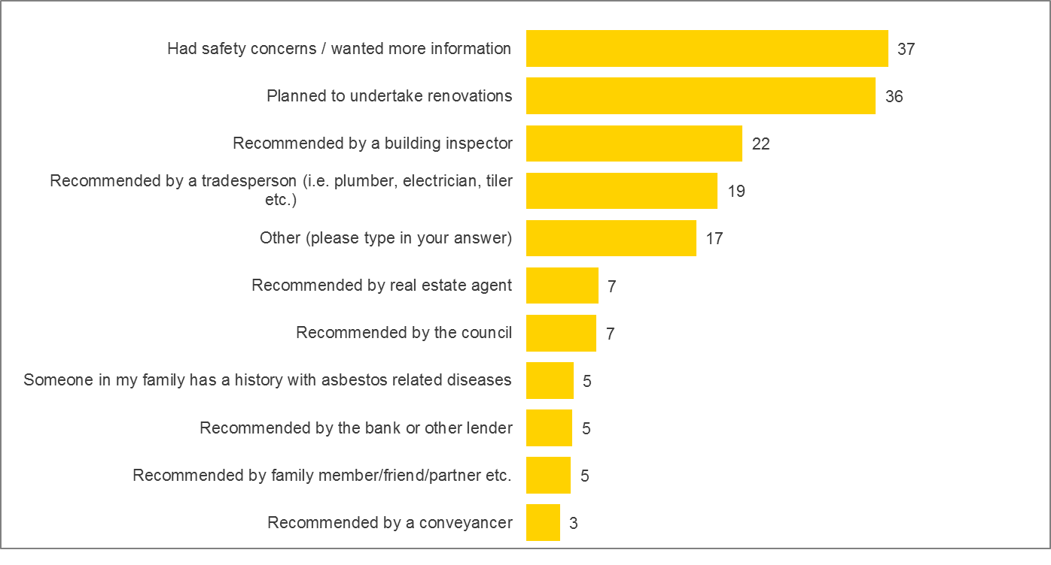
Base: Those with asbestos assessment completed by an asbestos assessor, n=132
Q41. Which of the following best describes why you chose to have an asbestos assessment?
All values shown in percentages. Weighted data

According to asbestos assessors, it is rare to have an asbestos assessment prior to purchasing a home. Those who do are usually intending to undertake high level renovation or demolition of the property. In Canberra, ‘Mr Fluffy’ fears drive some residential asbestos assessments primarily to ensure a property is not a ‘Mr Fluffy’ house.
There was some suggestion in the qualitative research that the typical residential client is a younger professional with a tendency to be responsible and go the extra mile on research. This ‘managerial’ class of person is not a victim and less concerned with public opinion on the matter.
“They are more likely to have a managerial headspace.” (Assessor Melbourne)
There were also some suggestions that women are more likely to drive the purchase of an Asbestos Assessment of the home.
“Women worry more.” (Assessor Melbourne)

Chart 23 shows all information provided in an asbestos assessment report. This includes the location of the asbestos (71%), a detailed description of the asbestos (61%), the amount (60%) and the condition of the asbestos (60%). Nearly half (49%) say they were given information on the risk of further deterioration or interference and 40% say there were provided with photos of the asbestos. More than half (58%) were also provided with advice on how to manage the asbestos moving forward. In the end, 66% of those who had an assessment say there were very or extremely satisfied with it.

Chart 23: What is included in an asbestos assessment (%)
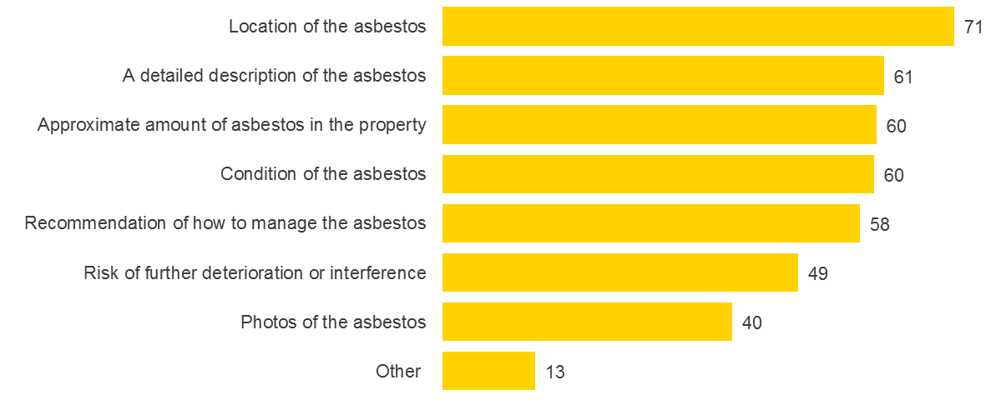
Base: Those with asbestos assessment completed by an asbestos assessor, n=132
Q44. What was included in your asbestos assessment?
All values shown in percentages. Weighted data

Barriers to asbestos assessments
In the quantitative research, the majority of home buyers and renovators say they recognised the benefit of having an asbestos assessment. Three quarters (75%) believe that an asbestos assessment would be very or extremely beneficial to home owners and home buyers. Yet the likelihood to consider an assessment is much lower. Chart 24 represents how likely buyers and renovators are to get an asbestos assessment (if they have not had one before). Although a high proportion believe an assessment is beneficial, just 30% say they are very or extremely likely have an asbestos assessment. Positively, those under the age of 40 years are significantly more likely to conduct an asbestos assessment in the future.

Chart 24: Likelihood to consider an asbestos assessment (%)
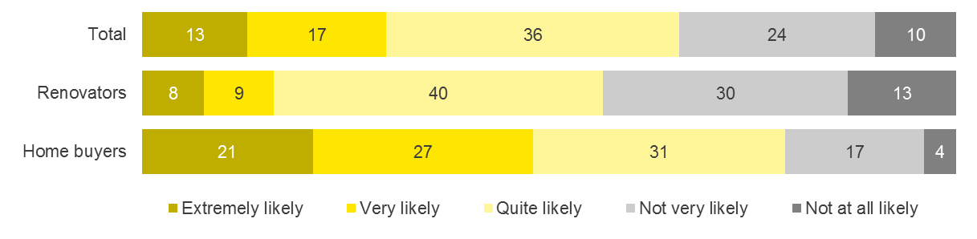
Base: Those who haven’t had an asbestos assessment, n=871, Renovators, n=528, Home buyers, n=343
Q52/Q53.How likely are you to consider getting an asbestos assessment in the future?
All values shown in percentages. Weighted data

Chart 25 shows the spontaneous reasons cited for not considering an assessment. By and large, the most common reason is a belief that there is no asbestos in the home (20%). A further 17% feel an assessment isn’t necessary because they already know the whereabouts and condition of the asbestos.

Chart 25: Reasons for not considering an asbestos assessment (%)
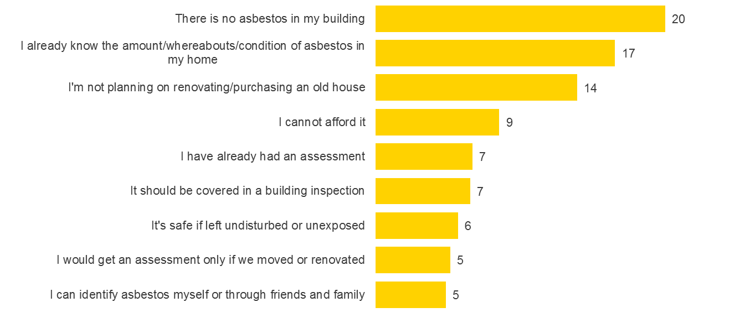
Base: Those who are unlikely to consider getting an asbestos assessment, n=289
Q55. Why are you not likely to consider getting an asbestos assessment? Coded response
All values shown in percentages. Weighted data

The qualitative research uncovered other themes to support why some home buyers are not currently likely to consider an asbestos assessment…
- Asbestos is so frightening - some home owners and buyers find it unacceptable to believe asbestos would be in their home. They believe it is a rare hazard and something they feel far removed from. They are in denial about it being located where they live.
- They resent the cost and administration time - home buyers feel “slugged at every turn” when buying a house and resent all costs to do with inspections, legal fees, stamp duty and real estate agents’ selling fees (if they are disposing of one house and purchasing another). At present an asbestos assessment represents poor value in the mix of ‘added extras’ when purchasing a property as many Australians feel uneducated about asbestos in the home and do not fully understand what an asbestos assessment entails.
- They believe it has already been done by the building inspector - most home buyers in the qualitative and quantitative research believe the building inspector should tell them about the presence of asbestos in the home. They already believe they have been told if they have employed a building inspector and believe it is (and should be) part of his/her duties.
“I’d do it if I knew the building inspector wasn’t doing it.” (Sydney Home Buyers)
- They think a tradesperson will tell them if they renovate - most Australians trust tradespeople and builders to take responsibility when renovating. They believe in the event of major renovations the builder will take care of it.
“Tradies and builders remove it.” (Sydney Home Buyer)
“I wouldn’t do it. I’d rather deal with it when the time comes - when I renovate.” (Melbourne Home Buyer)
- They are thinking of financial rather than health issues when they purchase - asbestos assessments are not considered akin to a building and pest inspection, as the latter relate to financial risk, rather than health. Health is a low consideration when purchasing. At the same time, the health risk of asbestos is intangible. Particles are unseen and exposure may have already occurred. Asbestos related illness may take years to present and this leaves people feeling distant and unconcerned about it. Many home buyers are only thinking of financial risk at the time of purchase and asbestos in a home is not believed to affect the capital gain or saleability of a property.
“I’d do it if I knew it would affect my re-sale value.” (Sydney Home Buyer)
“It’s a long period from exposure to when you get sick.” (Melbourne Home Buyer)
“You can take it away but not termites.” (Sydney Home Buyer)
- They believe the conveyancer is responsible to tell them - many of the home buyers in the qualitative research believed the conveyancer would have records relating to asbestos in their home. The conveyancer often recommends conducting building and pest inspections on behalf of their clients. Therefore some Australians believe they would conduct an asbestos assessment if it was warranted.
- The value of the house is marginal compared to the land - home buyers in expensive markets such as inner city Sydney and Melbourne believe the structure of the property does not even warrant a building or pest inspection as the value of the house is marginal compared to the land value. They feel no need to scrutinize the structure in any way as replacement cost is affordable in the overall price.
- There is only a little bit somewhere…and it was too small to consider an assessment.
“Why do an Asbestos Assessment. It’s not riddled with asbestos – there’s just a bit somewhere” (Melbourne Home Buyer)
“I would do it if the whole house looked like asbestos.” (Sydney Home Buyer)
Real estate agents also present a subtle barrier to the uptake of asbestos assessments. Real estate agents take a neutral view on asbestos in the home. They would neither encourage nor discourage asbestos assessments. When asked if a house contains asbestos, they recommend professional assessment and disclose the fact that they are unqualified to judge.
Some do not however, believe asbestos assessments are necessary, as it is likely to be a small cost when renovating and can be done at a later stage. Some real estate agents do not believe building inspections or pest inspections are necessary. Real estate agents do not believe vendors would allow a buyer to take samples during an assessment, which would make the presence of asbestos difficult to confirm in some instances.
They are quick to point out that their legal responsibilities lie with the interests of the vendor who wants to sell the house quickly. They cannot say anything that is not within their vendor’s interests.
“There are many dangers in life and living.” (Real Estate Melbourne)
“It’s a personality thing – nervous nellies.” (Real Estate Melbourne)
“How can a buyer take samples? A seller would never allow it. They don’t like people poking around.” (Real Estate Melbourne)
“Haven’t heard of anyone having a problem. “ (Real Estate Melbourne)
“Some people are attention to detail freaks.” (Real Estate Melbourne)

The mindset of the home buyer prior to purchase
To understand the propensity to consider an asbestos assessment prior to buying a home, the qualitative research looked at the mindset of buyers at this time. When people buy a home, health is not always on their mind. Thoughts and behaviours usually lie with financial risks prior to purchase. Priorities typically lie in the following order…
- Meeting emotional and lifestyle needs…Finding the house a person loves that is desirable for lifestyle reasons is a priority and the fundamental driver for purchase in the first place. The ‘perfect’ house is the goal. This includes location, number of rooms, aesthetic appeal, aspect, potential for renovation. Emphasis is on fulfilling lifestyle needs.
“In the beginning you’re thinking about all the good things.” (Sydney Home Buyer)
- Avoiding financial risks…such as buying a house with structural damage and over spending. Avoiding costs when acquiring is a priority. Getting the property at the right price is of utmost importance.
“When you buy a home you’re thinking about so many other things like the mortgage and I’m looking at the structure.” (Melbourne Home Buyer)
- Hazards… like lead paint and asbestos might be considered but in many cases is met with denial.
“We’re not thinking 25 years down the track.” (Melbourne Home buyer)

Attitudes to conducting reports prior to purchasing a home
Building inspection reports are conducted to avoid major structural damage that presents a financial risk. Sometimes they are done to assess possibilities for redevelopment. There is a discourse of ‘horror stories’ in the market and home buyers want to avoid “the house falling down.” Overall, building inspections are done to avoid the worst case scenario; they are disaster checks.
Sometimes they are done in slow markets (like Tasmania) where houses do not go to auction as often as other cities, and time is available to buyers to construct an inspection as ‘leverage’ when making offers. However, many buyers in ‘hot’ property markets like Sydney and Melbourne at present do not always conduct inspections before going to auction and buying a house. In this research, home buyers in these buoyant property markets missed up to 4 properties before finally securing one at auction. If they were to conduct asbestos assessments prior to each auction, costs would escalate very quickly.
When conducting a building inspection home buyers say they are most often looking for major structural damage in the form of…
- Bora
- Termites
- Roof issues
- Physical structure issues
- Tree root damage and so on
“It’s not a huge risk. Not like termites.” (Sydney Home Buyer)
“Major structural damage.” (Home Buyer Sydney)
“Big ticket repairs.” (Home Buyer Melbourne)

Some home buyers do not hold property related reports in high esteem. These people are experienced home buyers and real estate agents who have experience with reports. They believe they contain disclaimers and caveats, have a short legally responsible lifespan (some only a few weeks) and overall avoid taking responsibility and never liability. Pest inspections are considered not very reliable unless samples are taken (which they never are prior to purchase as the vendors generally do not allow for it) and pest inspectors often avoid going into roofs or under houses. People who think building related inspections are of poor value are likely to distrust asbestos assessments too.
“They don’t do a thorough report.” (Sydney Home Buyer)
“They’re not worth the paper they’re written on.”(Sydney Home Buyer)
“The building inspection reports have so many caveats. There are building inspectors I’d use for selling and ones I’d use for buying.” (Canberra Real Estate Agent)
“The pest inspection is a farce – so completely full of caveats like ‘couldn’t get under the carpet etc.” (Canberra Real Estate Agent)

The property valuer’s role in asbestos assessment
The property valuers included in this research do take asbestos into account when valuing property and occasionally alert their clients to the risk of asbestos from a financial perspective. Part of what property valuers assess (whether it be for a bank or a private individual) are ‘environmental hazards’ such as ‘contamination’. The presence of asbestos does affect how property valuers value a house. If the house contains a significant amount of asbestos (such as a ‘fibro’ house clad entirely with asbestos) they sometimes subject the valuation to land value only.
When a house potentially contains enough asbestos to incur substantial cost for removal, a property valuer may alert his/her client to the need for an asbestos assessment before they commit to a valuation price. If a property valuer knows there is to be a demolition and redevelopment of a residential home (for example, for the building of units) they will reduce the price substantially as removal will be classed a ‘contamination’ or an ‘environmental hazard’. One property valuer said she had on occasion reduced the value of Melbourne homes by $100,000 due to asbestos. Removal costs are estimated to be between $100 to $120 per square metre. If asbestos is present in a dwelling and an asbestos assessment is conducted, property valuers will include removal costs in the valuation.
That said property valuers are only concerned with accurately valuing from a financial perspective. They do not inspect houses in the manor of a building inspector or an asbestos assessor. Small amounts of asbestos that are not in friable condition are overlooked as the need for and the cost of removal is small. Property valuers do not look into roofs or under houses like a building inspector. Sometimes they may not be able to assess the presence of asbestos at all. In this research, the incidence of property valuers recommending asbestos assessments was low.
That said the property valuer is positive about encouraging residential asbestos assessments and believes that Australians should manage all asbestos in their homes. Unlike the real estate agent, who generally takes a neutral or negative view on encouraging any form of assessment of a dwelling, the property valuer takes an objective view and wishes to provide fair and accurate representation on housing to his/her client. In the future, property valuers are likely to be supportive in encouraging Australians to conduct residential asbestos assessments.
“We need to check the contaminated land register and flag with the bank if the property is on contaminated land. It would be good if there was also an asbestos register.´ (Brisbane Property Valuer)

Drivers and possible foundations for change
The concept of conducting an asbestos assessment prior to purchase is a novel idea that few Australians have considered. There is clearly a culture of fear and denial and mixed degrees of awareness and knowledge. Changing the mindset of the public from one of denial to one of empowerment and responsibility is in its infancy.
Despite challenges, this research suggests there are some clear foundations on which to create change…
- There is a high level of awareness of the concept of asbestos and some informal education surrounding the nature of its dangers.
- Australians are emotionally activated by asbestos. The issue is emotionally charged, albeit in a way that sometimes drives denial rather than responsibility.
- Despite not accepting responsibility for asbestos in the home, most home owners would like to know about asbestos in their own home. This is particularly true for people with children. They accept that asbestos is dangerous and should be avoided. They know it should not be disturbed and that accidental interference can be harmful and would like to avoid risks. This gives a basis for further education and developing interest in conducting asbestos assessments.
“It makes me worry; I would want to get rid of it.” (Adelaide Home Buyer)
“I’m solution oriented – I would get rid of it or do what I needed to do so it wasn’t a threat.” (Adelaide Home Buyer)
Using quantitative data from the research we also performed a driver analysis to determine what has the greatest influence on likelihood to consider conducting an assessment.
Chart 26 shows the priority of key drivers in considering an asbestos assessment. The strongest driver of consideration is that assessments can ‘help protect the health and wellbeing of my family.’ That an asbestos assessment can offer ‘peace of mind’ also drives consideration, as does the ability to be able to better understand the health risks of asbestos. Messaging that addresses and speaks to these sentiments to provide reassurance and ‘peace of mind’ is likely to have the biggest impact on consideration of asbestos assessments.
There are further ‘lower order’ drivers which play a role in influencing consideration of asbestos, but to a lesser degree than those mentioned above. Knowledge of how to manage asbestos and identify safe and unsafe areas for renovation drives consideration. Property value also has an impact on consideration, by ‘ensuring the best resale price possible can be achieved.’

Chart 26: Drivers of asbestos assessment consideration (%)
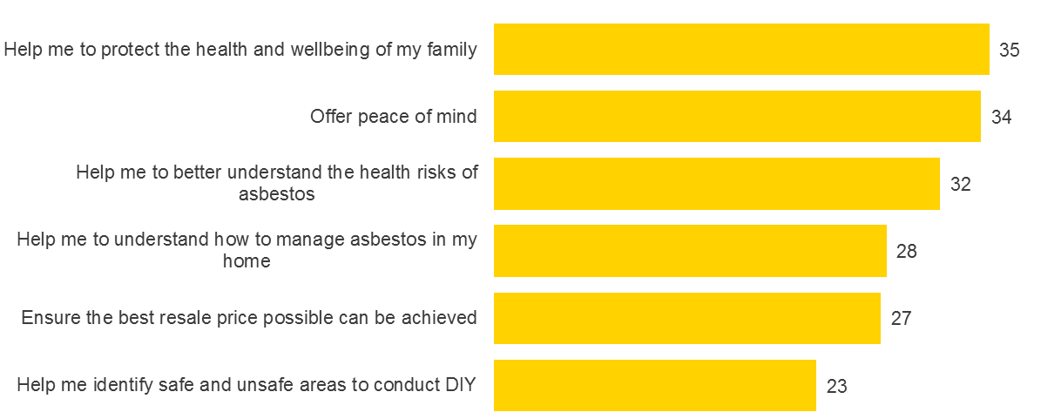
Base: All respondents, n=1,003
Drivers of asbestos assessment consideration (%)
All values shown in percentages. Weighted data

When asked for ways to drive interest in asbestos Assessments, home owners call for greater education as a foundation step towards change. What they would like to know includes…
- Is asbestos likely to be in the home they may be buying, for example, what percentage of homes have asbestos?
- Asbestos is not always in sheet form and can occur anywhere including under lino or behind tiles
- Asbestos related illnesses are real, kill many people and can happen to the home owner
- Asbestos is the home owner’s responsibility
- The building inspector and the conveyancer do not know about asbestos in your home
- The real estate agent is not able to tell you about asbestos in a home
- There are many myths about asbestos
- Asbestos is frightening but you can be empowered to manage it.
“Not enough knowledge out there.” (Assessor Melbourne)
“There are not enough stories out there except for James Hardie.” (Assessor Melbourne)

Summary
Awareness of asbestos assessments is low amongst Australian home buyers and most find it hard to conceptualise what an assessment involves. Once aware, Australians tend to defer responsibility of asbestos in the home and make assumptions as to who is responsible. When buying a home, it is widely assumed that a building inspection will include an asbestos check. When undertaking substantial renovations, Australians believe tradespeople will inform them if there is asbestos and tell them what they should do. In the event of DIY renovations, the amount of asbestos is often deemed too small to be of concern. These assumptions present a significant barrier to increasing asbestos assessments as most Australians do not recognise the need and benefit of one. However, while most defer responsibly of asbestos in the home they would like to know whether it is there. Increasing education around asbestos in the home and who is responsible is an important step to increasing asbestos assessments.
The key triggers currently for conducting an asbestos assessment are generally more reactive than proactive. Asbestos assessments predominately occur when asbestos has been interfered with, usually during a renovation. As such, home owners look to asbestos assessors to provide ‘peace of mind’ and information that will reassure them. Messaging which informs home owners that asbestos is a significant issue but that they can be empowered to manage it and protect themselves and their family against accidental interference will be most effective in increasing consideration.
In addition to this, education around the real cost of an asbestos assessment is critical in managing expectations and ultimately acceptance. At present most people would expect to pay around $320 for an assessment, when in reality people who claimed to have commissioned assessment recalled paying on average $790. An understanding of the real cost and what is included as part of the assessment will assist in improving knowledge of the assessment process and help people attribute value for money.

Strategic considerations and recommendations
This research suggests there a range of opportunities when developing strategies to increase the uptake of asbestos assessments by home buyers and owners. These strategies include:
Increasing awareness |  | Although most Australians know about asbestos, there are significant gaps in the awareness of the threat it can pose to owners and DIY renovators. Many Australians do not think the asbestos issue applies to them. At the moment the problem is not top-of-mind and competes with other toxic materials and substances in the environment for attention. It is particularly important to raise awareness of where asbestos may be found in the home, such as under linoleum and tiles and that asbestos comes in many forms.

Empowerment through education |  | Many Australians know that asbestos is a hazardous substance. However, they remain unaware of productive management strategies. Many are aware that asbestos should be left alone but are not aware of other management approaches for asbestos in the home. They are not empowered with knowledge about asbestos assessments and the profession of asbestos assessors.

Addressing myths |  | The qualitative component of this research highlighted that some Australians deal with the emotional nature of asbestos and their lack of empowerment around this issue, with denial and myths. Some classic myths include; asbestos is mainly found outside the home; only a small number of people ever get sick from asbestos so it is unlikely to be ‘me’; the DIY home renovator is not particularly vulnerable people (only tradespeople or factory workers); it is uncommon for people to interfere with asbestos in their homes; it’s prevalence means we should learn to live with it forget about it or accept it as normal. Clarifying these misconceptions is important, as knowledge is likely to be the only way to reduce the fear that drives denial.

DISCLAIMER:
This report may be relied upon by the Asbestos Safety and Eradication Agency for the purpose set out in the objectives only pursuant to the terms of the engagement as agreed with the Asbestos Safety and Eradication Agency. EY Sweeney disclaim all responsibility to any other party for any loss or liability that the other party may suffer or incur arising from or relating to or in any way connected with the contents of this report, the provision of this report to the other party or the reliance upon this report by the other party.
Appendix

Quantitative sample profile
The following charts represent the sample profile for the quantitative phase of research. The sample profile of respondents in the qualitative research can be found on pages 8 to 10 of the report.

Chart 27: Gender (%)
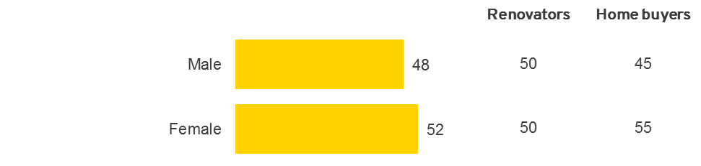
Base: All respondents, n=1,003, Renovators, n=602, Home buyers n=401
S2. Please indicate your gender.
All values shown in percentages. Weighted data

Chart 28: Age (%)
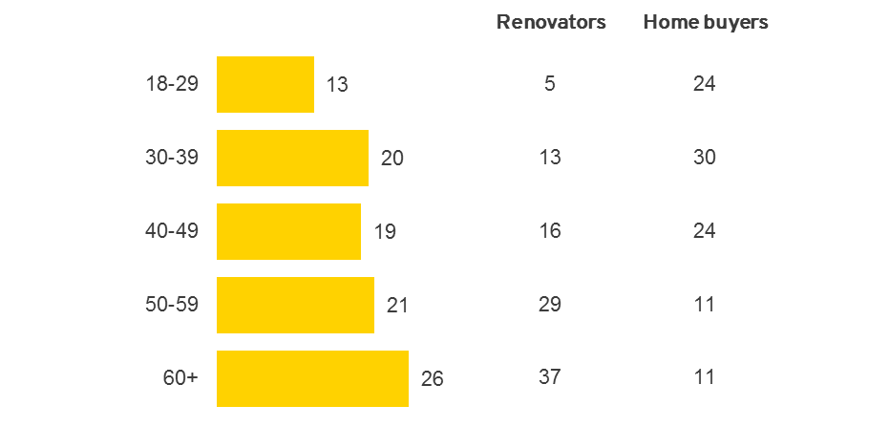
Base: All respondents, n=1,003, Renovators, n=602, Home buyers n=401
S3. Which of the following age groups do you fall into?
All values shown in percentages. Weighted data

Chart 29: State (%)
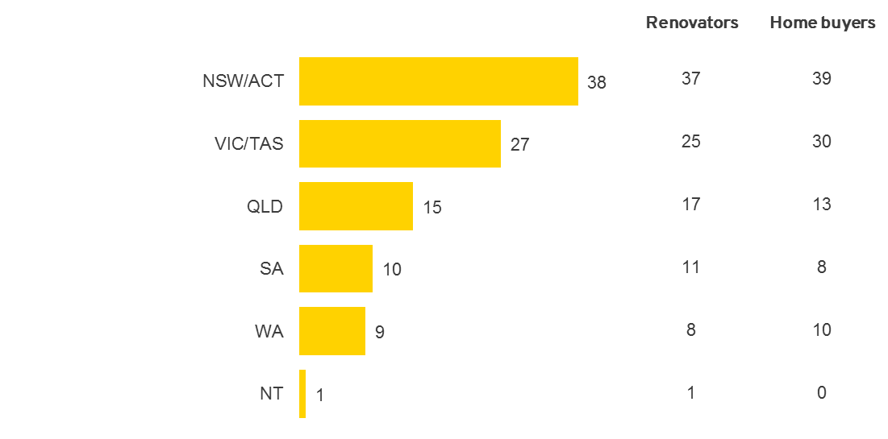
Base: All respondents, n=1,003, Renovators, n=602, Home buyers n=401
S4. Where do you currently live?
All values shown in percentages. Weighted data

Chart 30: Living arrangement (%)
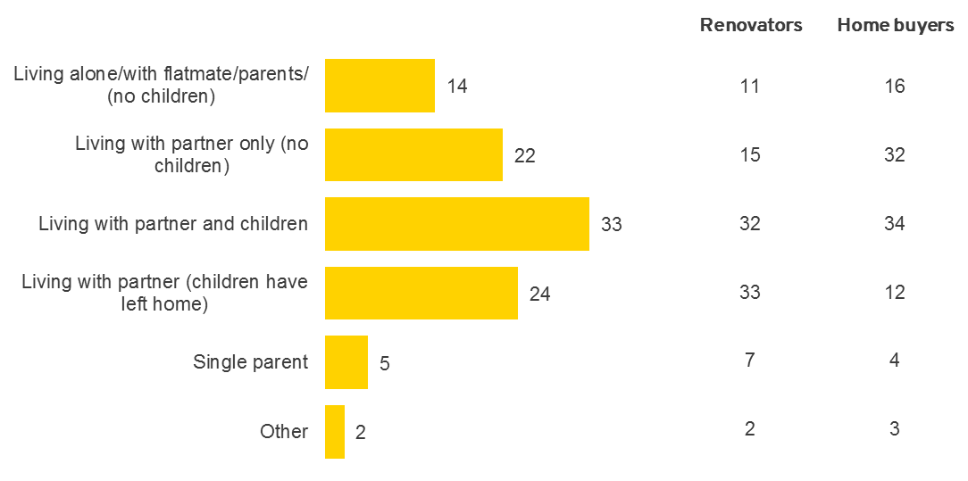
Base: All respondents, n=1,003, Renovators, n=602, Home buyers n=401
S5. Which of these best describes you?
All values shown in percentages. Weighted data

Chart 31: Household Income (%)
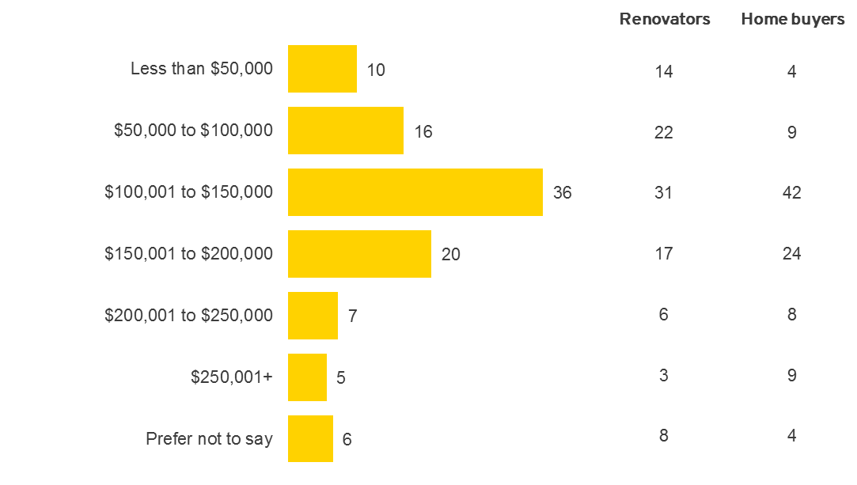
Base: All respondents, n=1,003, Renovators, n=602, Home buyers n=401
D1. Into which of the following income brackets does your total household annual income before tax fall?
All values shown in percentages. Weighted data

The ACT Government did provide a free testing service for homes affected by loose fill asbestos insulation. It is possible that the majority of these misconceptions arise from the belief that this testing covered all homes and asbestos materials, not just those containing loose fill asbestos.

