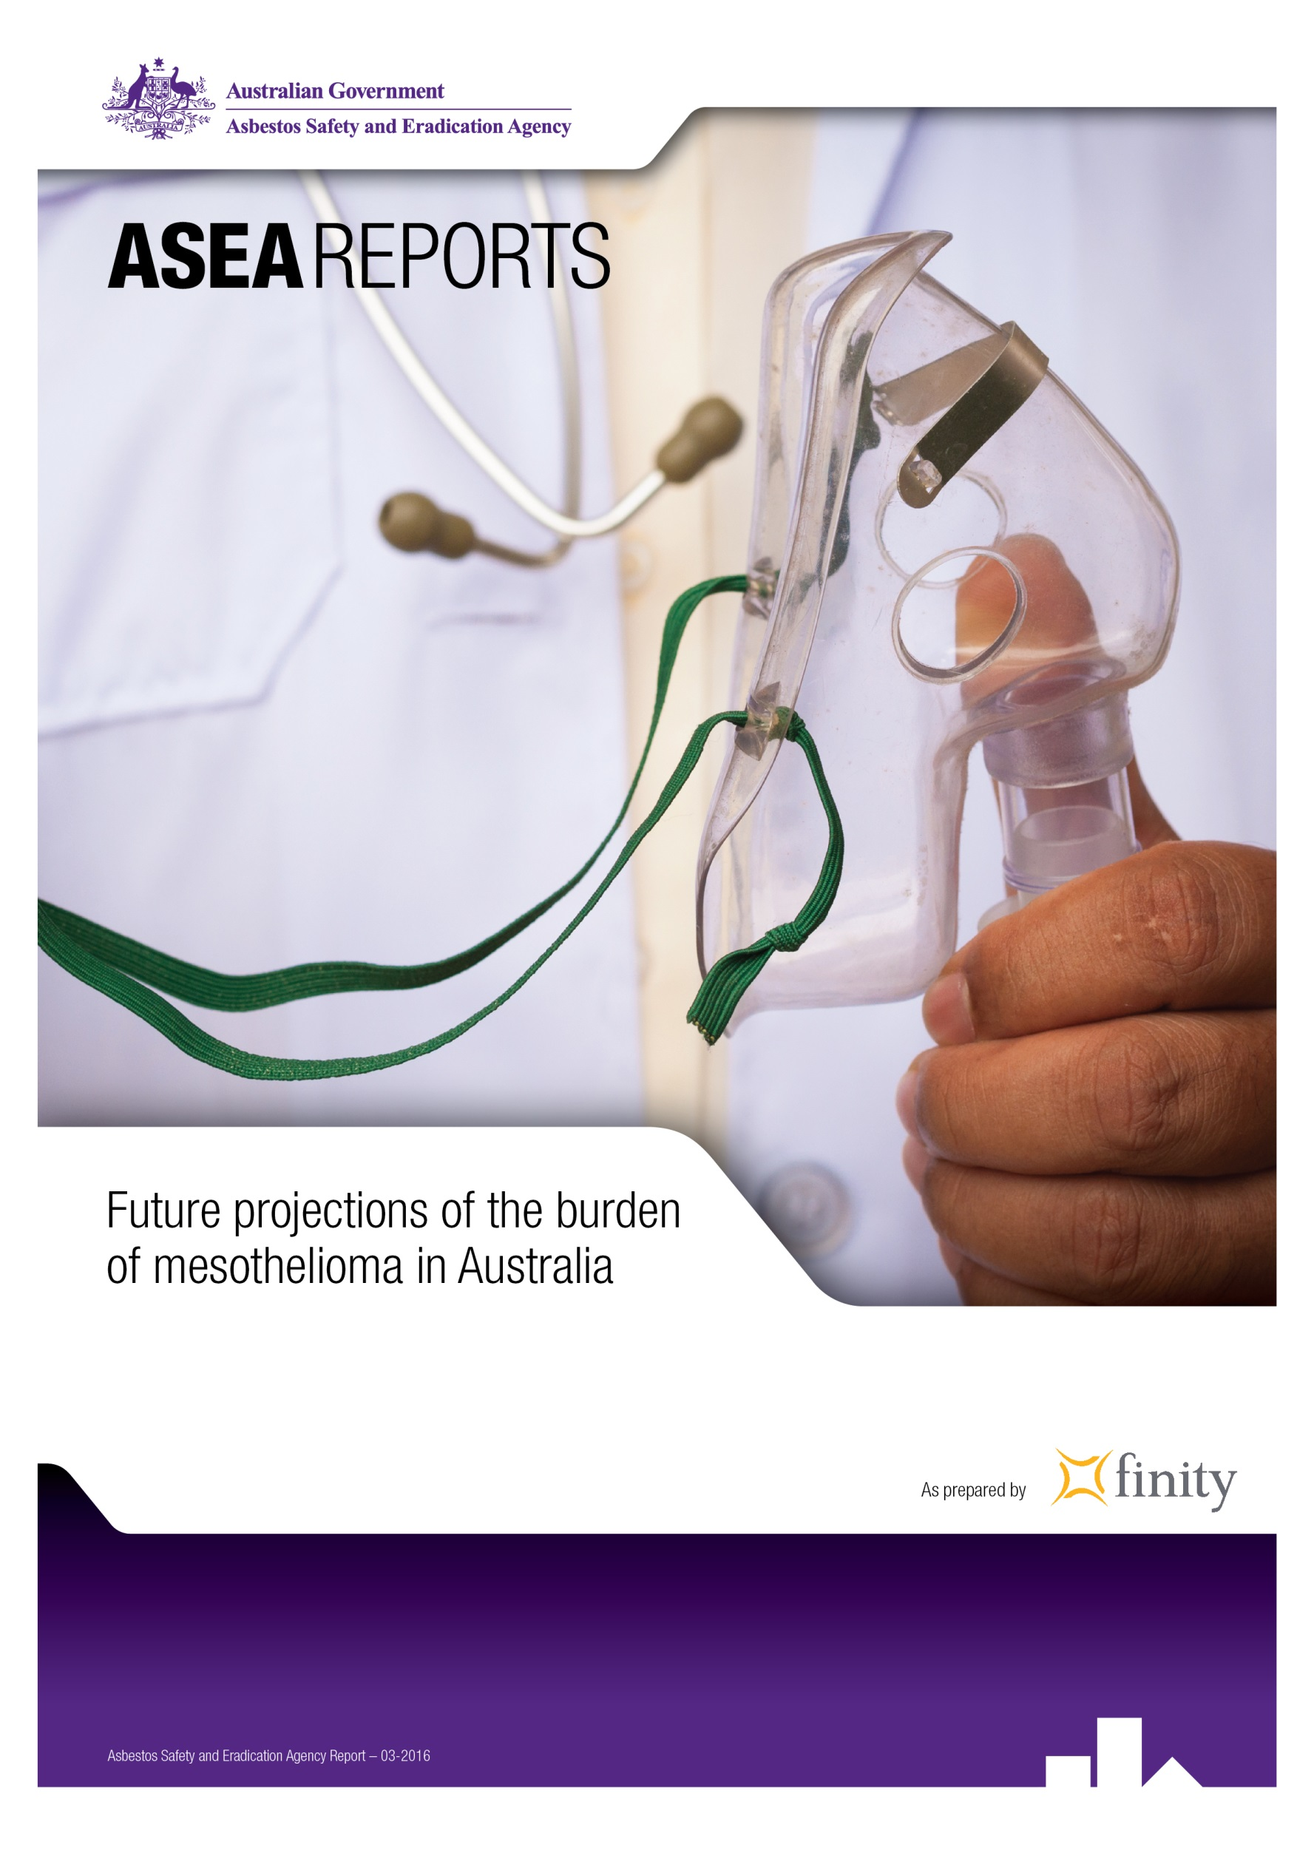

24 March 2016

Mr Peter Tighe

Chief Executive Officer

Asbestos Safety and Eradication Agency

Level 8, 255 Elizabeth Street

SYDNEY NSW 2000

Dear Peter

This report documents our analysis and projection of Australian mesotheliomas, including those cases relating to on-going non-occupational exposure sources. Although high risk exposure segments (e.g. asbestos miners and tradesmen) are often the focus of attention for asbestos-related projections, an increasing number of current mesotheliomas are attributed to lower dose non-occupational exposures.

Our base scenario is based on current available information and scientific evidence. It is intended to reflect a central estimate, in the sense that there is no intentional bias to understate or overstate the projection. However the known delay between asbestos exposure and mesothelioma emergence, as well as incomplete information, necessitates many assumptions to project future cases. For this reason, the eventual outcome will almost certainly vary from the projections and a wide range of plausible scenarios could be constructed.

The reliances and limitations in this report are an important part of our work. These should be read by any person receiving this report.

We look forward to discussing our results with you further.

Yours sincerely

Brett Riley David McNab

**Fellows of the Institute of Actuaries of Australia**

Chief Executive Officer foreword

Understanding the challenges of mesothelioma in Australia will help us better target our prevention efforts now.

In reading this report, I encourage you to think about the future asbestos exposure pathways leading to new cases of mesothelioma and not to focus on numbers as a total. Any projections are inherently uncertain. This is why the report presents projected future cases as a range. Through understanding what the causes of the high and low estimates will be, we can focus on what we can do now to reduce the number of people being diagnosed with mesothelioma in the future.

In total, roughly 40% of future cases of mesothelioma are seen to be caused by third wave exposure. What this shows is the changing nature of exposure risks leading to mesothelioma in Australia and that it is likely by 2050 the majority of people diagnosed with mesothelioma will be relatively low dose non-occupational third wave cases caused by residential and background exposures to asbestos fibres.

These projections present a base case of future scenarios. All things being equal, if the remaining asbestos is removed from Australia’s built environment at a greater than predicted rate and background asbestos exposure is reduced, this will have the greatest likelihood of reducing the occurrence of mesothelioma. If we do not maintain safe handling practices and continually drive for improvement in asbestos management and awareness, a higher number of cases may be diagnosed.

Most importantly, the future health of Australian people is what this report is about. Mesothelioma is a terribly unfair and devastating disease, not just for those who have been diagnosed, but also their family, friends and the community. In my role, I have met a number of people with asbestos-related diseases such as mesothelioma and I am continually touched by their spirit and fight to ensure that we do all we can to stop exposure to asbestos fibres and end this preventable disease.

I hope that this report will contribute to us targeting our efforts to reduce the number of Australian people who are diagnosed with mesothelioma in the future.

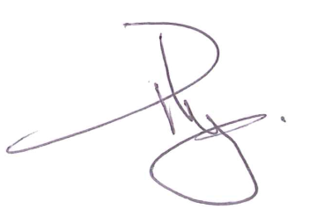

**Peter Tighe**

**Chief Executive Officer**

Table of contents

Chief Executive Officer foreword 3

Table of contents 4

Part I Executive summary 5

Introduction 5

Scope 6

Approach 7

Principles and underlying assumptions 8

Data 10

Assumptions 13

Back testing results 21

Results 23

Conclusion 26

Acknowledgements 27

Reliances and limitations 28

**Disclaimer**

This report was commissioned by the Asbestos Safety and Eradication Agency and was prepared by Finity Consulting.

Part I Executive summary

Introduction

The Asbestos Safety and Eradication Agency (the agency) has retained Finity Consulting Pty Limited (Finity) to project the number of mesothelioma cases diagnosed in future years in Australia. The agency is a Commonwealth statutory authority, providing a national focus on asbestos issues via the National Strategic Plan on Asbestos Awareness and Management. It considers workplace health and safety, environmental and public health matters in this context.

The purpose of our advice is to support discussions around asbestos exposure and to inform policy options for future asbestos management in Australia.

An increasing proportion of cases are arising from exposure other than during asbestos mining, manufacture and heavy industrial use (the first wave) and mainstream product use (the second wave). This so-called third wave arises from other sources of exposure, including disturbance while living in, or renovating, a home containing asbestos containing materials (ACMs). The third wave also includes background cases, where the source of exposure may not be known. Third wave cases are generally caused by low-dose asbestos exposure and typically occur later than the first and second waves.

Less is known about the Australia-wide impact of the third wave compared to the earlier waves. The agency has asked Finity to give special consideration to third wave exposures and the associated mesotheliomas in our projection of all Australian mesotheliomas.

Figure 1 shows some key groups of people who have been or will be exposed to asbestos. We have ranked them based on the size of the exposed population and the relative lifetime risk of contracting mesothelioma (per exposed person) in each group.

**Figure 1  – Relative size and lifetime risk of contracting mesothelioma**

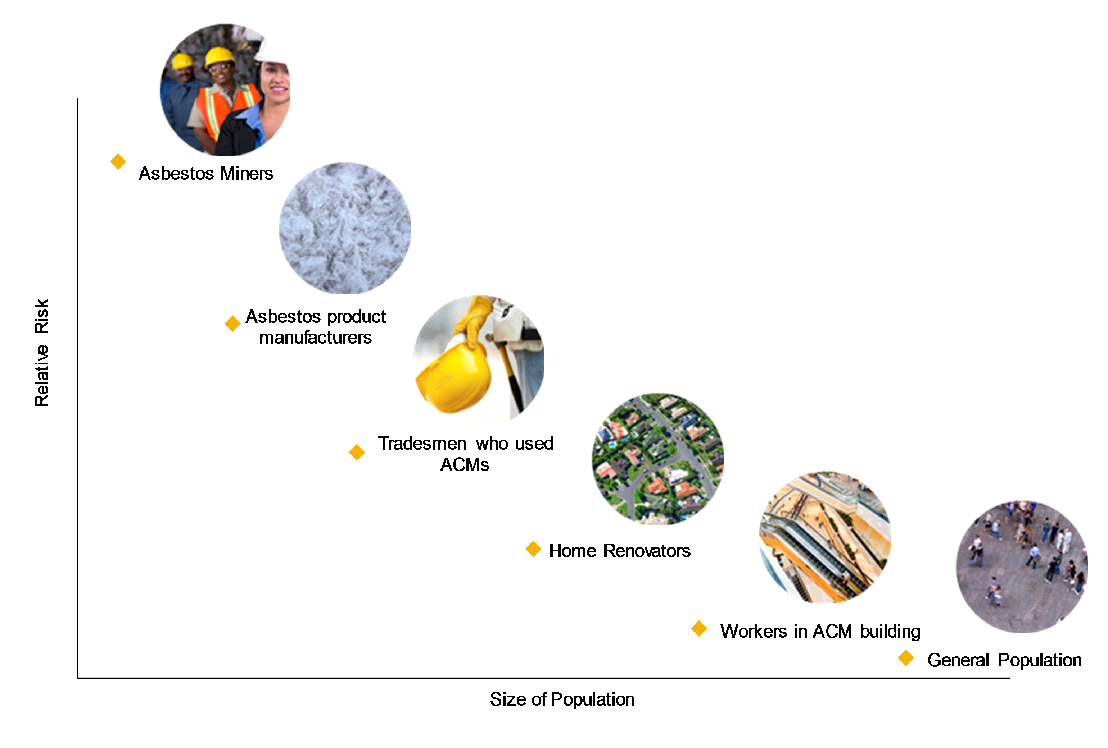

*Note: this chart is not drawn to scale and is for illustration purposes. Not all groups exposed in Australia are shown.*

Asbestos miners are a small group but probably had the highest lifetime risk of contracting mesothelioma due to high fibre concentrations from their work. By contrast, the entire Australian population is exposed to background levels of asbestos with significantly lower fibre concentrations on average.

The purpose of Figure 1 is to illustrate that the high risk groups are not the only sources of mesothelioma in Australia.

The remainder of this summary provides an overview of the main points from our full report. The reader requiring more detail should read the full report and accompanying appendices for a better understanding of the work done, its limitations and its implications. The full report also contains references to the publicly available data, papers and other research which we have used.

Scope

We estimated the number of past and future cases of Australian mesothelioma as at 31 December 2014. Our estimates include several scenarios to indicate a range of plausible outcomes and emphasise the uncertainty around the projection. More extreme outcomes are possible. Our projections focus on cases arising from identifiable asbestos exposure, both occupational and non-occupational. However, we also consider situations where mesothelioma arose from background or unidentified exposure.

Our base scenario may be viewed as the most likely of the specific scenarios documented in this report. It is a central estimate, with no intentional bias to overstate or understate the projection. The alternative scenarios show other plausible outcomes. Unless stated to the contrary, any discussion of our projection or model in this summary refers to the base scenario.

The number of cases refers to individuals diagnosed with mesothelioma. This differs from the number of claims where an injured person makes a legal claim for compensation for their injuries, either for statutory benefits or at common law. We do not consider the compensation status of any of the mesothelioma cases that we have projected.

The following are also ***not*** covered within this report:

* Other asbestos-related malignant diseases, such as lung cancer. While it is widely accepted that asbestos exposure does increase the risk of contracting lung cancer, other factors may cause lung cancer (e.g. cigarette smoking). To best understand the effect of non-occupational asbestos exposures we restricted our study to mesothelioma.
* Non-malignant asbestos-related diseases such as asbestosis.
* Splits within our projections of mesotheliomas by Australian state, industry, occupation or type of mesothelioma (e.g. pleural vs peritoneal).
* Property remediation costs.
* Estimates of economic cost or the value of mesothelioma cases.

Approach

Our projections are based on a population exposure and incidence model. This allows for many factors which influence the number of mesotheliomas over time, including:

* The volume of asbestos fibres affecting the exposed population.
* The intensity and duration of the exposure.
* The age distribution of the population when exposed, as well as the gender mix.
* The relative risk of different asbestos products and types of asbestos fibres.
* The impact of changes in asbestos handling practices and exposure regulations over time.
* The incidence of mesothelioma by duration since exposure. Mesothelioma is known to have a long latency period and incidence rates increase exponentially based on time since exposure.
* Mortality rates from other causes affecting the exposed population.

The model is based on historical mesothelioma data from the following sources:

* Public data from the Australian Institute of Health and Welfare (AIHW) covering all Australian cases for the period 1982-2011, including statistics by age and gender.
* Australian Mesothelioma Registry (AMR) data for the period 1 July 2010 to 9 July 2015. The AMR collates mesothelioma data from the state cancer registries, also split by age and gender. This dataset had no personal details for individuals with mesothelioma (e.g. name or address). This file covered all Australian states but excluded cases from the Australian Capital Territory and Northern Territory. We estimated an allowance for these missing cases.
  + A subset of cases included the results of the AMRs exposure questionnaire and interview process.
* We also used a wide range of published information on asbestos and mesothelioma. The papers and sources are cited throughout our full report and listed in Appendix A.

For this project we were able to incorporate information on the consumption, removal and the remaining asbestos stock over time. This information, provided to us by the agency, came from a stocks and flows model developed by Blue Environment Pty Ltd. The stocks and flows model gives estimates of the quantity of asbestos first used, remaining in situ and removed in each past and future year, including splits by broad product types (e.g. asbestos sheeting, pipes, friction products and roofing). The consumption data in this model matches the widely used public estimates of national asbestos consumption.

We consider the Blue Environment model to be fit for purpose for our project. We acknowledge the enhancements to our model from using this information, although the projections provided in this report remain the responsibility of Finity.

A key part of the process is to calibrate the model to past observed cases and known characteristics of those cases such as age, gender, exposure periods and known sources of exposure. We calibrated and projected different waves of exposure to form our aggregate view. Our ability to calibrate the different waves was assisted by the provision of exposure information from the AMR. This detail, not publicly available for individual cases, provided us with an improved understanding of the characteristics of cases from different exposure sources. We acknowledge its importance to the projection. The different segments which we have projected and shown are:

* Wave 1 & 2: this includes the occupational exposures from waves 1 and 2. It also includes the non-occupational exposures linked to these waves, including family members exposed to asbestos brought into the home by a worker (dusty families), those living near an asbestos factory or asbestos mine. This group covers asbestos exposures occurring from 1921 to 2002 (the last year of published consumption, before asbestos was banned in Australia on 31 December 2003).
* Wave 3 Total. This includes the following sub-groups:
  + Occupational post-2003: this covers lighter occupational exposure resulting from in situ asbestos in workplaces or asbestos removal, covering exposure from 2003 to 2055.
  + Wave 3 Domestic: this concerns non-occupational exposures in Australian homes linked to construction, asbestos in situ and its removal. It includes exposure to home renovators, those living in a house during a renovation, those living in a home with asbestos or working on a car at home which contains asbestos in the brakes or clutch. This group covers exposure in the years 1960 to 2055. This approach is broadly consistent with detailed exposure data available from the Western Australian Mesothelioma Register.
  + Background exposures: mesotheliomas in this category have no identifiable exposure to asbestos. We discuss the nature of these exposures later in this summary.

To make our approach manageable we did not model asbestos exposure from removals after 2055. Exposure after 2055 is expected to produce a small number of additional cases (perhaps an additional 1% above the cases we have already projected in our base scenario). Omitting this period does not materially impact the conclusions in our report.

Principles and underlying assumptions

There are many assumptions, explicit and implicit, that support our projections. Some of the important assumptions for interpreting this report are:

1. Most cases of mesothelioma are caused by asbestos exposure.
2. There is no safe threshold for asbestos exposure. All asbestos is carcinogenic.
3. For a proportion of mesothelioma cases it will not be possible to identify a possible or probable source of exposure.
4. Exposure to white asbestos (chrysotile) can cause mesothelioma, although it is less toxic than blue asbestos (crocidolite) and brown asbestos (amosite).
5. There is a rough offset between diagnoses in Australia of people who were exposed to asbestos overseas, and people exposed in Australia who live overseas by the time they are diagnosed.
6. Risk for a person or group:
   1. Is proportional to the dose, or average fibre-load i.e. the fibres per millilitre of air when they were exposed. So risk is reduced by any precautions taken, such as wetting asbestos-containing materials (ACMs) before cutting them, or wearing protective equipment.
   2. Is proportional to their duration of exposure.
   3. Varies based on their age at exposure. Mesothelioma is a latent disease which rarely emerges within the first 10 years after exposure and typically around 40-50 years later. All other factors being equal, our approach assumes that those exposed at younger ages face more risk of contracting mesothelioma across their lifetime than those exposed at advanced ages, due to more expected years of life after being exposed and the rising incidence by duration since exposure.
7. The information provided by patients or their families in the AMR exposure survey is reasonably accurate, unbiased and broadly representative of the overall profile of cases, including those who did not provide details of their exposure.
8. We assume that there are no medical improvements or potential discoveries (such as a new vaccine) which reduce the occurrence of mesotheliomas in future.
9. We assume no changes over time to the criteria for diagnosing mesothelioma. Similarly, we assume no change in the completeness of diagnoses.
10. Under our base scenario, we assume that there is no significant change in future in the risk associated with handling in situ asbestos.
11. The majority of mesotheliomas diagnosed within Australia have been reported to the AMR (and predecessor organisations).

Data

Figure 2 shows the latest data on historical mesotheliomas, split by gender and year of diagnosis.

**Figure 2 – Historical mesothelioma cases by gender and year of diagnosis**

figures rane from 1982 to 2014

Figure 2 shows a rising trend in mesotheliomas since 1982, for men, women and in total. The female proportion of cases has also increased, from about 12% in the early 1980s to 18% in recent years.

The lower number of cases in 2013 and 2014 may reflect delays between diagnosis and reporting to the AMR. Analysis of the data in AMR annual reports shows that cases can be reported for up to three years after the year of diagnosis, and possibly longer. We have analysed these delays and allowed for further unreported cases from the later diagnosis years shown above. Unreported cases are also known as Incurred but not reported, or IBNR cases. Once we include these late reports (not shown in Figure 2), we expect the level of mesotheliomas has been relatively flat over 2011-2014, at just over 700 mesotheliomas per annum on average.

We also considered the potential for past cases of mesothelioma to have been misdiagnosed by physicians or incorrectly classified by the state cancer registries. We consider this to be a small risk, for the reasons given in Section 3.1 of the full report.

The AMR data file provided to us excluded cases from the Australian Capital Territory and Northern Territory, collectively representing around 1-2% of all cases. We grossed up the data received to allow for these missing cases when setting overall case numbers for Australia.

Age profile

The average age at diagnosis has also increased, from about 63 years in the early 1980s to 74 years in 2014. Females have been, on average, around two years younger than males at diagnosis.

Few people are diagnosed below age 50, due to the long latency of mesothelioma (often more than 40 years). The proportion diagnosed at advanced ages (85 or older) is rising.

Exposure data

Our projection comprises several waves, based on their different exposure profiles. This requires us to allocate the latest data for total cases by exposure wave.

The AMR offers an exposure survey to collect information on possible sources of asbestos exposure for the participant. The AMR is supported in this process by the Monash Centre for Occupational and Environmental Health and Hunter Research Foundation.

From this assessment the AMR assigns scores of unlikely, possible or probable to each of the person’s identified jobs and potential sources of non-occupational exposure (e.g. ever lived near an asbestos mine or asbestos products factory or ever did major home renovations which involved asbestos products).

In the data provided to us, out of a total of 3,264 mesothelioma patients, 539 people (17%) provided exposure information which we could use. Some cases had multiple sources of exposure; for these we allocated each case to the various sources of exposure on a risk-weighted basis. More detail on the allocation of cases to exposure sources is available in Section 3.5 of the body of the full report.

Table 1 summarises the resulting profile of the 539 cases which provided exposure information from AMR assessments made from 1 July 2010 to 30 April 2015.

**Table 1 – AMR exposure profile**

the table seperates occupational and non-occupational as well as male and female

The data shows that 61% of recent cases are attributed to confirmed occupational exposure. Another 6% of cases do not have a confirmed possible or probable source of exposure; these may be due to occupational or non-occupational exposures, including secondary background exposures.

Of the remaining third, 20% relate to exposures in the home (renovations or living in a house with ACMs). A further 4% relates to domestic exposures from working on car brakes and clutches at home.

The 5% of cases from workers bringing dust home and 4% of cases from other exposure (e.g. living near asbestos mines or factories) are non-occupational in nature. However, they are strongly associated with wave 1 & 2 exposures. We grouped these exposures with occupational wave 1 & 2 exposures in our projection.

Men comprise 94% of the confirmed occupational cases, reflecting historical employment patterns and the high risk of exposure among blue collar workers. The non-occupational cases are more evenly split between males and females.

Overall, 20% of cases submitting exposure information are female. This compares with the aggregate AMR data provided to us for this review (i.e. all cases including those who did not submit exposure information), where women represent 18% of cases.

Extrapolating to all cases

With the exception of some modest adjustments to the gender mix and the split between occupational and non-occupational cases, we assumed the 17% of all patients who provided exposure information were broadly representative of all cases. In the base year for calibrating our model (2013) this implies:

* 452 occupational wave 1 & 2 cases per annum.
* 63 environmental wave 1 & 2 cases each year (e.g. dusty families and living near asbestos mines and factories).
* 193 wave 3 cases, including background cases.
* 708 cases in total.

More detail on this profile is contained in Table 5.6 in the body of the full report.

There is uncertainty surrounding the extrapolation of the exposure subset to all cases. On the one hand, some will contend that wave 1 & 2 occupational cases might be underrepresented in the group that provided exposure information to the AMR. This is because older patients may be less likely to provide exposure information, due to a greater risk of dying soon after being diagnosed or from an inability to recall the circumstances of their exposure. Wave 1 & 2 cases are older on average at present compared to wave 3, due to their earlier exposure profile.

We have also heard anecdotal evidence that some wave 1 & 2 plaintiffs have deliberately not provided exposure information to the AMR for fear of jeopardising their common law claims for compensation against previous employers or other defendants.

Conversely, wave 3 cases could be underrepresented in the AMR exposure subset. This is because they typically have lower levels of cumulative asbestos exposure (compared to wave 1 & 2 cases) and may not know their exposure source. Due to this limited understanding it might be inferred that those with wave 3 exposures are less likely to complete the exposure survey, if they think they have little or no information to offer.

We analysed data from the Dust Diseases Board (DDB) when extrapolating the AMR exposure data to the full set of mesotheliomas. The DDB pays no-fault statutory benefits to any person exposed to asbestos while employed as a worker in New South Wales. Based on DDB data we estimate that there are currently around 160 occupational mesotheliomas each year on average in NSW. We extrapolated this to 445 Australian occupational mesotheliomas each year, based on NSW having 36% of the Australian population in 1975. Using this analysis, and other considerations, we assumed 452 occupational cases in 2013 in our base scenario. This represents 64% of total mesotheliomas, slightly higher than the 61% share of cases in the AMR data completing the exposure questionnaire.

We compared our approach to other data (e.g. Western Australia Mesothelioma Register). These other sources supported our approach. More detail is included in our full report.

Assumptions

As noted previously, our projections are based on a population exposure and incidence model. This allows for many factors which influence the number of mesotheliomas over time, including:

* The incidence of mesothelioma by duration since exposure. Mesothelioma is known to have a long latency period and incidence rates increase exponentially based on time since exposure.
* The volume of asbestos fibres affecting the exposed population.
* The relative risk of different asbestos products and types of asbestos fibres.
* The impact of changes in asbestos handling practices and exposure regulations over time.
* The age distribution of the population when exposed, as well as the gender mix.
* Mortality rates from other causes affecting the exposed population.
* The intensity and duration of the exposure.

Our assumptions in relation to each of these factors are discussed in the following subsections.

Mesothelioma incidence

We use a standard epidemiological incidence model derived from mesotheliomas from Johns Manville exposure in the United States (Stallard et al, 2005). This has been used by Finity to model asbestos-related claims and liabilities for over 10 years.

There are a number of other models available, including exposure models developed by Professor Geoffrey Berry (Berry, 1991 and Berry, 1999), age-cohort model forms developed by Professor Julian Peto and others (as described in Lowe et al, 2004) and variations of each type developed by Dr Mark Clements and others (Clements et al, 2007a). We discuss some of these alternative models briefly in Appendix C of our full report.

The model provides useful exposure-based outputs to test model fit (e.g. average age at diagnosis, average duration of exposure, average year of first exposure and case counts in each year split into different years or periods of exposure). Our model has been tested against a number of Australian portfolios and has usually required little recalibration once the model is established. Based on this performance we considered it to be appropriate for this assignment.

Consistent with many other epidemiological models, our incidence rates increase with time since exposure. Figure 3 illustrates conceptually how we use an incidence model to project future cases. In this hypothetical example we project the incidence rate and the number of cases for a single year of exposure (1965). The exposed population declines over time as the people in the exposed group age and die from other causes. However, the likelihood of mesothelioma being diagnosed increases with time since exposure. The combination of these two effects creates a wave of cases emerging from 1965 exposure.

**Figure 3 – Hypothetical incidence model: number of cases**

figure three - Hypothetical incidence model: number of cases

In this hypothetical example the number of cases is projected to peak around 2010 i.e. 45 years after first exposure.

Exposure

Figure 4 shows the components of our risk weighted exposure index. The shape of this index influences the peak in mesotheliomas diagnosed in our model, as well as the pattern of cases increasing up to that peak and then reducing in later years.

**Figure 4 – Asbestos risk weighted exposure index**

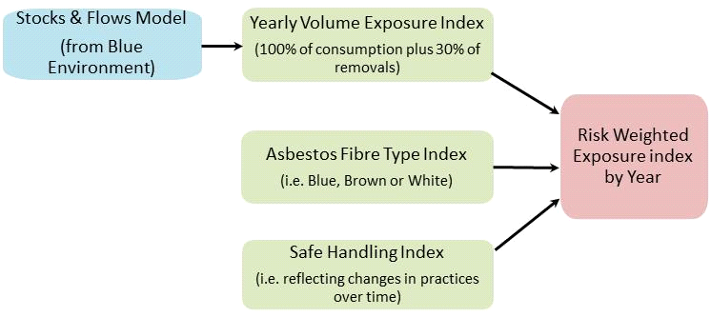

We briefly discuss each component below.

Stocks & flows model and volume exposure index

Table 2 shows the Blue Environment assumptions for asbestos removal rates, which vary by product. We show the average number of years until removal and the number of years until 90% of the asbestos is removed. The assumptions shown relate to one year of asbestos consumption.

**Table 2 – Summary of Blue Environment removal assumptions**

table 2 - summary of blue environment removal assumptions

The Blue Environment assumptions suggest that friction, flooring and other products have relatively short lifespans, with assumed average lives of 10-15 years after consumption. By contrast domestic cement sheeting has the longest run-off, with an assumed average lifespan of 60 years.

Figure 5 shows the resulting stocks and flows model output.

**Figure 5 – Asbestos consumption, removal & stocks – total**

figure five - asbestos consumption, removal and stocks - total

The level of consumption increased strongly from 1945 to the 1970s, before falling sharply in the early 1980s. We used separate versions of this model for domestic and commercial uses of asbestos.

A key assumption in our model is that asbestos removals represent 30% of the risk of consuming the same volume of fibres. This is because some of the high risk activities during consumption (e.g. sanding and cutting ACMs) do not occur during removal.

Mix by type of asbestos

Figure 6 shows net asbestos consumption in Australia split by asbestos type.

**Figure 6 – Australian net asbestos consumption by asbestos type and year**

figure six - Australian net asbestos consumption by asbestos type and year 

Blue asbestos was used until the mid-1960s. Around 10,000 tonnes of brown asbestos was consumed each year from the late 1940s until the late 1970s. Its use ended in 1983. By volume, white asbestos comprised the largest share of consumption and was used until it was banned at the end of 2003.

Blue asbestos is regarded as the most toxic form of asbestos. In Australia this was consumed mainly in the 1950s and 1960s, although blue asbestos was always less than 10% of the total consumption. It was withdrawn from use much earlier than brown and white asbestos. Brown asbestos was a significant contributor to net consumption up until the 1950s but was not consumed much after 1983. White asbestos was the dominant form used in Australia.

Although blue and brown asbestos were withdrawn from consumption before white asbestos, our projection of removals allows for the historical mix of types of asbestos in previous consumption years. In other words, our model allows for the fact that during the in situ and removal phases some people will be exposed to blue and brown asbestos after the 1980s.

The consumption weightings in Figure 6 are combined with risk weightings for each type of asbestos to derive a risk index reflecting the use of differing types of asbestos over time. The assumptions we used for the risk weighting were obtained from the Asbestos Working Party (AWP) of the Institute and Faculty of Actuaries in the UK. The relative risk weights summarised below, when combined with the other assumptions, produced a good back fit to the actual experience. We summarise this back fit later in this summary.

* Blue asbestos: 20
* Brown asbestos: 16
* White asbestos: 1

These relative risk weights suggest that a given volume of blue asbestos is assumed to have 20 times the toxicity of the same volume of white asbestos. Similarly, brown asbestos has 16 times the riskiness of white asbestos. Based on these relativities, the risk-adjusted levels of blue and brown asbestos reached higher peak levels than white asbestos. This is in contrast to the absolute levels of each type of asbestos consumed, as shown in Figure 6.

There is some debate about whether white asbestos causes mesothelioma. The World Health Organisation asserts that white asbestos can cause mesothelioma (WHO, 2006). In our review of the literature cited for this report the balance of opinion seems to support this view.

An alternative set of risk weights was developed by Hodgson and Darnton, based on risk relativities in cohort studies. Those relativities are as follows:

* Blue asbestos: 500
* Brown asbestos: 100
* White asbestos: 1

These risk weightings significantly reduce the effective weight for white asbestos compared to the two other types. The weight for brown asbestos is also lower relative to blue asbestos.

We tested the impact from using the Hodgson and Darnton weights. In this alternative scenario there are 12% fewer cases projected in 2015-2100. This indicates the sensitivity of our model to a significant change in the relativities. Further testing showed that the change in the blue to brown relativity is the main reason for the reduction in projected mesotheliomas. We set out all alternative scenarios tested in Section 6.

Risk index – asbestos handling

In addition to the mix by asbestos type, we also allowed for changes in risk levels over time arising from changed procedures and any precautions taken at differing points in time to minimise asbestos exposure. We refer to this as the asbestos handling or safe handling factor. In a work-related setting these actions and processes are part of an occupational health and safety framework. Our selected factors are judgemental and based on changes in regulation and the fibre load estimates of various activities under different conditions over time.

Our factors are shown in Figure 7 and are assumed to be the same for domestic and occupational exposures. In preparing this index we assumed that the level of compliance with applicable laws and regulations was broadly unchanged over time, and that the guidelines and regulations are the main drivers of changes in the asbestos handling factors.

We calibrated the factors relative to a score of 100% in 1970. The factors in other years were set to broadly reflect the changes over time shown in Table 5.5 of our full report.

We tested the shape shown above by changing the selected factors and reviewing the impact on how the model fits the historical experience (in particular, the number of cases in each year for 1988-2014). This testing was done in conjunction with reviews of the other model assumptions. The asbestos handling factors for the years 1921-1975 were most relevant for this back fitting. We found that the selected factors gave a strong back fit (combined with our other assumptions).

**Figure 7 – Asbestos handling factors**

figure seven - asbestos handling factors

Age at first exposure

We assumed the following average ages at first exposure:

* Wave 1 & 2: 38 years of age in 1921 decreasing to 33 years in 1950 and to 18 years in 1961 and later years.
* Occupational post-2003: 29 years for all periods.
* Wave 3 Domestic: 30 years of age for all periods.

The age of the exposed population at first exposure is assumed to be different for each wave, based on the profile of each group. This leads to different average life expectancies after exposure. This affects lifetime rates of mesothelioma incidence.

People in the wave 1 & 2 group first exposed in the 1920s are assumed to have an average age at first exposure reflecting the average age of the entire working population at the time. This is because asbestos was not widely used and was being introduced to incumbent workers.

The average age of those first exposed during the 1950s and 1960s is likely to be lower. We assume that younger people entering the workforce are the main group who were first exposed to asbestos during this time. Asbestos use became widespread after the Second World War, so most workers using asbestos at any point in this period would have been first exposed when they left school or higher education and started working.

For non-occupational wave 1 & 2 exposures we assume a broadly similar age profile for wives and partners. Our distribution of ages allows for some exposure for children (e.g. dusty families) and the elderly (e.g. residents living in asbestos towns and near industry).

Wave 3 Domestic and Occupational post-2003 exposures are assumed to be similar. People employed in asbestos removal or completing home renovations are assumed to be mostly of working age.

Mortality rates

We used standard male mortality rates, with the following adjustments:

* The key risk segments in wave 1 & 2 are blue collar workers. To accommodate this we added a mortality loading of 30% on standard mortality rates at younger ages, decreasing to a nil loading at older ages.
* We assumed 0.5% per annum mortality improvements in the past and future.
* We made reductions to the male mortality rates, to approximately allow for the proportion of women in these groups. Female mortality rates are consistently lower than male rates. The reductions were:
  + Wave 1 & 2 and Wave 3 Occupational: 2%
  + Wave 3 Domestic: 5%

Duration of exposure

Exposure continuation rates within each exposed population are used to project the years of asbestos exposure after first exposure. These rates do not project mortality, but rather how long a person remains in an exposed situation (e.g. in an exposed workforce). Our assumptions are based on testing the back fit of our models, as well as benchmarking to a number of other asbestos portfolios we have reviewed. A pattern of year-on-year exposure continuation rates is applied to each entry-year cohort. Specifically:

* Wave 1 & 2 has 18 years of exposure on average.
* Occupational post-2003 exposures occur for an average of 15 years, reflecting the greater tendency in recent years for workers to change jobs, compared to earlier periods.
* Wave 3 Domestic exposures are for 2 years on average.

The occupational exposures represent prolonged exposure over a person’s working life. The wave 3 exposure reflects the shorter timeframes over which this group was typically exposed, such as home renovators.

Background cases

For a proportion of mesotheliomas it will not be possible to identify a likely source of exposure.

The number of these background cases, both now and in the future, is highly uncertain. This is because the exposure sources of background and low dose mesotheliomas are often poorly understood.

Potential sources of exposure for background cases could include:

1. Unknown primary exposure to asbestos due to unknown or forgotten past exposures. By primary exposure we mean that the person was directly exposed to asbestos fibres within their workplace or in their home. Unknown sources will typically involve small doses of exposure.
2. Unknown secondary exposures e.g. due to renovations or construction on a neighbouring property.
3. Asbestos remaining in the air due to historical consumption within Australia.

Many have argued that there is an underlying level of mesotheliomas due to small fibre loads in the air in industrialised countries, particularly in cities. These small fibre loads might arise from historical asbestos consumption, and thus have no correlation to the future stock of ACMs or their removal.

1. Asbestos in the air due to the current in situ stock of asbestos. The small fibre loads described above could also be due to fibres released from recent disturbances to the current stock of ACMs, including their removal. This source of exposure is thus likely to end when all ACMs have been removed from the built environment.
2. Exposures to carcinogens other than asbestos, such as from radiation, plombage or erionite exposure in Turkey. Exposure to some viruses (e.g. SV40) may increase the risk of contracting mesothelioma as well, though this is inconclusive.
3. Cases developing due to spontaneous abnormal cell development, with no known exposure to carcinogens. This is a known explanation for some forms of cancer. However, it is generally accepted that some carcinogenic exposure (typically asbestos) is required to cause mesothelioma and spontaneous cell development cannot cause this specific cancer.

From this list we have excluded Category 1 from our definition of background cases. We have treated primary exposure cases as part of the main occupational and non-occupational wave projections.

Category 5 above is unlikely to be a significant factor for background cases of mesothelioma, particularly in the future. For the reasons given above we also rule out Category 6 as a source.

Our analysis and projection assumes that asbestos exposure is the primary driver of mesothelioma, noting that on a per capita basis Australia had the highest per capita usage of asbestos, and also has the highest per capita incidence of mesothelioma. The overwhelming cause of background mesothelioma is also assumed to be asbestos exposure. This approach is consistent with the view adopted by most others.

Our projection of background cases includes Categories 2, 3 and 4 above. Noting the uncertainty over exposure sources, the ability to estimate the level of background cases in future is imprecise. There are two possible approaches for projecting these cases:

1. Background cases are assumed to increase over time as the population grows. Background exposures due to Category 3 (as listed above) might be expected to be correlated to the size of the population.
2. The number of cases is assumed to be related to the actual stock of asbestos. In this situation the level of background cases reduces over time broadly following, on a lagged basis, the pattern of asbestos removals. This approach would be appropriate for background exposures from categories 2 and 4 (as listed above).

Noting this uncertainty, and our intention to project a central estimate, our base scenario has adopted the following approach for projecting background cases:

* Background cases from 1988 to 2014 increase in line with population growth.
* Future background cases after 2014 are an average of the projections based on population growth (method 1. above) and the asbestos stock (method 2. above). This means there is a 50% weight on both projection methods.

While our approach to project background cases has minimal impact on the current and historical number of cases, the approach has a very material effect on the projection after 2050. The sensitivity of the projection to this feature is highlighted in Section 6 of our full report.

Back testing results

Section 6 of the full report shows a comparison of various metrics observed historically with those produced by our model. A few of these back-tests are summarised below.

Figure 8 demonstrates that our model closely reproduces both the average age and age distribution of past mesotheliomas for wave 1 & 2.

**Figure 8 – Actual vs modelled – age profile**

**Average age – three year moving average**

figure eight - actual versus modelled - age profile - three year moving average

**Distribution of age at diagnosis**

figure eight - actual versus modelled - distribution of age at diagnosis

We also achieved a good fit for average age in our wave 3 model. For cases diagnosed in 2011-2014, the AMR dataset has an average age of 69. For the same period our model projects an average age of 70 years.

Table 3 summarises the actual and projected average year of exposure i.e. the year of midpoint exposure, for mesothelioma cases from the AMR data. It also shows average latency (from the same midpoint exposure). The actual experience is based on cases completing the AMR exposure questionnaire.

**Table 3 – Actual vs modelled – exposure & latency**



*Note: values may not add due to rounding*

Overall we are satisfied with the model fit, although this is not sufficient in itself to demonstrate that the projections are appropriate. We also consider our projections to be suitable, due to the exposure based approach we have taken, comparisons to other projections available to us and our confidence from using the epidemiological model for the past 10 years.

Results

Base scenario

Figure 9 shows our base scenario projection, along with the observed cases from 1988 to 2014.

**Figure 9 – Historical and projected mesothelioma cases (base scenario)**



Under our base scenario we project 19,427 cases of mesothelioma diagnosed in Australia between 2015 and 2100. Fifty eight per cent of these (11,264 cases) are attributed to the run-off of industrial exposures from the first and second waves, with the remaining 42% (8,163 cases) coming from the third wave (including background mesotheliomas).

Our base scenario projection indicates that we have reached the peak number of cases in 2015 (712), and that the number should decrease noticeably after 2020. The long term trajectory shows the number of cases halving to 350 per annum in about 2040 and reaching 100 per year in the 2050s. The total future cases are 27 times the 712 cases in 2015.

The wave 1 & 2 cases will decline relatively quickly from now, from 510 in 2015 to about 100 a year by 2050 and practically no cases by the late 2060s. This segment is estimated to have peaked in 2013 (513 cases). The total future wave 1 & 2 cases are 22 times the number in 2015.

Wave 3, on the other hand, will remain significant for much longer. We estimate 202 cases in 2015, after which the expected number will remain close to that level for at least another 20 years. From the middle of the century the majority of new mesothelioma cases will arise from third wave exposure. Our projection assumes a further 50 or so cases per annum from this source in each year from about 2060 onwards.

Due to its later exposure profile, wave 3 Total cases are projected to peak in 2021 (212 cases). Also, the total cases for this group in the period 2015-2100 are 41 times the number in 2015.

Uncertainty

The projections in this report are based on the information currently available to us. There are many uncertain factors and assumptions, both implicit and explicit, underlying the projection. Some of this uncertainty reflects difficulties caused by inputs which cannot be measured directly or where information is incomplete. The eventual outcome will almost certainly vary from our projections due to uncertainties associated with:

* The historical and future volumes of asbestos fibres inhaled by exposed individuals, including the pattern of asbestos consumption and removals.
* The riskiness of removal compared to consumption.
* Uncertainty about the functional form of the relation between the mesothelioma incidence rate and time.
* The relative toxicity of different types of asbestos.
* The impact of precautionary measures to minimise inhalation of asbestos fibres, both in the past and in the future.
* The on-going rate of future improvements in non-asbestos related mortality.
* The cause of mesothelioma for background cases.
* The profile (age, gender, latency and exposure source) of historical mesothelioma cases.
* The assumed split of cases between the exposure waves.

A further source of uncertainty arises because outcomes are dependent on future events extending many years into the future. Some outcomes are dependent on future actions e.g. practices for handling ACMs in 2015 and later years.

While we characterise our base scenario as a central estimate, it clearly sits within a wide range of plausible outcomes.

Section 6 of the full report considers individual sources of uncertainty in more detail, and shows scenarios whereby the projections could readily vary by a few thousand cases. More extreme outcomes are possible. We describe a range of plausible outcomes below.

Alternative scenarios

As noted above, there is considerable uncertainty surrounding our projection. Our base scenario is one plausible outcome. Alternatives of up to +/-10% in total future cases are possible from changing single assumptions. Wider variation is possible from changing several assumptions simultaneously.

Figure 10 combines the alternative scenarios tested in Section 6 of our full report, in order to produce an indicative range of plausible variation around our base scenario. Those scenarios tested the following:

* The relative riskiness of blue, brown and white asbestos, as described previously.
* Higher and lower risk levels associated with asbestos removal compared to consumption (10% and 50% compared to 30% in the base scenario).
* Higher and lower asbestos handling factors.
* Alternative splits for 2013 cases between wave 1 & 2 and wave 3 Domestic exposures.
* Different patterns for background cases, which either track wave 3 Domestic cases (so run-off earlier in the 21st century, compared to our base scenario) or follow the Australian population (so are higher than the base projection).
* Alternative assumptions for unreported (i.e. IBNR) cases in 2013. For the low estimate we assumed no further unreported cases for the period analysed i.e. 15 fewer cases per annum compared to the base. For the high scenario we assumed an additional 32 unreported cases in 2013, taking the total to 740.

We measured the variation in the projection output from those scenarios (versus the base). We aggregated the variations that increased the projection, to estimate a plausible high end scenario. We did the same for those scenarios which led to fewer cases, for the low end. The resulting range around the base scenario is shown in Figure 10.

**Figure 10 – Indicative range of outcomes considered by alternative scenarios**



Compared to the base scenario of 19,427 mesotheliomas, Figure 10 shows a range of approximately +/- 33% around the base case. Specifically:

* The low scenario projects 12,748 future cases (6,680 fewer than the base scenario).
* The high scenario projects 25,764 future mesotheliomas (6,336 more than the base).

This range around the base scenario is indicative and should not be interpreted as the minimum or maximum possible outcome. More extreme outcomes are possible. The indicative range is also simplified in that:

* It adds the impact of the individual scenarios described previously. It takes no account of possible multiplicative effects, offsets or partial impacts arising from these factors. It assumes that they all occur in full, as described.
* Some factors have not been tested. For instance, we did not test variations to the stocks and flows model of consumption and removal. An earlier or later pattern of exposure would probably lead to variation around our base scenario. We did not test this particular component of our model because we achieved a strong fit to the actual number of cases in 1988-2014, so focused on other uncertain factors.
* Some of the drivers of the range of outcomes shown in Figure 10 are specific features of our model (e.g. the allowance for unreported cases in 2013). However, the range also incorporates the potential impact of current and future asbestos management practices. These mainly affect future cases after 2050.

Conclusion

We project about 19,000 cases of mesothelioma diagnosed in Australia between 2015 and the end of the century.

An increasing proportion of these cases relate to non-occupational exposures spread across the broader Australian community. This has been identified as an emerging public health problem. These third wave cases are generally associated with relatively low doses of asbestos exposure and include some individuals who will be unaware that they have even been exposed to asbestos. Based on our estimates, the third wave currently represents around one in every three mesotheliomas diagnosed.

This proportion is projected to increase in future, due to the later exposure profile for this wave, compared to earlier occupational exposures. Significant volumes of ACMs remain in situ today. Allowing for this current stock of asbestos, we project over 8,000 future cases of third wave mesotheliomas.

The high and increasing incidence of mesothelioma in Australia is due to many factors. One reason that is often overlooked is the reluctance to recognise the causal significance of low dose occupational and non-occupational exposures.

The magnitude of third wave mesotheliomas highlights the importance of asbestos removalists, tradesmen, other workers, home renovators, businesses and all levels of government taking appropriate action. This includes raising awareness of ongoing asbestos exposures, and following risk minimisation strategies to deal with these exposures. This is particularly important because home renovation is so popular in Australia at present. By doing so, it is possible that there could be significantly fewer deaths from mesothelioma in Australia in the 21st century.

Acknowledgements

We would like to acknowledge the following people for their support or review of this assignment:

* The AMR, and by extension the state cancer registries, for providing the mesothelioma case data and reviewing this report.
* Blue Environment, whose stocks and flows model of asbestos consumption, removal and remaining asbestos stocks was used with the agency’s permission.
* Professor Lin Fritschi of the Epidemiology and Biostatistics Department of Curtin University, for providing an independent peer review of our report.
* Agency staff and the agency Research Advisory Committee for providing further review and feedback on this report.

Appendix A of the full report lists the body of research and publicly available information used in this project.

Reliances and limitations

This report has been prepared by Finity in accordance with the Code of Conduct of the Actuaries Institute.

Any distribution of the report must be in its entirety. Any publication of extracts from the report must be approved in advance by Finity in order to meet our professional obligations relating to the potential to mislead third parties by using our report for purposes that were not intended.

We have relied on the accuracy and completeness of the data and other information (qualitative, quantitative, written and verbal) provided to us for the purpose of this advice. We have not independently verified or audited the data, but we have reviewed the information for general reasonableness and consistency. The reader of this report is relying on the agency and the Australian Mesothelioma Registry and not Finity for the accuracy and reliability of the data. If any of the data or other information provided is inaccurate or incomplete, our advice may need to be revised and the report amended accordingly.

It is not possible to estimate future mesothelioma cases with certainty. As well as difficulties caused by inputs which cannot be measured directly, such as historical levels of asbestos exposure, or incomplete data, outcomes are also dependent on future events, including legislative, social, and medical changes. In particular, we can only estimate future levels of exposure; these will be affected by future removal rates and precautions which may or may not be followed by a large number of people. Deviations from our estimate, perhaps material, are normal and are to be expected. In the case of mesothelioma projections the uncertainty is heightened due to the need to make assumptions many years into the future.

Our report is based on a continuation of the current environment with allowance for known or projected changes in exposure profiles. It is quite possible that one or more changes to the environment could produce an outcome materially different from our estimates.

This report is being provided for the sole use of the agency for the purpose stated in Section 1 of the summary. It is not intended, nor necessarily suitable, for any other purpose. This report should only be relied on by the agency for the purpose for which it is intended. We understand that this report will be made available to third parties, to support the purpose stated in Section 1. Such distribution is acceptable on the condition that this entire summary, rather than any excerpt, is distributed.

Third parties, whether authorised or not to receive this report, should recognise that the furnishing of this report is not a substitute for their own due diligence and should place no reliance on this report or the data contained herein which would result in the creation of any duty or liability by Finity to the third party.

Our report should be considered as a whole, including all appendices. Members of Finity staff are available to answer any queries, and the reader should seek that advice before drawing conclusions on any issue in doubt.