Asbestos Safety and Eradication Agency

Annual Report 2016-17

**As of 10/10/2017 8:39 AM**

ISSN 2204-1419 [print]

ISSN 2204-1427 [online]

image informing readers that the document is covered by the Creative Commons Attribution 3.0 Australian Licence.

With the exception of the Commonwealth Coat of Arms and where otherwise noted all material presented in this document is provided under a Creative Commons Attribution 3.0 Australia ([www.creativecommons.org/licenses/by/3.0/au/](http://www.creativecommons.org/licenses/by/3.0/au/)) licence.

The details of the relevant licence conditions are available on the Creative Commons website, accessible using the links provided, as is the full legal code for the CC BY 3.0 AU ([www.creativecommons.org/licenses/by/3.0/au/legalcode](http://www.creativecommons.org/licenses/by/3.0/au/legalcode)) licence.

The document must be attributed as the Asbestos Safety and Eradication Agency Annual Report 2016–17.

**Access and further information**

The Australian Government aims to provide services that are fair, easy to access and simple to use and respond to the cultural and linguistic needs of Australia’s diverse society. For assistance with accessing the annual report, to request a copy (print or electronic), make an enquiry or comment, please contact the agency at:

**Asbestos Safety and Eradication Agency**

**Attention: Communications Manager**

Level 10, 255 Elizabeth Street

Sydney NSW 2000

Email: [enquiries@asbestossafety.gov.au](mailto:enquiries@asbestossafety.gov.au)

Phone: 1300 326 148

Web: [www.asbestossafety.gov.au](http://www.asbestossafety.gov.au)

Connect with the Asbestos Safety and Eradication Agency via social media:

Twitter: [www.twitter.com/AsbestosSafety](http://twitter.com/AsbestosSafety)

Facebook: [www.facebook.com/Asbestos-Safety-and-Eradication-Agency](https://www.facebook.com/pages/Asbestos-Safety-and-Eradication-Agency/590086754372681)

LinkedIn: [www.linkedin.com/AsbestosSafety](http://www.linkedin.com/groups?gid=6658671&home=)

**Table of Contents**

Letter of Transmittal 5

Section 1: Agency overview 6

Chief Executive Officer - year in review 6

The Agency 7

National Strategic Plan for Asbestos Management and Awareness 9

Table 1: 2016–17 at a glance 11

Section 2: the Asbestos Safety and Eradication Council 12

Secretariat and committees 18

Section 3: Report on performance 21

Annual Performance Statement 21

Trends in asbestos awareness and management 27

National Asbestos Exposure Register 28

Section 4: Additional work or ministerial directions 33

Section 5: Asbestos in the news 34

Section 6: Management and accountability 37

Corporate governance 37

External scrutiny 37

Management of human resources 38

Mandatory reporting 40

Section 7: Financial statements 43

Overview of financial performance 43

Independent auditors report 44

Statement by Chief Executive Officer and Chief Financial Officer 45

Financial statements 46

Appendices 63

Agency engagements and consultations 63

National Asbestos Exposure Register 68

Annual Report list of requirements 76

Glossary 81

Index 82

Letter of Transmittal

Senator the Hon Michaelia Cash

Minister for Employment

Minister for Women

Minister Assisting the Prime Minister for the Public Service

PO Box 6100, Senate

Parliament House

CANBERRA ACT 2600

Dear Minister

It is my pleasure to present to you the annual report of the Asbestos Safety and Eradication Agency for the 2016–17 year.

The report has been prepared in accordance with section 70 of the [*Public Service Act 1999*](http://www.legislation.gov.au/Details/C2016C00420) and section 46 of *the* [*Public Governance, Performance and Accountability Act 2013*](http://www.legislation.gov.au/Details/C2016C00414), which requires the agency to submit a report to the Minister on its operations for the year ending 30 June 2017. The report must be given to the responsible Minister by the 15th day of the fourth month after the end of the reporting period for the entity.

The report contains the financial statements for the year ending 30 June 2017. These statements were prepared in accordance with the Finance Minister’s orders and as required by section 46 of the [*Public Governance, Performance and Accountability Act 2013*](http://www.legislation.gov.au/Details/C2016C00414). The financial statements also accord with applicable accounting standards.

I certify that the Asbestos Safety and Eradication Agency has a fraud control plan in place which complies with the Commonwealth Fraud Control Guidelines.

Yours sincerely

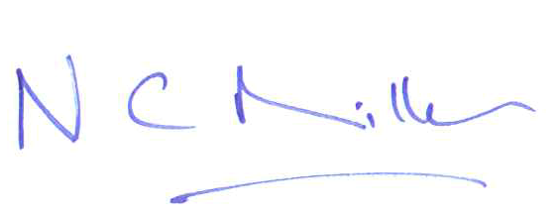

**Nick Miller**

Chief Executive Officer (acting)

25 September 2017

Section 1: Agency overview

Chief Executive Officer - year in review

The 2016–17 year has been another significant year of operations for the Asbestos Safety and Eradication Agency with the completion of a number of major projects and paving the way for the review of the *National Strategic Plan for Asbestos Management and Awareness 2014–18* during the 2017-18 year.

Through 2016–17, the agency continued to work diligently in building the evidence, practical information and processes to support the objectives of the [*Asbestos Safety and Eradication Agency Act 2013*](http://www.legislation.gov.au/Details/C2016C00410) (ASEA Act) and the goals, deliverables and outcomes in the [National Strategic Plan](http://www.asbestossafety.gov.au/national-strategic-plan). I’d like to thank agency staff and the members of the Asbestos Safety and Eradication Council for their hard work and commitment in the successful delivery of the plan over the year.

The key achievements of the agency for 2016–17 include:

* the agency building a significant body of evidence and research that will provide a solid base for future direction over the next two years and to guide the review of the National Strategic Plan in 2018
* delivering another successful International Conference on Asbestos Awareness and Management, held in Adelaide in November 2016, which saw over 350 delegates, guest speakers and a range of stakeholders convene to discuss local and international issues regarding asbestos awareness and management
* working closely with asbestos-related disease organisations through providing secretariat and other assistance to the Asbestos Support Group Network
* international leadership in commencing dialogue with the Government of Cambodia in working towards the development of National Asbestos Profile and a national ban on the production and use of asbestos-containing products.

The Australian Government has continued to express the importance of dealing with the legacy issues relating to asbestos and its impact on the community. I am confident the agency will continue to deliver the objectives of the ASEA Act and the National Strategic Plan to address these issues and reduce the impact of asbestos-related diseases in Australia.

I look forward to working with the agency staff, council, the Australian Government and all stakeholders in further coordinating the National Strategic Plan during the coming year and the development of a new National Strategic Plan to implement beyond 2018.

**Peter Tighe**

**Chief Executive Officer**

The Agency

The Asbestos Safety and Eradication Agency (the agency) is a statutory authority established to provide a national focus on asbestos issues that go beyond workplace safety to encompass environmental and public health issues.

The agency came into existence on 1 July 2013 through the enactment of the [*Asbestos Safety and Eradication Agency Act 2013*](http://www.legislation.gov.au/Details/C2016C00410) (the ASEA Act). Section 8 of the ASEA Act sets out the following functions of the agency:

1. to encourage, coordinate, monitor and report on the implementation of the National Strategic Plan;
2. to review and amend the National Strategic Plan as required by the National Strategic Plan or at the request of the Minister;
3. to publish and promote the National Strategic Plan;
4. to provide advice to the Minister about asbestos safety, if requested to do so by the Minister;
5. to liaise with Commonwealth, State, Territory, local and other governments, agencies or bodies about:
   1. the implementation, review or amendment of the National Strategic Plan; or
   2. asbestos safety;
6. to commission, monitor and promote research about asbestos safety;
7. such other functions as are conferred on the Agency by or under this Act, the rules or any other law of the Commonwealth;
8. to do anything incidental or conducive to the performance of any of the above functions.

The agency is responsible through its Chief Executive Officer (CEO) to the Minister for Employment and for financial purposes, operated under the[*Public Governance, Performance and Accountability Act 2013*](http://www.legislation.gov.au/Details/C2016C00414) (PGPA Act) for the 2016–17 year and the [*Public Service Act 1999*](http://www.comlaw.gov.au/Details/C2004A00538) (PS Act) for staffing purposes.

The Chief Executive Officer

|  |  |
| --- | --- |
| image of agency CEO, Peter Tighe standing at a lectern doing the presentation at the National Asbestos Forum on 25 November 2013. | **Mr Peter Tighe** is the Chief Executive Officer of the Australian Government Asbestos Safety and Eradication Agency – a position he has held since August 2013.  Peter has had extensive history working in the area of asbestos management. Prior to joining the agency he was National Secretary of the Communications, Electrical, Plumbing Union, a position he held from 1995 to 2013. Peter was also on the board of the National Occupational Health and Safety Commission. |

History

In 2010, a wide-ranging review was established by the Australian Government to make recommendations for the development of a national strategic plan to improve asbestos management in Australia.

The [*Asbestos Management Review Report*](http://www.asbestossafety.gov.au/publications) released in August 2012 recommended the development of a national strategic plan to improve asbestos awareness and management in the broader community. The review also recommended that an independent national agency be established to guide the implementation of the plan, which resulted initially in the creation of the Office of Asbestos Safety (the office) in September 2012 to start this work.

In June 2013, the Australian Parliament enacted the [*Asbestos Safety and Eradication Agency Act 2013*](http://www.legislation.gov.au/Details/C2016C00410)*,* which established the agency and the Asbestos Safety and Eradication Council and also prescribed the functions and objectives of these two bodies. The agency and council came into existence on 1 July 2013.

The agency and council are tasked with implementing the [*National Strategic Plan for Asbestos Management and Awareness 2014–2018*](http://www.asbestossafety.gov.au/national-strategic-plan) (National Strategic Plan), which was released to the public on 19 June 2015 and publicly launched by the Minister for Employment on 28 August 2015.

National Asbestos Exposure Register

Also in June 2013, the Australian Government established the National Asbestos Exposure Register to record the details of members of the community who believe they have been exposed to asbestos, either in the workplace or in the general community. The agency was given the responsibility to manage the register for the Australian Government and to ensure data collected was stored correctly under the [*Archives Act 1983*](http://www.legislation.gov.au/Details/C2016C00480) and statistical analysis was produced to identify potential risks through registration trends.

National Strategic Plan for Asbestos Management and Awareness

The *National Strategic Plan for Asbestos Management and Awareness 2014–18* was launched on 28 August 2015 by the Minister for Employment. This was the culmination of a national planning process that was endorsed by all Australian jurisdictions.

Since the formation of the nationally agreed plan, the agency has been coordinating quarterly national reporting to the Minister for Employment, and Asbestos Safety and Eradication Council as well as annual progress reports published in hard copy and on the agency website. This has highlighted extensive action being delivered in all jurisdictions that has contributed to preventing asbestos-related diseases.

In order to continue to build on this success, it is now time to review the agency’s coordination activities in order to identify areas to refine and improve. This will be used to inform the next phase of the plan, as the agency commences preparatory work on the National Strategic Plan beyond 2018.

During the 2017–18 reporting year, the agency will complete a process evaluation of the National Strategic Plan to identify what areas have worked well, what can be improved and how this will contribute to more effective coordination regarding the plan and prevention of ARDs in Australia.

Stakeholder engagement and coordination

The agency has a strong focus on consultation and coordination to support diverse stakeholder groups involved in asbestos issues. The diagram in figure 1 indicates some of the primary stakeholder groups that the agency works with in delivering its functions under section 8 of theASEA Actto provide advice to the Minister about asbestos safety and the implementation of the National Strategic Plan.

**Figure 1: Stakeholder engagement and coordination map**

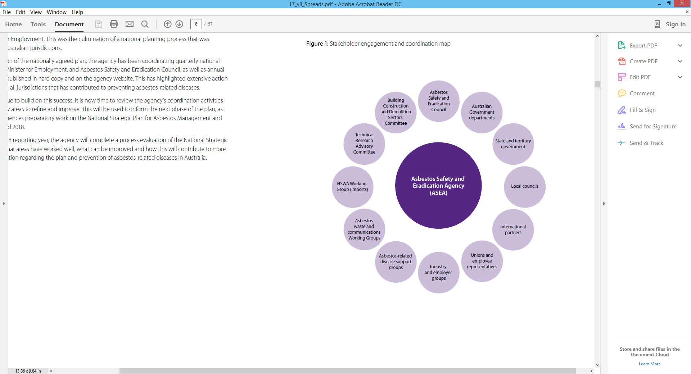

Table 1: 2016–17 at a glance

|  |  |
| --- | --- |
| 21 June 2017 | Parliamentary Group on Asbestos-Related Disease luncheon at Parliament House, Canberra |
| 21 June 2017 | **Second meeting of the new Asbestos Safety and Eradication Council held in Parliament House, Canberra** |
| 20 June 2017 | **Ninth meeting of the Building, Construction and Demolition Sectors Committee held in Sydney** |
| 6 June 2017 | **Second meeting of the Asbestos Communications Working Group held by teleconference** |
| 30 May 2017 | **Education and Employment Legislation Committee – Senate Estimates hearing in Parliament House, Canberra** |
| 02 May 2017 | **Celebration of the life of Louise (Lou) Williams (long-term mesothelioma patient, passed away 18 April 2017) held in Victoria** |
| 11 April 2017 | **Inaugural meeting of the Asbestos Communications Working Group held via teleconference** |
| 29 March 2017 | **Sixth meeting of the Technical Research Advisory Committee held in Sydney (formally known as Research Advisory Committee)** |
| 6 March 2017 | **Fourth meeting of the Asbestos Policy and Regulation Interdepartmental Committee held by teleconference** |
| 23 February 2017 | **First meeting of the second Asbestos Safety and Eradication Council held in Sydney – 21st meeting of the Council in total** |
| 21 February 2017 | **Eighth meeting of the Building, Construction and Demolition Sectors Committee held in Sydney** |
| 15 December 2016 | **Third meeting of the Asbestos Policy and Regulation Interdepartmental Committee held by teleconference** |
| 14 December 2016 | **New Asbestos Safety and Eradication Council appointed by the Minister for Employment** |
| 21–25 November 2016 | **National Asbestos Awareness Week activities for asbestos-related disease support groups** |
| 15 November 2016 | **Twenty-first meeting of the Asbestos Safety and Eradication Council (post-International conference) held in Adelaide** |
| 13–15 November 2016 | **Third International Conference on Asbestos Awareness and Management held in Adelaide** |
| 1–5 November 2016 | **South East Asian Ban Asbestos Network Conference in Jakarta, Indonesia (Agency Chief Executive Officer delivered presentation)** |
| 25 October 2016 | **Twentieth meeting of the Asbestos Safety and Eradication Council held in Sydney** |
| 24 October 2016 | **Second meeting of the Asbestos Policy and Regulation Interdepartmental Committee held by teleconference** |
| 11 October 2016 | **Seventh meeting of the Building, Construction and Demolition Sectors Committee held in Sydney** |
| 09 August 2016 | **Fifth meeting of the Research Advisory Committee** |
| 26 July 2016 | **Eighteenth meeting of the Asbestos Safety and Eradication Council held in Sydney** |
| 18 July 2016 | **Sixth meeting of the Building, Construction and Demolition Sectors Committee held in Sydney** |

Section 2: the Asbestos Safety and Eradication Council

Message from the Chair of the Council

Australia is widely recognised for its international leadership on asbestos management. I was honoured, therefore, to be appointed on 14 December 2016 as Chair of the second Asbestos Safety and Eradication Council by the Minister for Employment, Senator the Hon Michaelia Cash.

The Minister appointed six new members and reappointed three existing members. Members of the council are selected in accordance with the *Asbestos Safety and Eradication Agency Act 2013* for their experience and expertise in asbestos safety, public health, corporate governance or community advocacy.

The council met six times during the 2016–17 year and worked through important issues including ongoing development and implementation of the National Strategic Plan. I see a clear commitment and work towards improving asbestos awareness and management from council and thank them for their efforts.

The inaugural council chaired by Geoff Fary provided guidance to the agency in delivering on the goals of the National Strategic Plan thus laying solid foundations for the second council to continue this work. The success of the third International Conference on Asbestos Awareness and Management reflects the standing of the agency and this first council. Internationally renowned experts in public health and asbestos management travelled to Adelaide in November 2016 to share their expertise and advance the agenda of asbestos safety and eradication.

The CEO of the agency and his team can rightly be pleased with this and their other achievements over the 2016–17 year. Council very much appreciates their assistance. Council and management also acknowledge the Australian Government’s ongoing support of them as independent bodies. Continued constructive working relationships with all levels of government and stakeholders are essential in developing a new National Strategic Plan in the years beyond 2018. Council and the agency are committed to fostering these relationships as was highlighted by site visits arranged by the ACT Government before and after the 21 June 2017 council meeting in Canberra.

I look forward to working with the members of the second Asbestos Safety and Eradication Council over the coming years in delivering on the commitment towards a country that is free of asbestos-related diseases.

**Diane Smith-Gander**

**Chair, Asbestos Safety and Eradication Council**

Functions of Council

The Asbestos Safety and Eradication Council (the council), like the agency, was established by the assent of the ASEA Act.

The council is made up of a Chair and nine members who have been selected for their experience and expertise with asbestos safety, public health, corporate governance or the representation of people with asbestos-related diseases (ARDs) and their families. One position is reserved for an Australian Government representative and four positions are reserved for state, territory and local government representatives.

Section 29(1) of the ASEA Act sets out the functions of the council in providing guidance to the agency through the CEO. These functions include:

1. to provide advice, and make recommendations, to the CEO about the performance of the Agency’s functions, on its own initiative or at the request of the CEO; and
2. to provide advice to the Minister about asbestos safety; and
3. to monitor the implementation of the National Strategic Plan by Commonwealth, State, Territory and local governments; and
4. to provide advice, and make recommendations, about the National Strategic Plan and annual operational plans.

The council may issue written guidelines to the CEO about the performance of the agency’s functions but these must not be inconsistent with any directions given under section 14 of the ASEA Act governing ministerial directions to the CEO.

The Minister may give written directions to the council about the performance of the council’s functions and the council must comply with these directions.

Council members

|  |  |
| --- | --- |
|  | Chair |
| Diane Smith-Gander | **Diane Smith-Gander** Diane Smith-Gander is non-executive director AGL Energy Limited, Wesfarmers Limited, Chair of Safe Work Australia, a board member of Keystart Loans, Henry Davis York, Committee for Economic Development of Australia (CEDA) and immediate past President of Chief Executive Women. Ms Smith-Gander e has held a wide range of non-executive roles in the past including Chairman of Broadspectrum, Deputy Chair of NBN Co, non-executive director of the CBH Group and commissioner of Tourism WA. Ms Smith-Gander’s last executive role was as a group executive at Westpac Banking Corporation.  Prior to re-joining Westpac Ms Smith-Gander was a partner of McKinsey & Company in the United States serving clients in diverse industries globally.  Ms Smith-Gander became a senior advisor to McKinsey in Australia in 2016. Ms Smith-Gander is a fellow of the Australian Institute of Company Directors (AICD) and Governance Institute of Australia and adjunct professor of Corporate Governance at University of Western Australia where she serves on the advisory board of the Business School. |
|  | Members – Commonwealth representative |
|  | **Michelle Baxter** has been the Chief Executive Officer of Safe Work Australia since November 2014. Before her appointment Ms Baxter held senior roles across the Australian Public Service including as group manager in the former Department of Education, Employment and Workplace Relations (DEEWR), group manager responsible for agency change with the Fair Work Ombudsman and group manager, Council of Australian Governments (COAG) Taskforce with DEEWR. Ms Baxter is also a Commissioner of the Safety, Rehabilitation and Compensation Council. Ms Baxter has a bachelorof Laws and a Bachelor of Arts from the Australian National University and is admitted as a Barrister and Solicitor in the Australian Capital Territory. |
|  | Members – state and territory representatives |
|  | **Jim Dodds (WA)** is the Director of Environmental Health at the Department of Health Western Australia in the Public Health Division. He is also a member of the Food Regulatory Standing Committee and a Council Member and Executive Member of the Environmental Health Standing Committee (enHealth). Mr Dodds is undertaking a Master of Health Science and holds a number of qualifications including a Graduate Diploma in Occupational Health and Safety and a Master of Engineering Science – Waste Management. Mr Dodds’ previous roles include project lead of a reform program in the Department of Health, Director of Strategy and Environment, Chair of the enHealth Council and various roles in Shire Councils. Mr Dodds was previously the Chair of the enHealth Council and has co-authored nine journal articles in the last 16 years. |
| O:\Communications - TRIMMED\2016 - Third International Conference on Asbestos Awareness and Management\ASEA Conference 2016\Speakers\Pics\Andrew Kefford.jpg | **Andrew Kefford (ACT)** is the Head of the Asbestos Response Taskforce for the Australian Capital Territory Government, which is responsible for the design and implementation of the ACT Government’s Loose Fill Asbestos Insulation Eradication Scheme. Mr Kefford’s previous roles include Deputy Director-General Workforce Capability and Governance in the Chief Minister and Treasury Directorate and the Australian Capital Territory Commissioner for Public Administration. Mr Kefford has also worked for the Commonwealth Government as a senior adviser (Cabinet) in the Department of the Prime Minister and Cabinet and as a senior adviser (government) to the Hon John Howard OM, AC in the Office of the Prime Minister. |
| Julie Nielsen | **Julie Nielsen (QLD)** is the executive director of Compliance and Business Engagement in the Office of Industrial Relations, Queensland Treasury. Ms Nielsen’s previous roles include Brisbane North Sunshine Coast regional director, Workplace Health and Safety Queensland, in the Department of Justice and Attorney General. Before joining the Queensland public service, Ms Nielsen worked at the Queensland Chamber of Commerce and Industry. |
|  | **Marnie Williams (VIC)** is the executive director of Health and Safety at the Victorian WorkCover Authority. Ms Williams’ previous roles include chief executive officer of the Taxi Services Commission; general manager of the Department of Transport, Planning and Local Infrastructure and various roles at the Victorian WorkCover Authority and Worksafe Victoria, including as general manager of the Strategic Programs Division and as a chemical technologist. |
|  | Member – Employee representative |
| Mr Michael Borowick | **Michael Borowick** was elected as Assistant Secretary of the Australian Council of Trade Unions in 2010. Between 1990 and 2010 he held various elected and other positions in The Australian Workers’ Union and its predecessor organisations. Mr Borowick is on a number of boards including Safe Work Australia; the Safety, Rehabilitation and Compensation Commission; the National Workplace Relations Consultative Council and the Defence Reserves Support Council. Mr Borowick is also a Director of HESTA, the industry superannuation fund for the health and community sector. HESTA has 834,000 members and $40 billion of funds under management. |
|  | Member – Employer representative |
| Ms Tracey Browne | **Tracey Browne** has been manager, National Safety and Workers Compensation Policy and Membership Services, Australian Industry Group (Ai Group) since 2007. Between 2006 and 2007 she was AI Group’s national program manager, Small Business Occupational Health and Safety (OHS) Advisers Program, and from 2001 to 2007 she was a principal adviser, Workers Compensation and OHS. Her former positions also include group manager, Health Safety and Environment, Bendix Mintex Pty Ltd; coordinator, Occupational Health and Safety/Personnel, ACI Glass Packaging; and senior consultant, Occupational Health and Safety, Deloitte Touche Tohmatsu. |

|  |  |
| --- | --- |
|  | Other members |
| Ms Carolyn Davis | **Carolyn Davis** is an independent consultant and a former director of the Australian Chamber of Commerce and Industry (ACCI). Before joining ACCI, Ms Davis was a senior manager in various organisations and a consultant on occupational health and safety and workers’ compensation matters.  Carolyn has also lectured in occupational health and safety in Chemistry.  She is a former member of Safe Work Australia and has been an ‘observer’ at Council meetings since 2013. Ms Davis has a Bachelor of Science (Hons), an Education Diploma, a Graduate Diploma in Occupational Hygiene and is a member of Resolution Institute (alternative dispute resolution). |
|  | **Nancy Milne OAM** has extensive business experience as a non-executive director and lawyer and expertise in risk management. She was a lawyer for over 30 years specialising in insurance, corporate governance, risk management and commercial dispute resolution. Ms Milne acted for the underfunded trust created by James Hardie before and during the Jackson Special Commission of Enquiry, acted in disputes involving asbestos claims and has advised on matters relating to insurance arrangements for asbestos liability coverage. Ms Milne is currently a director of ALC Property Group Limited, Securities Exchange Guarantee Corporation Limited (chair since 2012), Superannuation Administration Corporation and the State Insurance Regulatory Authority. Ms Milne was awarded the Order of Australia Medal for services to the legal sector (particularly in insurance law) and to the community. |
|  | Observer |
| Dr Robert Walters | **Dr Robert Walters** is a general medical practitioner, part-time member of the Administrative Appeals Tribunal and Colonel in the Royal Australian Army Medical Corps. Dr Walters has been a general practice consultant to the Surgeon General, Australian Defence Force (ADF) since 1995 and has held positions in the ADF as a senior medical officer, Director of Medical Services (Tasmania Region) and military compensation adviser for Tasmania. His board memberships include Chair, Ministerial Asbestos Steering Committee; medical member of WorkSafe Tasmania Board, Headspace; and Chair of the General Practice Consultative Group, ADF. Dr Walters was also a state and territory representative on the first Asbestos Safety and Eradication Council, 2013 to 2016. |

Appointment of second Asbestos Safety and Eradication Council – 14 December 2016

The ASEA Act authorises the Minister for Employment to appoint members to the Asbestos Safety and Eradication Council for a period of no more than three years. On 14 December 2016, the Minister for Employment announced the appointment of the second Asbestos Safety and Eradication Council.

**Table 2: Council meetings and attendance – 01 July 2016 to 30 June 2017**

|  |  |  |  |  |  |  |  |
| --- | --- | --- | --- | --- | --- | --- | --- |
|  | **26/07/16** | **28/09/16** | **25/10/16** | **15/11/16n** | **Appointment of new Council 14 December 2016** | **23/02/2017** | **21/06/2017** |
| **Geoff Fary** | P | P | P | P |  |  |
| **Ian Gardner** | P | P | P | A |  |  |
| **Peter Dunphy** | A | P | P | A |  |  |
| **Lex McCulloch** | P | P | P | A |  |  |
| **Barry Robson** | P | P | P | P |  |  |
| **Tanya Segelov** | P | A | P | P |  |  |
| **Rob Walters** | P | P | P | A |  | O |
| **Michael Borowick** | P | P | A | A | A | P |
| **Tracey Browne** | P | P | P | P | P | P |
| **Carolyn Davis** | O | O | O | O | P | P |
| **Diane Smith-Gander** |  |  |  |  | P | P |
| **Michelle Baxter** |  |  |  |  | P | P |
| **Jim Dodds** |  |  |  |  | P | A |
| **Andrew Kefford** |  | O | O | O | P | P |
| **Julie Nielsen** |  |  |  |  | P | P |
| **Marnie Williams** |  |  |  |  | P | P |
| **Nancy Milne** |  |  |  |  | A | P |

P – Present A – Apologies T – Telephone O – Observer n – post 2016 conference council meeting

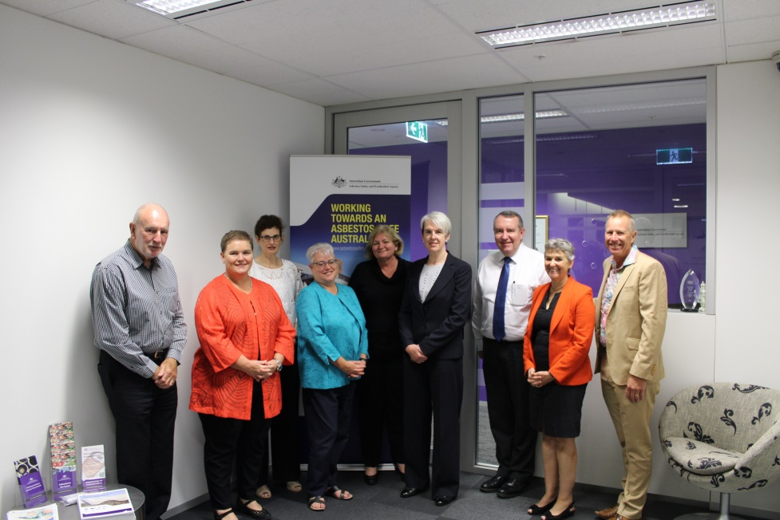

**From left to right:** Peter Tighe (CEO), Michelle Baxter, Marnie Williams, Tracey Browne, Julie Nielsen,

Diane Smith-Gander (Chair), Andrew Kefford, Carolyn Davis, Jim Dodds.

**Absent:** Michael Borowick, Nancy Milne

Secretariat and committees

Agency committees

Under section 24(1) of the ASEA Act, the CEO may establish committees to assist in the performance of his or her functions and the functions of the council. To support the coordination and operation of the National Strategic Plan, four committees and working groups were operating in 2016–17: the Building, Construction and Demolition Sectors Committee, the Technical Research Advisory Committee, the Asbestos Waste Working Group and the Asbestos Communications Working Group.

**Building, Construction and Demolition Sectors Committee**

The Building Construction and Demolition Sectors Committee (BCDS) is the agency’s primary industry consultation forum. The committee includes employer and employee representatives from industries impacted by Australia’s asbestos legacy. The BCDS provides advice to the agency on issues relating to the management of asbestos in the building, construction and demolition sectors and the implementation of the National Strategic Plan.

BCDS achievements during 2016–17 included:

* assisting in the development of an asbestos knowledge self-assessment tool including recommendations for targeted areas for best practice
* making recommendations to the agency to develop a suite of best practice guides for industry standard practices for minor works that may involve ACMs
* assisting in the finalisation of the *Safety information for the removal of less than 10m² of non-friable asbestos* booklet for publication
* providing advice on development of specific guidance for electricians and plumbers on working with asbestos
* providing advice on the impact of importation of asbestos-containing products and how to encourage greater awareness for workers.

The BCDS met four times during the 2016–17 year.

**Technical Research Advisory Committee**

The Technical Research Advisory Committee (TRAC) provides advice to the agency on technical research projects. The membership of the committee includes experts in public health, epidemiology, work health and safety and economic analysis. The committee met four times during 2016-17.

Key activities included a revision of ASEA’s research governance, formulation of direction for research project on exposure during DIY renovation activities, and advice and guidance on Australia’s National Asbestos Profile and the economic and social Impact of asbestos in Australia.

The committee met four times during the 2016–17 year.

Working Groups

**Asbestos Waste Working Group**

The Asbestos Waste Working Group (AWWG) consists of representatives from the environmental protection authorities and agencies across Australia including the Commonwealth Department of the Environment as well as state and territory bodies. The group has been convened to identify best practice for transport, storage and disposal of asbestos-containing materials (ACMs), in line with deliverable 2.4 of the National Strategic Plan.

The AWWG met once in the 2016–17 year.

**Asbestos Communications Working Group**

The Asbestos Communications Working Group (ACWG) held its inaugural teleconference meeting in April 2017 and was established to share information about communications campaigns in the states and territories and collaborate on national asbestos awareness campaigns being developed by the agency.

The membership of the ACWG includes media and communications representatives for the state and territory workplace health and safety regulators, Safe Work Australia, Department of Health and other members as required.

The ACWG met twice in the 2016–17 year.

Secretariat support

**Heads of Workplace Safety Authorities Imported Materials with Asbestos Working Group**

The agency is the secretariat for the Heads of Workplace Safety Authorities (HWSA) Imported Materials With Asbestos Working Group which was established to deal with incidences of asbestos-containing materials being imported into Australia in contravention of the [*Customs (Prohibited Imports) Regulations 1956*](http://www.legislation.gov.au/Details/F2016C00795).

The Working Group meets on an ad hoc basis to determine a course of action when asbestos-containing materials have been imported into Australia and detected in more than one jurisdiction, as outlined in the Rapid Response Protocol. The Working Group reports back to HWSA on the outcomes of discussions, through the secretariat following these instances and on a periodical basis.

The HWSA Working Group met fifteen times in the 2016–17 year (also refer Section 5).

**Asbestos Support Group Network**

The Asbestos Support Group Network (ASGN) is a coalition of all community-based asbestos-related disease support groups across Australia who are mainly funded by charitable donations, grant funding and fundraising events. These groups provide assistance and support to members of the community who have been diagnosed with an asbestos-related disease and their families and friends, which can be a traumatic time for all involved.

The network holds meetings to be kept informed about decisions made at the Asbestos Safety and Eradication Council meetings and other asbestos-related issues that arise from time to time. The agency provides secretariat support for the Network meetings including preparation and minute taking and teleconference facilities.

The ASGN met five times in the 2016–17 year.

Section 3: Report on performance

Annual Performance Statement

|  |
| --- |
| Introductory statement  I, as the accountable authority of the Asbestos Safety and Eradication Agency, present the 2016–17 annual performance statement of the Asbestos Safety and Eradication Agency, as required under paragraph 39(1)(a) of the *Public Governance, Performance and Accountability Act 2013* (PGPA Act). In my opinion, these annual performance statements are based on properly maintained records, accurately reflect the performance of the entity, and comply with subsection 39(2) of the PGPA Act. |
| Purpose  **Outcome one:** to prevent exposure to asbestos fibres in order to eliminate asbestos-related disease in Australia. |

Results against performance criteria

|  |  |  |  |
| --- | --- | --- | --- |
| **Criterion one** | **Increase public awareness about asbestos safety** | | |
| **Source** | National Strategic Plan for Asbestos Management and Awareness 2014–18  2016–17 Portfolio Budget Statement (page 58)  ASEA Operational Plan 2016–17 (page 5) | | |
|  | **2016–17 targets** | **How was this measured?** | **Results against criterion** |
| **Results against performance** | * Increase in utilisation of agency information, resources and events | Demonstrated positive increase | * Maintained number of delegates to agency conference at 360 in 2016, same as in 2015 * 2015. A key highlight of the 2016 conference was the attendance of international representatives from the Cambodian Government, who have established an ongoing relationship with the agency, showing the agency’s contribution to international leadership in the South East Asian region * Agency provided secretariat support for Asbestos Support Group Network and asbestos-related disease support groups * Presentations delivered and agency represented at external events and meetings across Australia, including five Customs Brokers and Forwarders Council of Australia (CBFCA) Regional Conventions and a seminar in Canberra to raise awareness about the risks of imported products containing asbestos * Continued development of agency website into ‘one-stop-shop’ online resource with new materials and social media collateral * During 2016–17, the agency advised on 23 applications for permits to import asbestos into Australia for the purposes of research, analysis or display |
| **Assessment:** exceeded target (100% agreement) | | | |

|  |  |  |  |
| --- | --- | --- | --- |
| **Criterion two** | **Effectively coordinate national issues that relate to the plan and asbestos issues** | | |
| **Source** | National Strategic Plan for Asbestos Management and Awareness 2014–18  2016–17 Portfolio Budget Statement (page 58)  ASEA Operational Plan 2016–17 (page 5) | | |
|  | **2016–17 targets** | **How was this measured?** | **Results against criterion** |
| **Results against performance** | * Survey of Asbestos Safety and Eradication Council, and committees agree the agency effectively engages with stakeholders * Progress report on the National Strategic Plan demonstrates coordination of national initiatives | More than 75% of council members agree | * Survey of council members showed 100% agreement that the agency effectively engaged with stakeholders during 2016–17 * Successful coordination and secretariat support for the council, agency committees, working groups and other fora * Release of the first National Strategic Plan progress report on 21 November, 2016 * The agency provided information, reporting and sought the feedback of senior officials from the work health and safety portfolio at least once per quarter during 2016–17 and written to senior officials six times with information updates, demonstrating effective reporting and sharing of information about asbestos safety and research, and the implementation of the National Strategic Plan |
| **Assessment:** exceeded target (100% agreement) | | | |

|  |  |  |  |
| --- | --- | --- | --- |
| **Criterion three** | **Identify targeted and practical initiatives to reduce the risks of asbestos-related disease in Australia** | | |
| **Source** | National Strategic Plan for Asbestos Management and Awareness 2014–18  2016–17 Portfolio Budget Statement (page 58)  ASEA Operational Plan 2016–17 (page 5) | | |
|  | **2016–17 targets** | **How was this measured?** | **Results against criterion** |
| **Results against performance** | * Identified initiatives demonstrate a reduction in asbestos exposure risks | Project evaluations | Agency research highlights for 2016–17:   * Release of the Asbestos in Remote Australian Communities report * Disaster research * Case studies on significant asbestos removal, land contamination and AC water pipes * Analysis of DIY behaviours relating to asbestos exposure * Local government’s role in asbestos safety |
| **Assessment:** on track | | | |

Analysis of performance against purpose

The evidence demonstrates that ASEA continues to support effective national coordination and sharing of information about asbestos risks and the National Strategic Plan.

Overall, in 2016–-17 the agency’s Council and committee secretariat support has been consistent with 2015–16. The agency has increased focus on asbestos communications with the establishment of an additional working group, and has done extensive work to support the coordination of information and awareness of the risks of imported products containing asbestos via the Heads of Workplace Safety Authorities Working Group, a targeted information event in the ACT and a number of events held by Customs Brokers and Forwarders Council of Australia.

This information reflects the agency’s Portfolio Budget Statement and is consistent with the evaluation plan for the National Strategic Plan (referenced in the image page 38). The alignment of ASEA’s program with the National Strategic Plan evaluation model shows how the short-term outcomes to increase national coordination and evidence will influence the medium and long-term outcomes of the National Strategic Plan, which are to reduce exposure to fibres in order to eliminate asbestos-related disease.

Coordination of the National Strategic Plan

The agency administers the National Strategic Plan by coordinating the activities, research and consultation that is undertaken in line with the plan and asbestos issues nationally across public health, environment and work health and safety.

This is achieved by working with the Asbestos Safety and Eradication Council under a tripartite framework; working with all levels of government, and employer and employee representatives, with the support of independent experts.

The agency has increased focus on asbestos communications with the establishment of an additional working group, and has done extensive work to support the coordination of information and awareness of the risks of imported products containing asbestos.

Council members have provided feedback on the work of the agency during 2016–17, and commented on their positive impression of the agency, general effectiveness, commitment to work and overall level of output produced by the agency. Additionally, members have highlighted the agency’s international engagement and leadership as a key point of impact that should receive continued focus in 2017–18.

Research themes

The agency’s role under the ASEA Act includes commissioning and promoting asbestos safety research (section 8(f)). During 2016–17, ASEA established the following themes for asbestos research and evidence:

* residential risks
* environmental contamination
* asbestos legacy in the built environment
* awareness
* asbestos-related diseases and social impact
* data, evidence and trends.

Outlook for 2017-18

During 2017–18, the agency will complete a process evaluation of the National Strategic Plan to identify what areas have worked well, what can be improved and how this will contribute to more effective coordination regarding the plan and prevention of asbestos-related diseases in Australia. Since the formation of the nationally agreed plan, the agency has been coordinating quarterly national reporting and annual progress reports. This has highlighted extensive action being delivered in all jurisdictions that contribute to preventing asbestos-related diseases. In order to continue to build on this success, it is now time to review the agency’s coordination activities in order to identify areas to refine and improve. This will be used to inform the next phase of the plan, as we commence the preparatory work the National Strategic Plan for Asbestos Management and Awareness after 2018.

**Agency program model demonstrating the contribution of short term outcomes to the elimination of asbestos-related disease in Australia:**

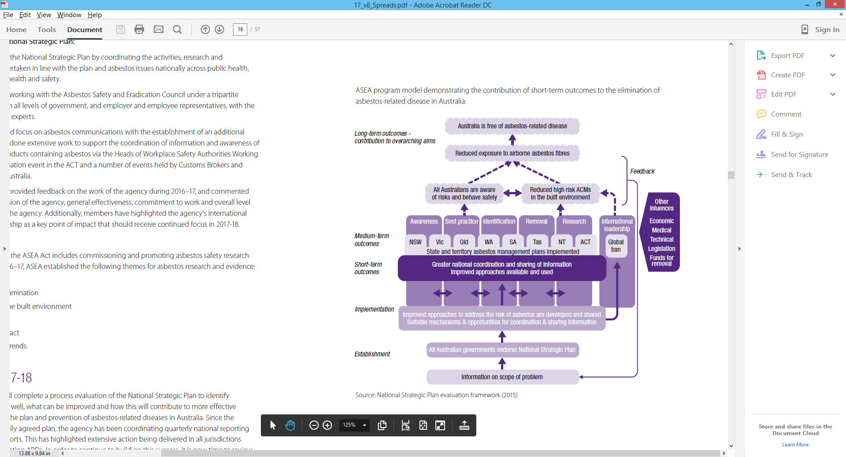

Source: National Strategic Plan evaluation framework (2015)

Third International Conference on Asbestos Awareness and Management

The third International Conference on Asbestos Awareness and Management was held on 13–15 November 2016 at the Adelaide Convention Centre in the week prior to National Asbestos Awareness Week.

Building on the agency conferences in 2014 and 2015, the event was a great success in drawing 360 attendees (experts in asbestos, industry and employer groups, unions, government representatives at all levels, researchers, medical experts and health professionals, community groups, victims of asbestos-related diseases and other stakeholders) to hear internationally and locally renowned speakers discussing a range of topics in asbestos awareness and management.

Delegates from all over Australia and other countries including New Zealand, Canada, Sweden, Nepal, Indonesia and India participated in thought-provoking and informative sessions and debates about how asbestos needs to be managed in order to achieve the goal of a worldwide ban on asbestos mining and manufacturing. The conference also included a delegation from the Government of Cambodia who expressed interest in collaborating with the Australian Government and the agency in working towards a national ban on asbestos in their country.

The agency is currently organising the Asbestos Safety and Eradication Summit, which will take place at Old Parliament House, Canberra in November 2017. This is the week after National Asbestos Awareness Week, which begins 20 November 2016.

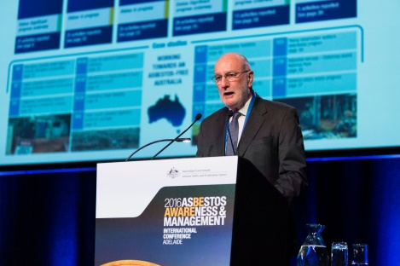 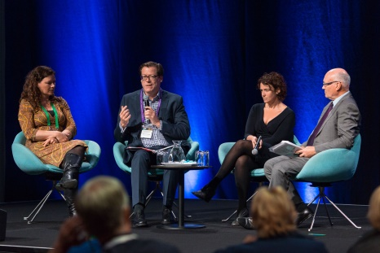 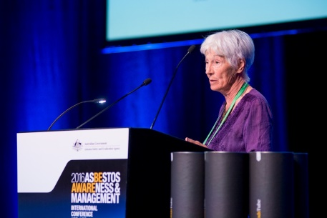

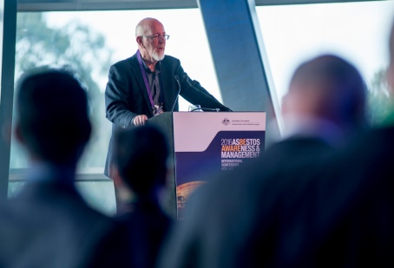 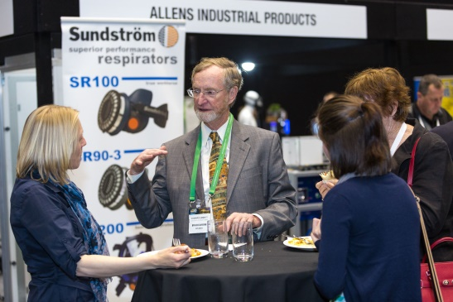 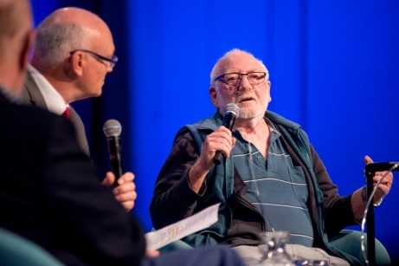

Trends in asbestos awareness and management

The 2016–17 year was the fourth year of full operation for the agency and another significant year in delivering the work required by the ASEA Act and the National Strategic Plan.

Awareness

Awareness levels of the agency and its activities have been slowly building since its establishment in 2013. However, more work needs to be done to further improve awareness, according to the results of the second national survey of asbestos awareness and attitudes run in 2015–16.

In 2014, the agency commissioned the first ever national survey of awareness of and attitudes towards asbestos and the risks of exposure to asbestos, creating a baseline of statistics on which the agency could test awareness levels and attitudes at biennial intervals into the future. In line with this, the agency conducted a benchmark national survey in May 2016 which showed that awareness levels have plateaued and in some places gone backwards leaving the agency with more work to do in certain sectors like the young do-it-yourself home renovators and young tradespeople.

The results of the 2016 national survey and comparisons to the 2014 baseline survey were published on the agency website in September 2016 and presented to the agency’s 3rd International Conference on Asbestos Awareness and Management in Adelaide in November 2016. The agency will conduct another benchmark national survey in the 2017–18 reporting year for comparison to the 2014 and 2016 years results to determine ongoing attitudes and awareness levels, as well as to focus awareness activities..

Trends in National Asbestos Exposure Register

The number of people registering their details on the National Asbestos Exposure Register (NAER) continues to increase each year of operation, with the total number of registrations reaching 5776 from June 2013 to 30 June 2017. The agency believes the annual increases are a result of better awareness of the register in the Australian community.

At 77 per cent to 23 per cent for male to female registrations respectively, the reporting gap has increased compared to the previous financial year. This is reflected by a large number of registrations from male dominated industries such as electrician, plumber and building/construction.

The occupational to non-occupational ratio has widened at 70 per cent to 30 per cent respectively; compared with approximately 64 per cent to 36 per cent in the previous financial year. This reflects a high incidence of reporting driven by employer referrals, which represent 31 per cent of all registrations compared to 27 per cent in the previous financial year.

Workplace exposure reported by registrants of less than 20 years of age was significantly up compared to the previous year as it was for the 20 to 49 age ranges. There are no clear reasons for this increase.

During this reporting period 40 registrants indicated they had been diagnosed with an asbestos-related disease. Some of them reported having been diagnosed with more than one disease. In 81 per cent of cases it was reported the disease was the result of workplace activity. Pleural plaques were the most reported disease.

National Asbestos Exposure Register

The National Asbestos Exposure Register (NAER) captures details of exposure, including where and when the potential exposure occurred, and details of any diagnosis of asbestos-related disease. The register provides the agency with a statistical analysis of potential or actual exposure events across Australia and allows the agency to remain informed about potential risks which are identified through registration trends. This report provides a snapshot of registrations from 1 July 2016 to 30 June 2017.

The data provided by registrants to the NAER allow the agency to analyse trends and themes in potential asbestos exposure based on age, gender, location and type of potential exposure, frequency of potential exposure, when potential exposure first occurred and the types of jobs or industries where the greatest potential risk may be. If people have been diagnosed with an asbestos-related disease it also allows the agency to estimate the time between the first exposure and when the disease was diagnosed.

Analysis of data in the NAER is based on information limited to the NAER and is general in nature. The registrations do not record confirmed exposure but where someone believes they have been exposed to asbestos fibres. This provides a view of perceived risk and general awareness can be inferred from what is recorded.

Registrations

Since its inception in June 2013, there have been 5776 registrations. There were 65 registrations in June 2013. There were 1045 registrations in the 2013–2014 financial year, 1369 in the 2014–2015 financial year, 1528 in the 2015–2016 financial year and 1770 in the 2016–2017 financial years.

NSW, ACT and WA had a high representation in the 2016–2017 financial year relative to their populations. For NSW, this is attributed to the ongoing issue of loose-fill asbestos in NSW homes; in WA it is attributed to a large number of registrations relating to workplace exposures where are significant proportion (almost 49 per cent) were referred to the NAER by employers.

Interestingly there has been a significant reduction (greater than 55 per cent) of registrants from the ACT compared to the last financial year. This is due to a significant fall in registrations relating to loose-fill asbestos insulation (‘Mr Fluffy’) exposure.

**Table 3**: Registrations by location of registrant in 2016–17

|  |  |  |  |  |  |  |  |
| --- | --- | --- | --- | --- | --- | --- | --- |
| **LOCATION** | | | | | | | |
| **ACT** | **NSW** | **NT** | **Qld** | **SA** | **Tas** | **Vic** | **WA** | **Total** |
| 86 | 478 | 61 | 279 | 122 | 92 | 161 | 491 | 1770 |
| 4.86% | 27.01% | 3.45% | 15.76% | 6.89% | 5.20% | 9.10% | 27.74% |  |

Exposure type and gender

The ratio of occupational exposure to non-occupational exposure was 70 per cent to 30 per cent for the 2016–2017 financial year. This is consistent with the long-term average of 70 per cent occupational to 30 per cent non-occupational.

The ratio of male to female exposure was approximately 77 per cent to 23 per cent for the financial year. This is an increase of approximately 8 percentage points in male representation as compared to the previous financial year (69 per cent male to 31 per cent female). The long-term average however, is approximately 74 per cent male to 26 per cent female. The higher than average proportion of male registrations was in all jurisdiction except WA where the proportion dropped by just over 2 per cent. This is possibly due to an increase in the reporting of occupational exposures which are generally in male dominated jobs.

Non-occupational exposure for men is approximately 20 per cent compared to approximately 80 per cent for occupational exposure. Occupational exposure is slightly higher than for the same period last financial year when the ratio was approximately 23 per cent to 77 per cent. Non-occupational to occupational exposure for women was 65 per cent to 35 per cent in the 2016–2017 financial year compared to 64 per cent to 36 per cent in the previous financial year.

Almost 18 per cent of male respondents were in electrical trades and just over 21 per cent were in building and construction which is a significant increase over the previous financial year. A further 7 per cent were in the mining sector. Of the 40 per cent of male respondents who answered ‘other’ to their occupational activity, significant proportions were in building and construction or trades related activities.

Almost 76 per cent of female respondents answered ‘other’ to their occupational activity; however most of these did not appear to be in occupations with a direct relationship to working with asbestos as many were in education or administrative positions.

**Figure 2**: Exposure type by gender (male) **Figure 3**: Exposure type by gender (female)

Age at exposure and frequency

Just over 70 per cent of reported first exposures occurred before the age of 40 with just under 22 per cent occurring before the age of 20. Of these, approximately 78 per cent were non-occupational exposures. Occupational exposures for the other age groups are significantly higher.

In comparison with the 2015–16 financial year, the once only frequency has increased significantly (5 percentage points or more) for all age groups and decreased significantly for the greater than five year frequency for all age groups excepting the over 60s. Variations for the other exposure frequencies in the order of 5 percentage points or more are a drop in reporting of exposures of greater than two years to five years for the 40-49 age range, increases in the greater than six months to two years for the under 20 and 30-39 age ranges and zero to six months for the 40-49 age range. This can possibly be attributed to an increase in the proportion of occupational to non-occupational exposures of just over 5 percentage points compared to the 2015–16 financial year.

**Table 4**: Exposure type by age range at first exposure

|  |  |  |
| --- | --- | --- |
| **Age** | **Exposure type** | |
| **Non-Occupational** | **Occupational** |
| <20 | 44.41% | 55.59% |
| 20–29 | 15.75% | 84.25% |
| 30–39 | 29.85% | 70.15% |
| 40–49 | 32.96% | 67.04% |
| 50–59 | 32.35% | 67.65% |
| 60+ | 53.13% | 46.88% |
| **Total** | 30.23% | 69.77% |

**Table 5**: Frequency of exposure by type of exposure

|  |  |  |
| --- | --- | --- |
| **Frequency** | **Exposure type** | |
| **Non-Occupational** | **Occupational** |
| >5 years | 33.89% | 66.11% |
| >2 years to 5 years | 33.93% | 66.07% |
| >6 months to 2 years | 23.26% | 76.74% |
| 0 to 6 months | 34.16% | 65.84% |
| Once only | 24.12% | 75.88% |
| **Total** | 30.23% | 69.77% |

Trends

At 77 per cent to 23 per cent for male to female registrations respectively, the reporting gap has increased compared to the previous financial year. This is reflected by a large number of registrations from male dominated industries such as electrician, plumber and building/construction.

Interestingly, reports of exposure in QLD increased significantly from 177 in 2015–16 to 279 in 2016–17 (approximately 63 per cent). This is possibly due to an almost 9 per cent increase in registrations encouraged by the employer. WA also recorded a significant increase in the number of registrants. Analysis of the responses has revealed large numbers of registrations referring to potential exposure due to the Roe 8 road extensions, school asbestos exposure incidents and employer initiated registrations. (See Table 1, Page 18.)

The occupational to non-occupational ratio has widened at 70 per cent to 30 per cent respectively; compared with approximately 64 per cent to 36 per cent in the previous financial year. This reflects a high incidence of reporting driven by employer referrals, which represent 31 per cent of all registrations compared to 27 per cent in the previous financial year.

Workplace exposure reported by registrants of less than 20 years of age was significantly up compared to the previous year as it was for the 20 to 49 age ranges. There are no clear reasons for this increase.

During this reporting period 40 registrants indicated they had been diagnosed with an asbestos-related disease. Some of them reported having been diagnosed with more than on disease. In 81 per cent of cases it was reported the disease was the result of workplace activity. Pleural plaques was the most reported disease.

**Factors influencing registration numbers**

There have been significant fluctuations from one month to another in the number of registrations on the NAER. Influencing factors include point in time media reports on asbestos issues such as:

* government funded loose-fill asbestos inspection programs
* reports of illegal dumping
* reports of import of illegal building products
* reports of incidents in schools or hospitals
* large numbers of employer or union initiated registrations.

**The NAER into the future**

Media focus on asbestos issues appears to impact reporting patterns on the NAER. Issues during the 2016–17 financial year have included loose-fill asbestos in residences in both the ACT and NSW as well as reports which appear in the media from time to time about the existence of asbestos-containing materials in schools and hospitals. This indicates a growing concern amongst community members about the risks they may be incurring in settings other than their workplaces.

This is likely to become more apparent with the increasing trend in DIY activities and major home renovations. The agency has received a number of enquiries from concerned members of the public about neighbourhood renovation activities. This also reflects growing awareness amongst members of the public that there are risks in the residential setting of asbestos fibres becoming airborne and posing a risk to the community.

With average monthly registrations of 148 per month in the 2016–2017 financial year, some trends are now beginning to emerge. Despite variations from month to month and year to year, it is clear that the majority of male registrations are work related, while the majority of female registrations are not directly related to their work. There seems to be a growing concern among employers to inform employees of the existence of the NAER and to encourage them to register if they believe they have been exposed. It is hoped that the NAER will continue to be an avenue by which community members can express their concerns about asbestos exposure and to inform the agency of how and where they believe their exposure occurred.

Analysis of the data collected in the NAER will continue to build on the statistical base which is being developed and support the agency to develop an evidence base which is vital for the implementation of the National Strategic Plan. The NAER is an important component of the work of the agency and continues to complement the other sources of information collected by the agency through other research which will help to address the issue of asbestos and its risks to the Australian community into the future.

Section 4: Additional work or ministerial directions

The agency was not required to do additional work and did not receive any ministerial directions during the 2016–17 year.

Section 5: Asbestos in the news

Asbestos continues to be an emotive issue that will generate attention in the community and in the media. The prevalence of asbestos-containing materials in the domestic built environment will continue to cause significant problems in the Australian community while it remains in place.

Importation of asbestos-containing materials into Australia

The 2016–17 reporting year saw more detection of asbestos-containing materials at the Australian customs border and in the community resulting in action by the Heads of Workplace Safety Authorities (HWSA) Imported Materials with Asbestos Working Group and the Australian Competition and Consumer Commission (ACCC).

In June 2017, the HWSA Working Group issued a consumer and retailer alert regarding the sale of children’s crayons sold within Australia that were found to contain trace amounts of asbestos. Other examples of illegal importation were asbestos brake shoes detected in Vespa motor scooters and electrical scooters imported into Australia and a range of asbestos parts found in Polaris youth quad bikes resulting in a nationwide recall of several models.

In August 2016, friable asbestos was detected in new plant equipment imported from China to be installed at the Port Pirie smelter redevelopment in South Australia. It was revealed in media reports at the time SafeWork South Australia were notified of the breach of work health and safety laws and customs regulations making importation of asbestos unlawful.

The agency has been working with stakeholders, notably the Department of Immigration and Border Protection and customs brokers, to promote sample testing prior to the full importation of materials to ensure these events are prevented. The agency provides advice to the Minister for Employment, who is responsible for granting permission to parties that want to import asbestos-containing samples or goods into Australia.

Senate Inquiry into non-conforming building products

The Senate Economics References Committee Inquiry into Non-Conforming Building Products also generated attention in the media with a number of public hearings across Australia to hear evidence on the impact of non-conforming building products in the building industry and the danger of asbestos-containing materials being illegally imported into Australia.

Following the federal election in August 2016, the Senate Inquiry was reconstituted and adopted extended terms of reference in October 2016 specifically relating to the illegal importation of products containing asbestos. This was a result of the high-profile media stories regarding imported asbestos being detected on the Qld Government building in Brisbane, the Perth Children’s Hospital redevelopment and a number of other instances.

The agency’s submission to the Inquiry argues that it is the duty and responsibility for all decision-makers along the supply chain to ensure that Australian laws and regulations are enforced at all stages, not just when they arrive in Australia. (see diagram below)

The Senate Committee is due to publish their final report during the 2017–18 reporting year and the agency will provide whatever advice and assistance to all levels of government and corporate Australia to ensure the importation of asbestos materials no longer occurs.

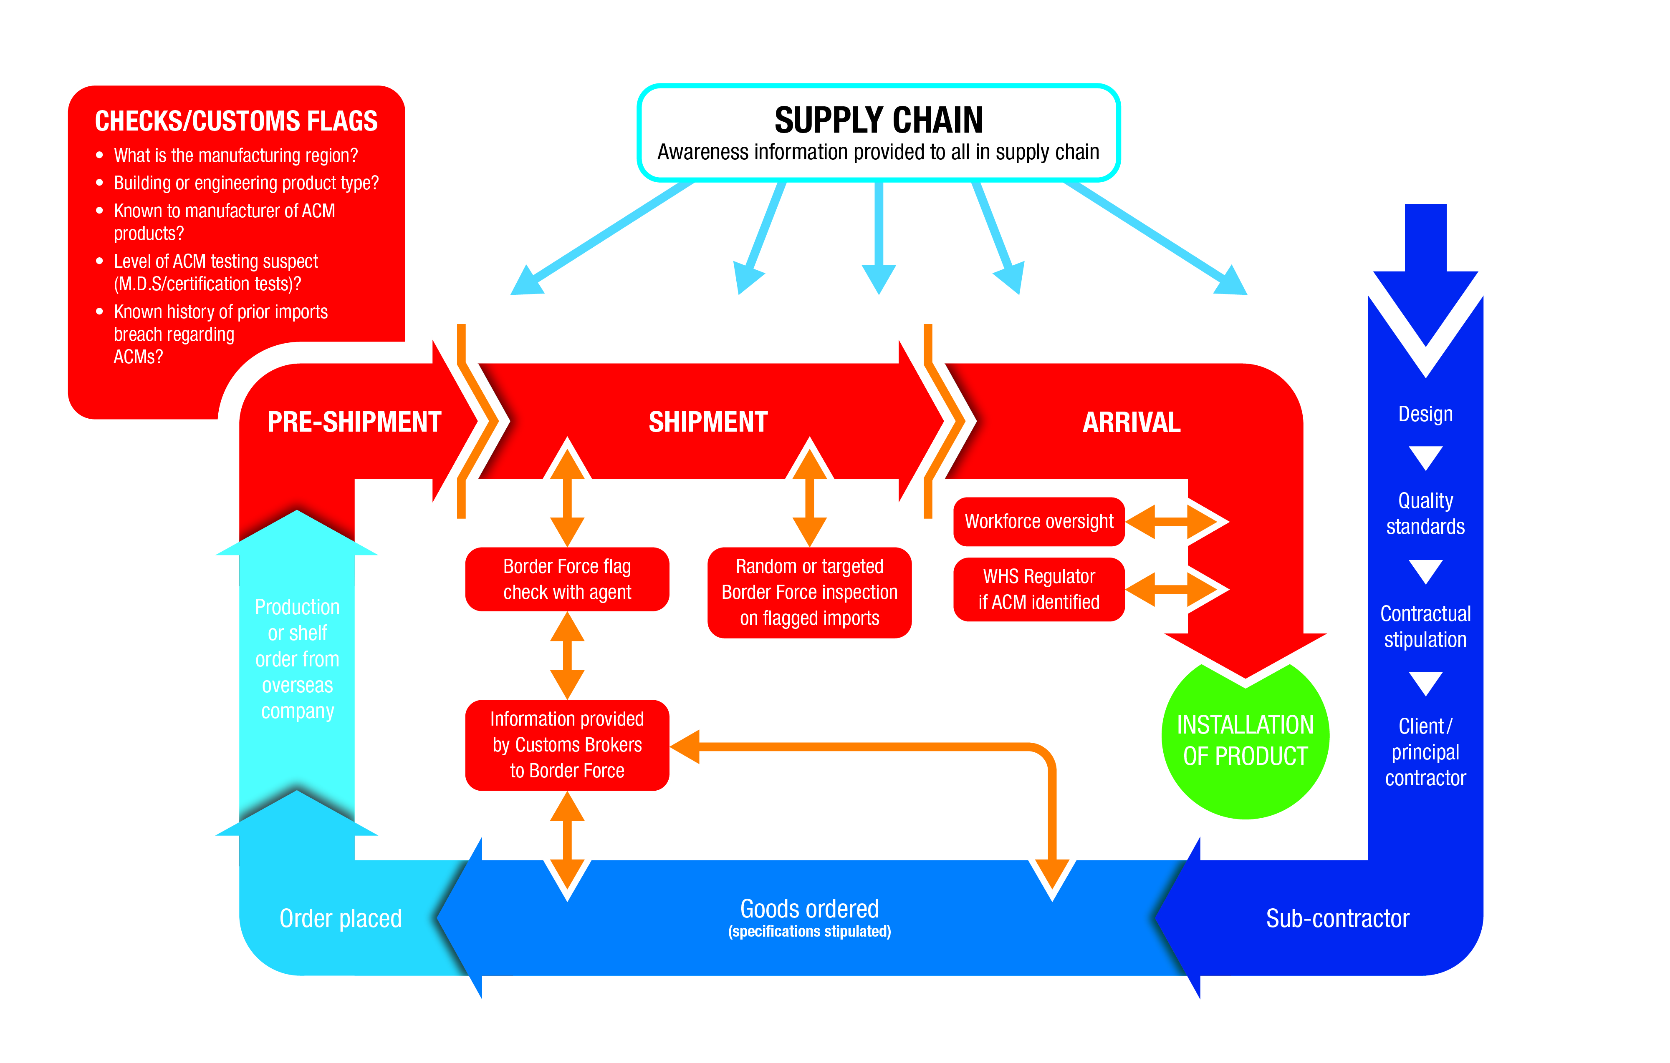

Asbestos in the community – natural disasters and infrastructure

The Australian community experienced a number of natural disasters in the 2016–17 year, one particular event in southern Sydney showing that disaster action plans and strategies are changing for the better when it comes to managing damaged property which contains asbestos.

In March 2017, Tropical Cyclone Debbie hit the north coast of Qld causing significant damage to property and its aftermath bring torrential rain and flooding to the east coast of Qld and NSW. A significant number of properties in coastal towns along the east coast of Australia were built using asbestos-cement ‘fibro’ sheeting so every natural disaster that occurs brings a new set of challenges in preventing exposure to that damaged asbestos.

Illegal dumping of asbestos material in the community

The media reporting of instances of illegal asbestos materials dumping in the community continued to be of concern to the agency, with a number of high-profile dumping events occurring across the country.

During the 2016–17 reporting year, the NSW Independent Commission Against Corruption conducted an investigation into illegal asbestos waste dumping involving alleged bribery of a NSW Government employee responsible for investigating these illegal dumping events. Allegations in this case included the Western Sydney Regional Illegal Dumping Squad officer soliciting bribes from people in return for not investigating their illegal asbestos dumping activities.

The ongoing activities of a serial illegal asbestos dumping offender in NSW were highlighted in the media during the reporting year, with reports that he has moved to Vic and operating a similar business in Melbourne. This serial offender has been found guilty in the NSW Land and Environment Court for illegally dumping asbestos more than a dozen times and has been ordered to clean up a number of sites and pay up to $500,000 in fines.

The agency will continue to monitor illegal dumping events to assist in the development of policy, with the assistance of the Asbestos Waste Working Group, regarding effective removal and disposal of asbestos-containing materials.

Asbestos in remote Indigenous communities

The agency published a report in May 2017 which received media attention, finding there are unique challenges with asbestos in remote Australian communities and that the cost of removing asbestos in remote areas can be up to three times higher than for other parts of the country.

Indigenous corporations and land councils have inherited ageing infrastructure that was full of asbestos-structures such as housing, churches and public buildings and they require targeted resources to deal with this legacy; in most cases the communities have limited resources and many other priorities to address.

The findings of this study have given remote communities and governments practical options to consider which can overcome the enormous obstacles to dealing with asbestos. The study has examined what works, and sets out effective ways to tackle this problem.

Section 6: Management and accountability

Corporate governance

The agency’s governance framework has its foundation in the ASEA Act,which established the agency and its functions, and the appointment of a CEO to ensure the agency performs these functions. The functions of the agency are set out in section 1 (Agency Overview) of this report.

The CEO is appointed by the Minister by written instrument for a period not exceeding five years and is responsible for the day-to-day administration of the agency. The CEO ensures the agency achieves its performance objectives in accordance with the [*National Strategic Plan for Asbestos Management and Awareness 2014–18*](http://www.asbestossafety.gov.au/national-strategic-plan) and the policies, programmes and performance requirements set out for internal governance purposes.

Agency staff members are responsible for ensuring that the CEO is provided with all necessary information to perform their management responsibilities and to keep the council briefed on agency operations.

The CEO is accountable to the Minister for Employment through the ASEA Act and the Minister for Finance in relation to the PGPA Act*,* which was the relevant legislation during the 2016–17 year.

The ASEA Act also established the council to provide guidance to the CEO about the performance of the agency’s functions and provide advice to the Minister regarding asbestos safety. The functions of the council are set out in section 2 (Asbestos Safety and Eradication Council) of this report.

External scrutiny

The Audit Committee held four meetings in the 2016–17 year, providing independent assurance and advice to the CEO on agency financial matters, including risk management. The Australian National Audit Office (ANAO) was again appointed to audit the agency’s 2016–17 financial statements.

No judicial or tribunal decisions that could have a significant impact on agency operations have been made or are pending.

No reports on the operations of the agency by the Auditor-General, a parliamentary committee or the Commonwealth Ombudsman have been released.

Management of human resources

On 30 June 2017, 16 people worked with the agency at various grade levels, 13 covering full-time ongoing, non-ongoing and three temporary employment arrangements, all based in Sydney, NSW. The agency did not have staff who identified as Indigenous during the year, but will seek opportunities to address the Australian Government Indigenous employment policy in the 2017–18 year and beyond if recruitment is required.

**Table 6**: Agency staff during the 2016–17 year

|  |  |  |  |  |  |  |  |  |
| --- | --- | --- | --- | --- | --- | --- | --- | --- |
| Class | Female | Male |  | Permanent FT/PT | Non-ongoing APS | Temporary/contract |  | Total |
| CEO |  | 1 |  | 1 |  |  |  | 1 |
| EL2 | 2 | 2 |  | 3 |  | 1 |  | 4 |
| EL1 | 1 | 3 |  | 4 |  |  |  | 4 |
| APS6 | 1 |  |  |  | 1 |  |  | 1 |
| APS5 | 4 | 2 |  |  | 4 | 2 |  | 6 |
| APS4 |  |  |  |  |  |  |  |  |
| total | 8 | 8 |  | 8 | 5 | 3 |  | 16 |

Learning and development

The agency provided learning and development opportunities for staff to support the functions of the agency, with staff attending various conferences and training programs throughout the year to supplement already acquired skills and knowledge.

The goal of approved learning and development was to enhance the skills base of the existing staff to minimise the need for external assistance, ensure compliance with regulatory requirements and operate with maximum efficiency as an independent agency.

Collective Determination

Formal separation of the agency from the Department of Employment came into effect on 17 November 2014 upon approval by the Minister for Employment of a collective determination under section 24(1) of the PS Act.

A Notice of Employee Representational Rights under the [*Fair Work Act 2009*](http://www.legislation.gov.au/Details/C2016C00785) was issued on 2 March 2016 to commence the process of developing an enterprise agreement to cover employees that are non-SES employees engaged under the PS Act in the agency. The agency anticipates the Asbestos Safety and Eradication Agency Enterprise Agreement will come into operation during the 2017–18 year.

Performance pay

Agency staff do not receive performance bonuses or performance pay. Non-SES staff were covered by the Department of Employment Enterprise Agreement 2012–14, which provided for pay increments as per the standard pay scale.

Work health and safety

The agency is committed to fostering a proactive and collaborative approach to the management of employee health, safety and wellbeing.

The agency has an elected health and safety representative who successfully completed the accredited training course, assuming the responsibilities of that position as set out in the [*Work Health and Safety Act 2011*](http://www.comlaw.gov.au/Details/C2015C00472) (WHS Act).

The agency also has a trained first aid officer with access to a first aid facility and a trained floor warden for emergency evacuation procedures.

Employee assistance programme

During part of the year, the agency had access to the services provided by Optum through the Department of Employment, which included providing staff with confidential and personalised counselling for personal and vocational/professional matters. The agency was in the process of transitioning to a new provider towards the end of the reporting year.

Ethical standards

The agency maintained its commitment to high ethical standards by reinforcing the Australian Public Service (APS) values and APS code of conduct.

Induction programs highlighted the importance of APS values and the code of conduct as a vehicle for instilling a positive, collaborative and professional workplace culture with the aim of establishing the agency as a leading APS employer.

During the 2016–17 year, there were no formal cases involving alleged breaches of the APS values or the APS code of conduct.

Mandatory reporting

Asset management

The agency’s asset management strategy emphasises whole-of-life asset management and seeks to minimise holdings of surplus and under-performing assets.

The agency’s stocktake of fixed and intangible assets in 2016–17 confirmed their location and condition, and emphasised to custodial officers their responsibility to ensure the safe-keeping of assets in their custody.

Details of the assets administered by the agency in 2016–17 can be found in section 7 (Financial statements).

Purchasing

In 2016–17, with the exception of those instances reported in its Certificate of Compliance, the agency complied with the Australian Government’s purchasing policies. Its procurement and purchasing activities were conducted in accordance with the Commonwealth Procurement Rules to ensure value for money, and efficient, effective, economical and ethical procurement outcomes.

Consultants

Due to the size of the agency, it is necessary to engage consultants to provide specialist expertise or independent research and to provide value for money. The decision to engage a consultant is made in accordance with the *PGPA Act* and regulations, and relevant agency and departmental policies.

In the 2016–17 year, 30 consultancy contracts were entered into. In addition, two ongoing consultancy contracts were active during 2016–17 year. The total actual expenditure related to these consultancy contracts was $1,470,311.33 (GST exclusive).

Information on the value of contracts and consultancies is available on the AusTender website at [www.tenders.gov.au](http://www.tenders.gov.au).

Prior to engaging consultants, the agency takes into account the skills and resources required for the task, the skills available internally, and the cost-effectiveness of engaging external expertise. Legal advice on consultancy arrangements is sought where relevant.

Grant programmes

Information on grants awarded by the Asbestos Safety and Eradication Agency during the period 1 July 2016 to 30 June 2017 is now available at [asbestossafety.gov.au/about-us](http://asbestossafety.gov.au/about-us).

Australian National Audit Office access clauses

All of the agency’s awarded contracts or Deeds of Standing Offer valued at $100,000 (GST inclusive) or greater, contain standard clauses granting the Auditor-General access to contractors’ premises.

Exempt contracts

The agency did not enter into any contracts in 2016–17 that have been exempted under the [*Freedom of Information Act 1982*](http://www.comlaw.gov.au/Details/C2015C00541) (FOI Act) from reporting on AusTender.

Advertising and market research

In accordance with section 311A of the [*Commonwealth Electoral Act 1918*](http://www.legislation.gov.au/Details/C2016C01022), the agency is required to report on all payments over $13,000 (GST inclusive) to advertising agencies, market research organisations, polling organisations, media advertising organisations, public relations organisations and direct mail organisations.

The total payment by the agency for market research during the 2016–17 reporting year was $13,085 (GST inclusive) paid to News Limited to advertise for the 2016 Asbestos Safety Conference in the Adelaide Advertiser.

**Procurement initiatives to support small business**

The agency supports small business participation in the Commonwealth Government procurements market. Small enterprise participation statistics are available on the Department of Finance’s website ([www.finance.gov.au/procurement/statistics-on-commonwealth-purchasing-contracts](http://www.finance.gov.au/procurement/statistics-on-commonwealth-purchasing-contracts/)). In supporting small business, the agency also uses the following:

* the Commonwealth Contracting Suite for low-risk procurements valued under $200,000
* Australian Industry Participation Plans in whole-of-government procurement where applicable
* the Small Business Engagement Principles (outlined in the Government’s Industry Innovation and Competitiveness Agenda), such as communicating in clear, simple language and presenting information in an accessible format
* electronic systems or other processes used to facilitate on-time payment performance, including the use of payment cards.

The agency also recognises the importance of ensuring that small businesses are paid on time. The results of the survey of Australian Government Payments to Small Business are available on the Treasury’s website ([www.treasury.gov.au](http://www.treasury.gov.au/)).

Ecologically sustainable development and environmental performance

The agency has considered and applied the principles of ecological and environmental sustainability to all of its projects and operations during the reporting period.

Projects included adhering to already established departmental policies and specifications regarding sustainability and preference for dissemination of the agency’s public reports through electronic media.

The agency accommodation is located in the NSW state office for a number of Australian Government departments and agencies, which enjoys a five-star NABERS rating on energy efficiency, water usage, waste management and indoor environment quality of a building or tenancy and its impact on the environment. More information regarding the NABERS rating system for buildings can be found on their website ([www.nabers.gov.au](http://www.nabers.gov.au)).

Information publication scheme statement

Agencies subject to the [*Freedom of Information Act 1982*](http://www.comlaw.gov.au/Details/C2015C00541) (FOI Act) are required to publish information to the public as part of the Information Publication Scheme (IPS). This requirement is in Part II of the FOI Act and has replaced the former requirement to publish a section 8 statement in an annual report. Each agency must display on its website a plan showing what information it publishes in accordance with the IPS requirements. The agency’s current IPS information can be found at [www.asbestossafety.gov.au/publications](http://asbestossafety.gov.au/publications)

Changes to disability reporting in annual reports

Since 1994, Commonwealth non-corporate entities have reported on their performance as policy adviser, purchaser, employer, regulator and provider under the Commonwealth Disability Strategy. In 2007–08, reporting on the employer role was transferred to the Australian Public Service Commission’s *State of the Service Report* and the *APS Statistical Bulletin*. These reports are available at [www.apsc.gov.au](http://www.apsc.gov.au). From 2010–11, entities have no longer been required to report on these functions.

The Commonwealth Disability Strategy has been overtaken by the National Disability Strategy 2010–2020, which sets out a 10-year national policy framework to improve the lives of people with disability, promote participation and create a more inclusive society. A high-level two-yearly report will track progress against each of the six outcome areas of the strategy and present a picture of how people with disability are faring. The first of these reports was made available in late 2014 and can be found at [www.dss.gov.au](http://www.dss.gov.au).

Section 7: Financial statements

Overview of financial performance

The agency had an overspend of $107,000 at the end of the 2016–17 financial year which is 2.3 per cent of total appropriation ($4,603,000) for the reporting year.

Independent auditors report

Statement by Chief Executive Officer and Chief Financial Officer

In our opinion, the attached financial statements for the year ended 30 June 2017 comply with subsection 42(2) of the [*Public Governance, Performance and Accountability Act 2013*](http://www.legislation.gov.au/Details/C2016C00414) (PGPA Act), and are based on properly maintained financial records as per subsection 41(2) of the PGPA Act.

In our opinion, at the date of this statement, there are reasonable grounds to believe that the Asbestos Safety and Eradication Agency will be able to pay its debts as and when they fall due.

|  |  |
| --- | --- |
| Signed | Signed |
| **Nick Miller**  **Chief Executive Officer (acting)**  3 October 2017 | **Shane McArdle**  **Chief Financial Officer (acting)**  3 October 2017 |

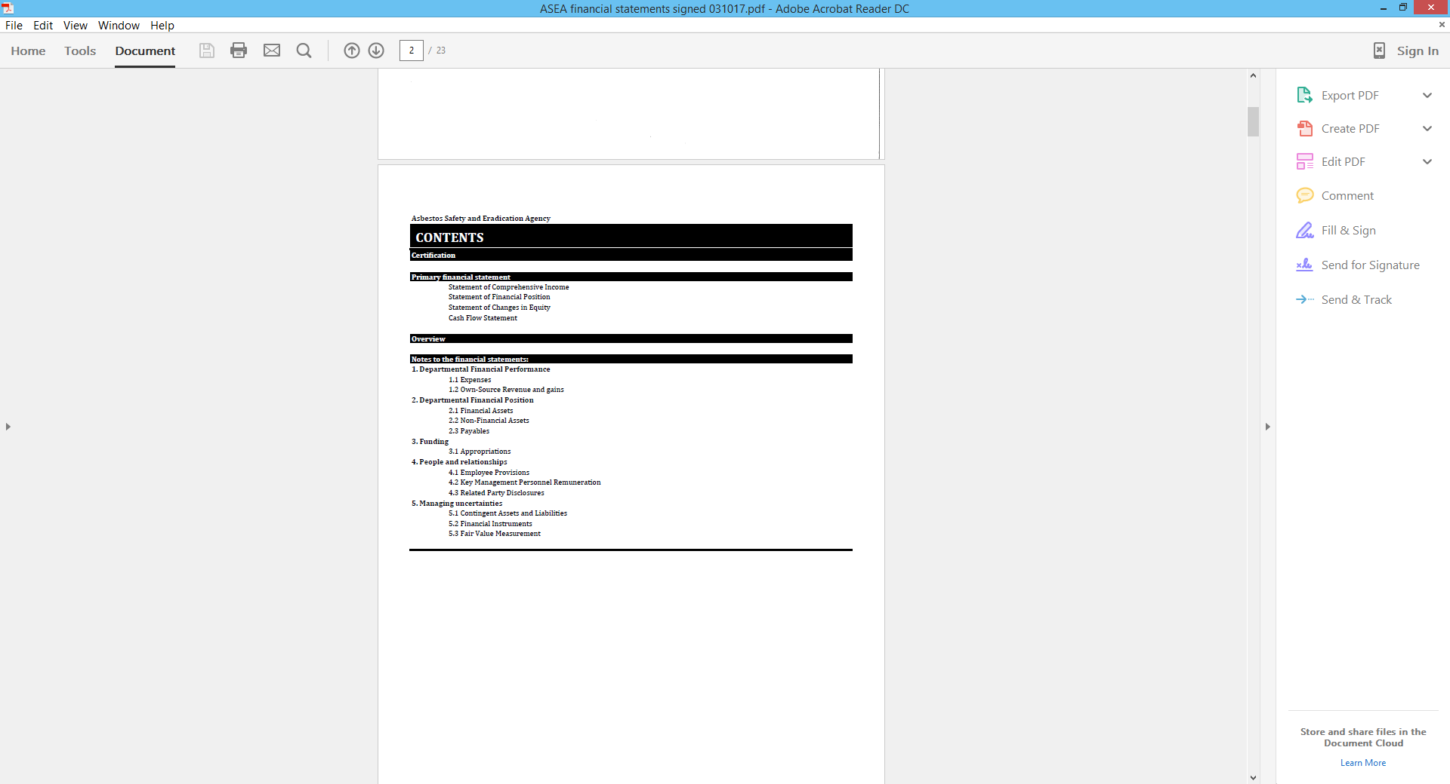

Financial statements

**Asbestos Safety and Eradication Agency**

**STATEMENT OF COMPREHENSIVE INCOME**

*for the period ended 30 June 2017*

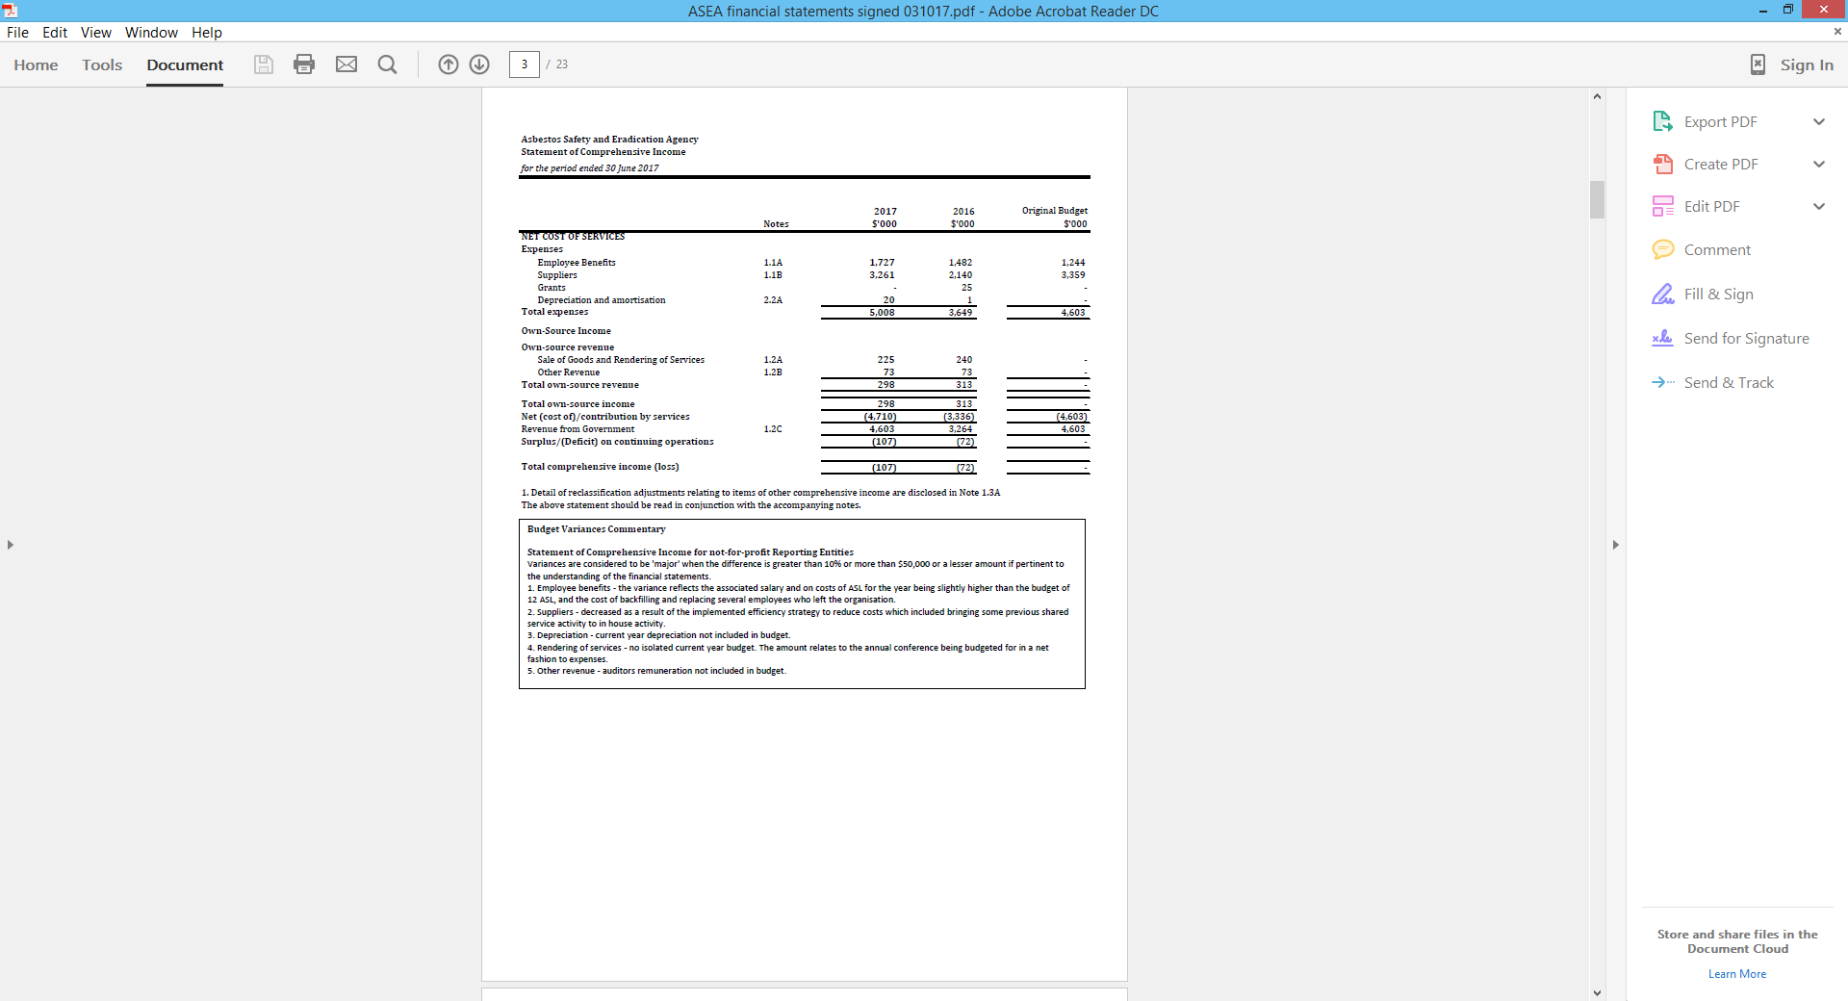

**Asbestos Safety and Eradication Agency**

**STATEMENT OF FINANCIAL POSITION**

*for the period ended 30 June 2017*

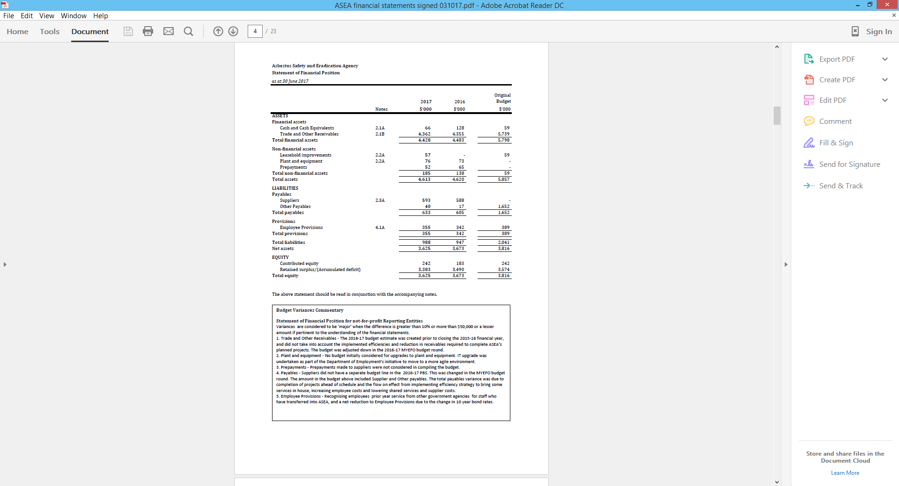

**Asbestos Safety and Eradication Agency**

**STATEMENT OF CHANGES IN EQUITY**

*for the period ended 30 June 2017*

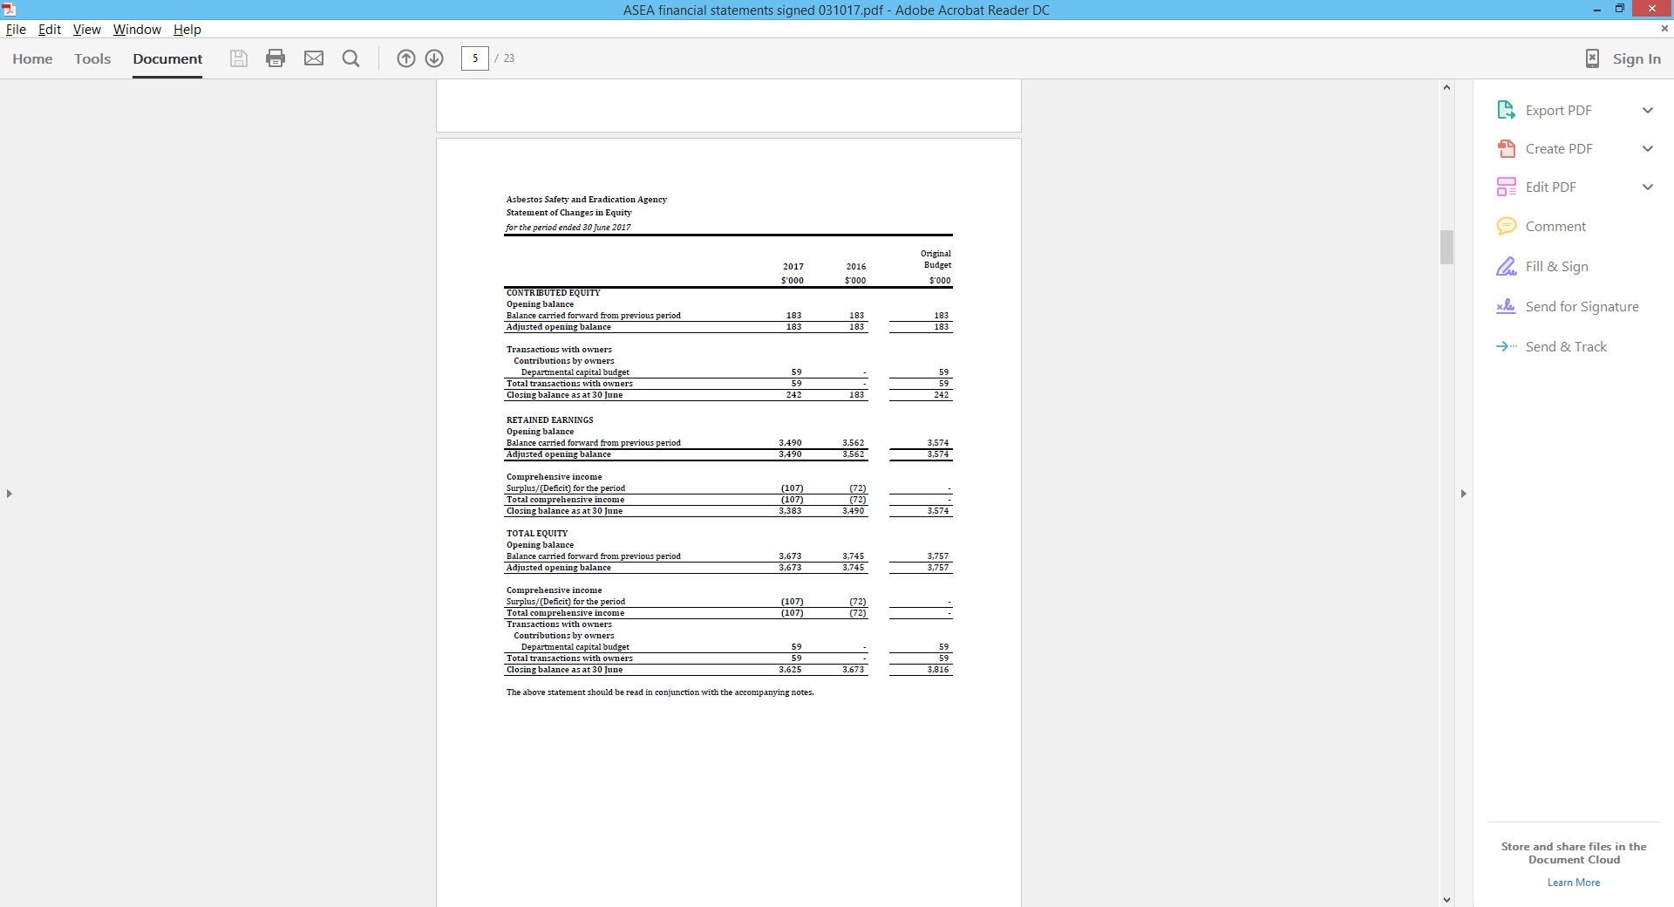

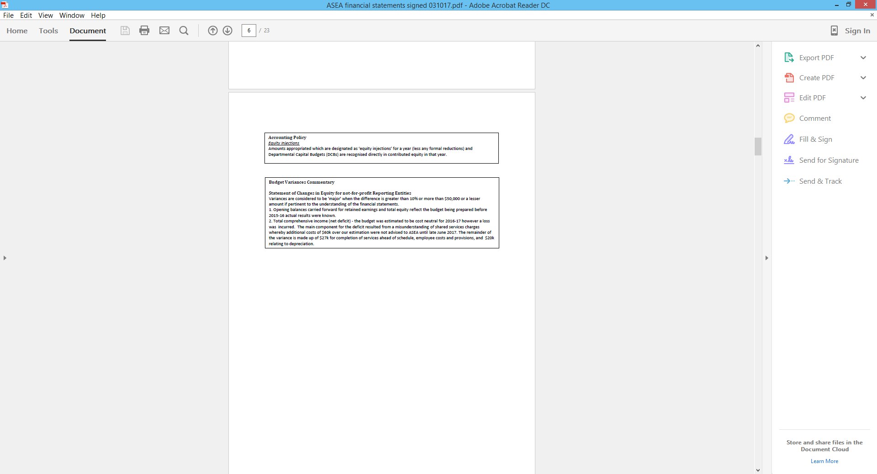

**Asbestos Safety and Eradication Agency**

**CASH FLOW STATEMENT**

*for the period ended 30 June 2017*

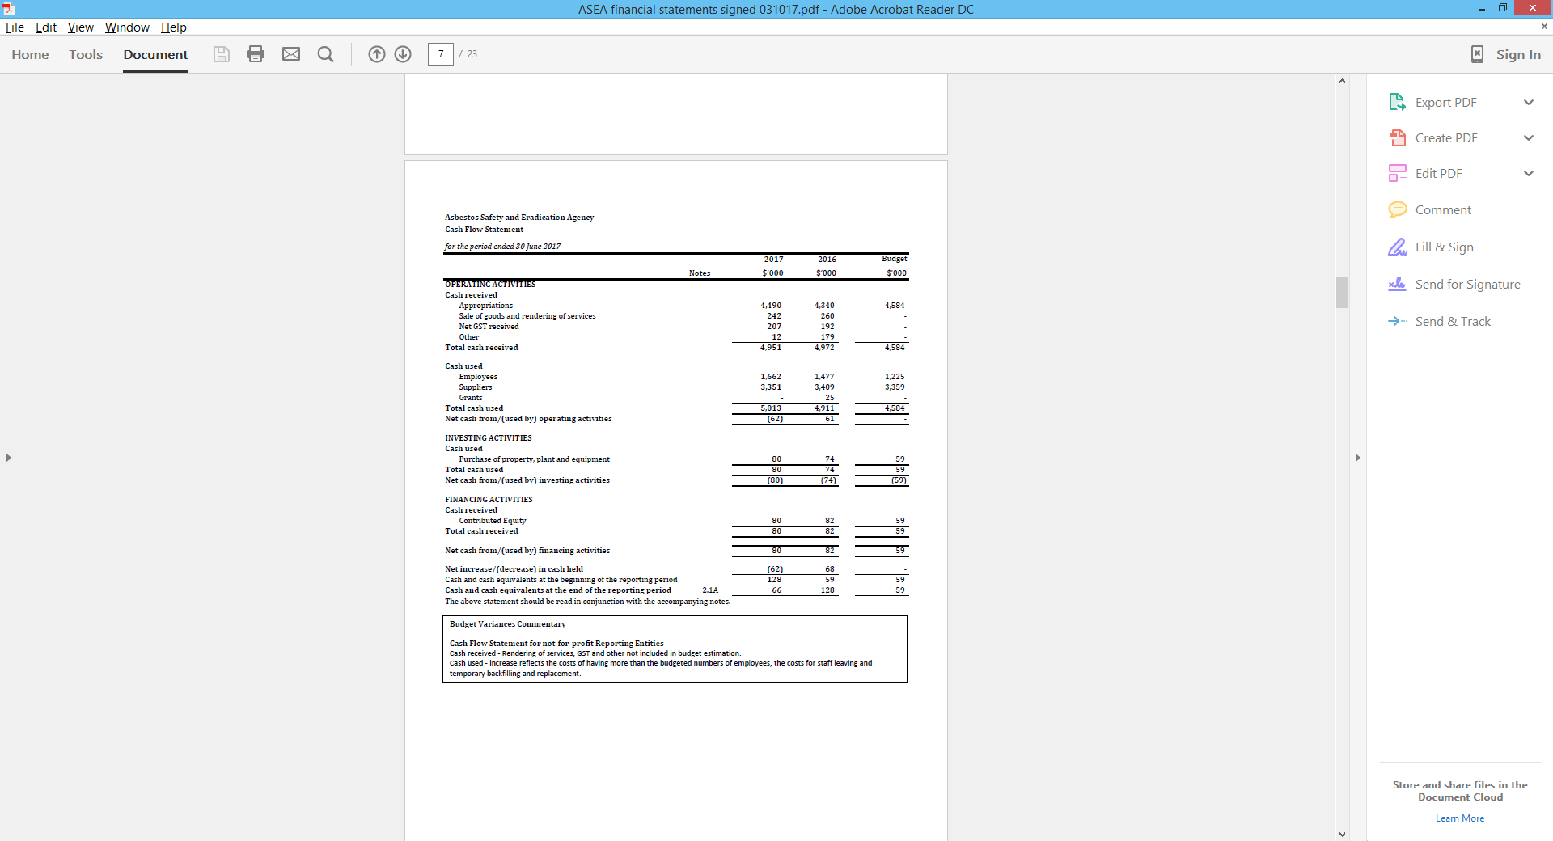

**Asbestos Safety and Eradication Agency**

**OVERVIEW**

*Objectives of the Asbestos Safety and Eradication Agency*

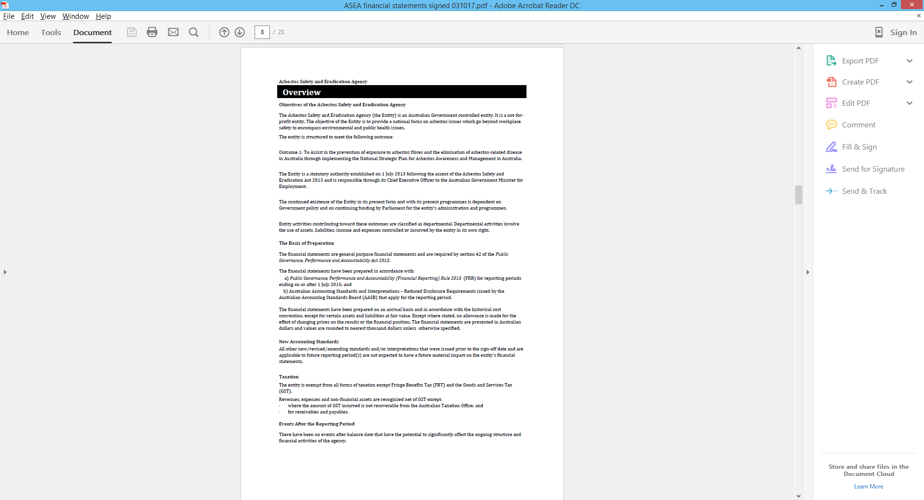

**Asbestos Safety and Eradication Agency**

**Financial Performance**

**1.1 Expenses**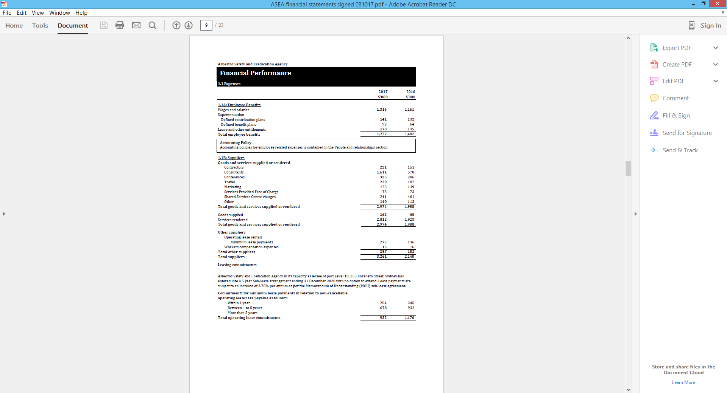

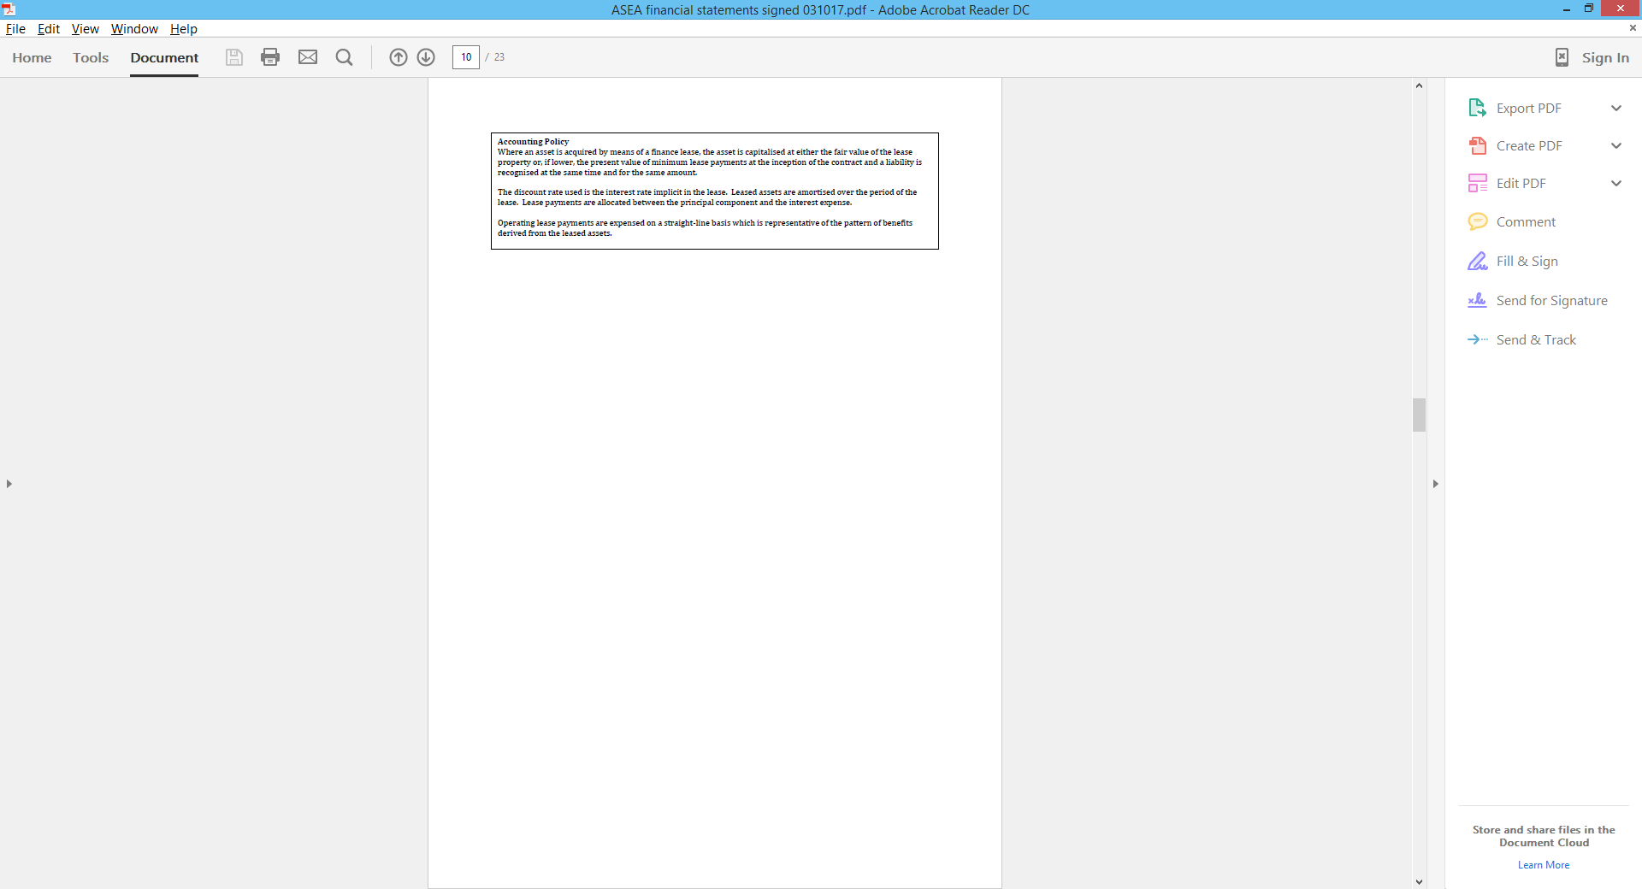

**Asbestos Safety and Eradication Agency**

**FINANCIAL PERFORMANCE**

**1.2 Own Source revenue and gains**

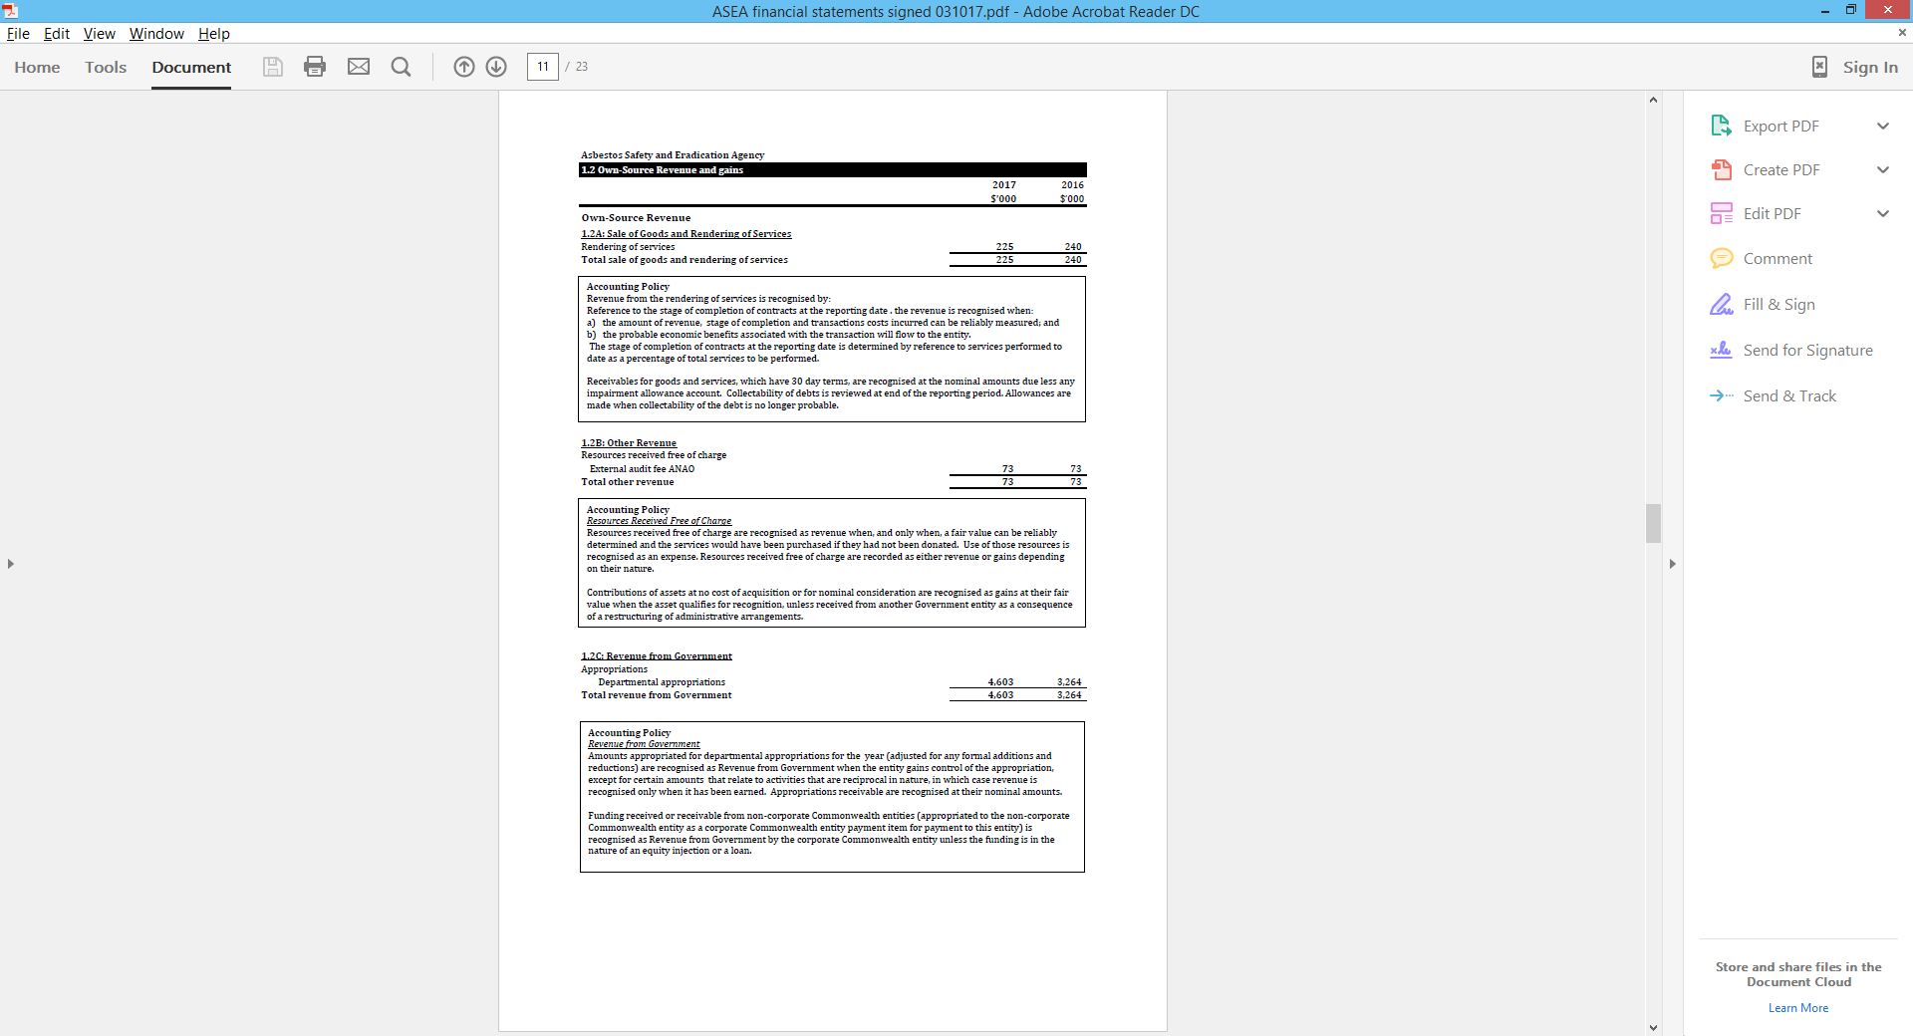

**Asbestos Safety and Eradication Agency**

**FINANCIAL POSITION**

**2.1 Financial Assets**

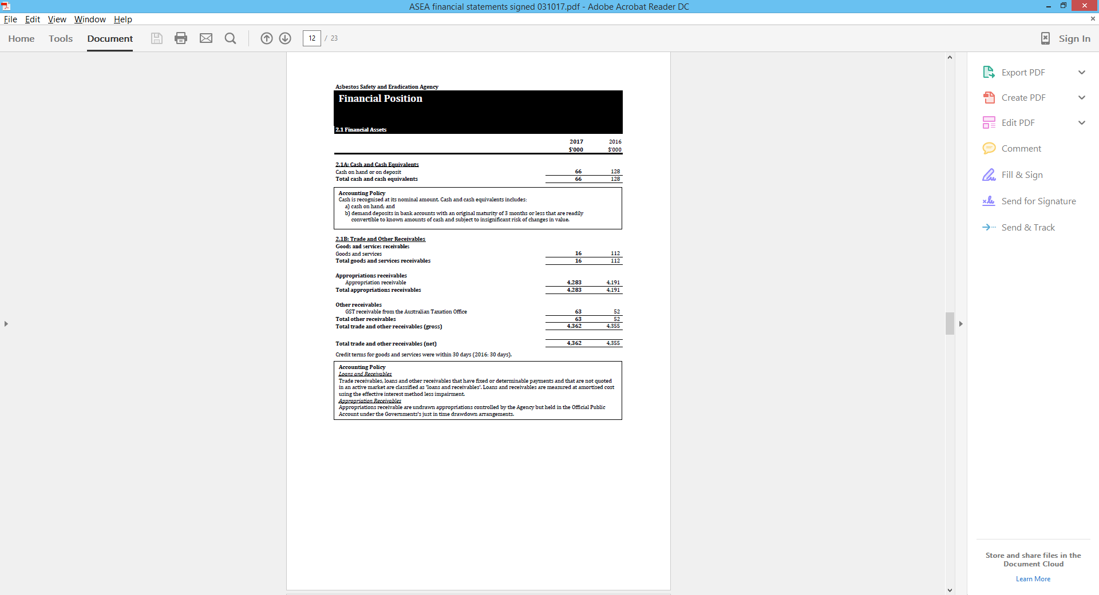

**Asbestos Safety and Eradication Agency**

**FINANCIAL POSITION**

**2.2 Non-financial assets**

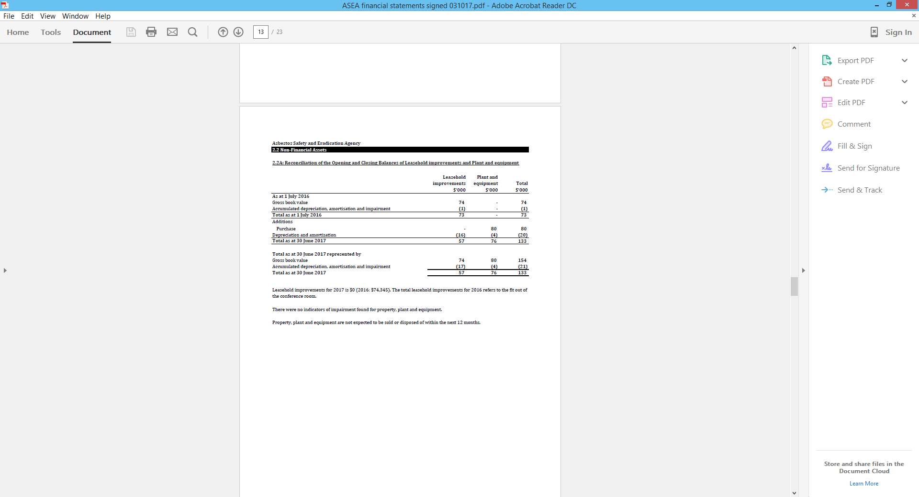

**Asbestos Safety and Eradication Agency**

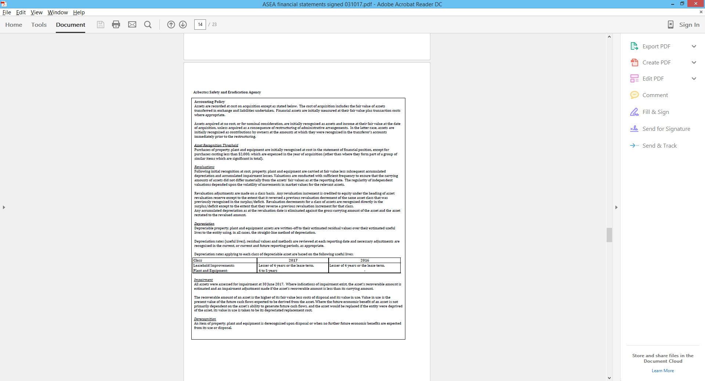

**Asbestos Safety and Eradication Agency**

**FINANCIAL POSITION**

**2.3 Payables**

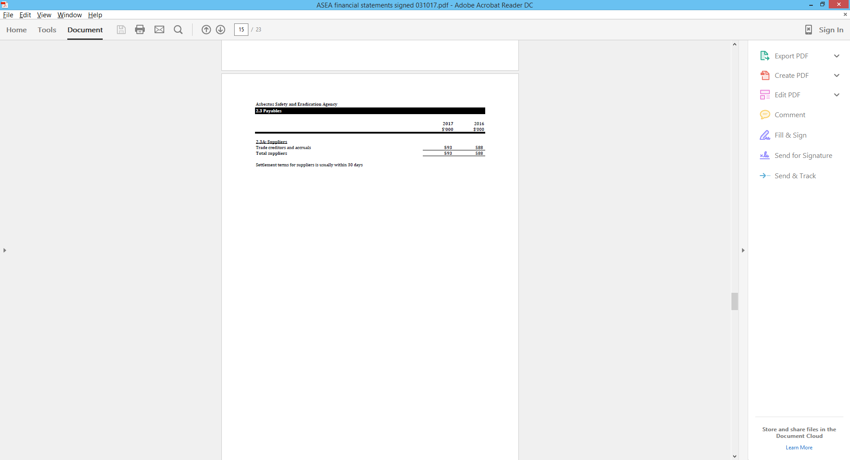

**Asbestos Safety and Eradication Agency**

**FUNDING**

**3.1 Appropriations**

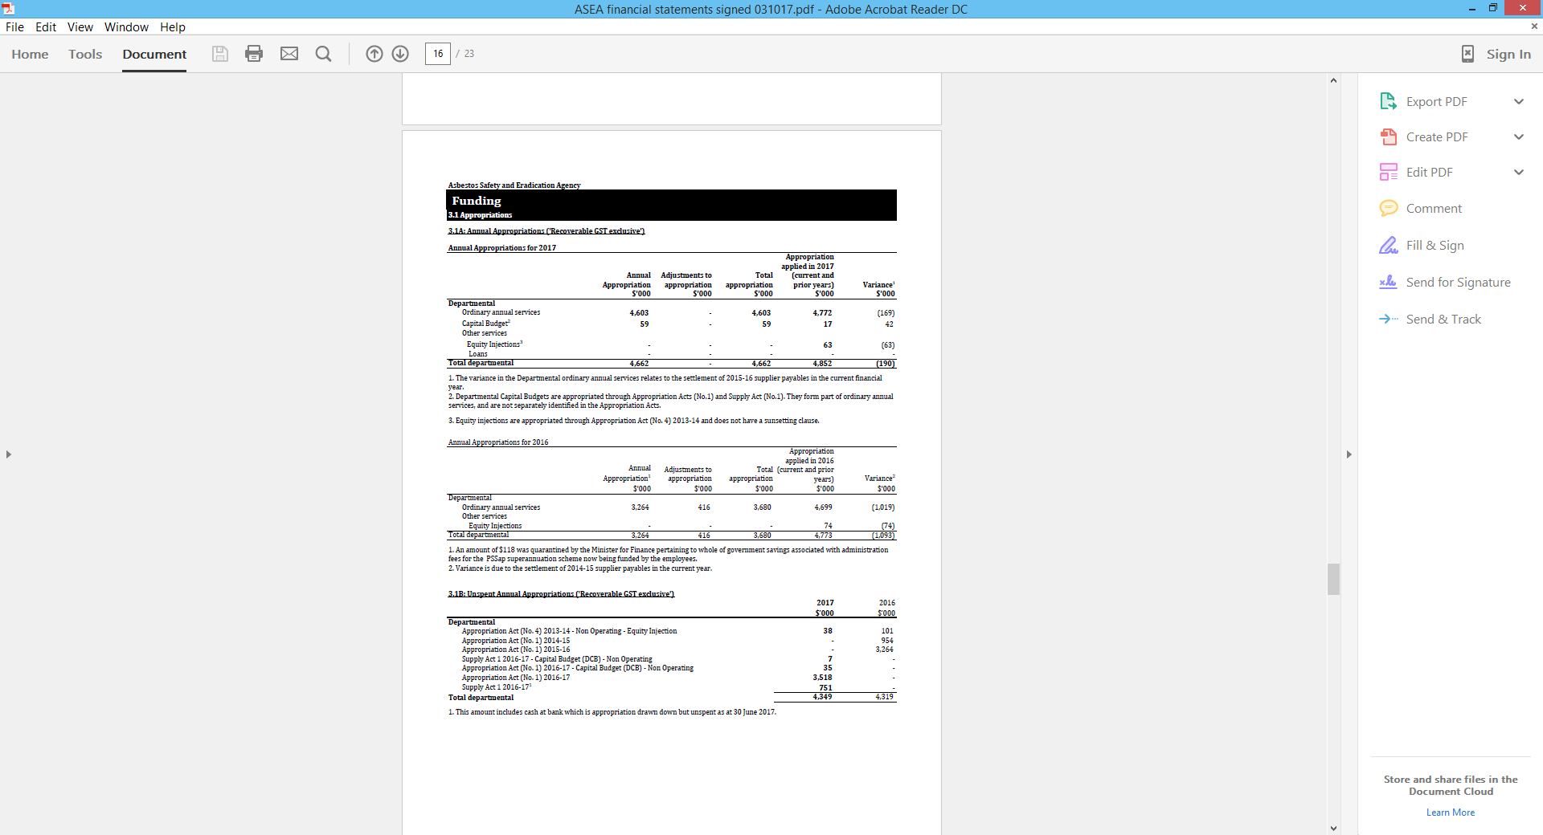

**Asbestos Safety and Eradication Agency**

**PEOPLE AND RELATIONSHIPS**

**4.1 Employee provisions**

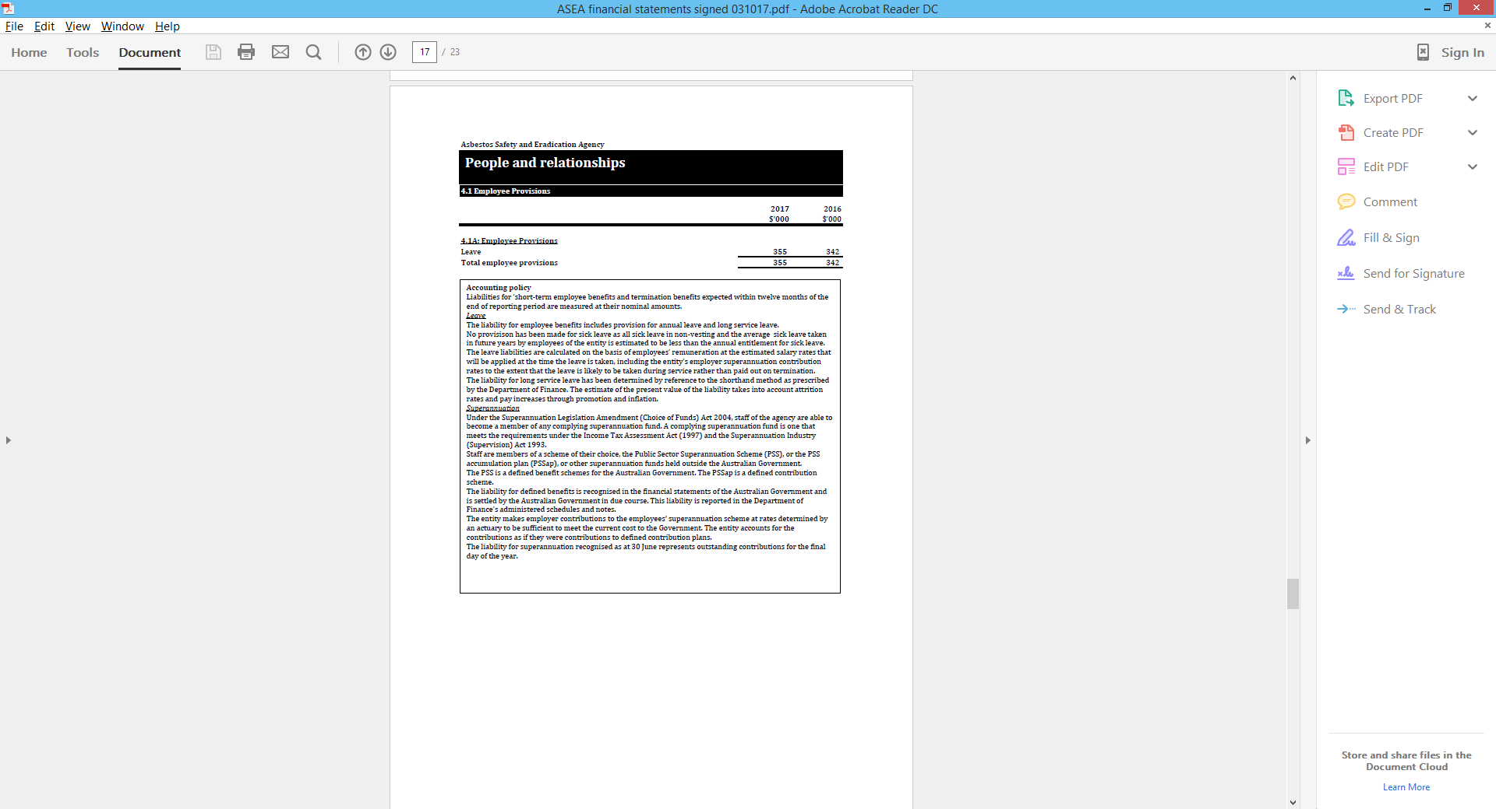

**Asbestos Safety and Eradication Agency**

**PEOPLE AND RELATIONSHIPS**

**4.2 Key management personnel remuneration**

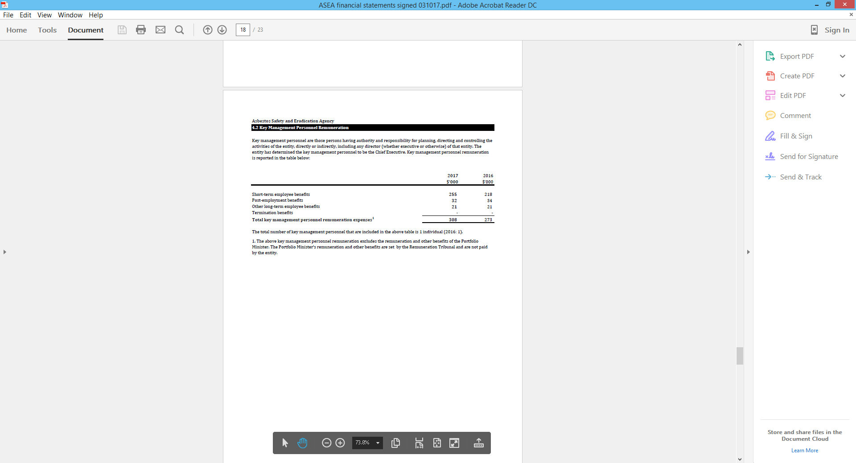

**Asbestos Safety and Eradication Agency**

**PEOPLE AND RELATIONSHIPS**

**4.3 Related party disclosures**

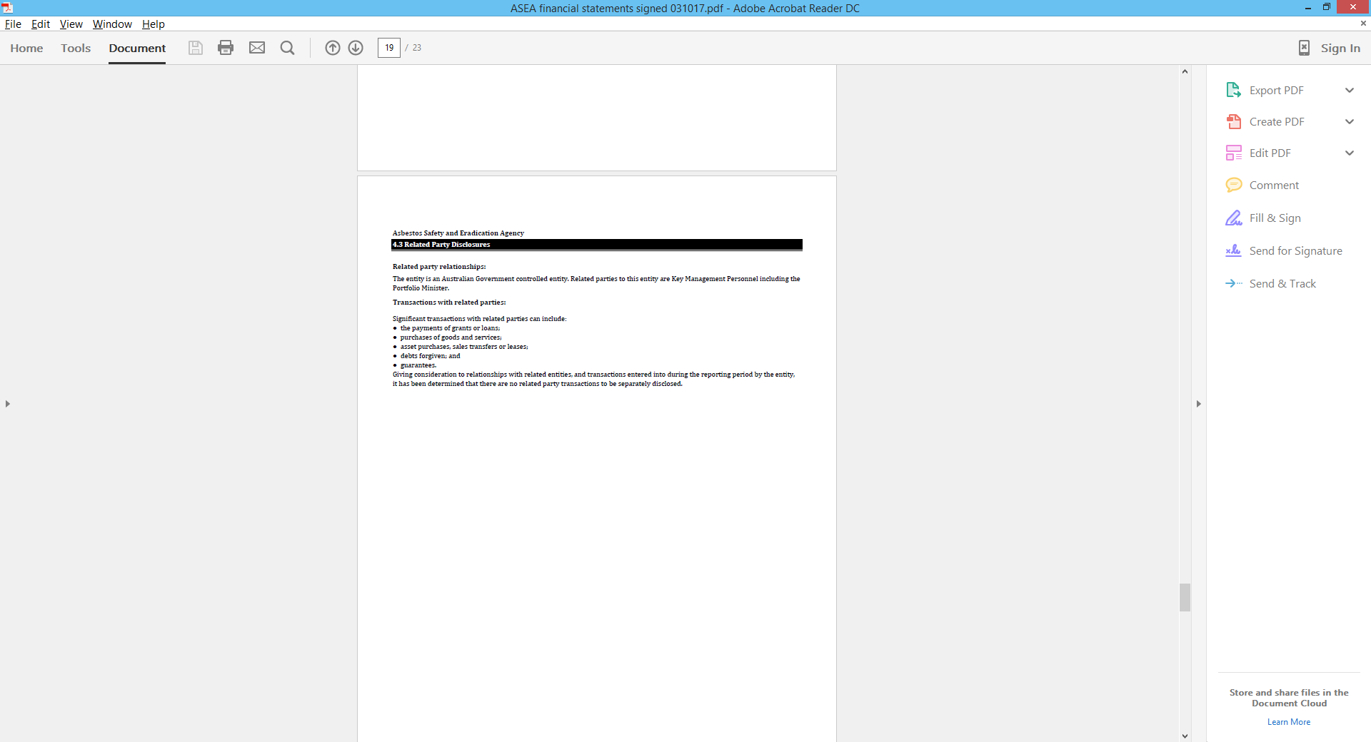

**Asbestos Safety and Eradication Agency**

**MANAGING UNCERTAINTIES**

**5.1 Contingent assets and liabilities**

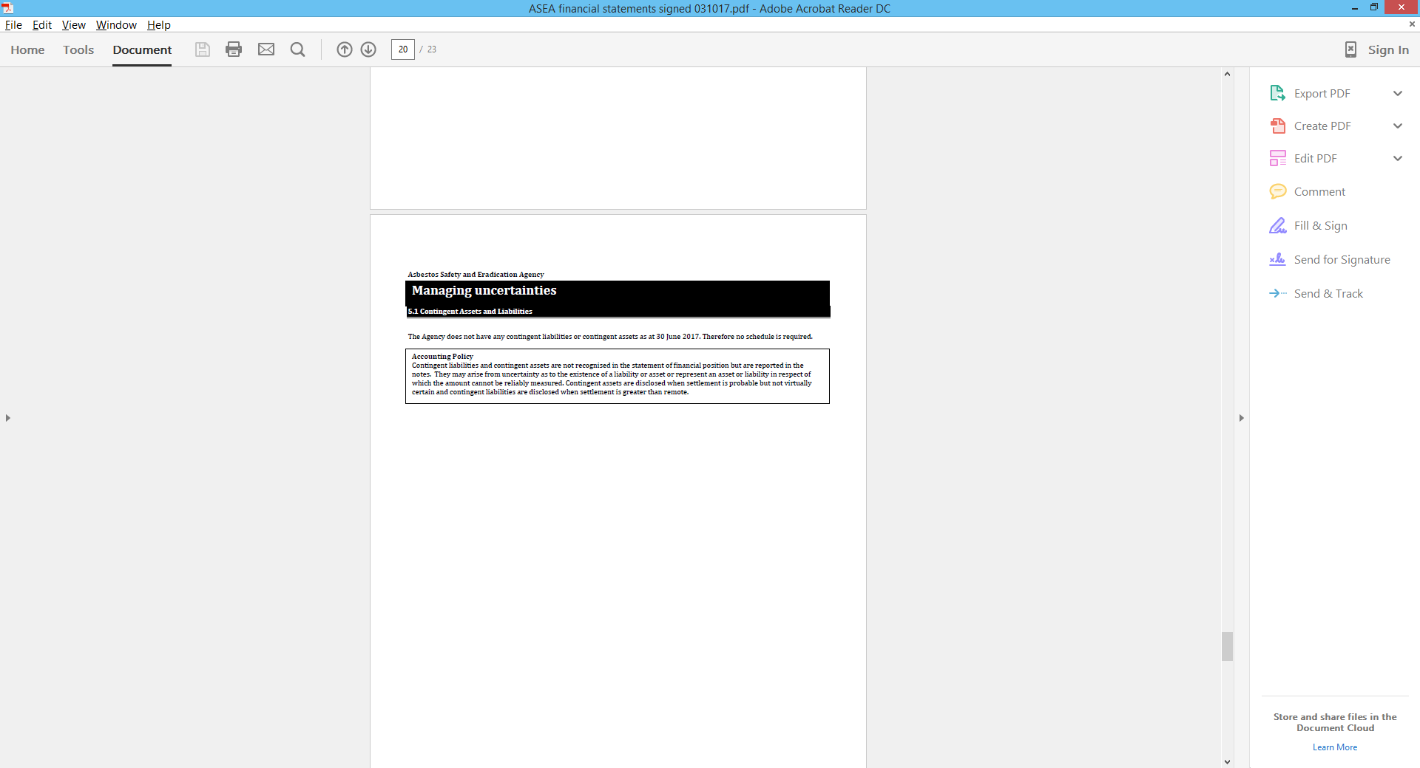

**Asbestos Safety and Eradication Agency**

**MANAGING UNCERTAINTIES**

**5.2 Financial instruments**

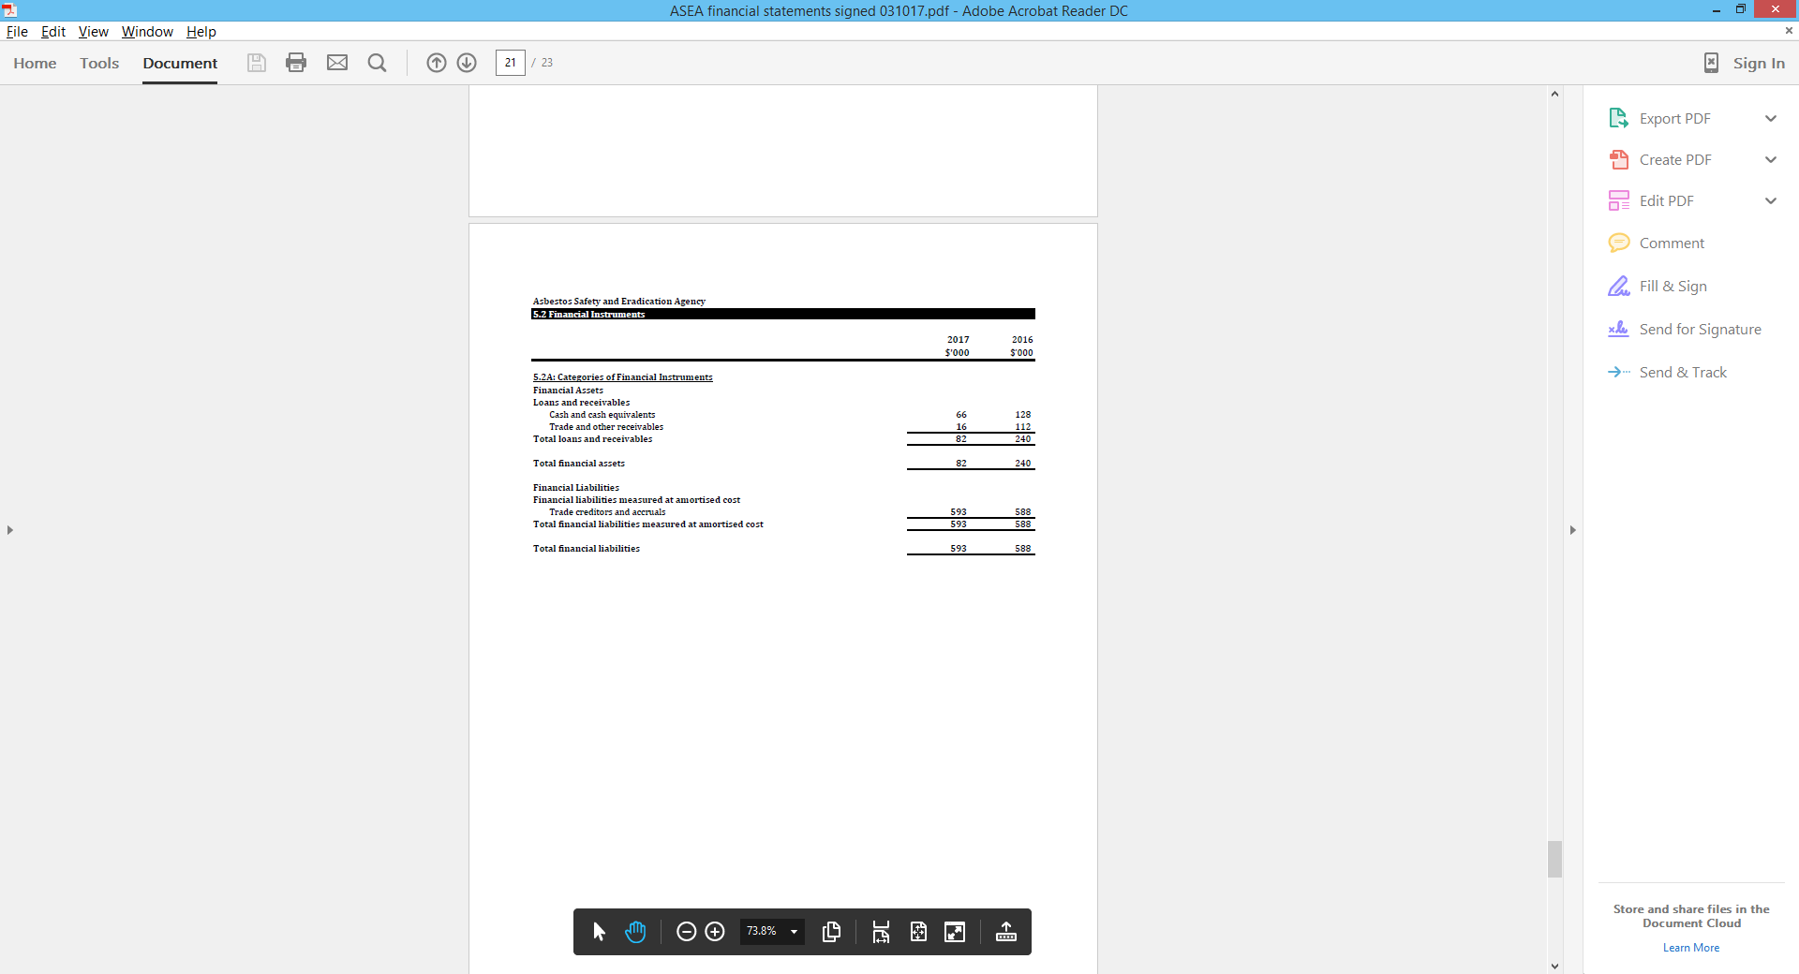

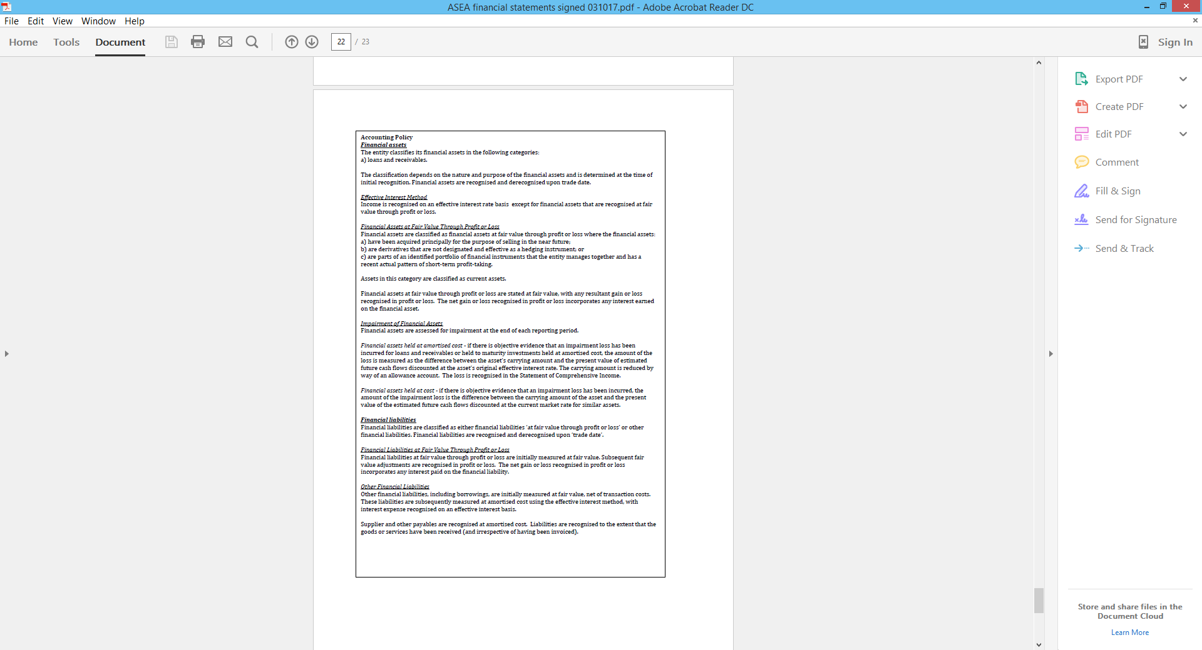

**Asbestos Safety and Eradication Agency**

**MANAGING UNCERTAINTIES**

**5.3 Fair value measurement**

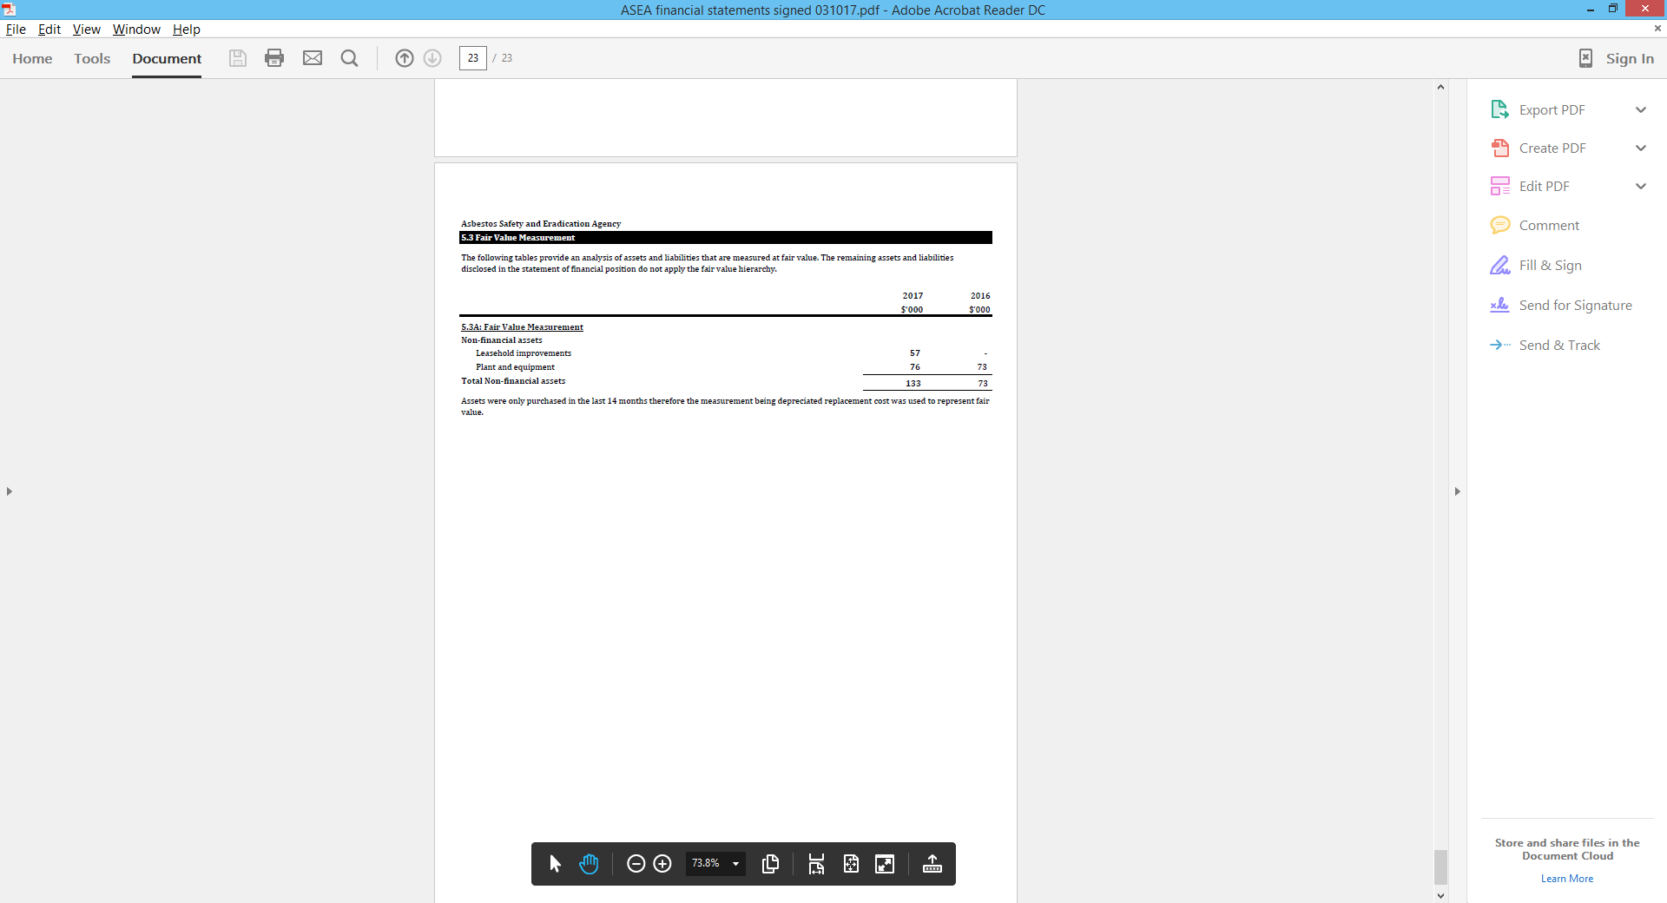

Appendices

Agency engagements and consultations

| **Date of event** | **Location** | **Organisation** | **Type** |
| --- | --- | --- | --- |
| **July 2016** |  |  |  |
| 07 Jul 16 | Sydney | Health Canada – Asbestos ban in Canada | Teleconference |
| 08 Jul 16 | Tweed Heads | Asbestosis and Mesothelioma Association of Australia | Meeting |
| 15 Jul 16 | Sydney | Heads of Workplace Safety Authorities Imported Materials containing Asbestos Working Group | Teleconference |
| 18 Jul 16 | Sydney | Building, Construction and Demolition Sectors Committee | Meeting |
| 19 Jul 16 | Sydney | Department of Employment | Meeting |
| 20 Jul 16 | Sydney | EY Sweeney – briefing on results of 2016 National Survey | Meeting |
| 26 Jul 16 | Sydney | Asbestos Safety and Eradication Council | Meeting |
| **August 2016** |  |  |  |
| 05 Aug 16 | Sydney | Heads of Workplace Safety Authorities Imported Materials containing Asbestos Working Group | Teleconference |
| 09 Aug 16 | Sydney | Research Advisory Committee | Meeting |
| 16 Aug 16 | Sydney | Union Aid Abroad – APHEDA, projects update | Meeting |
| 18 Aug 16 | Sydney | Steering Committee – Project to strengthen asbestos-related training materials in the utilities sector | Meeting/  Teleconference |
| 19 Aug 16 | Sydney | WorkSafe New Zealand | Teleconference |
| 23 Aug 16 | Canberra | Department of Immigration and Border Protection | Meeting |
| 26 Aug 16 | Adelaide | South Australian Asbestos Coalition | Meeting |
| 26 Aug 16 | Adelaide | SafeWork South Australia | Meeting |
| 29 Aug 16 | Sydney | Steering Committee – Project to strengthen asbestos-related training materials in the utilities sector | Meeting/  Teleconference |
| **September 2016** |  |  |  |

|  |  |  |  |
| --- | --- | --- | --- |
| 07 Sep 16 | Sydney | Safety in Action Conference – Asbestos Safety in an Disaster | Presentation |
| 14 Sep 16 | Sydney | Brian Miller Construction Safety Forum | Presentation |
| 18–20 Sep 16 | Alice Springs | Public Health Association of Australia – Annual Conference and Chronic Disease Conference | Conference |
| 22 Sep 16 | Sydney | NSW Independent Commission Against Corruption – Illegal asbestos dumping | Meeting |
| 27 Sep 16 | Sydney | Centre for Social Impact, Swinburne University of Technology | Meeting |
| 30 Sep 16 | Sydney | Heads of Workplace Safety Authorities (HWSA) Imported Materials containing Asbestos Working Group | Teleconference |
| **October 2016** |  |  |  |
| 6–8 Oct 16 | Melbourne | Customs Brokers and Forwarders Council of Australia | Conference |
| 6–8 Oct 16 | Adelaide | Housing Industry Association Home Show | Exhibition |
| 11 Oct 16 | Sydney | Building, Construction and Demolition Sectors Committee | Meeting |
| 19 Oct 16 | Canberra | Education and Employment Legislation Committee - Senate Estimates | Hearing |
| 21 Oct 16 | Sydney | South East Asian Ban Asbestos Network – pre-conference briefing and Rotterdam Convention | Teleconference |
| 24 Oct 16 | Sydney | Asbestos Policy and Regulation Interdepartmental Committee | Teleconference |
| 25 Oct 16 | Sydney | Asbestos Safety and Eradication Council | Meeting |
| 27 Oct 16 | Adelaide | Safe Work Month (Illegal importation of asbestos – what can be done?) | Address |
| **November 2016** |  |  |  |
| 1–5 Nov 16 | Jakarta, Indonesia | South East Asian Ban Asbestos Network – presentation and attendance | Meeting |
| 08 Nov 16 | Gold Coast | E-Oz and Skills Oz conference | Presentation |
| 09 Nov 16 | Sydney | NSW Heads of Asbestos Coordination Authorities review | Teleconference |
| 09 Nov 16 | Sydney | SafeWork NSW | Meeting |
| 10 Nov 16 | Sydney | National Electrical and Communications Association – Workplace Health and Safety Seminar | Presentation |
| 13/15 Nov 16 | Adelaide | 3rd International Conference on Asbestos Awareness and Management | Conference |
| 17 Nov 16 | Sydney | Delegation from Royal Government of Cambodia | Meeting |
| 18 Nov 16 | Sydney | Heads of Workplace Safety Authorities Imported Materials containing Asbestos Working Group | Teleconference |
| 21 Nov 16 | Sydney | NSW Heads of Asbestos Coordination Authorities state-wide consultation | Teleconference |
| 21 Nov 16 | Sydney | Bernie Banton Day – Asbestos Awareness Week memorial | Function |
| 25 Nov 16 | Sydney | Asbestos Disease Foundation of Australia – Asbestos Awareness Week memorial | Function |
| 31 Nov 16 | Sydney | WorkSafe Tasmania – awareness of asbestos in residential sector | Meeting |
| **December 2016** |  |  |  |
| 01 Dec 16 | Canberra | Parliamentary Group on Asbestos-Related Disease | Presentation |
| 5–6 Dec 16 | Gold Coast | Australian Institute of Occupational Hygienists conference | Conference |
| 09 Dec 16 | Sydney | WorkSafe New Zealand | Teleconference |
| 13 Dec 16 | Sydney | Interdepartmental Meeting – Rotterdam Convention (lead by Department of Environment) | Teleconference |
| 15 Dec 16 | Sydney | Asbestos Policy and Regulation Interdepartmental Committee | Teleconference |
| 16 Dec 16 | Sydney | Secretariat of the Pacific Regional Environment Programme – Asbestos in the South Pacific | Meeting |
| 20 Dec 16 | Sydney | Victorian School Building Authority – School asbestos removal program | Teleconference |
| **January 2017** |  |  |  |
| 06 Jan 17 | Sydney | Heads of Workplace Safety Authorities Imported Products Containing Asbestos Working Group | Teleconference |
| 18 Jan 17 | Sydney | NSW Government regarding international leadership (Indonesia) | Meeting |
| 19 Jan 17 | Sydney | National Asbestos Awareness Campaign – planning | Meeting |
| 25 Jan 17 | Adelaide | South Australian Asbestos Coalition | Meeting |
| 30 Jan 17 | Sydney | Heads of Workplace Safety Authorities Imported Products Containing Asbestos Working Group | Teleconference |
| **February 2017** |  |  |  |
| 02 Feb 17 | Sydney | Global Asbestos Action Alliance – Rotterdam Convention Conference of the Parties planning | Videoconference |
| 02 Feb 17 | Sydney | Heads of Workplace Safety Authorities Imported Products Containing Asbestos Working Group | Teleconference |
| 07 Feb 17 | Canberra | Senator Lisa Singh - Parliamentary Group on Asbestos-Related Disease | Meeting |
| 13 Feb 17 | Sydney | South East Asian Ban Asbestos Network – planning for Rotterdam Convention Conference of the Parties | Teleconference |
| 15 Feb 17 | Sydney | Asbestos Support Group Network Sub-Group – National Asbestos Awareness Week planning | Teleconference |
| 21 Feb 17 | Sydney | Building, Construction and Demolition Sectors Committee | Meeting |
| 23 Feb 17 | Sydney | Asbestos Safety and Eradication Council | Meeting |
| 24 Feb 17 | Adelaide | South Australian Asbestos Coalition | meeting |
| **March 2017** |  |  |  |
| 02 Mar 17 | Canberra | Education and Employment Legislation Committee – Senate Estimates | Hearing |
| 06 Mar 17 | Sydney | Professor Ken Takahashi – Director, Asbestos Disease Research Institute | Meeting |
| 06 Mar 17 | Sydney | Union Aid Abroad - APHEDA | Meeting |
| 09 Mar 17 | Sydney | Asbestos Policy and Regulation Interdepartmental Committee | Teleconference |
| 14 Mar 17 | Sydney | Construction and Engineering breakfast – Asbestos (and other non-conformities) in new building products | Seminar |
| 14 Mar 17 | Sydney | Rotterdam Convention Conference of the Parties stakeholders meeting | Videoconference |
| 14 Mar 17 | Sydney | Asbestos Support Group Network | Teleconference |
| 17 Mar 17 | Sydney | Rotterdam Convention Conference of the Parties stakeholders meeting | Videoconference |
| 21 Mar 17 | Sydney | Asbestos Disease Research Institute – Events and Patient Education Day | Meeting |
| 28 Mar 17 | Sydney | Rotterdam Convention Conference of the Parties stakeholders meeting | Videoconference |
| 29 Mar 17 | Sydney | Technical Research Advisory Committee | Meeting |
| **April 2017** |  |  |  |
| 4–5 Apr 17 | Melbourne | 15th World Congress on Public Health | Presentation |
| 19 Apr 17 | Sydney | Lesley Onyon, World Health Organisation | Meeting |
| 20 Apr 17 | Sydney | Rotterdam Convention Conference of the Parties stakeholders meeting | Videoconference |
| 26 Apr 17 | Sydney | Occupational Hygienists – research project proposal | Meeting |
| **May 2017** |  |  |  |
| 02 May 17 | Woodend, Victoria | Celebration of Life for Louise (Lou) Williams | Ceremony |
| 09 May 17 | Sydney | Centre for International Economics | Videoconference |
| 10 May 17 | Sydney | Rotterdam Convention Conference of the Parties stakeholders meeting | Videoconference |
| 16 May 17 | Sydney | Asbestos Audits, Removals and Management Services | Meeting |
| 17 May 17 | Melbourne | Australasian Land and Groundwater Association | Conference |
| 24 May 17 | Sydney | Rotterdam Convention Conference of the Parties stakeholders meeting | Videoconference |
| 30 May 17 | Canberra | Education and Employment Legislation Committee – Senate Estimates | Hearing |
| 31 May 17 | Canberra | Department of Employment Portfolio Agency Heads | Meeting |
| **June 2017** |  |  |  |
| 07 June 17 | Sydney | Asbestos Support Group Network | teleconference |
| 09 June 17 | Sydney | Australian Capital Territory Asbestos Taskforce | teleconference |
| 14 June 17 | Canberra | Raising Awareness about the risk of imported products containing asbestos | Seminar |
| 20 June 17 | Sydney | Building, Construction and Demolition Sectors Committee | Meeting |
| 21 June 17 | Canberra | Asbestos Safety and Eradication Council | meeting |
| 21 June 17 | Canberra | Parliamentary Group on Asbestos Related Disease | Luncheon |
| 22 June 17 | Canberra | Department of the Environment – Rotterdam Convention, 2017 Convention of the Parties | Meeting |
| 28 June 17 | Sydney | Asbestos Policy and Regulation Interdepartmental Committee | Teleconference |

National Asbestos Exposure Register

**Statistics for 1 July 2016 to 30 June 2017**

**Table A1**: Monthly responses by jurisdiction of current residence

|  |  |  |  |  |  |  |  |  |
| --- | --- | --- | --- | --- | --- | --- | --- | --- |
|  | **Jurisdiction** | | | | | | | |
| **Month** | **ACT** | **NSW** | **NT** | **QLD** | **SA** | **TAS** | **VIC** | **WA** | **TOTAL** |
| **2016** | **26** | **291** | **24** | **146** | **62** | **57** | **74** | **276** | **956** |
| July | 4 | 108 | 7 | 21 | 6 | 6 | 16 | 103 | 271 |
| August | 10 | 70 | 5 | 30 | 11 | 26 | 10 | 31 | 193 |
| September | 2 | 26 | 2 | 19 | 15 | 9 | 11 | 17 | 101 |
| October |  | 24 | 5 | 24 | 7 | 3 | 16 | 24 | 103 |
| November | 7 | 50 | 1 | 24 | 11 | 4 | 14 | 35 | 146 |
| December | 3 | 13 | 4 | 28 | 12 | 9 | 7 | 66 | 142 |
| **2017** | **60** | **187** | **37** | **133** | **60** | **35** | **87** | **215** | **814** |
| January | 2 | 35 | 1 | 27 | 10 | 2 | 16 | 121 | 214 |
| February | 16 | 25 | 7 | 37 | 5 | 3 | 12 | 32 | 137 |
| March | 4 | 47 | 11 | 25 | 15 | 2 | 16 | 9 | 129 |
| April | 6 | 14 | 5 | 19 | 7 | 2 | 13 | 18 | 84 |
| May | 18 | 38 | 9 | 18 | 5 | 12 | 18 | 13 | 131 |
| June | 14 | 28 | 4 | 7 | 18 | 14 | 12 | 22 | 119 |
| **TOTAL** | **86** | **478** | **61** | **279** | **122** | **92** | **161** | **491** | **1770** |
|  | **4.86%** | **27.01%** | **3.45%** | **15.76%** | **6.89%** | **5.20%** | **9.10%** | **27.74%** |
| **Population**  **(2016 Census)** | 406,400 | 7,797,800 | 245,000 | 4,833,700 | 1,717,000 | 519,100 | 6,244,200 | 2,567,800 |
| **Proportion of population** | 1.67% | 32.05% | 1.01% | 19.87% | 7.06% | 2.13% | 25.66% | 10.55% |

**Table A2**: Gender breakdown by jurisdiction of exposure

|  |  |  |  |  |  |  |  |  |  |
| --- | --- | --- | --- | --- | --- | --- | --- | --- | --- |
|  | **Jurisdiction of exposure** | | | | | | | | |
| **Gender of registrant** | **ACT** | **NSW** | **NT** | **QLD** | **SA** | **TAS** | **VIC** | **WA** | **TOTAL** | **% Gender** |
| Female | 15 | 84 | 20 | 54 | 19 | 15 | 26 | 174 | 407 | 22.99% |
| Male | 71 | 394 | 41 | 225 | 103 | 77 | 135 | 316 | 1362 | 76.95% |
| Not specified |  |  |  |  |  |  |  | 1 | 1 |
| **TOTAL** | **86** | **478** | **61** | **279** | **122** | **92** | **161** | **491** | **1770** |
| Female | 17.44% | 17.57% | 32.79% | 19.35% | 15.57% | 16.30% | 16.15% | 35.44% | 22.99% |
| Male | 82.56% | 82.43% | 67.21% | 80.65% | 84.43% | 83.70% | 83.85% | 64.36% | 76.95% |
| Not specified | 0.00% | 0.00% | 0.00% | 0.00% | 0.00% | 0.00% | 0.00% | 0.20% | 0.06% |

**Table A3**: Occupational to non-occupational exposure by gender

|  |  |  |  |  |  |
| --- | --- | --- | --- | --- | --- |
|  | **Exposure type** | |  | **Exposure type** | |
| **Gender** | **Outside workplace** | **Workplace** | **TOTAL** | **Outside workplace** | **Workplace** | **TOTAL** |
| Female | 266 | 141 | 407 | 65.36% | 34.64% | 100.00% |
| Male | 268 | 1094 | 1362 | 19.68% | 80.32% | 100.00% |
| Not Specified | 1 | - | 1 | 100.00% | 0.00% | 100.00% |
| **TOTAL** | **535** | **1235** | **1770** | **30.19%** | **69.81%** | **100.00%** |

**Table A4**: Age range by gender at 1st exposure

|  |  |  |  |  |  |  |  |  |  |  |
| --- | --- | --- | --- | --- | --- | --- | --- | --- | --- | --- |
|  | **Gender** | | |  | **% of age group** | |  |  | **%**  **FEMALE TOTAL** | **% MALE TOTAL** |
| **Age range - 1st exposure** | **Female** | **Male** | **Not specified** | **TOTAL** | **Female** | **Male** | **Not specified** | **% of TOTAL** | **Female** | **Male** |
| <20 | 79 | 270 |  | 349 | 22.64% | 77.36% | 0.00% | 19.72% | 19.41% | 19.82% |
| 20-29 | 80 | 428 |  | 508 | 15.75% | 84.25% | 0.00% | 28.70% | 19.66% | 31.42% |
| 30-39 | 96 | 316 |  | 412 | 23.30% | 76.70% | 0.00% | 23.28% | 23.59% | 23.20% |
| 40-49 | 82 | 185 |  | 267 | 30.71% | 69.29% | 0.00% | 15.08% | 20.15% | 13.58% |
| 50-59 | 47 | 123 |  | 170 | 27.65% | 72.35% | 0.00% | 9.60% | 11.55% | 9.03% |
| 60+ | 23 | 40 | 1 | 64 | 35.94% | 62.50% | 1.56% | 3.62% | 5.65% | 2.94% |
| **TOTAL** | **407** | **1362** | **1** | **1770** | **22.99%** | **76.95%** |

**Table A5**: Proportion of workplace exposure to not workplace exposure

|  |  |  |  |  |  |
| --- | --- | --- | --- | --- | --- |
|  | **Exposure type** | |  | **Exposure type** | |
| **Age Range** | **Not Workplace** | **Workplace** | **TOTAL** | **Not Workplace** | **Workplace** |
| <20 | 101 | 28 | 129 | 78.29% | 21.71% |
| 20-29 | 48 | 285 | 333 | 14.41% | 85.59% |
| 30-39 | 92 | 307 | 399 | 23.06% | 76.94% |
| 40-49 | 109 | 232 | 341 | 31.96% | 68.04% |
| 50-59 | 95 | 227 | 322 | 29.50% | 70.50% |
| 60+ | 90 | 156 | 246 | 36.59% | 63.41% |
| **TOTAL** | **535** | **1235** | **1770** | **30.23%** | **69.77%** |

**Table A6**: Location of exposure

|  |  |  |
| --- | --- | --- |
| **Location of exposure** | **Count** | **% of TOTAL** |
| Environmental/domestic | 88 | 4.97% |
| Other | 61 | 3.45% |
| Residential | 285 | 16.10% |
| School/educational | 101 | 5.71% |
| Work | 1235 | 69.77% |
| **TOTAL** | **1770** | **100.00%** |

**Table A7**: Exposure by job category

|  |  |  |
| --- | --- | --- |
| **Job category** | **TOTAL** | **% TOTAL** |
| Asbestos removal/disposal | 16 | 1.52% |
| Boilermaker | 24 | 2.28% |
| Building/construction | 213 | 20.25% |
| Electrician | 177 | 16.83% |
| Fitter and machinist | 46 | 4.37% |
| Mining/resources occupations | 74 | 7.03% |
| Other | 452 | 42.97% |
| Plumber | 50 | 4.75% |
| **TOTAL** | **1052** | **100.00%** |

**Table A8**: Loose-fill asbestos exposure by jurisdiction of residence at time of exposure

|  |  |  |  |  |  |  |  |
| --- | --- | --- | --- | --- | --- | --- | --- |
|  | **Loose fill exposure type** | | | | | |  |
| **Jurisdiction** | **Owner – no work done on house** | **Owner having done DIY on house** | **Owner having had work done on house** | **Tenant** | **Tradesperson worker** | **Visitor to residence of family friends** | **TOTAL** |
| ACT | 5 | 9 | 5 | 5 | 1 | 1 | 26 |
| NSW | 25 | 19 | 30 | 11 | 1 |  | 86 |
| NT |  |  |  | 2 |  |  | 2 |
| QLD | 5 | 14 | 5 | 14 | 3 |  | 41 |
| SA |  |  |  | 2 | 2 |  | 4 |
| TAS |  | 1 |  |  |  |  | 1 |
| VIC | 1 | 2 | 4 | 7 | 3 |  | 17 |
| WA | 1 | 2 |  | 13 | 2 | 4 | 22 |
| **TOTAL** | 37 | 47 | 44 | 54 | 12 | 5 | 199 |

**Table A9**: Frequency of exposure

|  |  |  |  |  |  |  |
| --- | --- | --- | --- | --- | --- | --- |
|  | **Location of exposure** | | | | | |
| **Frequency** | **Environmental/domestic** | **Other** | **Residential** | **School/educational** | **Work** | **TOTAL** |
| > 5 years | 10 | 6 | 93 | 34 | 279 | 422 |
| >2 years to 5 years | 1 | 8 | 35 | 13 | 111 | 168 |
| >6 months to 2 years | 2 | 4 | 41 | 13 | 198 | 258 |
| 0-6 months | 48 | 27 | 83 | 21 | 345 | 524 |
| Once only | 27 | 16 | 33 | 20 | 302 | 398 |
| **TOTAL** | **88** | **61** | **285** | **101** | **1235** | **1770** |
| **Frequency by exposure location** | |  |  |  |  |  |
| **Frequency** | **Environmental/domestic** | **Other** | **Residential** | **School/educational** | **Work** | **TOTAL** |
| > 5 years | 11.36% | 9.84% | 32.63% | 33.66% | 22.59% | 23.84% |
| >2 years to 5 years | 1.14% | 13.11% | 12.28% | 12.87% | 8.99% | 9.49% |
| >6 months to 2 years | 2.27% | 6.56% | 14.39% | 12.87% | 16.03% | 14.58% |
| 0-6 months | 54.55% | 44.26% | 29.12% | 20.79% | 27.94% | 29.60% |
| Once only | 30.68% | 26.23% | 11.58% | 19.80% | 24.45% | 22.49% |
| **% of TOTAL exposure types** | 100.00% | 100.00% | 100.00% | 100.00% | 100.00% | 100.00% |
| **Frequency as % of location** |  |  |  |  |  |  |
| **Frequency** | **Environmental/domestic** | **Other** | **Residential** | **School/educational** | **Work** | **TOTAL** |
| > 5 years | 2.37% | 1.42% | 22.04% | 8.06% | 66.11% | 23.84% |
| >2 years to 5 years | 0.60% | 4.76% | 20.83% | 7.74% | 66.07% | 9.49% |
| >6 months to 2 years | 0.78% | 1.55% | 15.89% | 5.04% | 76.74% | 14.58% |
| 0-6 months | 9.16% | 5.15% | 15.84% | 4.01% | 65.84% | 29.60% |
| Once only | 6.78% | 4.02% | 8.29% | 5.03% | 75.88% | 22.49% |
| **% of TOTAL exposure types** | **4.97%** | **3.45%** | **16.10%** | **5.71%** | **69.77%** | 100.00% |

**Table A10**: Means of finding out about NAER

|  |  |  |  |  |  |  |  |  |
| --- | --- | --- | --- | --- | --- | --- | --- | --- |
|  |  | | | | | | | |
| **Means of finding out about register** | **ACT** | **NSW** | **NT** | **QLD** | **SA** | **TAS** | **VIC** | **WA** | **TOTAL** | **% TOTAL** |
| ASEA website | 1 | 21 | 1 | 8 | 1 | 1 | 2 | 10 | 45 | 2.54% |
| Employer | 24 | 159 | 14 | 99 | 38 | 47 | 27 | 140 | 548 | 30.96% |
| Friends/family | 16 | 75 | 3 | 50 | 22 | 4 | 32 | 117 | 319 | 18.02% |
| Internet search | 7 | 49 | 10 | 23 | 17 | 11 | 28 | 35 | 180 | 10.17% |
| Local council |  | 8 |  | 4 |  | 1 | 3 | 13 | 29 | 1.64% |
| Medical practitioner |  | 13 | 4 | 6 | 3 | 3 | 5 | 7 | 41 | 2.32% |
| Newspaper/television report |  | 22 |  | 7 | 2 | 1 | 2 | 13 | 47 | 2.66% |
| Other | 11 | 81 | 11 | 61 | 39 | 16 | 34 | 74 | 327 | 18.47% |
| Pamphlet/leaflet |  | 14 |  | 2 | 2 |  | 1 | 2 | 21 | 1.19% |
| State/territory regulator | 3 | 14 | 5 | 5 | 2 | 7 |  | 1 | 37 | 2.09% |
| Training course | 2 | 6 | 1 | 2 | 2 |  | 3 | 1 | 17 | 0.96% |
| Union |  | 29 | 4 | 34 | 4 | 3 | 30 | 55 | 159 | 8.98% |
| **TOTAL** | **64** | **491** | **53** | **301** | **132** | **94** | **167** | **468** | **1770** | 100.00% |

**Table A11**: Proportion of workplace to non-workplace disease diagnoses

|  |  |  |  |
| --- | --- | --- | --- |
| **Row Labels** | **Workplace** | **Outside workplace** | **Grand Total** |
| Asbestosis | 9 | 1 | 10 |
| Cancer | 1 |  | 1 |
| Mesothelioma | 2 | 2 | 4 |
| Pleural Plaques | 24 | 5 | 29 |
| **Grand Total** | **36** | **8** | **44** |
|  | **81.82%** | **18.18%** |  |

Annual Report list of requirements

|  | Description | Requirement | Page |
| --- | --- | --- | --- |
|  | Letter of transmittal | Mandatory |  |
|  | Table of contents | Mandatory |  |
|  | Index | Mandatory |  |
|  | Glossary | Mandatory |  |
|  | Contact officer(s) | Mandatory |  |
|  | Internet home page address and Internet address for report | Mandatory |  |
| Review by Chief Executive Officer | |  |  |
|  | Review by Chief Executive Officer | Mandatory |  |
|  | Summary of significant issues and developments | Suggested |  |
|  | Overview of agency’s performance and financial results | Suggested |  |
|  | Outlook for following year | Suggested |  |
|  | Significant issues and developments – portfolio | Portfolio departments – suggested |  |
| Agency overview | |  |  |
|  | Role and functions | Mandatory |  |
|  | Organisational structure | Mandatory |  |
|  | Outcome and programme structure | Mandatory |  |
|  | Where outcome and programme structures differ from PB Statements/PAES or other portfolio statements accompanying any other additional appropriation bills (other portfolio statements), details of variation and reasons for change | Mandatory |  |
|  | Portfolio structure | Portfolio departments - mandatory |  |

|  |  |  |  |
| --- | --- | --- | --- |
| Report on performance | |  |  |
|  | Review of performance during the year in relation to programmes and contribution to outcomes | Mandatory |  |
|  | Actual performance in relation to deliverables and KPIs set out in PB Statements/PAES or other portfolio statements | Mandatory |  |
|  | Where performance targets differ from the PBS/PAES,  details of both former and new targets, and reasons for the change | Mandatory |  |
|  | Narrative discussion and analysis of performance | Mandatory |  |
|  | Trend information | Mandatory |  |
|  | Significant changes in nature of principal functions/services | Suggested |  |
|  | Performance of purchaser/provider arrangements | If applicable, suggested |  |
|  | Factors, events or trends influencing departmental performance | Suggested |  |
|  | Contribution of risk management in achieving objectives | Suggested |  |
|  | Performance against service charter customer service standards, complaints data, and the department’s response to complaints | If applicable, mandatory |  |
|  | Discussion and analysis of the department’s financial performance | Mandatory |  |
|  | Discussion of any significant changes in financial results from the prior year, from budget or anticipated to have a significant impact on future operations. | Mandatory |  |
|  | Agency resource statement and summary resource tables by outcomes | Mandatory |  |
| Management and accountability | |  |  |
| * Corporate governance | |  |  |
|  | Agency heads are required to certify that their agency complies with the Commonwealth Fraud Control Guidelines | Mandatory |  |
|  | Statement of the main corporate governance practices in place | Mandatory |  |
|  | Names of the senior executive and their responsibilities | Suggested |  |
|  | Senior management committees and their roles | Suggested |  |
|  | Corporate and operational plans and associated performance reporting and review | Suggested |  |
|  | Internal audit arrangements including approach adopted to identifying areas of significant financial or operational risk and arrangements to manage those risks | Suggested |  |
|  | Policy and practices on the establishment and maintenance of appropriate ethical standards | Suggested |  |
|  | How nature and amount of remuneration for SES officers is determined | Suggested |  |
| * External scrutiny | |  |  |
|  | Significant developments in external scrutiny | Mandatory |  |
|  | Judicial decisions and decisions of administrative tribunals and by the Australian Information Commissioner | Mandatory |  |
|  | Reports by the Auditor-General, a Parliamentary Committee. the Commonwealth Ombudsman or an agency capability review | Mandatory |  |
| * Management of human resources | |  |  |
|  | Assessment of effectiveness in managing and developing human resources to achieve departmental objectives | Mandatory |  |
|  | Workforce planning, staff retention and turnover | Suggested |  |
|  | Impact and features of enterprise or collective agreements, individual flexibility arrangements (IFAs), determinations, common law contracts and Australian Workplace Agreements (AWAs) | Suggested |  |
|  | Training and development undertaken and its impact | Suggested |  |
|  | Work health and safety performance | Suggested |  |
|  | Productivity gains | Suggested |  |
|  | Statistics on staffing | Mandatory |  |
|  | Indigenous employment statistics | Mandatory |  |
|  | Enterprise or collective agreements, IFAs, determinations, common law contracts and AWAs | Mandatory |  |
|  | Performance pay | Mandatory |  |
| Assets management | |  |  |
|  | Assessment of effectiveness of assets management | If applicable, mandatory |  |

|  |  |  |  |
| --- | --- | --- | --- |
| Purchasing | |  |  |
|  | Assessment of purchasing against core policies and principles | Mandatory |  |
| Consultants | |  |  |
|  | The annual report must include a summary statement detailing the number of new consultancy services contracts let during the year; the total actual expenditure on all new consultancy contracts let during the year (inclusive of GST); the number of ongoing consultancy contracts that were active in the reporting year; and the total actual expenditure in the reporting year on the ongoing consultancy contracts (inclusive of GST). The annual report must include a statement noting that information on contracts and consultancies is available through the AusTender website. | Mandatory |  |
| Australian National Audit Office Access Clauses | |  |  |
|  | Absence of provisions in contracts allowing access by the Auditor-General | Mandatory |  |
| Exempt contracts | |  |  |
|  | Contracts exempted from publication in AusTender | Mandatory |  |
| Financial statements | |  |  |
|  | Financial statements | Mandatory |  |
| Other mandatory information | |  |  |
|  | Work health and safety (Schedule 2, Part 4 of the *Work Health and Safety Act 2011)* | Mandatory |  |
|  | Advertising and Market Research (Section 311A of the *Commonwealth Electoral Act 1918)* and statement on advertising campaigns | Mandatory |  |
|  | Procurement initiatives to support small business | Mandatory |  |
|  | Ecologically sustainable development and environmental performance (Section 516A of the *Environment Protection and Biodiversity Conservation Act 1999*) | Mandatory |  |
|  | Compliance with the agency’s obligations under the *Carer Recognition Act 2010* | If applicable, mandatory |  |
|  | Grant programmes | Mandatory |  |
|  | Disability reporting – explicit and transparent reference to agency‑level information available through other reporting mechanisms | Mandatory |  |
|  | Information Publication Scheme statement | Mandatory |  |
|  | Correction of material errors in previous annual report | If applicable, mandatory |  |
|  | List of Requirements | Mandatory |  |

Glossary

**ABF Australian Border Force**

**ACM** Asbestos-containing materials

**agency** Asbestos Safety and Eradication Agency

**ASEC** Asbestos Safety and Eradication Council

**AMR** Asbestos Management Review 2012

**ANAO**  Australian National Audit Office

**APS** Australian Public Service

**ARD**  Asbestos-related disease

**ASEA Act** *Asbestos Safety and Eradication Agency Act 2013*

**CEO** Chief Executive Officer

**Council** Asbestos Safety and Eradication Council

**Department** Department of Employment (unless otherwise stated)

**DIBP** Department of Immigration and Border Protection

**DIY** Do-it-yourself (renovators/renovations)

**EL** Executive Level

**FOI Act** *Freedom of Information Act 1982*

**GST** Goods and Services Tax

**HWSA** Heads of Workplace Safety Authorities

**Minister** Minister for Employment (unless otherwise stated)

**NAER** National Asbestos Exposure Register

**NABERS** National Australian Built Environment Rating System

**NSP/Plan** National Strategic Plan for Asbestos Awareness and Management 2014-18

**PBS** Portfolio Budget Statement

**PGPA Act** *Public Governance, Performance and Accountability Act 2013*

**PS Act** *Public Service Act 1999*

**WHS Act**  *Work Health and Safety Act 2011*

Index

**Page number conventions:** ‘f’ refers to figures, ‘p’ refers to photographs, ‘t’ refers to tables

abbreviations 110

access and further information v

accountability 57–65

acronyms 110

additional work 47–50

advertising expenditure 64

age at exposure to asbestos 43, 101–2

annual performance statement 34–8

annual report requirements 107–9

Asbestos Communications Working Group 17, 29–30

Asbestos in Remote Australian Communities report 36

Asbestos Management Review Report 14

Asbestos Policy and Regulation Interdepartmental Committee 17–18

asbestos products

conditions relating to 40, 104

detected in imports 54–5

illegal dumping of 55

in Indigenous communities 56

in the community 55

media coverage 51–6

registrations relating to insulation 41

statistics on reported exposures 100–4

trends in awareness and management 40–5

Asbestos Safety and Eradication Agency

committees 28

engagements and consultations 96–9

overview 12–18

program model 38

*Asbestos Safety and Eradication Agency Act 2013* 12–14, 23, 37, 60

Asbestos Safety and Eradication Agency Enterprise Agreement 61

Asbestos Safety and Eradication Council

attendance at 27

functions of 23

meetings 17

member survey 35

message from Chair 22

overview 19–30

year in review 12

Asbestos Safety and Eradication Summit 39

Asbestos Support Group Network 12, 30, 34

Asbestos Waste Working Group 29

asset management 63

attendance at ASEC meetings 27

Audit Committee 60

Australian Capital Territory, NAER registrations from 41

Australian National Audit Office 60, 64

Australian Public Service values 62

awareness of asbestos, trends in 40

Baxter, Michelle 24, *24*, *28*

Borowick, Michael 25, *25*

Browne, Tracey 26, *26*, *28*

Building, Construction and Demolition Sectors Committee 17–18, 28–9

Cambodian Government 12, 39

Cash, Michaelia vi, 22 *see also* Minister for Employment

Chief Executive Officer *see also* Miller, Nick; Tighe, Peter

appointment of 60

financial statement 73

report by 14

collective determination for staff 61

committees 28–30

Commonwealth Disability Strategy 65

consultancy contracts 63

consultations by the ASEA 96–9

corporate governance 60

*Customs (Prohibited Imports) Regulations 1956* 30

Customs Brokers and Forwarders Council of Australia 34, 36–7

Davis, Carolyn 26, *26*, *28*

Department of Immigration and Border Protection 54

development programs for staff 61

disability reporting 65

Dodds, Jim 24, *24*, *28*

ecologically sustainable development 65

Education and Employment Legislation Committee 17

employee assistance programs 62

employees 61–2

enabling legislation 13, 23, 60

engagements by the ASEA 96–9

environmental performance 65

ethical standards 62

exempt contracts 64

external scrutiny 60, 71–2

Fary, Geoff 22

financial statements 67–92

freedom of information scheme 65

frequency of exposure to asbestos 43, 103

functions of ASEC 23

gender differences in reported exposure to asbestos 42, 101

glossary 110

grant programmes 64

Heads of Workplace Safety Authorities Imported Materials with Asbestos Working Group 30, 36–7, 54–5

Health and Safety Representative 62

human resource management 61–2

illegal dumping of asbestos material 55

independent auditor’s report 71–2

Indigenous communities, asbestos products in 56

information publication scheme statement 65

Inquiry into Non-Conforming Building Products 54

International Conference on Asbestos Awareness and Management *39*

ASEC members attend 22

overview 39

schedule for 17

survey results presented to 40

year in review 12

Kefford, Andrew 25, *25*, *28*

learning and development programs for staff 61

letter of transmittal vi

list of requirements 107–9

location of asbestos exposure registrations 100–2

loose-fill asbestos exposure 101–2

management 57–65

mandatory reporting 63–5

market research expenditure 64

McArdle, Shane 73

media coverage, asbestos-related news 51–6

Miller, Nick vi, 73 *see also* Chief Executive Officer

Milne, Nancy 26, *26*

Minister for Employment *see also* Cash, Michaelia

accountability to 60

ASEA reports to 15

ministerial directions 23, 47–50

Minister for Finance, accountability to 60

National Asbestos Awareness Week 17

National Asbestos Exposure Register 14, 40–5, 100–4

National Asbestos Profile (Cambodia) 12

National Disability Strategy 65

National Strategic Plan for Asbestos Management and Awareness 2014-18 12–15, 34–6

New South Wales

accommodation in state office 65

NAER registrations from 41

Nielsen, Julie 25, *25*, *28*

Notice of Employee Representational Rights 61

NSW Independent Commission Against Corruption 55

occupational exposure to asbestos 42, 101–2

Office of Asbestos Safety 14

outlook for 2017-18 37

Parliamentary Group on Asbestos-Related Disease 17

performance pay 62

performance report 32, 70

pleural plaques 40–1

Portfolio Budget Statement 36–7

procurement initiatives to small business 64

program model 38

*Public Governance, Performance and Accountability Act 2013* 13, 60

*Public Service Act 1999* 13

purchasing 63

purpose, performance against 36

Queensland, NAER registrations from 44

Research Advisory Committee 17–18, 29

research themes 37

SafeWork South Australia 54

secretariat 30

Senate Economics References Committee Inquiry into Non-Conforming Building Products 54

Smith-Gander, Diane 22, 24, *24*, *28*

South East Asian Ban Asbestos Network Conference 17

staff, human resource management 61–2

stakeholder engagement and communication 16

survey of attitudes to asbestos 40

Technical Research Advisory Committee 17–18, 29

Tighe, Peter 14, *14*, *28* *see also* Chief Executive Officer

trends in asbestos awareness and management 40

Tropical Cyclone Debbie 55

Walters, Robert 26, *26*

Western Australia, NAER registrations from 41, 44

Western Sydney Regional Illegal Dumping Squad 55

Williams, Louise (Lou) 17

Williams, Marnie 25, *25*, *28*

work health and safety 62

working groups 29

year in review 12–13