TASMANIAN GOVERNMENT

Strategy:
WorkSafe Tasmania – The safest tool to use
Awareness
Outcome:
(O1.1) Increased community awareness of the risks posed by asbestos and its impact on the health of the community.
Deliverable:
(D1.2) Develop a ‘one-stop-shop’ of information on asbestos-related issues, integrating information, and providing referral points for members of the public
Location: TASMANIA

The issue
WorkSafe Tasmania recognised that workplace and DIY home renovators had limited awareness of asbestos in buildings and limited direction to access asbestos safety and management information.

Action taken
WorkCover Tasmania, WorkSafe Tasmania and ASEA collaborated during 2017 to run an asbestos awareness campaign. It included the message ‘The safest tool to use’. This referred to what tool should be used when asbestos is first identified – ‘not a drill, not a paintbrush, but your smartphone’. The message and associated resources connected with people across Tasmania and was accessed from other states and territories.

Results
The central message of this campaign was demonstrated to be effective in the recall of tradespeople and the action taken by the DIY sector showed benefits as the leading responder to Helpline inquiries and the targeted DIY web page was the second most popular web page in the campaign (after the main landing page) suggesting that there
is a strong appetite for greater access to information with clear and simple messages.

Outcomes
A campaign evaluation highlighted the success of running integrated simple messages about asbestos safety by combining workplace and DIY messages..
The audience overview identified that the leading locations for people accessing the campaign’s webpages was Melbourne, with Sydney and Brisbane also featuring in the top five cities. Evaluation suggests it may be more effective for jurisdictions to collaborate on a single campaign creating a stronger awareness and more cost effective campaign.

Next step
WorkSafe Tasmania continues to work closely with licensed asbestos removalists and assessors in promoting greater awareness of asbestos related issues.

More information
https://www.worksafe.tas.gov.au/safety/safety_ subjects/subject/asbestos_safety
Find a licensed asbestos removalist in Tasmania https://worksafe.tas.gov.au/licensing/asbestos_ licensing/asbestos

Asbestos Fact vs Myth (pdf, 244.3 KB) https://worksafe.tas.gov.au/__data/assets/pdf_ file/0004/376915/Facts_V_MythsWeb.pdf

Getting a Residential Asbestos Survey (pdf, 354.7 KB) info sheet https://worksafe.tas.gov.au/__data/assets/pdf_ file/0004/376168/Asbestos_Surveyor.pdf

For full guidance, see these codes of practice:
How to Manage and Control Asbestos in the Workplace

https://www.safeworkaustralia.gov.au/doc/ model-code-practice-how-manage-and-control- asbestos-workplace”
How to Safely Remove Asbestos in the Workplace

https://www.safeworkaustralia.gov.au/doc/ model-code-practice-how-safely-remove- asbestos
Figure 23: Asbestos: Fact vs Myth poster
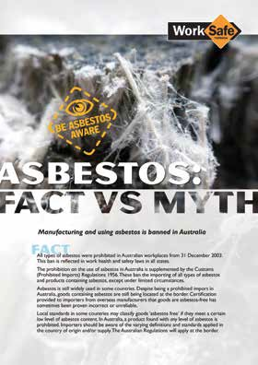

Figure 24: Asbestos campaign television advertisement 2017

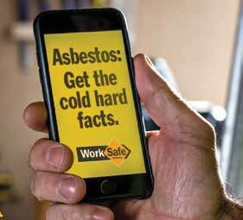

38 39

