CASE STUDY TWO

Ergon Energy – A Systematic Approach to Managing Asbestos
Ergon Energy is a Queensland Government-owned corporation that builds and maintains the electricity distribution network for regional Queensland. They also supply electricity to over 720,000 customers across regional, rural and remote communities across Queensland and the Torres Strait. Effective management of asbestos is a significant issue for the company. Asbestos Containing Materials (ACMs) are, or have been, present in a wide range of property and assets owned or managed by Ergon Energy - from office buildings, depots, company owned houses, substations and remote power generation sites, through to electrical installations and electrical equipment in buildings (including customer owned switchboards in residential properties) and on electricity poles.
Ergon Energy has taken a proactive approach to providing and maintaining a safe and healthy work environment for its employees, its contractors, and for members of the public. They have adopted a systematic, organisation-wide approach to managing asbestos-related issues, and in many cases have gone above and beyond the requirements of the relevant safety legislation and codes of practice, as they work towards their long-term goal – to achieve, as far as is practicable, an asbestos-free workplace by 2027.
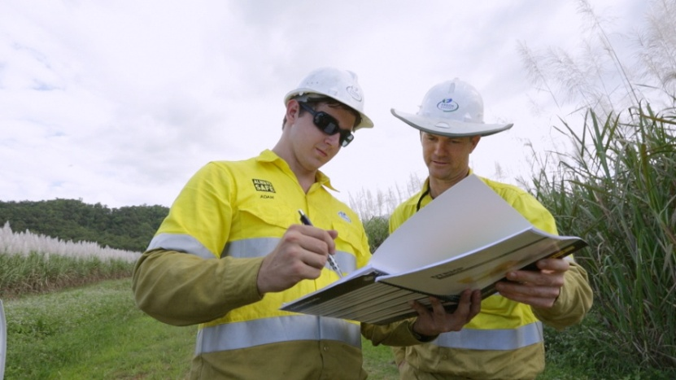

What have they done?

Established a single point of accountability
About 4 years ago Ergon Energy realised that by having multiple parts of the organisation responsible for different aspects of asbestos management that they were at risk of issues slipping through the cracks. The executive team decided to create a single point of accountability, with a program of work and budget attached. A new position of Asbestos Manager was established. The Asbestos Manager is now responsible for managing anything and everything to do with asbestos, right across the entire organisation.
Peter Billing, EGM Customer Service, emphasised the significance of the decision to have a single approach and point of accountability for asbestos, as well as “finding someone who has the right passion, knowledge and drive and then supporting them to do what they need to do”. He further explains that this has made the rest of the process much more straightforward:
We’ve achieved a lot with only one full time employee – but you have to fund it and get the right person.
As a company that works with electricity, Ergon Energy places safety and risk management at the core of everything that it does. For them, asbestos is another risk that needs to be carefully managed. However, by separating it from other work health and safety accountabilities, it has also signalled to all staff that asbestos is an issue that they take seriously.

Adopted a systematic approach to identifying and removing ACM
Ergon Energy has systematically audited every site built before 2004 for asbestos and identified, labelled, risk rated and set up a risk register for every site. Where possible, Ergon Energy has actually sampled and tested suspected ACMs at each site to confirm that they are actually asbestos. This allows them to develop and implement the appropriate safety control at each site and means that they aren’t implementing costly control measures in situations where they aren’t needed.
“With our maintenance personnel, if we assume that it’s asbestos, they have to treat it as asbestos. So then the cost is magnified…. A number of times it’s been treated as asbestos, but it’s only gyprock and it’s cost us four times as much. It’s much cheaper to take samples up front.”(Wayne Cullen, Asbestos Manager)
Recently, Ergon Energy also surveyed all customers, including residential households built prior to 2004, which contain a customer owned switchboard (around 540,000 customers) to identify those that are suspected of containing asbestos. The suspected asbestos switchboards have now been labelled and recorded in an effort to further protect Ergon Energy employees, electrical contractors and members of the public from asbestos exposure risks. It is also enabling them to identify which switchboard jobs will require the use of asbestos safety equipment and give the company the ability to be able to schedule resources more effectively, making the process more efficient for field teams.
All ACMs are assessed according to level of ‘consequence’ (i.e. potential for harm) and ‘likelihood’ (i.e. the potential for that harm becoming a reality) and result in a rating of Extreme, High or Medium risk. Ergon Energy does not consider that there is such a thing as ‘low risk’ asbestos.
Control measures for ACMs are determined using the common Hierarchy of Hazard Control:
Wherever possible the highest control measures are used. Asbestos Manager, Wayne Cullen explains, “It can be perceived as an expensive approach in implementing hard controls. Some companies tend to rely solely on Soft Controls because of this potential cost factor and because they are so much easier to implement.” However, the higher control measures are more effective in reducing risk of exposure and are actually more cost effective in the long term. Although removal can be expensive, once the asbestos is gone, the costs and the time involved in continuing to implement safety measures are also removed. And as Peter points out – “removal can often be done for only another 5-7% of cost on top of other work already being completed or planned”.
All extreme risk ACMs have already been removed through a structured removal program, and by the end of 2015 all manned depots will be asbestos free. Senior management’s support for the removal program has made the process relatively straightforward.

Created and maintained detailed registers
All identified or assumed asbestos is documented in a comprehensive Asbestos Register for each site. The registers are updated immediately after any work that involves disturbing or removing ACM and all work documentation is attached to the register so there is a complete history of activity for each site.
They can be accessed online, or in hard copy at each site. Currently, Ergon Energy conducts audits and reassessment based on level of risk. High Risk Sites are audited/reassessed annually, while Moderate risk sites are audited/reassessed every 3 years.
Recently, Ergon Energy has implemented the use of Quick Response (QR) codes to access the registers. These are a type of barcode that can be scanned by devices such as smart phones at each site, which will enable the register to be read on the device. This gets around the problem that sometimes hard copies are accidentally taken away by contractors at unmanned sites.

Ensure removal work is done by skilled and reputable contractors
Ergon Energy has established a preferred contractor panel for asbestos removal work. These contractors are highly vetted before being accepted onto the panel and continue to be monitored during works through on-site safety checks.
All contractors hold ‘A class’ asbestos removal licences (even though most work only requires a ‘B class’ licence). This means that if previously unidentified friable ACMs are discovered during a removal process, they can be dealt with regardless of their type (‘B class licence holders can only remove non-friable asbestos). This decision has proven to be a much more cost effective practice, as evidenced by an example that Wayne described:
“The biggest problem for Ergon Energy is distance and remote locations. The major cost is derived from the mobilisation of suitable qualified contractor teams. In these smaller towns [out west and in the islands of the Torres Strait] there are a limited number of qualified personnel, so they have to come from the larger cities along the coast. In one case, a crew was sent out to a sub-station to remove a large quantity of bonded asbestos. However, after commencing the task, it was identified that friable asbestos was present and had to be removed [which requires an ‘A class’ licence]. Ergon Energy had to stop the job, demobilise that crew and get another qualified crew out to the site. This resulted in a huge cost to the business.”
Other higher safety measures (beyond what is required under the code) are used in removal processes, such as air monitoring in situations that are ‘B class’ removals, but taking place in sites close to busy public spaces (e.g. a depot in the main street of a town), and the use of clearance certificates for all B class, as well as A class removals.

Challenges
The biggest challenges in implementing a system-wide approach have been about changing culture. There are still “old and bold” employees who have the attitude that asbestos can’t/won’t affect them. This is partly because the effects of asbestos exposure aren’t seen for a long time.
As Wayne explains:
“When you make a mistake with electricity you know about it straight away. Whereas with asbestos, you don’t know about it for 20 or 30 years”
He has worked hard to change these attitudes – producing videos to get the message out to staff across the company, running face to face training sessions, visiting staff out in the field, engaging staff and unions in developing safe work processes, and keeping the issue on the agenda with staff, managers and the senior executive through regular presentations and updates.
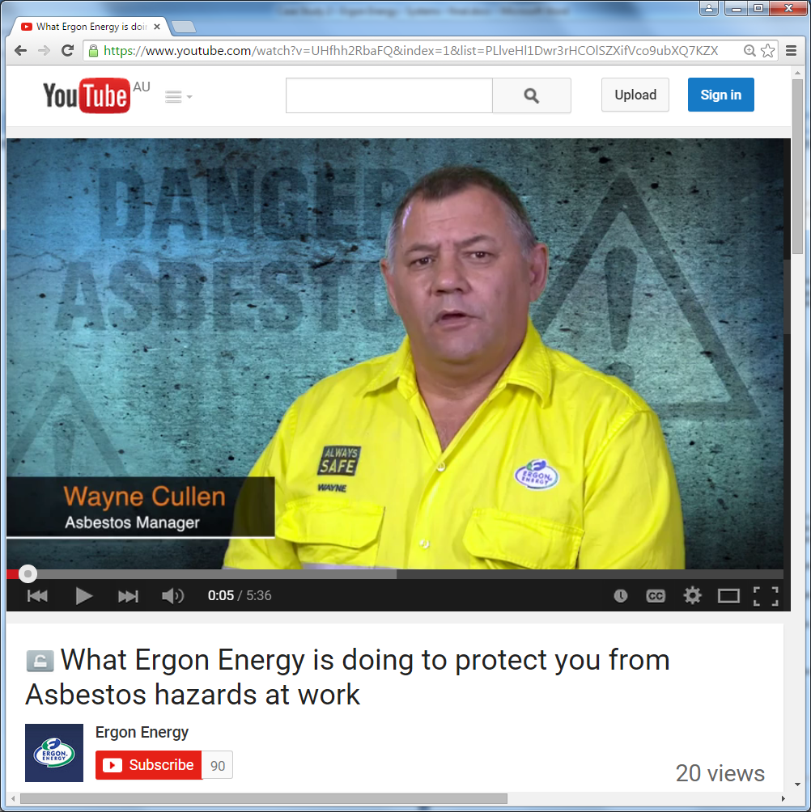

Key messages about how to make it work
Since beginning implementation of a systematic approach to managing asbestos about four years ago, there has not been a single asbestos exposure incident reported. Regular monitoring activities conducted by internal and external teams, targeting parts of the system including work practices, also show the system is working.
Wayne and Peter have the following messages for other organisations seeking to create an effective and consistent approach to managing asbestos:
- There has to be someone in the organisation who is held accountable for asbestos safety. If it’s not part of someone’s day job, it won’t happen.
- If you don’t have the support of senior management, the unions and staff in the field, it’s a hard, if not impossible task.
- You need middle managers who are willing to promote a safety culture.
- While there may be great costs involved initially, higher levels of control (i.e. elimination and isolation):
  - are much more effective in reducing risk of exposure to asbestos fibres
  - remove the need for ongoing costly and time consuming safety practices
  - often make it easier for employees to follow procedures
  - provide evidence that protects the organisation from any claims of risk to public health and safety.

